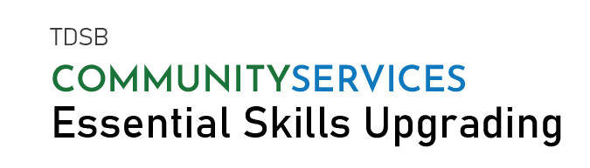

COMPUTER WORKSHOPS STARTING IN SEP. 2021
Topic | Start Date | End Date |  | Time | Location
Microsoft Excel | Sep. 27, 2021 | Nov. 17, 2021 |  | 6:30-9:00 PM | Online
Microsoft Excel | Sep. 28, 2021 | Nov. 18, 2021 |  | 9:30AM-12:00PM | Online
Microsoft Word | Sep. 28, 2021 | Oct. 21, 2021 |  | 1:00PM-3:30PM | Online
Microsoft PowerPoint | Sep. 28, 2021 | Oct. 21, 2021 |  | 12:00-2:30PM | Online
Microsoft Word | Sep. 28, 2021 | Oct. 21, 2021 |  | 6:30-9:00PM | Online
To attend workshop:
- Attendees need laptop/computer with software installed.
- Learners MUST be registered to attend workshop.
- Valid SIN required

WORKSHOPS ARE FREE.  REGISTRATION REQUIRED.  Essential Skills for Employment  Facebook @TDSBCommunityServices  Twitter @TDSB_CS |  |  | TO REGISTER,  CALL 416-396-6386 OR  EMAIL MAHNAZ.CHINOY@TDSB.ON.CA

