

TDSB/OISE Action Research
Team Research Summary

Introducing the Teacher-Researcher, Students & School:
Teacher: Dimitra Tsanos
Class: CGF3M - Forces of Nature - 22 students
School: Humberside CI
Research Question:
How can journaling about place-based education support students' connections to nature?
Curricular Implementation:
- Having sit spots and time to sketch and listen to nature will help student re-connect to earth - water, air and land.
- Reflective learning through journaling (achievement. Important to reflect, take notes and sketch with observations.
- Sharing Circles on school grounds (March 24/ April 15/April 22), Bluffs/Don Valley Brickworks (April 16) and High Park (May 2)
Photo Documentation:
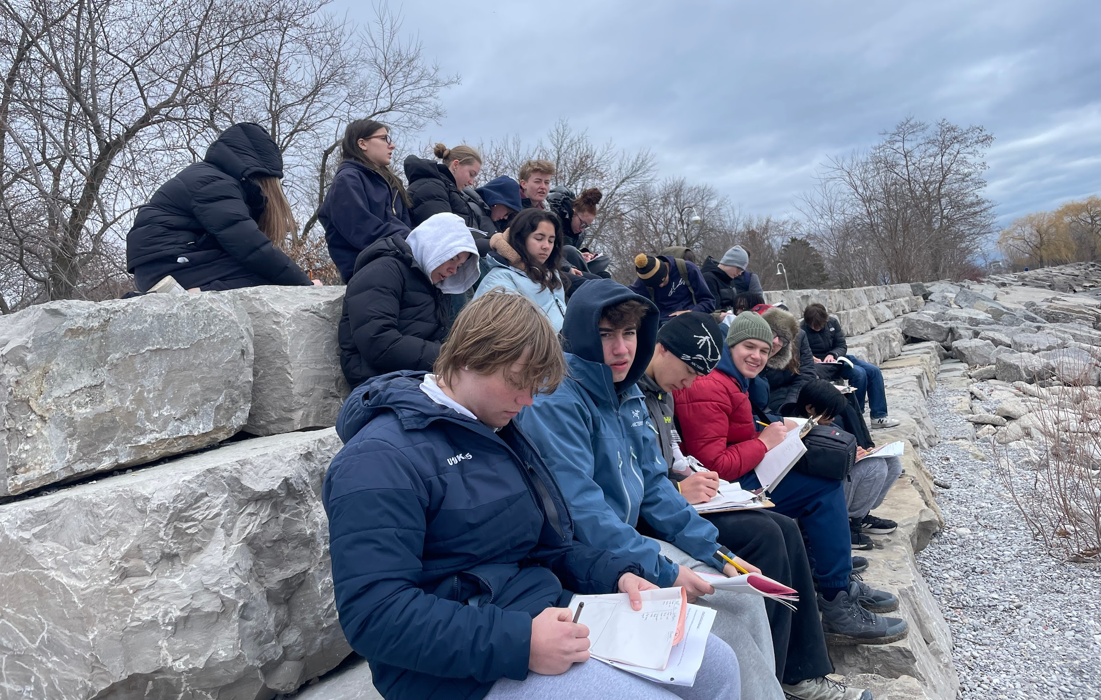
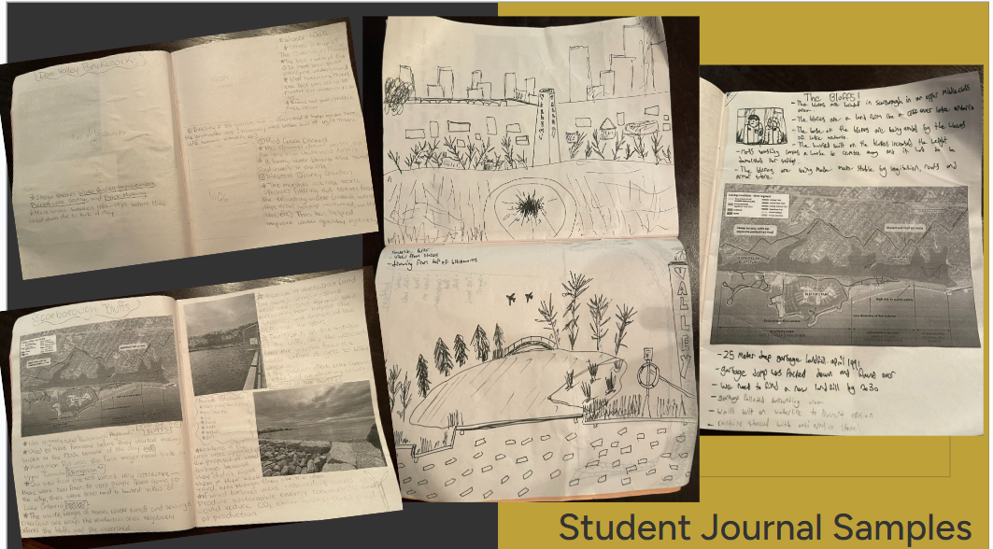
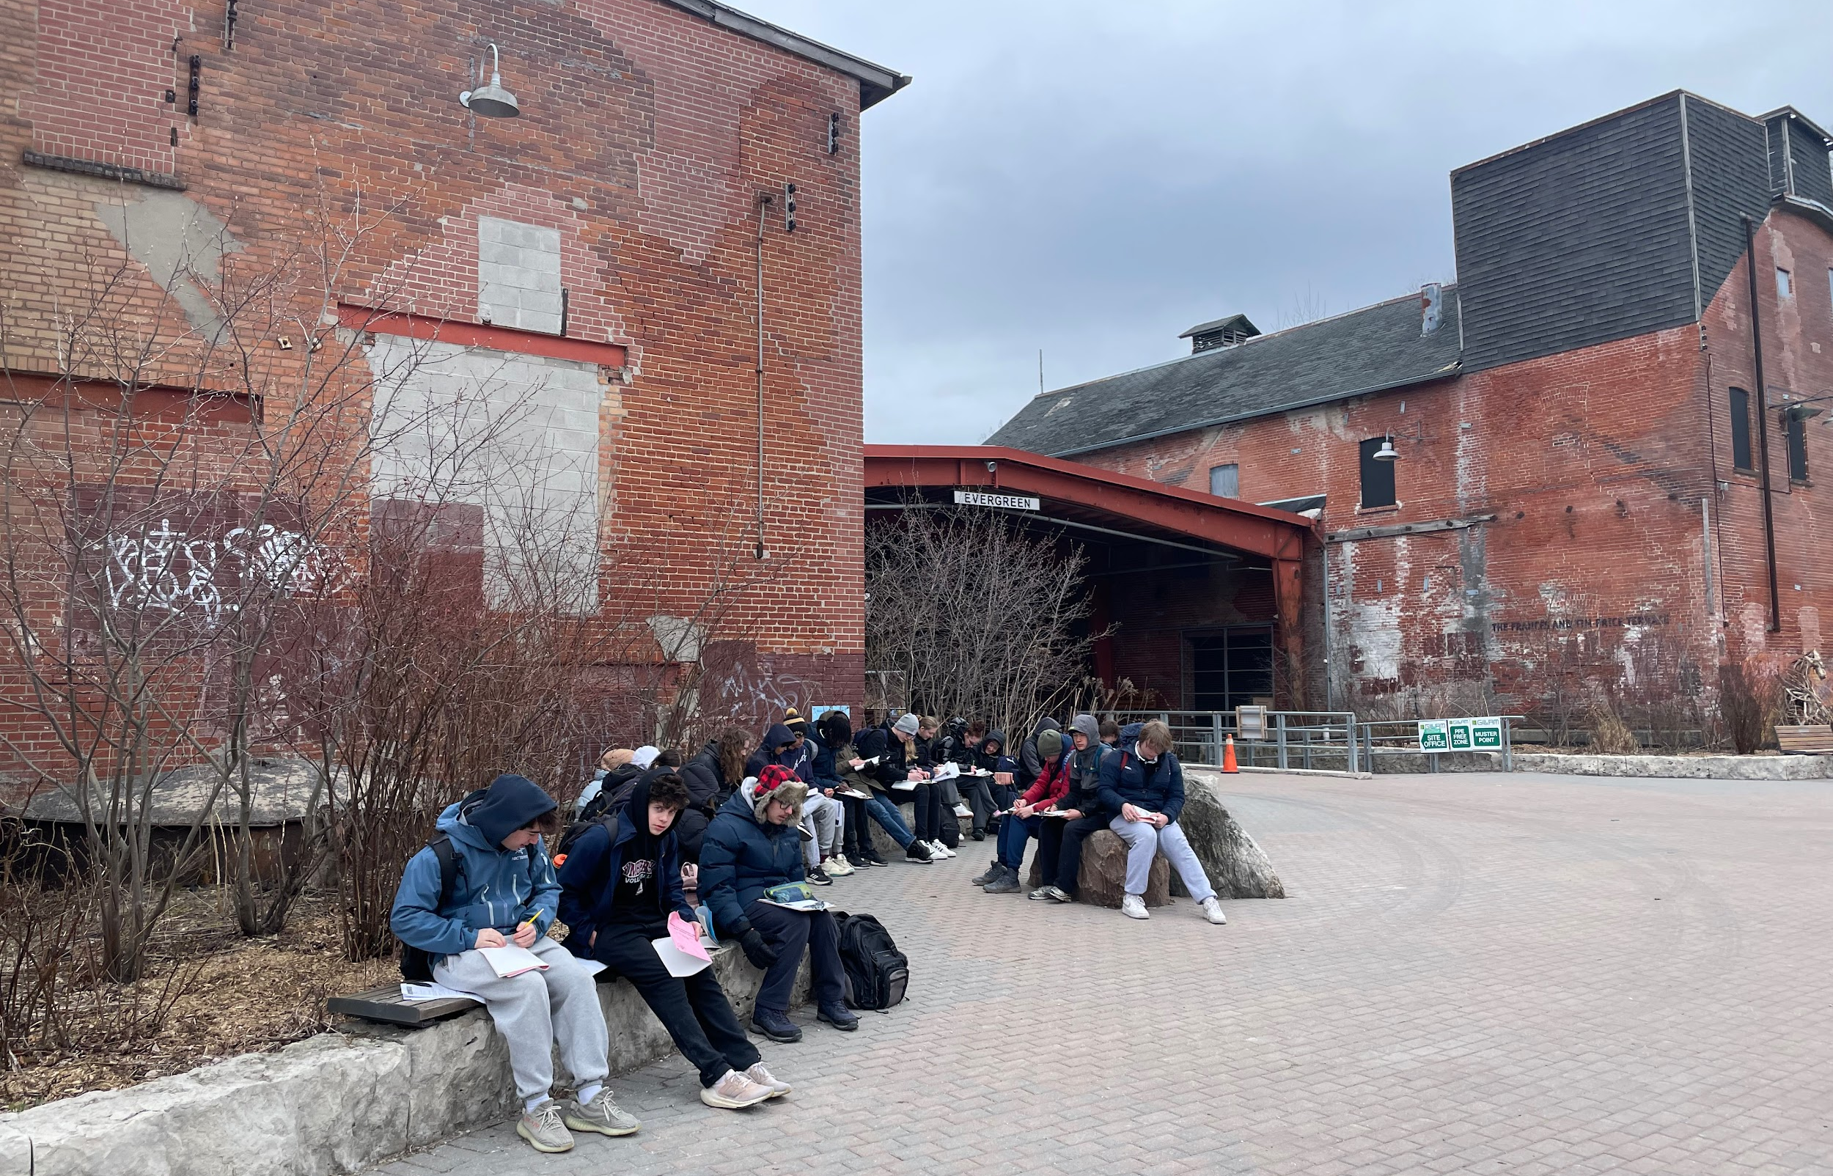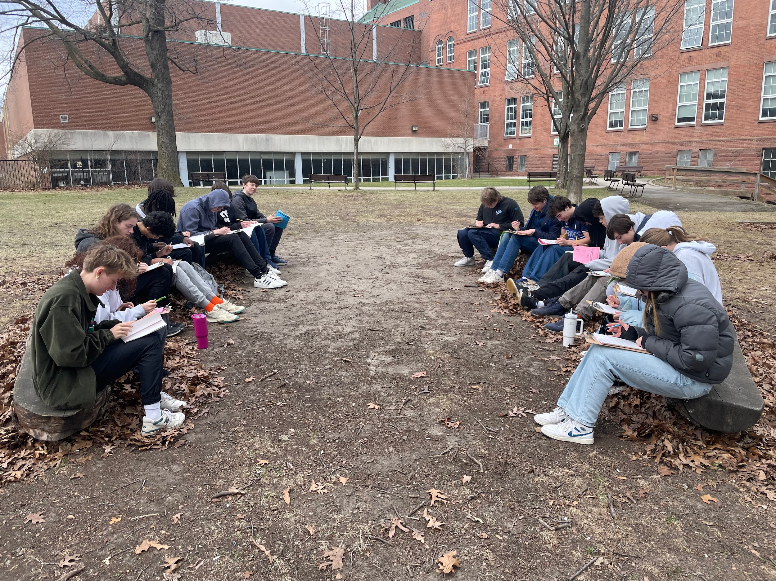

Data Collection Strategies:
• Photos from trips
• Student work samples - Journal Entries/Notes
• Student Survey 123- done before journaling activities, after trip #2 April 16 (Bluffs/DVBW)- https://arcg.is/0vnnCH, Survey done after all activities - https://arcg.is/mP8180
• Participant Interviews
Insights from this Action Research Study
- Students seemed to enjoy going outside as the semester progressed (as the weather became warmer)
  - The survey results did not completely prove this, but interviews and observations highlighted enjoyment
  - Students would ask to go outside after going a few times
- It helped them cultivate patience and fully embodied sensory awareness.
  - Students were starting to close their eyes and listen, even shushing each other during our trips to listen to trickling water and waves at the Brickworks and Bluffs trip
- The journal provided a much needed reason to sit still, be quiet, and practice attentiveness.
  - Having screen free time in class was important and much needed for positive mental health.
Other Notes:
- It helped them cultivate patience and fully embodied sensory awareness.
- The process of learning was more important than the product.
- The journal provided a much needed reason to sit still, be quiet, and practice attentiveness.

Useful Supporting Literature:
Warkentin, T. (2011). Cultivating Urban Naturalists: Teaching Experiential, Place-based Learning through Nature Journaling in Central Park. Journal of Geography (Houston), 110(6), 227–238.

Info about the TDSB/OISE Action Research Team can be found on the TDSB and OISE websites

