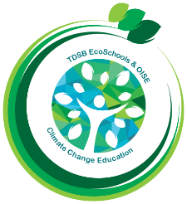
TDSB/OISE Action Research
Team Research Summary

Introducing the Teacher-Researcher, Students & School:

Alison Williams, Outdoor Learning Coach, Toronto Outdoor Education Schools (TOES), TDSB

Research Question:

How can I be a bridge to connect and broaden student awareness of their local school community, and how can they learn more about the changes that have occurred, and that are currently occurring?

Sub-questions:
What can be done to broaden the awareness of parents and caregivers, regarding the activities that can be done with their families with the school community?

Curricular Implementation:

I work with 20 different classes, from Kindergarten to Grade 8. For the three schools on which I have decided to focus for this Action Research study, the activities connect directly with Science and Social Studies curriculum, as well as History and Geography for the Grade 8 students.

Photo Documentation:

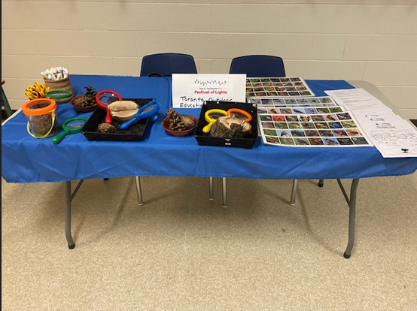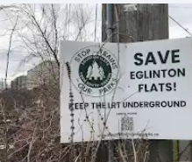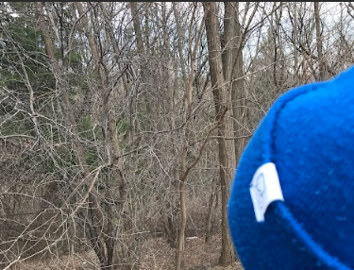

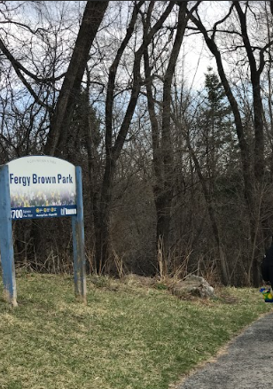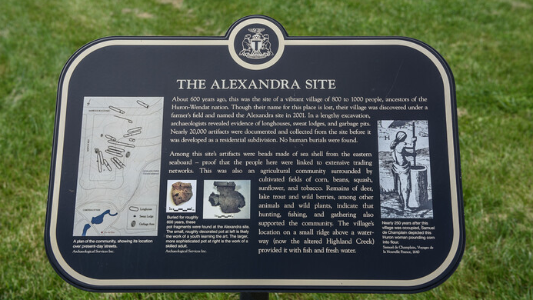

Data Collection Strategies:
- Anecdotal observations, notes from visits with schools
- Opinions from students
- Feedback from parents and community members involved
Insights from this Action Research Study
One of the insights that I have gained from doing this Action Research Study is that many of our students are not yet aware of the events or activities that may be occurring in their broader school community. This could range from the building of major infrastructure, such as the Eglinton Crosstown extension through Eglinton Flats, near Bala Avenue Community School, to the knowledge of community events and access to local parks, trails and paths near John G. Diefenbaker Public School.

In other instances, I have learned that at times, there may be a lack of awareness about the historical significance of the land on which our schools are located. For example, the burying of the Highland Creek to create housing developments, and The Alexandra Site, where a commemorative plaque now exists, to highlight the Indigenous Village that once stood in the L’Amoureaux community. Both of these historical elements are located near Sir Ernest MacMillan Senior Public School.

I have always felt that schools are the main hubs for a community. As educators, through our work with students at school, we can, and should, provide them with a broader awareness of what may be occurring within their own community, as well as provide access and opportunities to explore and enjoy the various events and spaces around them.

Info about the TDSB/OISE Action Research Team can be found on the TDSB and OISE websites

