Math Tasks: Intermediate (Grades 7-8)

Monday, October 19th
Learning Goal: Add, subtract, multiply, and divide fractions, using appropriate strategies, in various contexts; Convert between fractions, decimal numbers, and percents, in various contexts.
Task: Fractions Talk!  - Write a mathematical statement that, to you, describes the whole Fraction Talks image. Your statement can be an expression, an equation, a ratio, or anything else it makes sense to use.  - In the image, what fraction of the whole is yellow? How do you know?  - If you subtract blue from yellow, what fraction of the whole remains? Verify your answer using operations with fractions.  - What is the result of dividing blue by green? Verify your result.  - What percent of the whole is not orange or green? What process did you use to find your answer?  - Create your own fraction or percent question based on the image, and figure out what the answer should be. Either use the image shown, or create and colour your own fraction talk!  Share your question with someone in your home, and discuss the answer. |  | 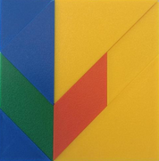  Source: Fraction Talks

Tuesday, October 20th
Learning Goal: I apply proportional reasoning to solve problems; I identify various societal and personal factors that may influence financial decision making.
Task: Would you Rather?  - Which box of foil would you rather buy? Explain any calculations you did, as well as any other factors you considered.  - Do you think everyone would give the same answer to this question? Explain one other choice a person might make, and why.  - Create your own “Would You Rather” from information about a different grocery item.  If it is not possible to visit a grocery store, you can look for prices and sizes of items online. Here are two examples: https://freshco.com/, https://www.nofrills.ca/  - Share your activity with another person in your home. Do you both agree on which choice is the best? |  | 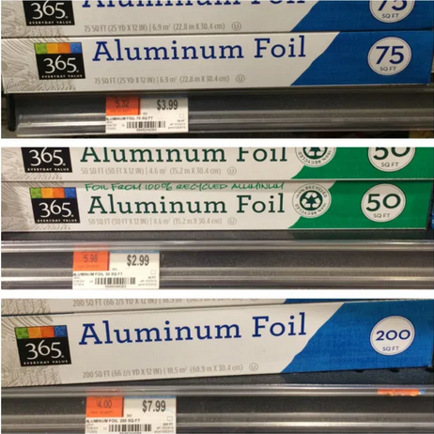  A larger image is here:  1 thought on “Would You Rather…”

Wednesday, October 21st
Learning Goal: Describe the Pythagorean relationship using various geometric models
Task: Right on, Triangles!  - Try the Proof Without Words for Right Triangles. Drag each region to its matching dot. What do you notice? What do you wonder?  Write a sentence to summarize what you think the Proof is showing.  - Explore the Right Triangle Review. Drag the red dots to adjust the size and shape of the right triangle.  - Click the “Area” button and observe the measurements.  - Reflect on your previous summary from the Proof. Were the area measurements what you expected? Adjust your summary if needed.  - Draw, cut out, or find in your home examples of right triangles. Measure their side lengths. Use side lengths to calculate the areas of the squares on each side, and share the relationship between the areas with someone in your home.  hint: ${{Area of a square = (side length ×side length) =(side length)}^{2}}^{}$ |  | 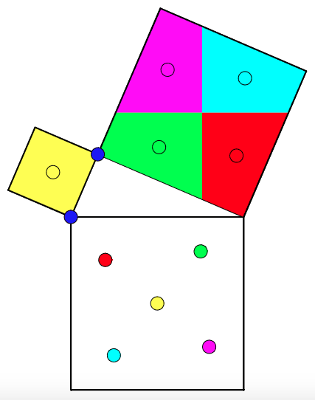  Proof Without Words – GeoGebra  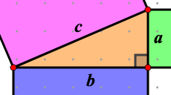  Right Triangle Review

Thursday, October 22nd
Learning Goal: Create and translate repeating, growing, and shrinking patterns involving whole numbers, decimal numbers, and rational numbers using various representations; I will create computational representations of mathematical situations
Task: A Trick of the Eye  - Optical art contains geometric shapes and patterns. Sometimes these patterns trick the eye with an “optical illusion”.  - Look at the three examples. Do you see anything in the patterns that creates an optical illusion?  - Using a 100-square area on grid paper (10x10), create your own interesting pattern. Can you create an optical illusion within your artwork?  - Can you see any patterns, fractions or decimals in your artwork? Where are they?  - Think of a mathematical question you could ask about your artwork.  - If someone wanted to recreate your artwork, what directions would you give them? Share your directions with someone at home, and see if they can draw your pattern.  Task adapted from youcubed |  | 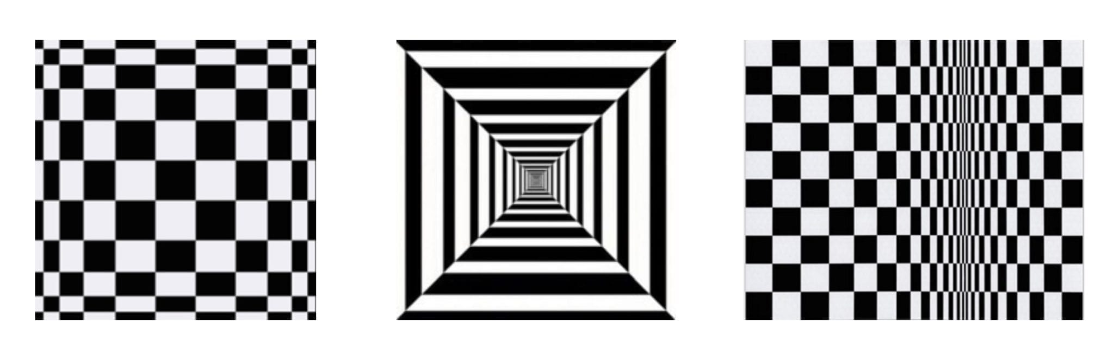  A larger image of the illusions is here  If printing, a grid clipart is here

Friday, October 23rd
Learning Goal: I will solve counting problems and create computational representations of mathematical situations
Task: Cone Combinations  - Imagine a shop that sells 10 flavours of ice cream.  - How many different 2-flavour cones could they sell, if the order of flavours doesn’t matter? Show how you came up with your result.  - Write instructions for someone to determine the total number of different 3-flavour cones, if the order of flavours doesn’t matter.  What advice would you give for making this process as efficient as possible?  - Share your instructions with someone in your home, and complete the calculations together. Would you adjust your strategy? Explain.  Task adapted from youcubed |  | Image source: Ice Cream Scoop

