Math Tasks: Primary (Grades 1-3)

Monday, October 13 - Bonus
Learning Goal: I am learning to sort two-dimensional shapes according to one attribute.
Materials:  The materials needed to play are quite simple, most of which you probably have from other math resources.  - 2 to 5 shape boards (located in the back of this packet)  - One paper bag per group  - Physical shapes (circle, octagon, rectangle, square, triangle) in three colors (blue, red, yellow) and two sizes.  How do I play Attribute Grab Bag?  Attribute Grab Bag can be played in groups of two to four students. Each player needs their own shape board and one bag of shapes for the group. The instructions are quite simple:  - Decide which player is going first (rock, paper, scissors or some other way to determine the order of players).  - Without looking, the first player reaches into the bag and takes out one shape.  - The player places the shape on their shape board if the shape, size and color ALL MATCH.  - If the player cannot place the shape on their shape board, they place the shape back in the bag.  - Players take turns taking shapes from the bag.  - The first player to get all SIX shapes is declared the winner  Source: http://www.pepnonprofit.org/uploads/3/4/0/7/34070191/attribute_grab_bag.pdf |  | 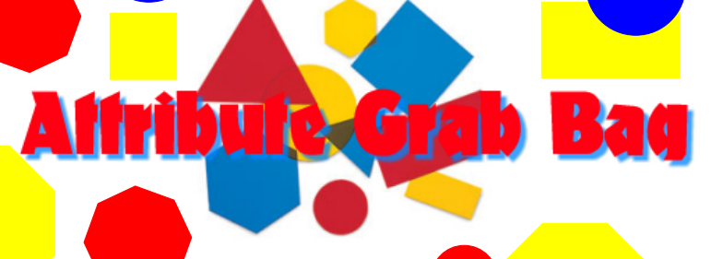

Tuesday, October 13
Learning Goal: I am learning to compare and order whole numbers up to and including 200, in various contexts.
Task: More, Less, Equal  Materials:  - A bowl of small objects (buttons, paper clips, acorns)  - A spinner made with a paper clip, pencil, and the attached spinner circle  - Paper and pencil or pen  Rules:  - Each player takes a handful of small objects from the bowl and places the objects in a pile.  - Each player counts his or her objects.  - Players take turns spinning the spinner.  - If the spinner lands on ‘More,’ the player who has more objects earns a point.  - If the spinner lands on ‘Less,’ the player who has less objects earns a point.  - If the spinner lands on ‘Equal,’ the players work together to make their piles equal by trading objects from one pile to the other. If the players can make equal piles, both players get a point.he game continues until one player has earned 10 points.  Thinking Questions:  - How can we check to see who has more objects?  - How can we check to see who has less objects?  - Was it better to have more in your pile or less in your pile? Why?  Source: https://www.mathies.ca/files/Patterning%20and%20Algebra%20Grade%201.pdf |  | 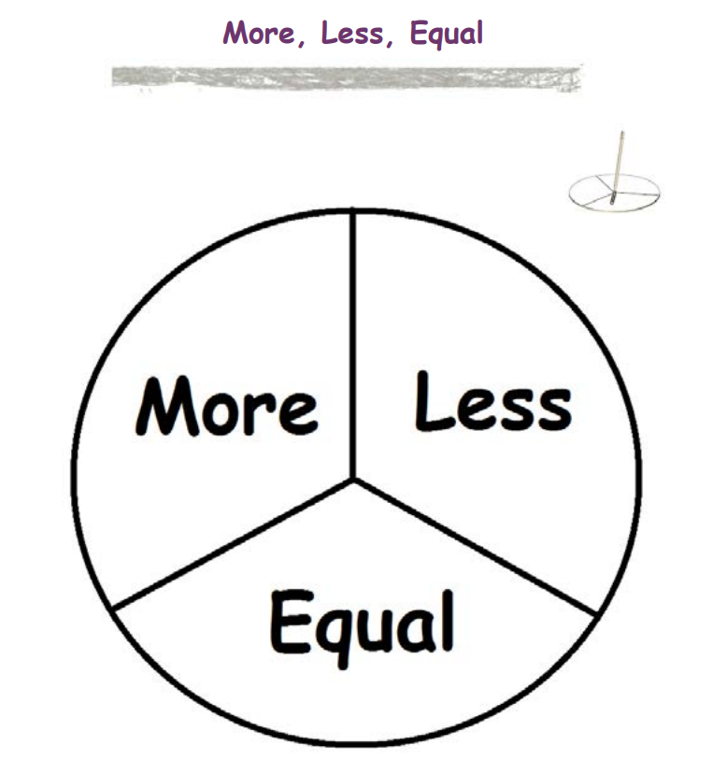

Wednesday, October 14
Learning Goal: I am learning to use objects, diagrams, and equations to represent, describe, and solve situations involving addition and subtraction of whole numbers that add up to no more than 100.
Task: Roll and Add Game  Materials:  - Attached Game Cards  - 2 Dice  - Marker, Crayon, or Pencil  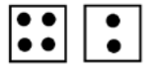  Rules:  - Give each player a game card.  - Take turns rolling the dice.  - Add the dots that show on the top of the dice.  - Find the sum on the game card.  - Colour in one square in that column.  The winner is the first player to fill his or her game card!  Thinking Questions:  - Which sum appeared the most during the game? Why do you think that is?  - Which sum appeared the least during the game? Why do you think that is?  Source:https://www.mathies.ca/files/Number%20Sense%20and%20Numeration%20Grade%201.pdf |  | 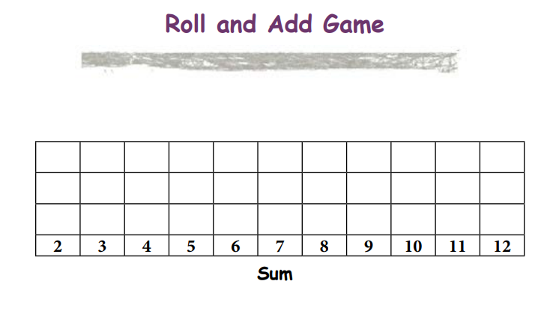

Thursday, October 15
Learning Goal: I am learning to represent multiplication of numbers up to 10 × 10 and division up to 100 ÷ 10, using a variety of tools and drawings.
Task: Circles and Dots Game
Materials:
- Paper and pencil
- Dice

Rules:
- Player 1 rolls one die. The number that comes up is how many circles Player 1 will draw on a piece of paper.
- Player 1 rolls the second die. This number indicates the number of dots to draw in each circle.
- Player 1 uses those numbers rolled to make a multiplication equation. For example: If the first roll is a 3, the player draws 3 circles.
- If the second roll is a 4, the player puts 4 dots in each circle. It would look like this: The multiplication equation would be 3 x 4 = 12.
- Now it’s Player 2’s turn.
- The answer to a multiplication question is called a product. After each round, the player with the largest product earns a point. Keep playing until one player gets 10 points.

Thinking Questions:
- Which product did you find most challenging? Explain what you did to find it.

Source: https://www.mathies.ca/files/Number%20Sense%20and%20Numeration%20Grade%203.pdf

Friday, October 16
Learning Goal: I am learning to use use place value when describing and representing multi-digit numbers in a variety of ways, including with base ten materials
Task: Place Value Pile  You will Need:  - Place value cards, you can either make them using your own paper, print them off or use them on your computer.  How to Play:  - Take a card from each place value and pile it on top of the other according to place value to create a number.  - Write the number  - Write the number in expanded form  Thinking questions to ask:  - Can you draw the quantity of each of the numbers?  - Are you curious about the exponent cards? What do you notice?  Source: http://www.pepnonprofit.org/uploads/3/4/0/7/34070191/place_value_piles.pdf |  | 