Math Tasks: Primary (Grades 1-3)

Monday, October 5
Learning Goal: I will be able to read, represent and compose numbers up to 1000 and use place value to describe multi-digit numbers.
Task: Let’s Sing About Tens  - Watch the video about place value as many times as you’d like! Learn the song and sing along!  - After watching the video and singing along:  - Find a pile of something that there’s a lot of  - Make groups of ten with the items in your pile  - Count how many groups of ten you made  - Count by tens to see how many items you have  Adapted with permission from District School Board of Niagara Virtual School |  | 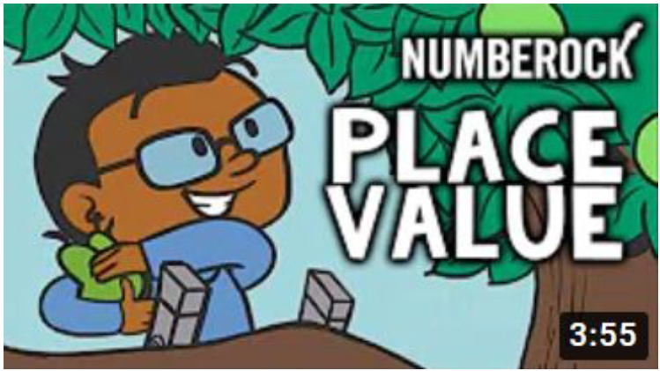  NUMBEROCK Place Value

Tuesday, October 6
Learning Goal: I will develop and apply reasoning skills (e.g., classification, recognition of relationships, use of counter-examples) to justify my thinking.
Task:

- Look at the shapes and compare them:

- What is the same about the shapes?

- What is different about the shapes?

- Which shapes do you think belong together, and why? Is there more than one way to make a group of shapes that belong together?

- Which shape doesn’t belong? Ask this question to someone in your home. Do your answers agree?

- Imagine four friends who each choose a different shape as not belonging. What reasons do you think each friend would give?

Adapted with permission from District School Board of Niagara Virtual School
Image: wodb

Wednesday, October 7
Learning Goal: I can identify various two-dimensional shapes and apply spatial sense.
Task: Create a “Cootie Catcher”  - Follow the instructions in the video provided (you need a square piece of paper and some markers)  - Label the outside with colours  - Numbers in the inside  - Write 4 fortunes (You will... )  - What shapes do you see? How many of each shape are there?  - Find a family member to play with - Have fun!  Adapted with permission from Peel District School Board Online School |  | 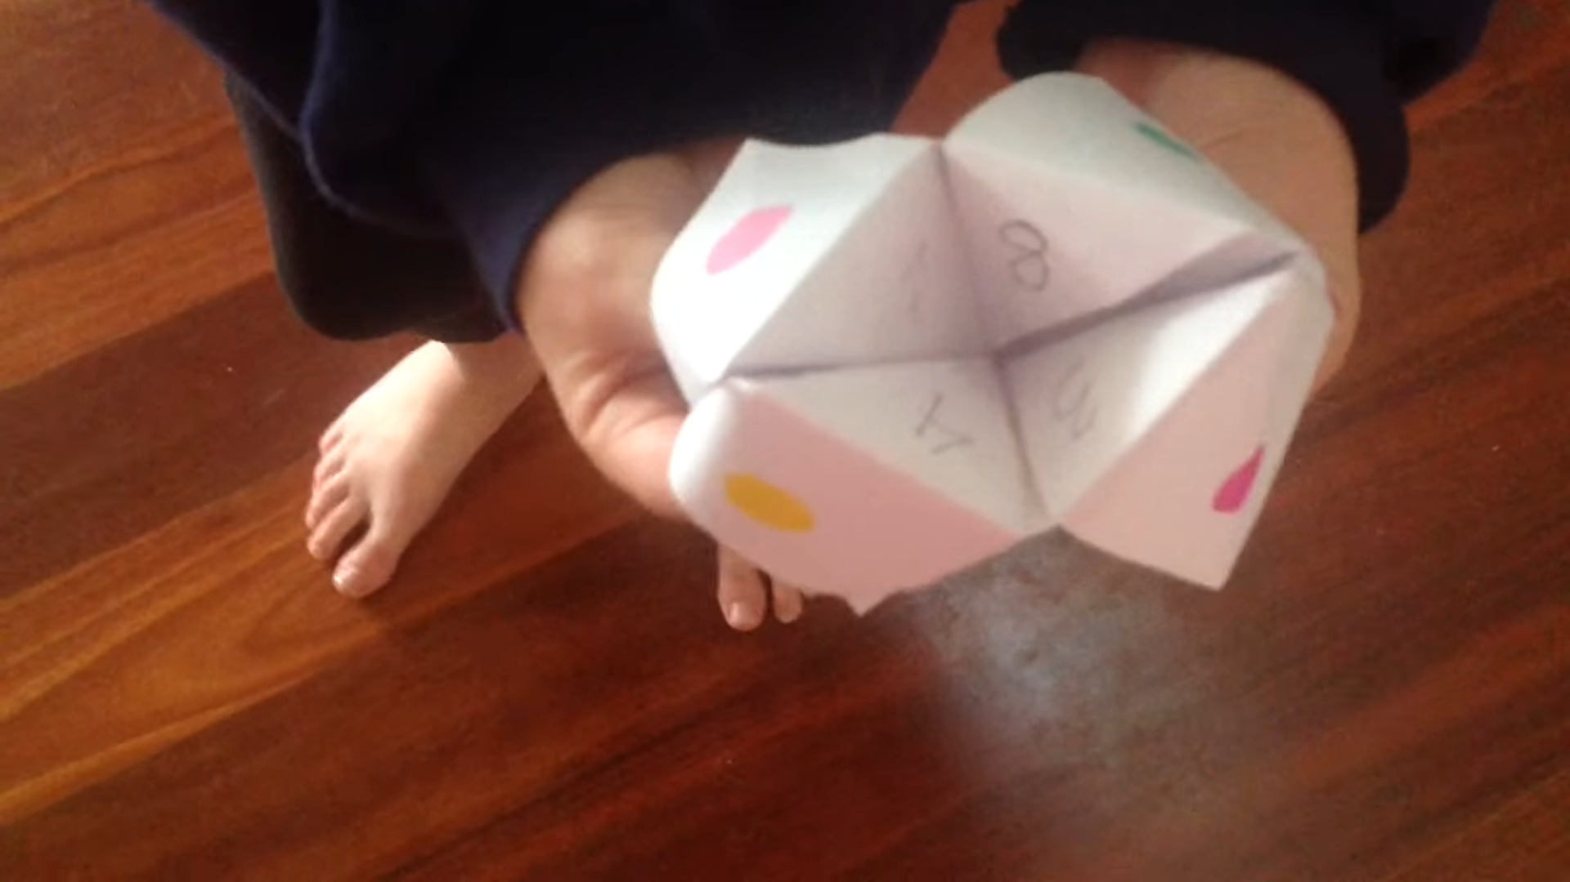  How To Make A Cootie Catcher

Thursday, October 8
Learning Goal:
We are learning how to be positive about solving challenging problems and to help others learn to be positive.
We are learning to solve challenging problems in math by sticking with it and trying different strategies.
I will be successful when:  - I try more than one way to solve a problem  - I stop and think when I get stuck  - I listen to my group and ask for ideas and suggestions  - I believe that I will find a solution  Task:  - The shapes in each row and column in the puzzle adds to ten.  - What numbers could go in the empty boxes so they can add to ten?  - Is there more than one solution?  Adapted with permission from: SCDSB First 20 Days of Math  Number Cross Puzzles Source: Hana Murray, Hana Murray on Twitter (Sept. 2020)  To explore more Cross Number Puzzles search #crossnumberpuzzle on Twitter |  | 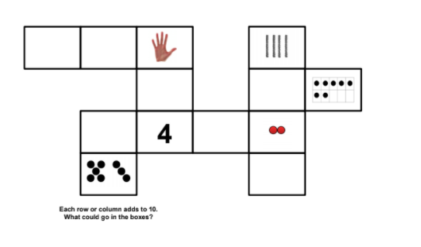  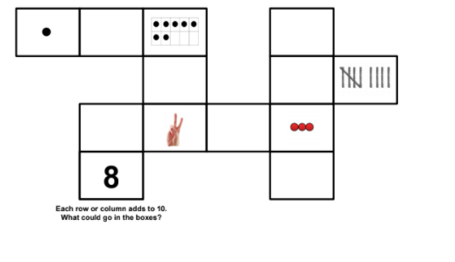  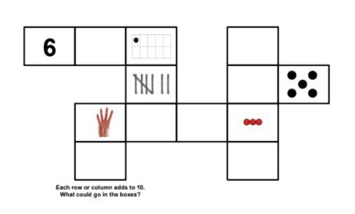

Friday, October 9
Learning Goal: I am learning to use a variety of strategies to calculate the value of their cards and compare their calculations to their opponents to determine a winner.
Task: Multiplication Number Battle  You will Need:  - Deck of Cards (face cards worth 10, Ace worth 1 or 11)  How to Play:  - Players split a deck of cards and simultaneously flip over their top two cards. The highest product wins all four cards.  - If the cards products have the same value, the cards are placed in a center pile. The next hand is played normally and the winner of the next multiplication number battle takes the center pile as well.  Thinking questions to ask:  - Is there one card that you could substitute for another that would help you win the game?  - What card(s) do you/ your opponent need to win this round?  Source: http://www.pepnonprofit.org/uploads/3/4/0/7/34070191/acing_math.pdf |  | 