Math Tasks: Junior (Grades 4-6)

Monday, October 2nd
Learning Goal: I will be able to compare numbers and communicate my mathematical thinking in various ways.
Task: Which One Doesn’t Belong?  - Which numbers do you think belong together, and why? Is there more than one way to make a group of numbers that belong together?  - Which number doesn’t belong with the other three? For each number, can you find a mathematical reason why it doesn’t belong?  - It’s your turn! Create a “Which One Doesn’t Belong” with four different numbers of your choice. Make sure there are at least two different ways to choose a number as not belonging to the group. |  | 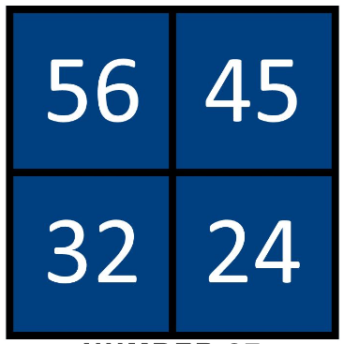  By Beth Bejamin in Numbers

Tuesday, October 3rd
Learning Goals: I will use the properties of operations, and the relationships between addition, subtraction, multiplication, and division, to solve problems involving whole numbers, including those requiring more than one operation, and check calculations
Task: Krypto Challenge  - Try the interactive Krypto game. Use the numbers provided, along with the four arithmetic operations, to make the target number. Each operation is only used once.  - Complete at least three rounds of interactive Krypto.  - Now, it’s your turn to create a Krypto!  - Choose five numbers from 1 and 10  - Use each of the four arithmetic operations between your five numbers  - Make sure that your target number is also from 1 to 10  - Arrange your five numbers at random, state the target, and ask a friend or family member to play! |  | 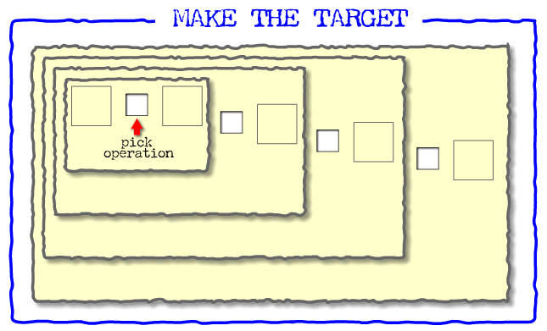  Primary Krypto

Wednesday, October 4th
Learning Goal: I will represent and create equivalent ratios
Task: Waves of Light  - Light waves are very short - their tiny length is measured in nanometres. A nanometre is one billionth of a metre!  The “colour” of an object we see is really the colour of the light being reflected away from it.  - Look at the image of the spectrum of light. Red light waves measure around 700 nm in length.  - Based on the spectrum, what do you estimate the wavelengths to be for orange, yellow, green, and purple light?  - The butterfly and bumblebee photo was taken at Rouge National Urban Park in Scarborough.  Choose two colours in the photo and write a fraction in lowest terms to represent the ratio of their wavelengths. Explain how you put your fraction in lowest terms.  How many times longer was the longest wavelength of the two? How did you decide?  - Changing spectrum brightness reveals many more colours without changing the wavelength. For example, mint is pale green, navy is dark blue.  What wavelength do you estimate for the dried grasses in the photo?  - Choose any two objects in your surroundings and estimate the ratio of their wavelengths in lowest terms. Share your findings with someone in your home. |  | 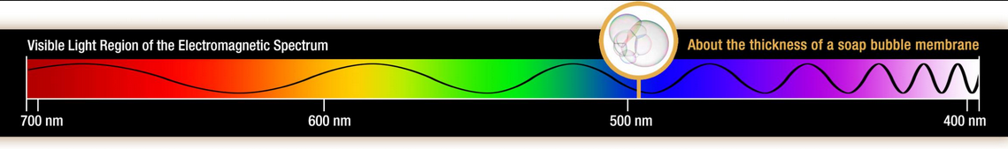  A larger spectrum is here  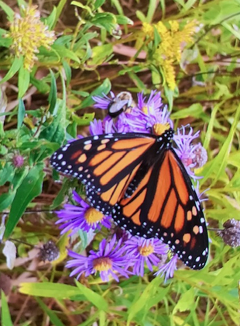

Thursday, October 5th
Learning Goal: I will recognize when I feel stressed, and I will cope with challenges when learning math.
Task: What are my cards?  - I have fifteen cards numbered 1− 15. I put down seven of them on the table in a row.  - The numbers on the first two cards add to 15.  - The numbers on the second and third cards add to 20.  - The numbers on the third and fourth cards add to 23.  - The numbers on the fourth and fifth cards add to 16.  - The numbers on the fifth and sixth cards add to 18.  - The numbers on the sixth and seventh cards add to 21.  - What are my cards?  - Can you find any other solutions?  - How do you know you've found all the different solutions?  Thinking Questions:  - How did you feel at the beginning, middle and end of the task?  - What strategies did you use to problem-solve?  - How did you share your thinking with others?  - How did you feel when your idea was correct or incorrect?  Adapted with permission from: SCDSB First 20 Days of Math  Source: NRICH, Fifteen Cards (Sept. 2020) |  | 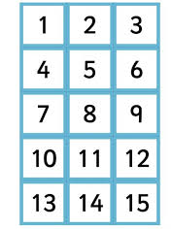

Friday, October 6th
Learning Goal:
- We are learning to work together and share ideas to solve problems.
- We are learning to identify how we are feeling and to understand the feelings of others.
Task: Making Rectangles
- Every member of the team has to end up with the same rectangle in front of them. The task is only successfully completed when everyone on the team has completed their rectangle.

- You will need to work in a team of four. Distribute the 16 pieces randomly amongst the team (four pieces each). Players pass pieces to other team members in order to help one another complete their rectangle.

- No one can talk or give non-verbal signals to other members of the team.

- Each member of the team starts with four pieces in front of them.

- The pieces in front of each person should be visible to everyone.

- Team members can only give pieces; they cannot take pieces from someone else.

- Each team member must have at least two pieces in front of them at all times.

Thinking Questions:
- What did you do to support others on your team?
- What strategies did you use to work together?
- What have you learned about working together?
- What would have been difficult about this task if you worked alone?

Adapted with permission from: SCDSB First 20 Days of Math
Source: NRICH, Making Rectangles (Sept. 2020)

