TDSB Guide to Special Education for Parents/Guardian/Caregivers
If you wish to receive this guide in Braille, large print, or audio format, please contact the principal of your child’s school. Through the principal for your child’s school, you can also access translators to assist with the interpretation of this guide. If, after reading this guide, you require more information, please contact the principal for your child’s school.
Throughout this guide, the word “parents” includes guardians and caregivers.
Some of the information in this guide has been directly copied from the Ontario Ministry of Education’s Special Education in Ontario Kindergarten to Grade 12 - Policy and Resource Guide, Appendix D-1: A sample parents' guide to special education and other documents created by the Toronto District School Board’s Special Education and Inclusion Department.

Purpose of the Guide
The Education Act requires that school boards provide, or purchase from another board, special education programs and services for their exceptional students. This Guide to Special Education and Inclusion for Parents/Guardians/Caregivers contains information about programs and services for students with special education needs provided in the Toronto District School Board (TDSB). It sets out the Identification, Placement and Review Committee (IPRC) procedures involved in identifying a student as exceptional, in deciding on program placement, and in appealing such decisions when parents do not agree with the IPRC.

Parent Concern Protocol
The TDSB values your questions, concerns and suggestions, and makes every effort to address them as quickly as possible. For school-based concerns, your child’s classroom teacher is the first point of contact, followed by the school principal, and the school superintendent. These school-based staff members will work closely with staff from the Special Education Department and other departments as needed to support you and your child.

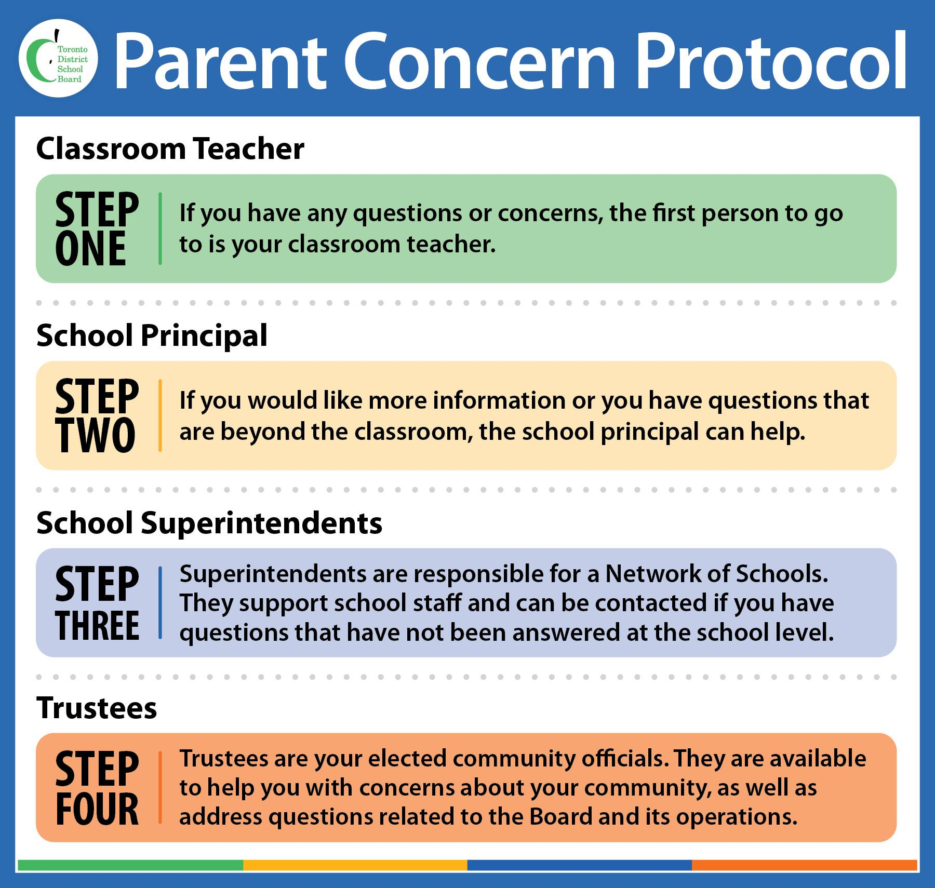

TDSB’s Vision for Special Education
The Toronto District School Board (TDSB) is committed to student achievement and well being. We recognize that students develop and learn in different ways, and that some students require special education programs and services to meet their needs. TDSB staff are committed to working collaboratively with parents and students in a respectful and transparent way, and value our partnership with families. We encourage parents to approach their child’s teachers and principal to engage in discussions about their child in an ongoing manner. The sharing of information between parents and school staff is critical to ensuring the success of the student.

The Special Education Department, in collaboration with all staff, is committed to providing equitable access to learning opportunities for all students. This includes our ongoing commitment to inclusion, human rights, anti-oppression, equity, anti-ableism, and anti-racism. This commitment is aligned with the foundation of the TDSB Equity Policy and underpins all programming across all grade levels.

The TDSB is committed to creating inclusive learning environments for students with intersecting identities, and to building capacity of staff to deepen their understanding of how to serve students with special education needs. The TDSB holds high expectations for students and supports their achievement and well-being by removing systemic barriers that stand in the way of their success.

Ontario Regulation 181/98 requires school boards to consider placing students with exceptionalities into regular classes with appropriate special education services before considering placement in special education classes. In the TDSB, we continue to be responsive to the understanding that as students learn, they develop skills and so their special education service and program needs change over time. Students being welcomed, included and supported in well-resourced neighbourhood schools in age-appropriate, regular classes are able to learn, contribute and participate in all aspects of school life. This allows for valuable learning opportunities for groups which have been historically excluded, such as students with disabilities and intersecting identities.

Equity of outcome is supported in the TDSB through the provision of a range of special education supports and services for students. This range includes both in-school and itinerant support, short term intervention services, and placements in regular classes as well as self-contained classes for students who need them.

The TDSB’s Vision of Special Education is also guided by the following principles:

- All students, their families and the staff who support them have the right to be treated with respect.
- All students have the right to a program developed in response to their strengths and areas for growth.
- All students have the right to a range of placements, programs, and services to meet their individual requirements in their neighbourhood school wherever possible.
- All students and the staff who support them have the right to a safe, accepting, welcoming, secure, and encouraging environment.
- Meaningful collaboration with all stakeholders and a partnership of students, school, family and support services is essential to the success of all students.

Please refer to the TDSB’s Special Education Plan for more information.

Special Education Programs
Special education programs are defined in the Education Act as educational programs that:

- Are based on, and modified by, the results of continuous assessment and evaluation; and
- Include a plan (called an Individual Education Plan or IEP) containing specific objectives and an outline of special education services that meet the needs of the exceptional pupil.

Special Education Services
Special education services are defined in the Education Act as the facilities and resources, including support personnel and equipment, necessary for developing and implementing special education programs.

Special Education Programs and Services Provided by the TDSB
The TDSB provides a range of programs and services to ensure that the needs of students are clearly identified and that the appropriate educational programs and services are provided for them, whether in the regular classroom, a specialized setting, or a combination of both. TDSB’s Special Education Plan reflects the board’s commitment to the development, implementation and consistent provision of effective special education programs and services to all students who need them, whether or not they are deemed to be “exceptional” (formally identified by an IPRC).

Exceptional Students
The Education Act defines an exceptional pupil as “a pupil whose behavioural, communicational, intellectual, and physical or multiple exceptionalities are such that they are considered to need placement in a special education program.” Students are identified through an Identification, Placement and Review Committee (IPRC) process, according to the categories and definitions of exceptionalities provided by the Ministry of Education. Categories include Behaviour, Communication, Intellectual and Physical Exceptionalities.

Identification, Placement and Review Committee (IPRC)
School boards must provide special education programs and services to students who are formally identified as exceptional pupils. This is set out in the Education Act. An exceptional pupil is a student who has behavioural, communicational, intellectual, physical or multiple exceptionalities that require them to have special education programs or services, as determined by an Identification, Placement and Review Committee (IPRC). All school boards are required to establish IPRCs.
The IPRC:

- decides if the student should be identified as exceptional;
- identifies areas of the student’s exceptionality;
- decides an appropriate placement for the student; and
- reviews the student’s identification and placement at least once in each school year.
How is an IPRC requested?
An IPRC can be requested by the school principal or in writing by parents. The principal:

- May, in consultation with the School Support Team (SST) and with written notice to you, refer your child to an IPRC when the principal believes that your child may benefit from a special education program;
- Must request an IPRC meeting for your child, upon receiving your written request;
- Within 15 days of receiving your request, or of giving you notice, the principal must provide you with a copy of this guide and a written statement of approximately when the IPRC will meet.
Who attends an IPRC meeting?
An IPRC must have at least three people, one of whom must be a Principal or Board Supervisory Officer. Other members of the committee may include:

- Parents/guardians/caregivers and student (students are welcome to attend as appropriate and students 16 or over are entitled to attend and participate in discussions);
- Principal/Supervisory Officer of the child’s school;
- The teacher(s) who know the student best, other resource people such as special education staff, Board support staff, or an agency representative who may provide further information or clarification;
- Additional resource people if needed, arranged by the school principal or parents (e.g., Special Education and/or Professional Support Services staff such as a special education coordinator or a psychologist);
- An interpreter (when needed);
- An advocate, if invited by the parents, to provide support or speak on their behalf.

May parents attend an IPRC meeting?
Regulation 181/98 entitles parents and pupils 16 years of age or older:

- To be present at and participate in all committee discussions about your child;
- To be present when the committee’s identification and placement decision is made.

What if parents are unable to attend the meeting?
Please contact the principal of your child’s school to arrange an alternate date or time or let the principal know that you cannot attend. The principal will contact you following the meeting to let you know the committee’s decisions, and will forward to you, for your consideration, a written statement about the IPRC’s decision concerning identification and placement.

Who else may attend an IPRC meeting?
The principal (or vice principal) of your child’s school will attend. You or the principal may request the attendance of others at the IPRC meeting, such as:

- Your representative (a person who may support you or speak on behalf of you or your child);
- Other resource people who may provide additional information or clarification, such as your child’s teacher, special education staff, board support staff, or the representative of an agency;
- A translator or an interpreter (You can request the services of a translator or an interpreter through the principal of your child’s school.).
What information will parents receive about the IPRC meeting?
Within 15 days of giving you notice of an IPRC, or receiving your request, the principal will provide you with written notification of approximately when the IPRC will meet. At least ten days in advance of the meeting, you will receive an invitation to attend the meeting as an important partner in considering your child’s placement. This letter will notify you of the date, time, and place of the meeting, and it will ask you to indicate whether or not you will attend. Before the IPRC meeting occurs, you will receive a written copy of any information about your child that the members of the IPRC have received. This may include the results of assessments or a summary of information.
Format of the IPRC Meeting
During the IPRC Meeting
The Chair of the IPRC will start the meeting by welcoming parents and introducing the committee members. Parents will then have the opportunity to introduce themselves and their guests. The IPRC Chair will outline the purpose of the meeting.
The committee will:

- review all relevant information about the student;
- consider an educational assessment of your child;
- consider a health or psychological assessment of your child, if required;
- consider any information you or your child (if over 16) submit; and
- discuss your child’s strengths and areas for growth.

The committee may discuss any proposal made about special education programs or services for your child.

Once all the information has been presented to the committee and considered, the IPRC will decide:

- if your child should be identified as exceptional. If yes, the committee must indicate the Category and Definition of Exceptionality according to those provided by Ontario’s Ministry of Education;
- the most appropriate placement for your child who has been identified as exceptional.

Ontario Regulation 181/98 requires school boards to consider placing exceptional students into regular classes before considering placement in a special education class. If the committee decides that a special education placement is required, it will first consider whether placement in a regular class with appropriate special education support will best meet your child’s needs.

Placement Decision
Placement | Definition
Regular Classroom with Indirect Service | The student is placed in a regular class for the entire day, and the teacher receives specialized consultative services.
Regular Classroom with Resource Assistance  (Kindergarten to Grade 8) | The student is placed in a regular class for most or all of the day and receives specialized instruction, individually or in a small group, within the regular classroom from a qualified special education teacher.
Regular Classroom with Withdrawal Assistance | The student is placed in a regular class and receives instruction outside the regular classroom for part of the school day from a special education teacher.
Partially Integrated Class | The student is placed in a special education class and integrated within a regular class for part of the school day (a minimum of one instructional period daily) based on readiness.
Fully Self-Contained Special Education Class (Congregated Sites) | The student is in a self-contained special education class for the entire school day.

Other options may exist to meet your child’s needs. You can contact the principal of your child’s school to explore options such as a Provincial School for students who are Deaf, blind, or deafblind, or a Demonstration School for students who have severe learning disabilities. More information on Demonstration Schools can be found later in this brochure.

Statement of Decision
A Statement of Decision will be completed at each IPRC meeting. If placement in a special education class is decided, the IPRC must cite the reasons in its written Statement of Decision. The IPRC’s written Statement of Decision will include:

- your child’s strengths and areas for growth;
- the categories and definitions of any exceptionalities identified;
- the IPRC’s description of the student’s strengths and areas for growth;
- the IPRC’s placement decision;
- the IPRC’s recommendations regarding a special education program and special education services; and
- if the IPRC has decided that the student should be placed in a special education class, the reasons for that decision.

Parents will be asked to sign the IPRC Statement of Decision, indicating agreement with the identification and placement decisions made by the IPRC. The Statement of Decision may be signed at the IPRC meeting, or taken home for further consideration and then returned to the child’s school principal.

After the IPRC Meeting
If the IPRC has identified your child as exceptional and you have agreed with the IPRC identification and placement decision, the principal of the school where the special education program will be provided will be notified of the need to develop an Individual Education Plan (IEP) for your child.

What can parents do if they disagree with the IPRC decision?
If you do not agree with either the identification or placement decision made by the IPRC, you may:

- within 15 days of receipt of the decision, request that the IPRC hold a second meeting to discuss your concerns and revisit the decisions; or
- within 30 days of receipt of the decision, file a notice of appeal with the school board.

If, after a second meeting, you do not agree with the decision, you may, within 15 days of your receipt of the decision at the second meeting, file a notice of appeal.

If you do not consent to the IPRC decision and you do not appeal it, the Board will instruct the principal to implement the IPRC decision.

How do parents appeal an IPRC decision?
If you disagree with the IPRC’s identification of your child as exceptional or with the placement decision of the IPRC, you may, within the timelines described above, give written notification of your intention to appeal the decision. This written notice should be addressed to:
Director and Secretary Treasurer
Toronto District School Board
5050 Yonge Street
Toronto, ON M2N 5N8

The notice of appeal must:
- indicate the decision(s) with which you disagree; and
- include a statement that sets out your reasons for disagreeing.
What happens in the appeal process?
The appeal process involves the following steps:
The Board will establish a special education appeal board to hear your appeal. The appeal board will be composed of three persons who have no prior knowledge of the matter under appeal. One of the three is to be selected by you and one by the board.
(For more about membership see Regulation 181/98.)
The chair of the appeal board will arrange a meeting, to take place at a convenient time and place, but no later than 30 days after he or she has been selected (unless parents and board both provide written consent to a later date).
The appeal board will receive the material reviewed by the IPRC and may interview any persons who may be able to contribute information about the matter under appeal.
You, the parent, and your child (if he or she is 16 years old or over), are entitled to be present at and to participate in, all discussions.
The appeal board must make its recommendation within 3 days of the meeting’s ending. It may:
- Agree with the IPRC and recommend that the decision be implemented, or
- Disagree with the IPRC and make a recommendation to the board about your child’s identification or placement, or both.
The appeal board will report its recommendations in writing, to you and to the school board, providing the reasons for its recommendations.
Within 30 days of receiving the appeal board’s written statement, the school board will decide what action it will take with respect to the recommendations. (Boards are not required to follow the appeal board recommendation.)
You may accept the decision of the school board, or you may appeal to a Special Education Tribunal. You may request a hearing by writing to the Secretary of the Special Education Tribunal. Information about making an application to the tribunal will be included with the appeal board’s decision.
Once a child has been placed in a Special Education Program, can the placement be reviewed?
A Review IPRC meeting will be held within the school year, unless the principal of the school at which the special education program is being provided receives written notice from you, the parent, dispensing with the annual review. A request for a Review IPRC meeting may be made any time after your child has been in a special education program for three months.
What does a Review IPRC consider and decide?
The IPRC conducting the review will consider the same kinds of information that were originally considered by the previous IPRC. It will also consider the progress your child has made in the special education program and, with your written permission, will reference the IEP.
The IPRC will review the placement and identification decisions and decide whether they should be continued or whether a different decision should now be made.
If you have unanswered questions about special education in the TDSB, visit the TDSB website or contact the principal of your local school.

Please refer to the TDSB’s Guide to Identification Placement and Review Committees (IPRCs) for Parents/Guardians/Caregivers for more information.

The Individual Education Plan
An Individual Education Plan (IEP) is a plan that describes special education programs, services, or additional support a student receives. This written plan is a working document which describes a student’s strengths and areas for growth, and the special education program, supports and services accessed or provided to meet the student’s individual needs.
The IEP helps with monitoring and assessing a student’s progress, and is adjusted as the student’s areas for growth change. It is reviewed and updated at every reporting period.
The IEP must be developed in consultation with parents. It must include:
- Accommodations – strategies and supports that differ from what is normally provided during instruction;
- Appropriately specific and measurable educational expectations;
- An outline of the special education program and services that will be received;
- A statement about the methods for reviewing your child’s progress; and
- A personalized transition plan with specific goals and actions that build on student strengths, needs and required support. If a student does not need a transition plan, the plan will state that no action is required.
The IEP must be completed within 30 school days after a child has been placed in a special education program and the principal must ensure that parents receive a copy. An IEP can also be developed for students who have not been formally identified as exceptional but who require special education programs and/or services.
Please refer to the Ministry’s The Individual Education Plan (IEP) A Resource Guide and the TDSB’s Guide to Individual Education Plans (IEPs) for Parents/Guardians/Caregivers.

Organizations Available to Assist Parents
Many local associations are available to provide information and support to parents of exceptional children. Some of them are members of the board’s Special Education Advisory Committee (SEAC). Information about SEAC associations and how to contact members of SEAC can be found on the SEAC webpage. The table below lists member organizations of the TDSB SEAC.
Association for Bright Children (ABC)  www.abcontario.ca | Down Syndrome Association of Toronto (DSAT)  www.dsat.ca | Integration Action for Inclusion in Education and Community  www.inclusionontario.ca | VOICE for Hearing Impaired Children  www.voicefordeafkids.com
Autism Society of Ontario (Toronto Chapter)  www.autismontario.com | Easter Seals Ontario  www.easterseals.org | Learning Disabilities Association Toronto District  www.ldatd.on.ca | Centre for ADHD Awareness Canada  https://caddac.ca/
Community Living Toronto  www.communitylivingtoronto.ca | Epilepsy Toronto  www.epilepsytoronto.org | Ontario Parents of Visually Impaired Children (OPVIC)  https://www.cnib.ca/en/ontario-parents-visually-impaired-children-opvic?region=gta | Sawubona Africentric Circle of Support  https://www.sawubonaacs.org/

Ministry Provincial Schools and Demonstration Schools
The Ministry of Education operates Provincial Schools and Demonstration Schools throughout Ontario for deaf, blind, deafblind, and severely learning-disabled students. Access is usually by way of an IPRC recommendation. The schools operate primarily as day schools with transportation provided by school boards. Residential programs are offered at the schools from Monday to Friday for students who live too far from school to travel daily.

Demonstration Schools provide intensive, one-year programs for students with severe learning disabilities, including learning disabilities associated with Attention-Deficit Hyperactivity Disorder (ADHD).

An in-service teacher education program is offered at each Demonstration School. Application for admission is made by the school board with parent consent and eligibility is determined by the Provincial Committee on Learning Disabilities.

Sagonaska School  350 Dundas Street West,  Belleville, ON K8P 1B2  Tel: 613-967-2830 | Trillium School  347 Ontario Street South,  Milton, ON L9T 3X9  Tel: 905-878-8428
Amethyst School  1090 Highbury Avenue,  London, ON N5Y 4V9  Tel: 519-453-4408 | Centre Jules-Léger  (for French-speaking students)  281 rue Lanark, Ottawa,  ON K1Z 6R8  Tel: 613-761-9300  TTY: 613-761-9302/930
Ernest C. Drury School  255 Ontario Street  South Milton, ON L9T  Tel: 905-878-2851  TTY: 905-878-7195 | Robarts School  1090 Highbury Avenue,  P.O. Box 7360, Station E,  London, ON N5Y 4V9  Tel/TTY: 519-453-4400
Sir James Whitney School  350 Dundas Street  West, Belleville, ON K8P 1B2  Tel/TTY: 613-967-2823 | Centre Jules-Léger (French-language school for the deaf )  281 rue Lanark, Ottawa,  ON K1Z 6R8  Tel: 613-761-9300  TTY: 613-761- 9302/9304

*Provincial Schools for the Deaf provide programs for deaf students from preschool level to high school graduation and resource services for families, school boards and other agencies. Admittance is determined by the Provincial Schools Admission Committee in accordance to requirements set out in Regulation 296.

For more information about Demonstration Schools or Provincial Schools, please contact:
Ministry of Education Provincial Schools Branch
255 Ontario Street, South Milton, ON L9T 2M5
Tel: 905-878-2851 Fax: 905-878-5405

Additional Information about Special Education

If you have unanswered questions about special education in the TDSB, visit the TDSB website. You can also contact the principal for your child’s school.

Toronto District School Board Special Education and Inclusion Website
https://www.tdsb.on.ca/Learning-Equity-and-Well-Being/Special-Education-and-Inclusion

Toronto District School Board Special Education Plan
https://www.tdsb.on.ca/Learning-Equity-and-Well-Being/Special-Education-and-Inclusion/Special-Education-Plan

Steps to Address Questions and Concerns
https://www.tdsb.on.ca/Contact-Us/Steps-to-Address-Questions-Concerns
Special Education Advisory Committee for Toronto District School Board
https://www.tdsb.on.ca/Community/How-to-Get-Involved/Advisory-Committees/Statutory-Advisory-Committees/Special-Education-Advisory-Committee.
Special Education in Ontario Kindergarten to Grade 12 - Policy and Resource Guide
https://www.ontario.ca/document/special-education-ontario-policy-and-resource-guide-kindergarten-grade-12

