SEPTEMBER HIGHLIGHTS
- What’s New, Reminders, Check it Out, Important Dates
- School Spotlight: Highfield JS
- FASD Awareness Month,
- Supporting the Mental Health and Well-Being of Newcomers
- TDSB OT/PT Services & International Day of Sign Languages & International Week of Deaf People
- TDSB SLP Services
Upcoming Important Dates:
Elementary PD Days:
September 26, 2025
October 10, 2025
November 14, 2025
January 16, 2026
February 13, 2026
June 5, 2026
June 26, 2026
Secondary PD Days:
September 26, 2025
October 10, 2025
November 14, 2025
January 29, 2026
February 13, 2026
June 25, 2026
June 26, 2026
School Year Holidays (as per Ministry)
Labour Day: September 1, 2025
Thanksgiving: October 13, 2025
Winter Break: December 22, 2025 – January 2, 2026
Family Day: February 16, 2026
Mid-Winter Break: March 16-20, 2026
Good Friday: April 3, 2026
Easter Monday: April 6, 2026
Victoria Day: May 18, 2026

CHECK IT OUT!!
- All Are Welcome – Read aloud kids book in full screen and with music!
- What is UDL? Universal Design for Learning Explained (3 minutes)
- 12 Strategies To Build Relationships With Students
- Inclusive education video series: Positive behaviour approach
- The 5-4-3-2-1 Method: A Grounding Exercise to Manage Anxiety
- Introduction to 5-4-3-2-1 and Skill Practice
- Circle Of Control Activity For Kids - Good Mental Health And Stress Management

Special Education and Inclusion Parent/Guardian/Caregiver Video Series
These videos provide an overview of our Guides to Special Education and Inclusion, designed to help families understand the programs, services, and supports available to students. From learning about Individual Education Plans (IEPs) to navigating the Identification, Placement, and Review Committee (IPRC) process, these resources can support you every step of the way.
Detailed information can be found in the full guides on the Special Education and Inclusion Website, where you will find additional Special Education resources for families.

School Spotlight
School Spotlight: Highfield JPS

A powerful assembly was held about Autism Awareness, led entirely by students with Autism Spectrum Disorder (ASD) in grades 1 to 5, showcasing their leadership and unique abilities. This assembly not only highlighted the incredible skills and talents of the students but also served as an important platform for raising awareness and understanding about autism within the entire Highfield JS school community.
They spoke candidly about the challenges they face, as well as the unique strengths they possess. This not only fostered empathy and understanding among their peers but also empowered the students to take pride in their identities. By sharing their stories, they encouraged the audience to consider how they can support individuals with autism in their everyday lives (i.e., in the school yard, in class, in the hallways).
RESOURCES
The Government of Canada officially recognized September as Fetal Alcohol Spectrum Disorder (FASD) Awareness Month. This month is devoted to raising awareness of FASD to improve prevention, diagnosis and support for individuals with FASD. Historically, research and discussion about FASD has focused on challenges. While this discussion is necessary, it is also important to recognize people’s unique talents, abilities and interests. When we don’t
explore the success of people with FASD and celebrate their contributions, we fail to recognize their immense potential.
The theme for this year’s FASD awareness month is Everyone Plays a Part.
For more information on how you can get involved, please visit: www.CANFASD.ca
Fetal Alcohol Spectrum Disorder (FASD)
FASD is a complex disorder that manifests with varied symptomology for each affected individual.
The symptoms of the disorder are a result of brain dysfunction due to prenatal alcohol exposure. Symptoms may include, but are not limited to:
- Difficulties with executive function (e.g. attentiveness, focus, organization, planning, etc.)
- Sensory processing challenges which may present as:
  - Auditory hyper/hypo sensitivities; Challenges with navigating visually stimulating environments; Challenges with recognizing body cues and bodily functions (resultant difficulties with adaptive function such as eating, dressing, knowing when to use the bathroom, recognizing fatigue, stress, pain, etc.); Food aversions and/or an inability to detect hunger cues; Tactile defensiveness or an inability to discriminate touch; Difficulty with grading movements and/or knowing where your body is in space; Balance/coordination challenges; Difficulty recognizing social cues; Difficulties with transitions
- Intellectual and/or cognitive delays
- Delays with fine and/or gross motor development
- Recognizing, understanding, and planning around safety/environmental cues
- Emotional lability and difficulty regulating emotions and responses
Effective strategies to support individuals with FASD may include:
- Short concrete instructions
- Use of visuals to support understanding
- Maintain structure and routine
- Allow for additional processing time
- Provide frequent breaks (opportunities for physical movement)
- Model and roleplay upcoming events and expected responses
Each individual with FASD is unique and thus there is no rubric or protocol in how you may best support their needs. One approach that is universally sound is developing and nurturing a close, safe, and trusting relationship; this will avail reciprocal and open-ended communication enabling a true understanding of how to meet their needs.
For additional information, please refer to the TDSB OT/PT services public webpage for links to more resources.

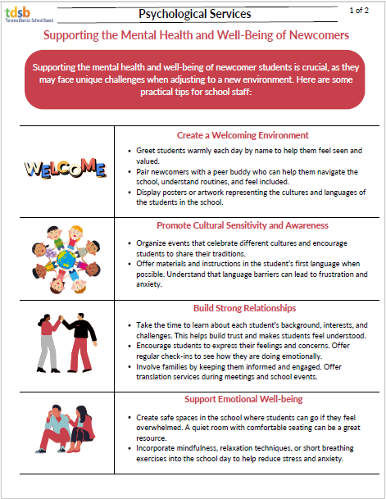
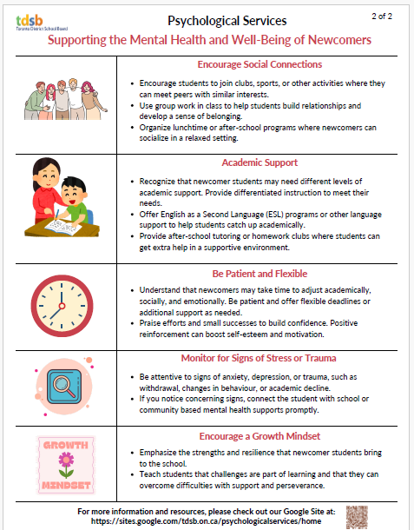


Welcome back to another school year!
As we all start to re-establish school routines, you may find it difficult to get back into the rhythm of things. Included in our “Daily Routines and Transitions” handout are strategies to make this transition easier.
One thing that may assist with resuming routines is having a visual chart to outline what is needed to get ready for school. See our “Get Ready for School” chart; text or visuals of the task can be placed in the ‘to do’ section and moved to ‘finished’ once complete.
Playing at Home & School
WHY PLAY?
Play time for children is essential to reduce stress and to help build relationships. Children may demonstrate emerging or repetitive play skills. Educators and parents/guardians/caregivers can help children choose developmentally appropriate toys and activities to foster their play skills. It is fun to be a play partner; a chance to be silly and have a good time together! As an educator or parent/guardian/caregiver, engaging in play supports critical learning. The summary below highlights the different stages of play starting with sensory exploration!

International Day of Sign Languages: September 23, 2025
International Week of Deaf People: September 22 to September 28, 2025
International Week of the Deaf (IWD) 2024 runs from September 22nd to 28th. The World Federation of the Deaf has declared this year’s theme as “No Human Rights without Sign Language Rights.”
Please visit their website for more information about celebrations and daily themes.

Understanding and Enhancing Oral Language and Literacy Development at School and at Home
This school year, Speech Language Pathology (SLP) Services is focused on providing educators and caregivers with information and resources supporting early oral language and literacy development for ALL students. September is a time of fresh starts, new connections, and exciting possibilities. By fostering meaningful conversations and creating language-rich classrooms/spaces, you are laying the foundation for your children to grow as confident communicators, social navigators and achieve meaningful academic success.
Our newsletter additions are designed to provide simple, effective strategies to encourage oral language development and make meaningful connections with your students/children. Each month will include SLP Services’ popular Kindergarten Oral Language and Literacy Calendars as well as our new Story Time Lessons. These lessons provide an interactive and engaging medium for all educators/caregivers to support oral language development. Any books referenced in our Story Time Lessons are available for FREE lending by your TDSB Library or the Toronto Public Library. SLP Services recommend reading from a physical book when one has a choice. We have included a YouTube video of the story being read aloud should one not have access to the physical book.
We hope these ideas inspire engaging interactions that strengthen your relationship with the children around you.
Wishing you a fantastic start to the school year!
Kindergarten Oral Language and Literacy Calendar
Story Time Lessons - Looking For Bongo

