Science, Technology & STEM Grade 4-6

Tuesday, September 22
Learning Goal:  - I can use problem solving skills to design, build and test a mini-glider that flies across a room. | Task  - In the video you will learn how to use materials you can find in your home to make a mini-glider.  - Design: What materials in your home could help you make a mini-glider that can fly across a room?  - Build: Gather your materials and make your own mini-glider  - Predict: how far do you think your mini-glider will travel?  - Test: Test your design by flying your mini-glider across the room. Did it go as far as you thought it would? What would you change about the design if you had to build it again? | Kids Engineering: Build a Mini-Glider  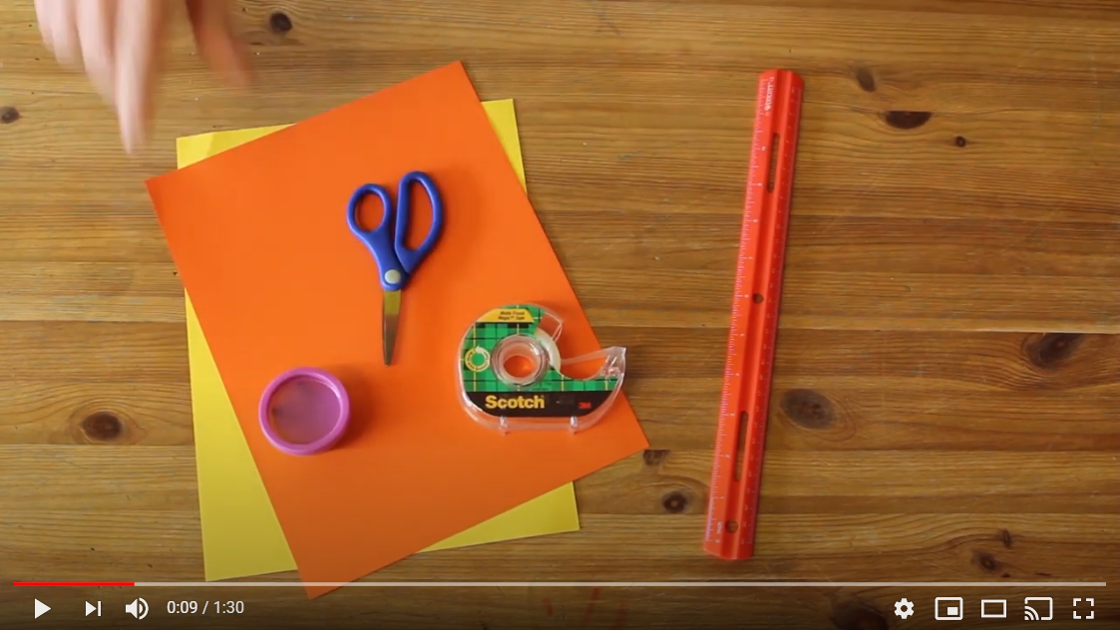  Video: https://www.youtube.com/watch?v=BfCt5sMyVJ4

Wednesday, September 23
Learning Goal:  - I can use problem solving skills to design, build and test a Rube Goldberg machine that performs a specific task. | Task  - Watch the video to see students in grade 5 and 6 testing Rube Goldberg machines.  - Design: Using objects found around your house design a Rube Goldberg machine that solves a simple problem (e.g., ringing a bell or knocking over a block)  - Build: Gather your materials and build your Rube Goldberg Machine.  - Test: Test your design to see if your Rube Goldberg machine works. Continue to make adjustments until the machine performs what it was intended to do. | Grade 5 and 6 Rube Goldberg Machines  Video: https://www.youtube.com/watch?v=WNfcjfHoaVc

Thursday, September 24

Learning Goal:  - I can use investigative and research skills to design a space suit that will help humans adapt to life in space. | Task:  - Watch the video to learn how space suits are made.  - Design: using pencil and paper or 3D modeling software like Tinkercad or SketchUp for Schools design and label your own spacesuit.  - Predict: What features would be most important to include if you were travelling in space?  - Reflect: what do you think it would feel like to be in space? What do you think your suit would help you do? | 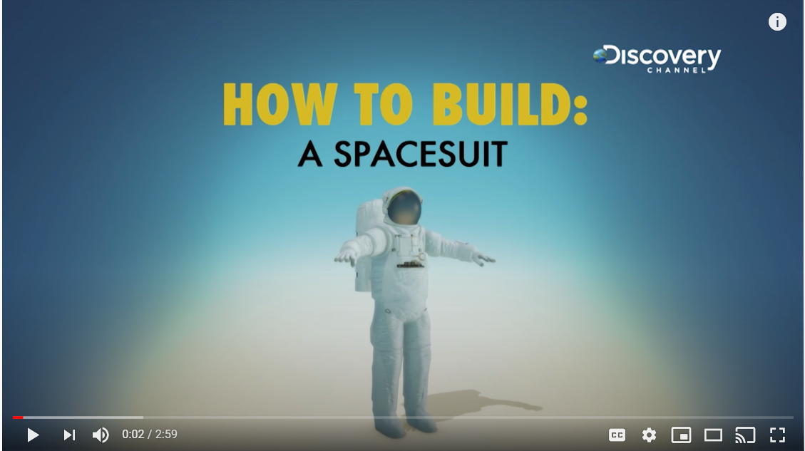  Video:  https://www.youtube.com/watch?v=RWpItu8JGFM

Friday, September 25
- I can use technological problem solving skills to design and build and test a working amplification device. | - Watch the video to see how you can make a simple speaker that amplifies sound.  - Design: Gather materials to design a simple speaker that will amplify the sound from a device in your home (e.g., mobile phone, tablet, computer or your own voice).  - Build: Construct your speaker  - Test: Place your speaker over a sound source and observe whether or not you were able to increase the volume  - Reflect: Did it work? Why or why not? Think about what shapes will best amplify sound? | Design a DIY Speaker from Simple Materials  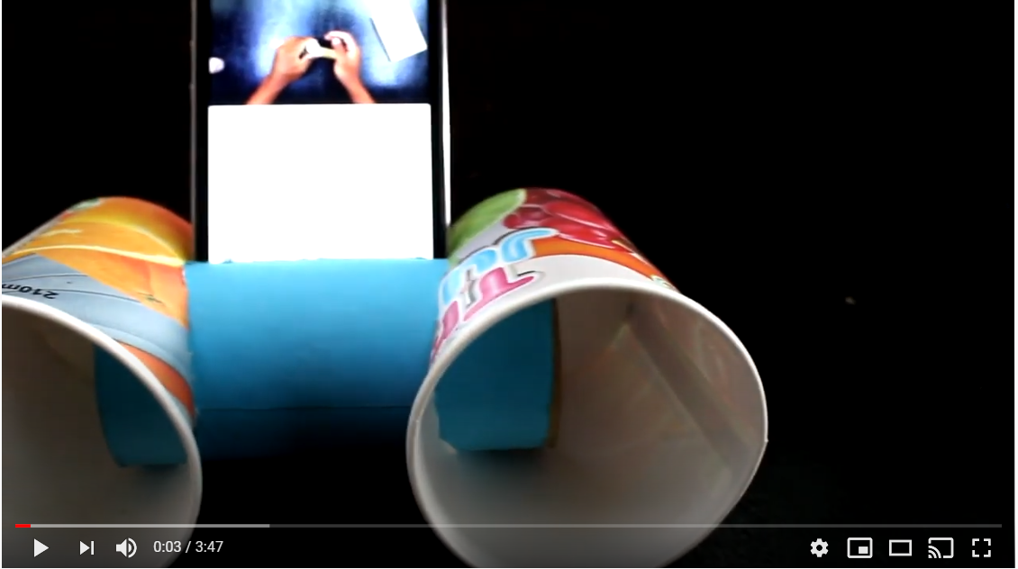  Video: https://www.youtube.com/watch?v=R5v0K23E_eE

