In order to access some resources, it will be useful to have an account with Idello. | - offers free French-language educational videos, digital books, apps and games to engage K-12 children in their second language learning  - subtitles available (use of French subtitles is suggested)  - How to create an Idello account (parents and students).pdf  - IDÉLLO : Video Tutorial for Parents & Students on how to create an account
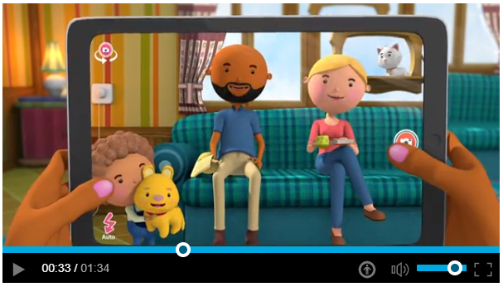 | - Let’s listen to a new song: https://www.idello.org/en/resource/12095-Jaime-Papa-Jaime-Maman  - Click here to read the words to the song.  - First viewing - watch and listen  - Second viewing - watch and listen, and follow along by reading the words.  - Third viewing- watch and try to sing along. Follow the words with your finger.  - What do you think the word “J’aime” means? Think about the people in your house and your family. Can you fill in the sentences on the second page? You can say them out loud to someone in your house or you can try to write the words down using sounds and letters you already know.
Les maths  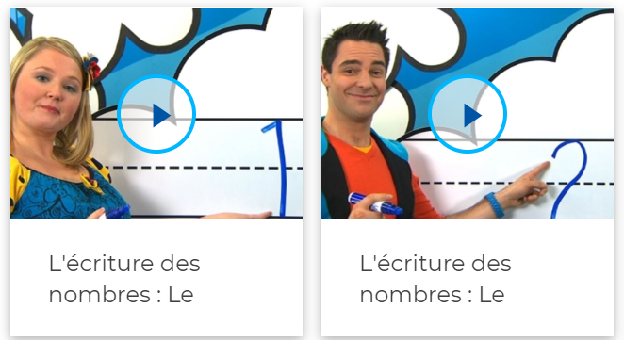 | - Watch these videos on how to write numbers.  - Write the numbers in the air. Draw them on a rough surface with your finger.  - Write the numbers down on paper. Can you draw that number of objects?  https://www.idello.org/en/resource/4550-Lecriture-Des-Nombres-Le-Nombre-1?navcontext=13663  - Can you practice numbers 5-10 today?
Écouter une histoire  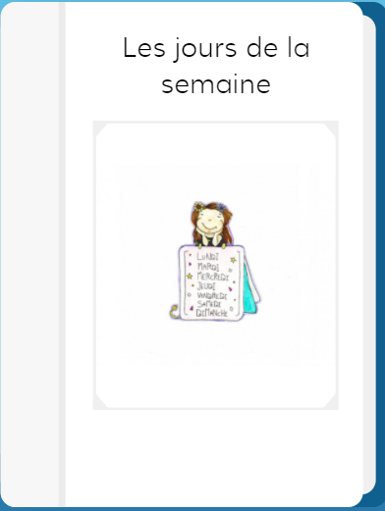 | - Listen to this story https://app.boukili.ca/livre/20 (Choose “mode narration”  - Listen again.Notice the word at the start of each sentence. These are the days of the week in French.  Lundi Vendredi  Mardi Samedi  Mercredi Dimanche  Jeudi  - Listen again, what sound do you hear at the end of most of these words?
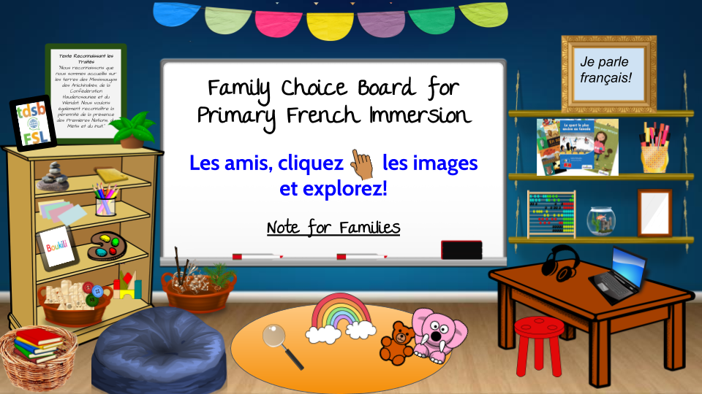 | Choose an activity from the Choice Board

