Asynchronous Learning for
SK-1 French Immersion

Week of March 8, 2021

Note: For this task, students must have an Idéllo account in order to access the video.
If you already have a student account (username and password) from previous years, you may continue to use it.
If you don’t have a student account, please create your free student account using code 03n7pv3718mp6.
For information and tutorials that show how to create an account, please visit TDSB FSL Resources for Families.
Please keep track of your username and password carefully.
You will need to create a free account using this link to access this platform and read the books.

Les jeux et les jeux de société

Learning Goals: We are learning about games and making connections to our lives.
Bonjour les amis! This week we are exploring games and board games that we can play with members of our families.

Les jeux classiques - classic games  Est-ce que tu aimes les jeux? Do you like games?  Some of the examples include:  Jeux Images  Bingo- le bingo https://pixabay.com/vectors/bingo-gambling-game-luck-159974/  Snakes and ladders/ les échelles et les serpents https://pixabay.com/vectors/search/ladder/  Cards/les cartes https://pixy.org/1523963/  Regarde et écoute  Watch some of the videos in the series L'univers: Des jeux classiques to see some examples of classic games and how Louis, Josée et Lexie play them.  Qu’est-ce que tu as appris? What did you learn?  Now think of the games/les jeux that you know or that you like. Les jeux que tu aimes  and use loose parts to represent your favorite game. | Les jeux dehors - Games and activities outdoors  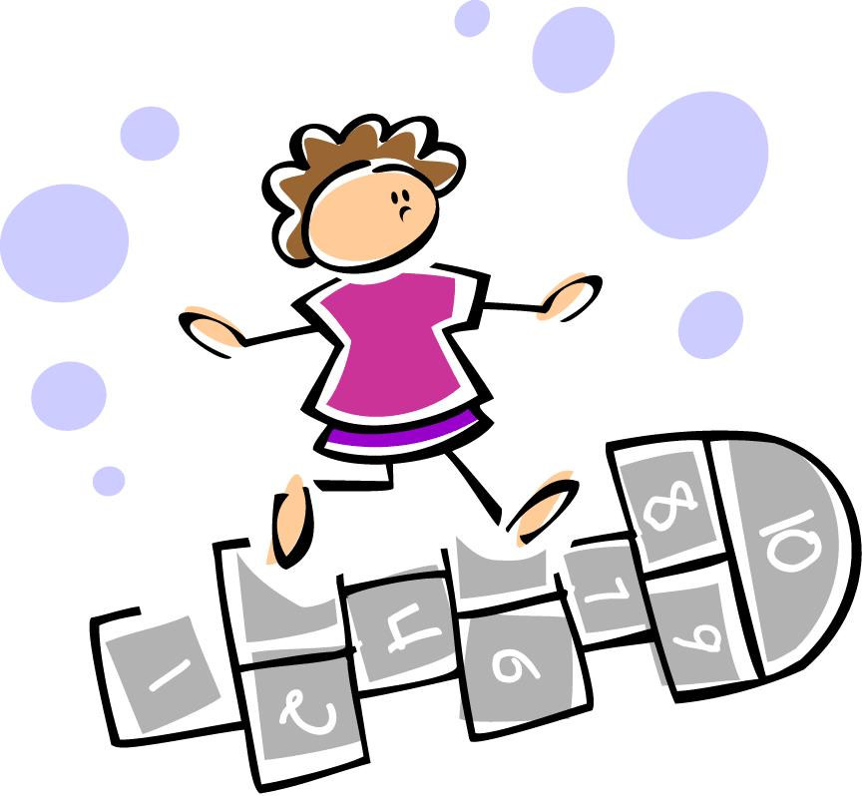  https://pixy.org/src/75/750236.jpeg  Another form of game is a game that you play outdoors or at school with friends during recess time.  In these videos from Idello, there are examples of some you can try: Les jeux.  Do you recognize any of the ones shown?  What are some of your favorite ones?  Choose a couple of games to play with someone in your family.
Lecture Boukili  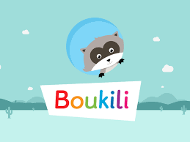  Instructions: Open the Boukili application or website. Connect to the platform. The book is located in Ma bibliothèque.  Select: Au Parc  Did you find any familiar words?  What did you learn from the books you read/listened to? | Lecture et jeu  https://pixy.org/1141103/  “Cherche et trouve” is another form of game you can do.  Open this magazine found in the TDSB Virtual Library and turn to pages 16 and 17. Can you look for the matches for the images?  In the Abracadabra site form the Virtual Library,  - Click on “Jouer zone élève". Select Activités- Bingo des lettres. Click OK.  - Watch the Demo, then click Select.  Select the level you want to try and play a game of letter Bingo.  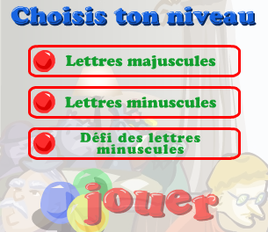  (image on the platform)  Click on jouer.

