Asynchronous Learning for
SK-1 French Immersion

Week of March 29, 2021

Note: For this task, students must have an Idéllo account in order to access the video.
If you already have a student account (username and password) from previous years, you may continue to use it.
If you don’t have a student account, please create your free student account using code 03n7pv3718mp6.
For information and tutorials that show how to create an account, please visit TDSB FSL Resources for Families.
Please keep track of your username and password carefully.
You will need to create a free account using this link to access this platform and read the books.

La Terre
Learning Goals: We are learning about Earth/la Terre, learning new words and making inferences and connections to our community and the world around us.
Bonjour les amis! This week we are exploring our planet Earth! La Terre!
Qu’est ce que c’est la Terre?  Utilise ton imagination pour faire un dessin de la Terre. Use your imagination and make a drawing of what you think planet Earth looks like. | Lecture Boukili  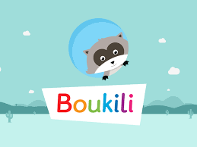  Instructions: Open the Boukili application or website. Connect to the platform. The book is located in Ma bibliothèque.  Select a book of from the choices below:  - Mini Météo ( Niveau 1)  - Les animaux (Niveau 3)  - Les quatre saisons (Niveau 4)  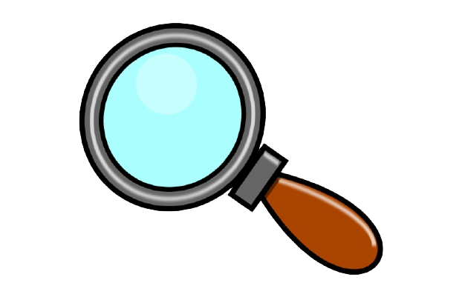Est-ce que tu vois des mots familiers? Do you see any familiar words?  What did you learn from the book you read/listened to? Talk about it with a caregiver.  Qu’est-ce que tu as appris? What did you learn?
Cherche et lis/Read and find  Le printemps est arrivé! Spring has arrived!  We see many of the new things changing outdoors.  Open this Mini-Mag Notre planète Mini mag - Notre planète.  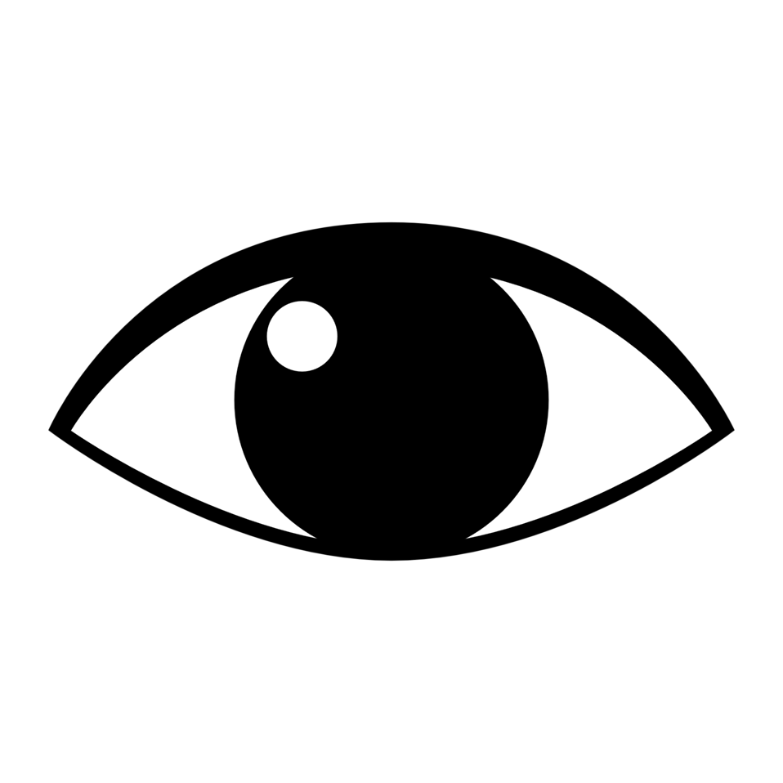Regarde la photo sur la page couverture. Look at the photo on the cover page.  Can you find these things in the photo?  Try saying the word that you see in the photo and draw a picture of it.  Exemple: Je vois un arbre  Je vois Mon dessin  un arbre https://pixabay.com/vectors/tree-forest-trunk-nature-leaves-576847/  les fleurs https://pixabay.com/illustrations/flower-yellow-clipart-nature-flora-5156246/  l’eau https://pixabay.com/illustrations/outdoor-beach-ocean-seaside-island-5350258/  un nuages les nuages https://pixabay.com/illustrations/cloud-isolated-cumulus-transparent-2421760/  un animal les animaux https://pixabay.com/vectors/woodland-animals-wildlife-deer-4872369/ | Regarde, 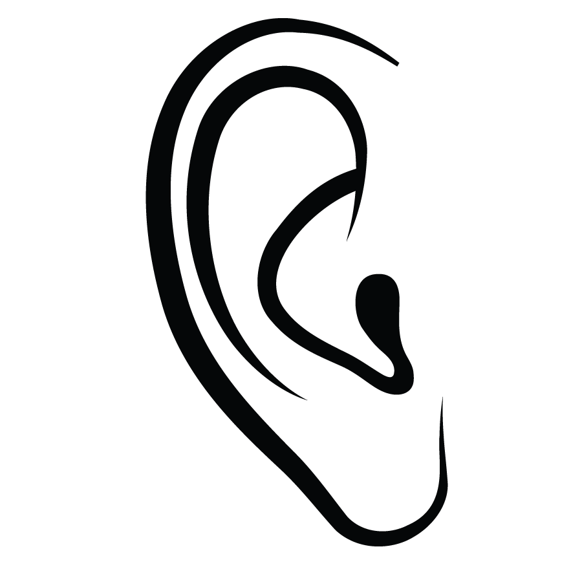Écoute et chante  In this video, Louis and Josee sing a song about Spring: Chanson Le printemps.  Watch season 2 of the series Mini-TFO: Les saisons de Mini to learn more about Spring/le printemps.  Quelle est ta saison préférée? What is your favorite season?  Look for things around you that represent Spring and make a visual representation of your learning.

