Asynchronous Learning for
SK-1 French Immersion

Week of March 22, 2021

Note: For this task, students must have an Idéllo account in order to access the video.
If you already have a student account (username and password) from previous years, you may continue to use it.
If you don’t have a student account, please create your free student account using code 03n7pv3718mp6.
For information and tutorials that show how to create an account, please visit TDSB FSL Resources for Families.
Please keep track of your username and password carefully.
You will need to create a free account using this link to access this platform and read the books.

L’espace
Learning Goals: We are learning about Space/ l’espace, learning new words and making inferences and connections.
Bonjour les amis! This week we are exploring space and things that are related to space.
Un/une astronaute et l’espace  Do you know what an astronaut is?  Qu’est-ce qu’un astronaute / une astronaute?  Do you know what space is?  Qu’est-ce que c’est l’espace?  Utilise ton imagination pour faire un dessin de l’espace et d’un/une astronaute. Use your imagination and make a drawing of what you think they are. | Regarde et 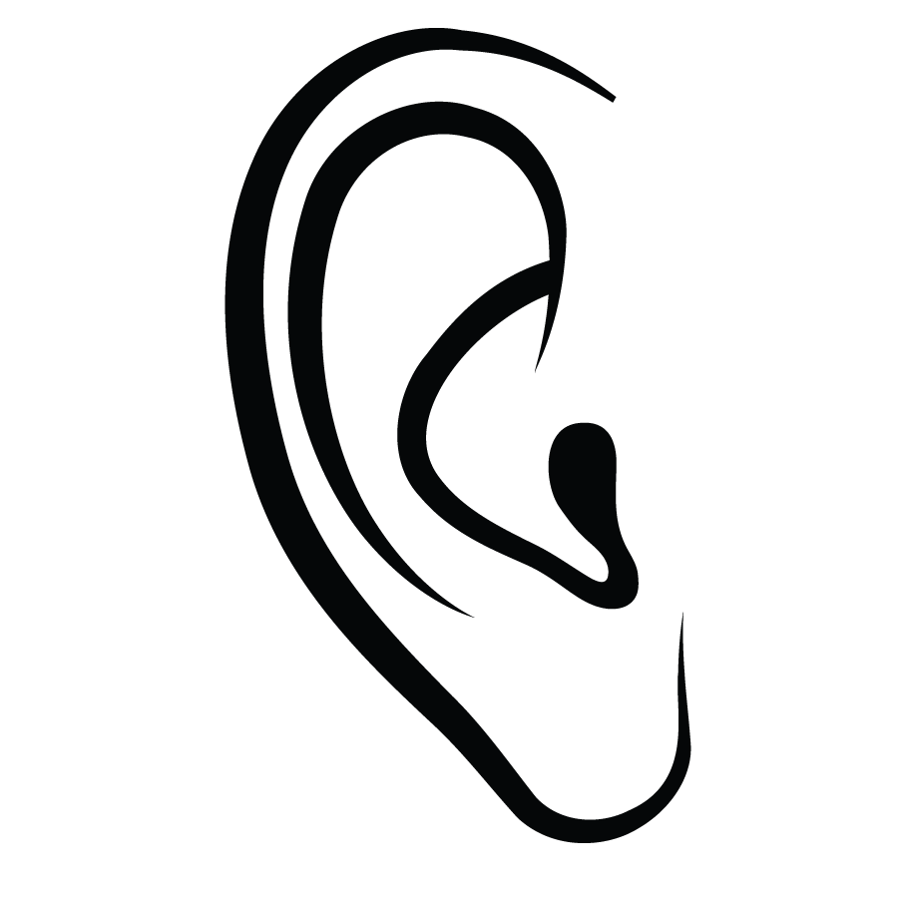Écoute  Madame Bonheur and Charlie pretend to work in space in this video from Idéllo: Ambulancier - astronaute.  Mme Bonheur is an astronaut/une astronaute and Charlie is a paramedic/un ambulancier.  If you want to learn about other things related to space you can also watch:  - La Chauve-souris astronaute  - Minivers: L'astronaute égaré  - Mini-TFO: Savais-tu que? (more advanced)  Qu’est-ce que tu as appris? What did you learn?
Cherche et lis/Read and find  Open this Mini-Mag magazine: Astronaute.  Regarde la photo sur la page couverture. Look at the photo on the cover page. Can you describe the photo?  Look at the story on pages 8-9. This is a story about l’espace. Now look at the pictures representing the items on the page and try to find the names for some of the words below:  les étoiles https://pixy.org/4513002/  l’astronaute https://pixy.org/src/76/769277.png  un casque https://pixy.org/370630/  une navette spatiale https://pixy.org/371548/  un Martien un extraterrestre https://pixabay.com/illustrations/martian-monster-green-1674016/  la lune https://pixabay.com/illustrations/the-moon-the-waning-moon-2816100/ | Chanter bouger et jouer/Sing, move and play  Chanter et bouger  Ecoute la chanson L'astronaute and follow along with Le rock des blocs.  Or, pretend you are on the moon/la lune and move along with Josee and Louis in this video, La Lune.  Jouer  Open the Mini mag magazine Astronaute and choose one, some or all of the activities. Ask an adult to help you.  Here are your choices:  Choix 1 : Bricolage-Crafts  - making a hand print craft (p.7)  - making a paper étoile (p. 10-11)  Choix 2: Jeux- games  - follow les étoiles to reveal something (p.14)  - Help the le martien or l’extraterrestre find his navette (p.17)  - cherche et trouve/search and find (p. 28-29)

