llo
Asynchronous Learning for
SK-1 French Immersion

Week of March 15, 2021

Note: For this task, students must have an Idéllo account in order to access the video.
If you already have a student account (username and password) from previous years, you may continue to use it.
If you don’t have a student account, please create your free student account using code 03n7pv3718mp6.
For information and tutorials that show how to create an account, please visit TDSB FSL Resources for Families.
Please keep track of your username and password carefully.
You will need to create a free account using this link to access this platform and read the books.

Le sirop d'érable 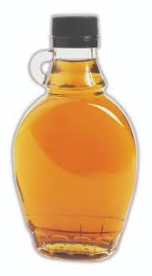
Learning Goals: We are learning about maple syrup and making connections to our lives.
Bonjour les amis! This week we are exploring a delicious treat - maple syrup - le sirop d'érable.

Le sirop d'érable  Do you know what maple syrup is? In French it is called le sirop d’erable.  Listen to the words below and repeat:  Regarde et écoute  L’image Le mot  https://pixabay.com/vectors/leaf-autumn-autumn-leaves-fall-red-984998/ une feuille d'érable  https://pixy.org/664112/ le sirop d'érable  https://pixy.org/216082/ la sève  https://commons.wikimedia.org/wiki/File:Cabane_a_sucre_-_panoramio_(2).jpg une cabane à sucre | Une cabane à sucre  Est-ce que tu as visité ou est-ce que tu as vu une photo d’une cabane à sucre? Have you ever visited, or seen a photo of a sugar shack?  Dans cette vidéo, Josée visite une cabane à sucre.  In this video from Mini TFO, Josée visits a sugar shack..  Regarde et écoute  Cabane à sucre: la sève  Qu’est-ce que tu as appris? Est-ce que tu peux décrire comment faire du sirop d’érable? What did you learn? Can you describe how to make maple syrup?
Lecture Boukili  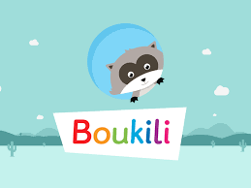  Instructions: Open the Boukili application or website. Connect to the platform. The book is located in Ma bibliothèque.  Select: Cléo et l’eau d’érable ( Niveau 1).  Est-ce que tu vois des mots familiers? Do you see any familiar words?  What did you learn from the book you read/listened to? Talk about it with a caregiver.  image credit: https://www.clipartmax.com/middle/m2i8K9i8G6H7m2b1_western-clipart-free-clipart-magnifying-glass-image-clip-art-magnifying-glass/ | C’est délicieux!  In the video Le sirop d'érable, Mouk and his friends discover le sirop d’erable and a delicious recipe.  Est-ce que tu as mangé du sirop d’érable? Have you tasted maple syrup before?  Si oui, qu’est ce que tu aimes manger avec le sirop d'érable? If so, what is your favorite thing to eat with maple syrup?  What foods do you think maple syrup would taste good with?  What might you do with maple syrup? Make a visual representation or use loose parts to show your learning about maple syrup/le sirop d’érable.  image credit: https://uxwing.com/eating-icon/

