Asynchronous Learning for
SK-1 French Immersion

Week of January 25, 2021

Note: For this task, students must have an Idéllo account in order to access the video.
If you already have a student account (username and password) from previous years, you may continue to use it.
If you don’t have a student account, please create your free student account using code 03n7pv3718mp6.
For information and tutorials that show how to create an account, please visit TDSB FSL Resources for Families.
Please keep track of your username and password carefully.

La santé mentale et le bien-être

But d’apprentissage: J’explore la santé mentale et le bien-être. J’identifie des stratégies pour gérer mon stress et favoriser une bonne santé mentale.
Bonjour les amis! This week, we are going to explore la santé mentale - mental health.

What is mental health? It is our state of being. It’s how we face problems in our lives. It’s how we think, feel and act.
When you have positive positive health, you feel good, you can solve problems, do your work and your regular activities.

When you have mental health challenges, your body might not feel well. You might have difficulties doing your work or your regular activities.

It’s important to take care of your mental health every day and get help if needed.

Quand est-ce que tu te sens bien? When do you feel content?  Fais une représentation visuelle et ajoute les mots ou les phrases pour expliquer tes idées. Make a visual representation and add some words to explain some of your ideas.  Tu peux/You could:  - faire un dessin sur un papier (do a drawing on a paper)  - utiliser les pièces détachées avec les objets trouvés autour de toi ou dans ce Google Slide (use loose parts/found objects around you or the digital loose parts in the Google Slide)  Quelques phrases utiles/some helpful words  Je me sens bien quand…  J’aime…  Je suis content(e) quand…  Je préfère... | Let’s practice relaxing with the help of these videos.  Explore les vidéos suivantes:  - La détente avec Louis-Josée-et-Lexie  - Mini Yoga  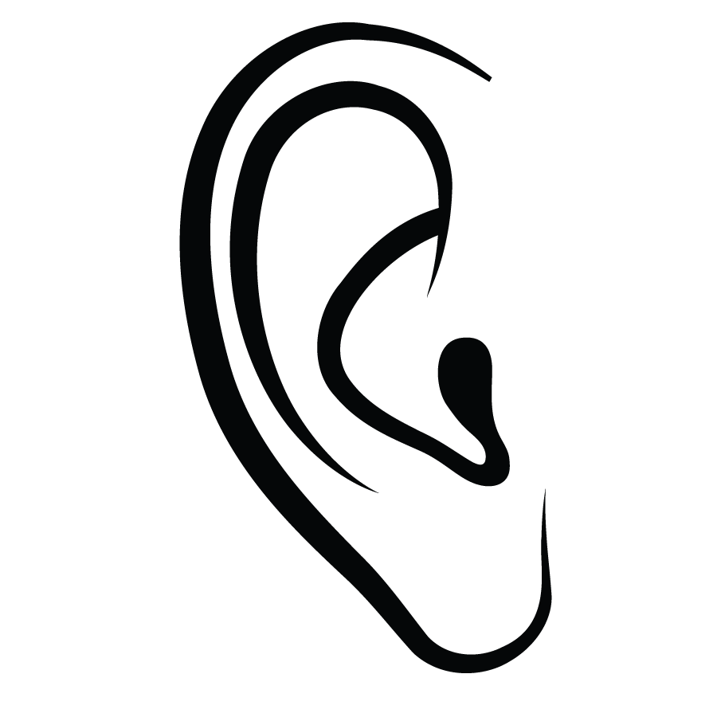Écoute la vidéo.  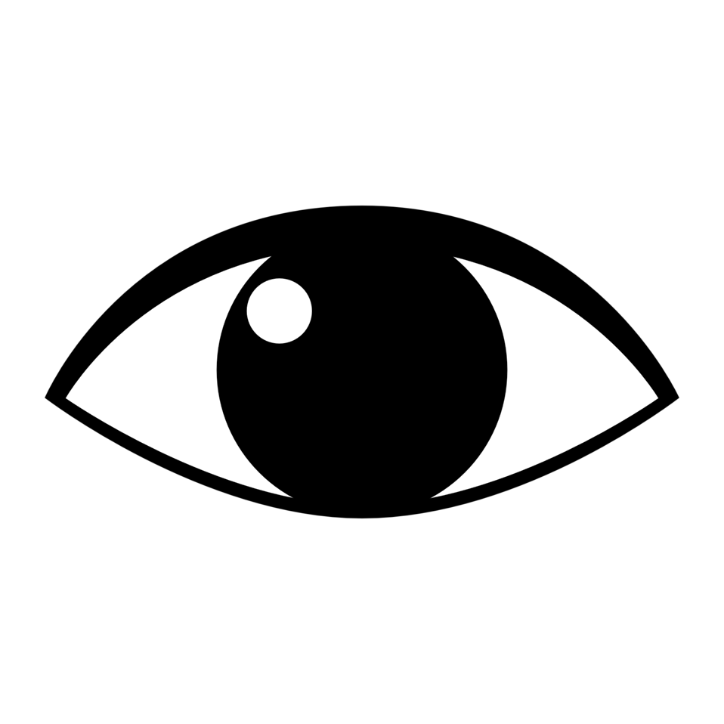Regarde les instructions.  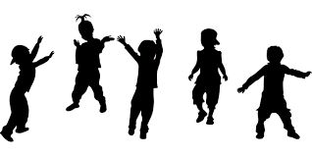Bouge et fais des exercices.  source of images: http://clipart-library.com/clipart/eyeball-clipart-3.htm  http://clipart-library.com/clip-art/ear-transparent-background-10.htm  https://pixabay.com/images/search/children%27s%20dance/  Montre à ta famille  Amuse-toi!  What was your favorite activity?
What do you like to do to help you feel good and have positive mental health?

Brainstorm some ideas with someone. Think about different types of activities, such as:
- activities to calm you
- activities to get you energized
- activities to get your body moving
- activities to let you be creative
- ?

Make une affiche (a poster) showing your favourite ideas.

Des mots utiles/Some helpful words (Dictionnaire Visuel- les activités)

dessiner | https://pixy.org/679724 | écouter de la musique | http://clipart-library.com/free-cliparts-music.html
marcher | https://pixabay.com/vectors/stickmen-walking-follow-pictogram-307531/ | faire de l’exercice | https://pixy.org/4542294/
danser | https://pixy.org/750238/ | faire un projet d’art | https://pixy.org/1460803/
inventer ______ (un jeu, une danse, etc) | https://pixabay.com/illustrations/idea-inspiration-invent-2135480/ | regarder la télé | https://www.iconfinder.com/icons/3215964/television_tv_watch_television_icon
parler à un ami/à un membre de la famille | https://pixabay.com/illustrations/talk-discussions-kids-clipart-cute-2782767/ | écrire/dessiner dans un journal | https://pixy.org/4648124/

