Asynchronous Learning for
SK-1 French Immersion

Week of Feb 15, 2021

Note: For this task, students must have an Idéllo account in order to access the video.
If you already have a student account (username and password) from previous years, you may continue to use it.
If you don’t have a student account, please create your free student account using code 03n7pv3718mp6.
For information and tutorials that show how to create an account, please visit TDSB FSL Resources for Families.
Please keep track of your username and password carefully.

Learning Goals: I am exploring some ways that I am unique. I am learning to appreciate that we are all different and that we must respect these differences.

Bonjour les amis! This week, we are going to explore and celebrate how you, other people and things are unique.
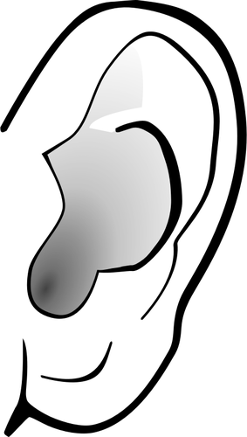Écoute et lis le livre Les cheveux dans le site Story books Canada.  Hair is one thing that makes us unique! Whether your hair is frisé (curly), raide (straight), fin (thin), épais (thick), court (short), long, crépu (kinky) or lisse (smooth), and no matter what colour it is (see page 3 for some colours), hair is part of what makes us unique and can help to shape who we are!  How can you describe your own hair? (use some of the French words from above or from the book to help you.) | 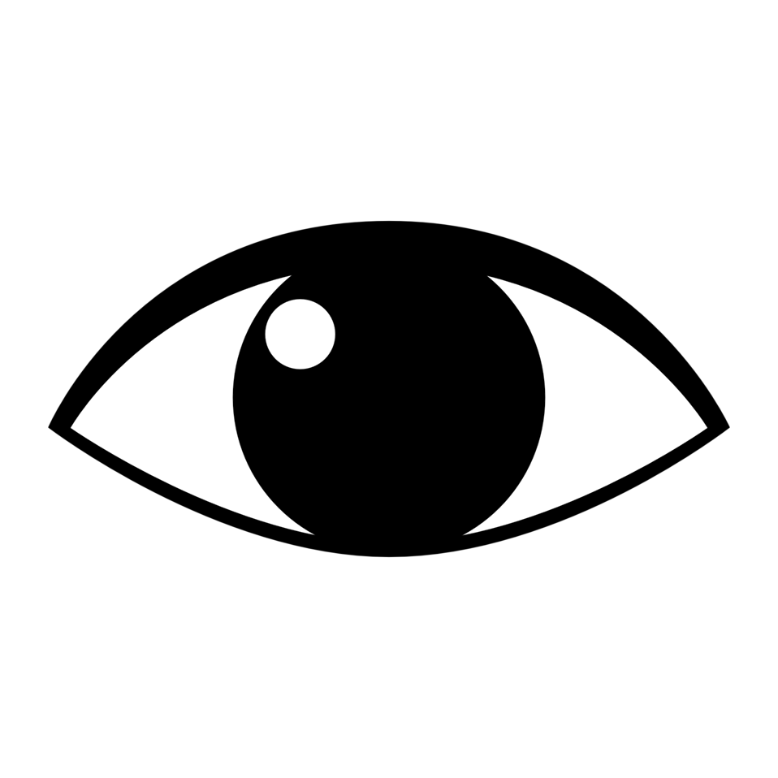Regarde cette affiche de Elise Gravel:  Tes cheveux sont beaux.  - What do you notice about the characters’ hair? (try to use some of French words from the previous activity)  - What do you wonder?  - Comment est-ce que tu es unique? How are you unique? Talk to a family member or friend about it.
Since we are looking at hair, let’s explore how Lexie uses her hair brush to measure something. That is also unique!  Regarde la vidéo Agent secret: Mesure brosse.  You can use different objects to measure.  In this video, Lexie uses une brosse à cheveux (hairbrush) to measure the tablette (shelf).  Qu’est ce que tu peux mesurer?  Can you measure something around you? You can use a brush or another object of your choice.  Make a list with things that you measure and the measurement.  Je peux mesurer  l’objet ce que je mesure combien ceci mesure  une brosse à cheveux la tablette 6 brosses  Source: Creative Commons Google Images clipart | Comment est-ce que tu es unique? What makes you unique?  Share your ideas, by choosing one of the following:  - utiliser les pièces détachées avec les objets trouvés autour de toi ou dans ce Google Slide (use loose parts/found objects around you or the digital loose parts in the Google Slide)  - faire un dessin sur un papier (do a drawing on a paper)  Try to label words to describe your drawing.  MOI - JE SUIS UNIQUE

