Asynchronous Learning for
SK-Grade 1 French Immersion

Week of December 7, 2020

Note: For this task, students will use Boukili in order to access the books. The application can be used on a tablet or on the website.
If you wish to track your child's progress with reading, you will need a parent account.
If you already have a parent account (username and password) from previous years, you may continue to use it.
If you don’t have an account, please create your free parent account using this link: https://boukili.ca
Please keep track of your username and password carefully.
The application also includes:
mini games
quizzes
passport system (for motivating students to achieve higher levels of reading)
Students have 3 options:
mode narration (students can listen to the book while following along)
mode solo (students read independently)
mode enregistrement (students can record themselves reading and playback the recording)
Getting started with Boukili
Learning Goal: I will discover and become familiar with the Boukili (app/website) and follow along with a narration of a story.
Instructions: Open the Boukili application or website. Select a level and listen to a book reading. After reading, complete the activities below.

Note: If you are not able to make a free account, please select one of the levels shown which do not require an account.
Step 1  Browse through the titles and images of the covers of the books in the Niveau 1 catalogue.  Do you see something you would like to read or listen to? What makes you want to read that one?  Select a book from the Niveau 1 list. Which book did you select? Describe what you see on the cover page. Make a prediction based on what you see. | Step 2  Click on the book that you selected so that you can listen to the reading. For this, you will select and click mode narration 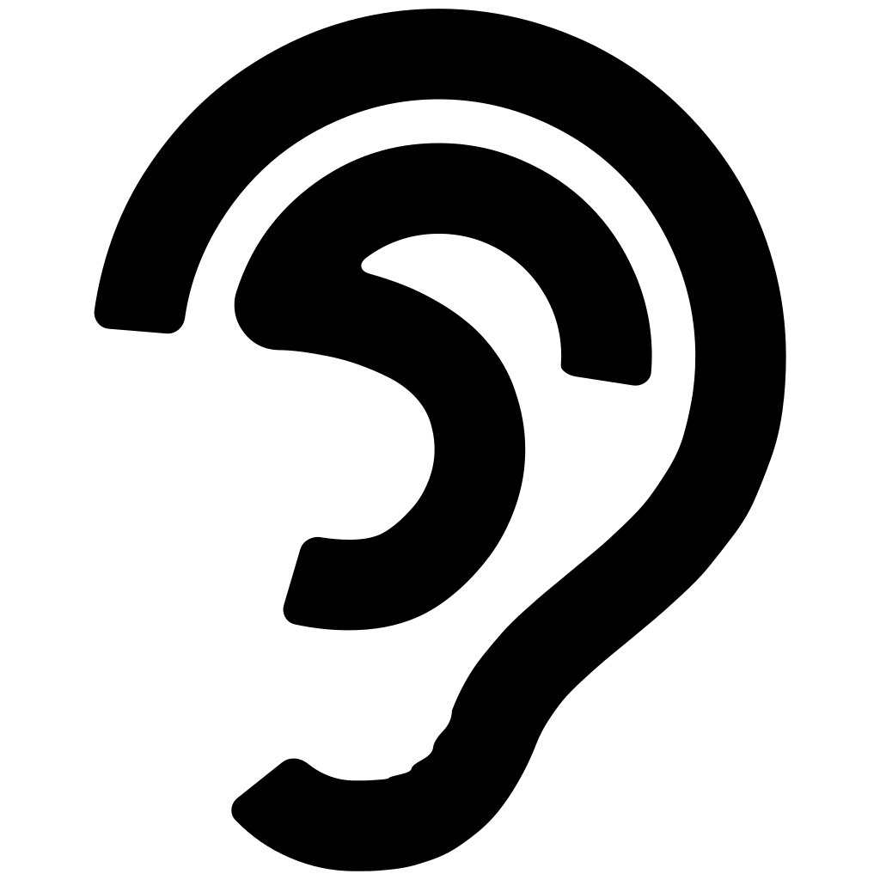.  Now listen to the story and follow along using the mouse or your finger.  What is the story about? How do you know?
Step 3  At the end of the book, there are some questions. See if you can select the correct responses. Use the symbol to hear the questions and possible answers and select the correct ones.  How did you do? Tell a member of your family what the book was about and if you liked it or not. Draw either your favorite part of the book or an interesting part. | Step 4  We hope you enjoyed this! If you would like, you can select another book and try it all again. Repeat all of the steps with a different book.  To go further, you can read, do more quizzes and play mini games. You will get a passport with badges for your reading. (please note an account is needed to access these features)

