Asynchronous Learning for
SK-1 French Immersion

Week of April 26, 2021

Note: For this task, students must have an Idéllo account in order to access the video.
If you already have a student account (username and password) from previous years, you may continue to use it.
If you don’t have a student account, please create your free student account using code 03n7pv3718mp6.
For information and tutorials that show how to create an account, please visit TDSB FSL Resources for Families.
Please keep track of your username and password carefully.
You will need to create a free account using this link to access this platform and read the books.

Protéger l'environnement
Learning Goals: We are learning about how we can help protect the environment.
Bonjour les amis! This week we are finding ways to protect Earth/ la Terre and the environment/l’environnement.
One way to help the environment is to know where to put things that we are finished with.  Regarde les images. Qu’est-ce qu’on met dans chaque bac? Look at the images below and think of what you put in each one.  https://pixabay.com/vectors/garbage-basket-bin-trash-rubbish-40357/  https://cdn.pixabay.com/photo/2014/04/03/10/38/recycle-310938_1280.png  https://pixabay.com/vectors/recycling-container-bin-boxes-41078/  Now look through these posters from TDSB Eco Schools to help you see if you made the right choices.  - Recyclage  - Poubelle  - Le bac vert | Lecture Boukili  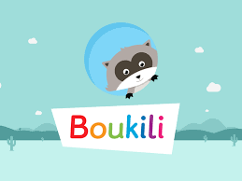  Instructions: Open the Boukili application or website. Connect to the platform. The book is located in Ma bibliothèque.  Select Madame Fruitée mange.  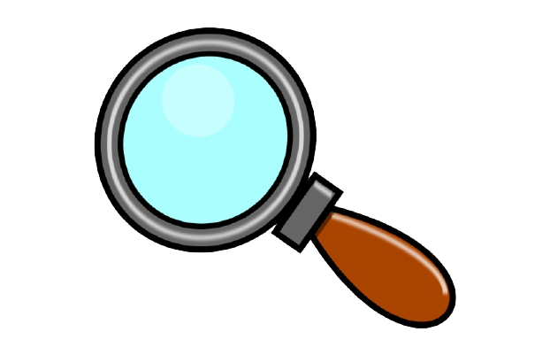Est-ce que tu vois des mots familiers? Do you see any familiar words?  What did you learn from the book you read/listened to? Talk about it with a caregiver.  Qu’est-ce que tu as appris? What did you learn?  Where can Madame Fruitée put her peels after she finishes eating ?
Regarde, 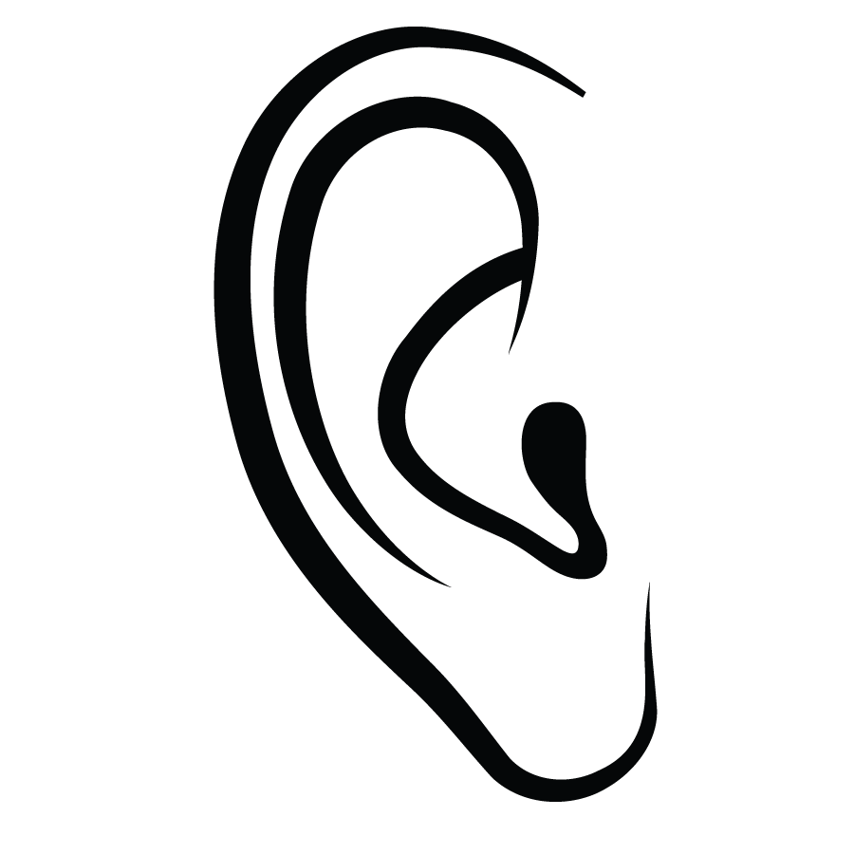Écoute  In this series from Mini TFO, Les aventures d'Écolo-Fille, the character looks for ways to be environmentally friendly/écologique.  Before watching, can you guess where the following items will be placed?/Où est-ce qu’on met ces choses? Place a ✅ in the correct space  la poubelle le bac vert /compost le bac bleu/ recyclage  une pelure de banane  https://pixy.org/1391048/  un coeur de pomme  https://pixy.org/143647/  des souliers  https://pixy.org/2159789/  une boîte de céréales  https://pixy.org/150310/  Select one or more videos to watch and see what she does in each case. Did you choose the correct container? | Apprendre et jouer  Do you know what a ver de terre is?  Regarde C'est le printemps: le ver de terre.  Les vers de terre can help with composting/le compost.  Open Mini Mag Magazine Splendeur du printemps to page 22 to learn about le compost.  Do you know what happens to the things we put in the bac vert?  You can also play the game on page 23 to see what can and can’t be put in le compost.  To learn more about compost you can watch Peg et Cat Faire du compost.  Amuse-toi!

