Special Education Advisory Committee Meeting
November 14, 2022
Leadership Report
Learning Transformation and Equity - Special Education and Inclusion
Audley Salmon, Associate Director, Learning Transformation and Equity
Nandy Palmer, System Superintendent of Special Education & Inclusion

Virtual Special Education and Inclusion Information Sessions for Parents/Guardians/ Caregivers
Beginning in November, these virtual sessions will provide Parents/Guardian/Caregivers an overview of Special Education and Inclusion supports, services and processes, through an equity lens, available within the TDSB. Parents/caregivers will be supported to become and to continue on as effective advocates for their children with special education needs. These sessions will be recorded and housed on the TDSB Special Education website for parents to access at any time.

Grade 8 - 9 Transition Information Session for Grade 8 Families
On Tuesday, November 1, Special Education and Inclusion joined the Guidance Department for a webinar on the Grade 8-9 Transition with a focus on tips and considerations in the transition to high school. Information was shared on the annual IPRC Review that takes place in January for students with exceptionalities and questions from the audience were answered on a wide range of questions on the 8-9 transitions for students with special education needs.

Guide to IEPs for Parents/Guardians/Caregivers
A new comprehensive guide has been developed to provide parents/guardians/caregivers with information on Individual Education Plans (IEPs). The guide is available in a digital format with audio, as well as in the accessible MS Word version. The guide explains what an IEP is, how it is developed, the role of parents/guardians/caregivers, and much more!
We will continue to work on developing new guides.
Guide in MS Word (Download)
Digital Guide with Audio

Parents as Partners Conference
The Parent and Caregivers as Partner Conference: Affirming, Belgoning, Connecting, was held on Saturday, October 22 and Sunday, October 23, 2022. The conference provided an opportunity to highlight innovation and high-impact strategies for partnering, collaborating, and nurturing parents’ and caregiversʼ partnerships and alliances. Special Education & Inclusion staff, in partnership with other central departments and educational partners, presented a number of workshops. These sessions were recorded and will be uploaded to the Parents and Caregivers as Partners website.
Here are the sessions led by Special Education and Inclusion staff:

Special Education Practices Based on the Principles of Equity, Inclusion, Anti-Oppression and Anti-Racism
As our Board continues to focus its efforts on racialized students who are overrepresented on IEPs and in ISP classes, there is a need to confront and disrupt unconscious bias within our schools. The session explored the current IEP strategy as well as ways that we can disrupt oppressive practices in our referral processes. Parents/caregivers were also supported with strategies to become and to continue on as effective advocates for their children with special education needs.

Supporting the Successful Transition to Kindergarten for Students with Autism
Entering kindergarten is often an exciting time for students and their parents/caregivers. This transition may also evoke feelings of worry, concern and apprehension particularly in relation to how the needs of students with Autism may be met. In this session, participants learned more about what to expect in kindergarten, how to best prepare their child for the transition to school, and an overview of the supports offered through TDSB’s Autism Services

Connecting with your child with complex needs, building cooperation with daily tasks and helping your child cope with stressful situations
This presentation provided information on ways you connect with their child with complex needs, how you can find your child's Happy, Relaxed, and Engaged (HRE) state, explore how to teach your child to cooperate with daily tasks in supportive and safe ways, and how to help your child cope with stressful situations. The presentation provided examples and short scenarios on ways to connect with your child. Ways to build strong partnerships with your child's school community were also explored.

Supporting Students with Developmental Disabilities and their Transition beyond High School
This session focused on practical long-term strategies for parents and caregivers as they support youth with special education needs through high school and in the transition to the workplace or post secondary. We explored in-school learning and skill development, how parents can support at home, and supports and resources within the school system and beyond.

IPRC Data - October 2022

October IPRCs
Learning Centre 1 | 39
Learning Centre 2 | 46
Learning Centre 3 | 14
Learning Centre 4 | 28
IPRCs Completed | 127
IPRC Cumulative since August 2022
IPRC Cumulative since August 2022 | 206

Psychological Assessment Data - October 2022

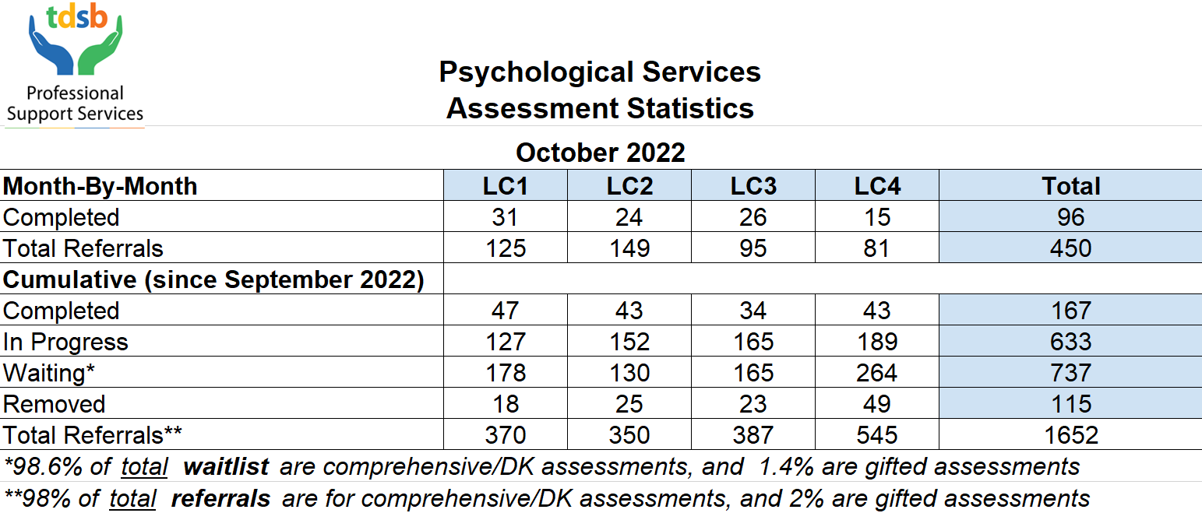

Psycho-Educational Assessments Statistics Including ‘Aged’ Statistics Per Learning Centre

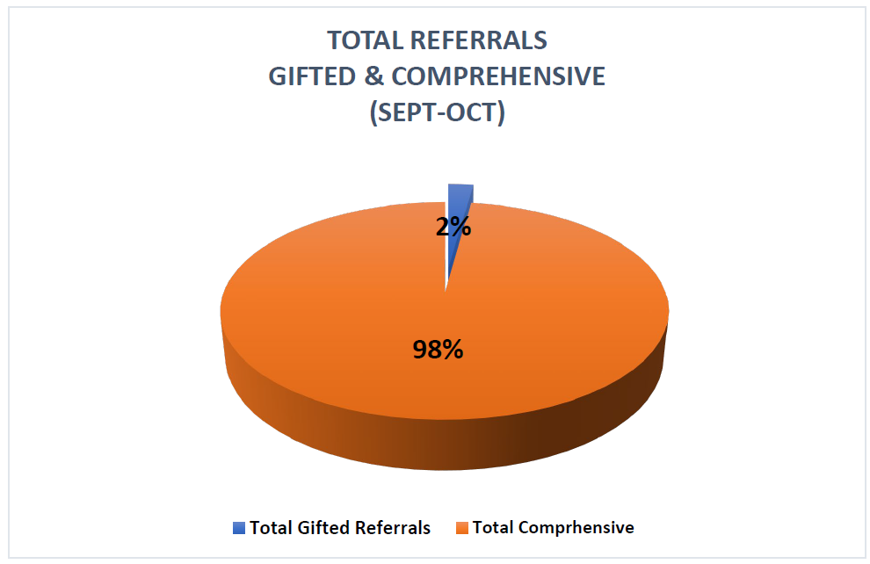
Since September 2022, the total number of referrals is 1537 (1652-115 which were removed).

Gifted referrals begin in late October after students have completed the CCAT. The total percentage of Gifted Referrals vs. Comprehensive Referrals is therefore quite low.

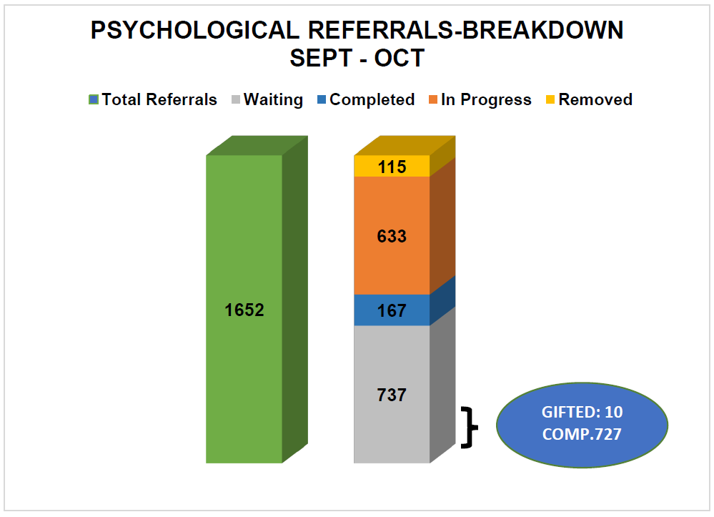

This chart indicates the breakdown of the 1652 psychological referrals received since September 2022 to October 2022.
- End of October 2022, 737 Compressive & Gifted Assessments are on the waitlist.
  - Of the 737 Total Waitlist: 727 and 10 are Comprehensive & Gifted Assessments respectively.
  - This is a total reduction of 7.3 % of the waitlist from September 2022.
- 167 Referrals (Comprehensive & Gifted) have been completed since September 2022.
- 633 Referrals (Comprehensive & Gifted) are in progress
- 115 have been removed for some these following reasons:
- The parent/guardian has not consented to the assessment
- The student has left the board
- The student moved out of the country
- Other supports were provided that supported the initial needs which initiated the assessment (trauma therapy; outside private psycho-educational assessment by parent/guardian; supports/differential strategies provided to the educators in the classroom that have positive outcomes etc.)

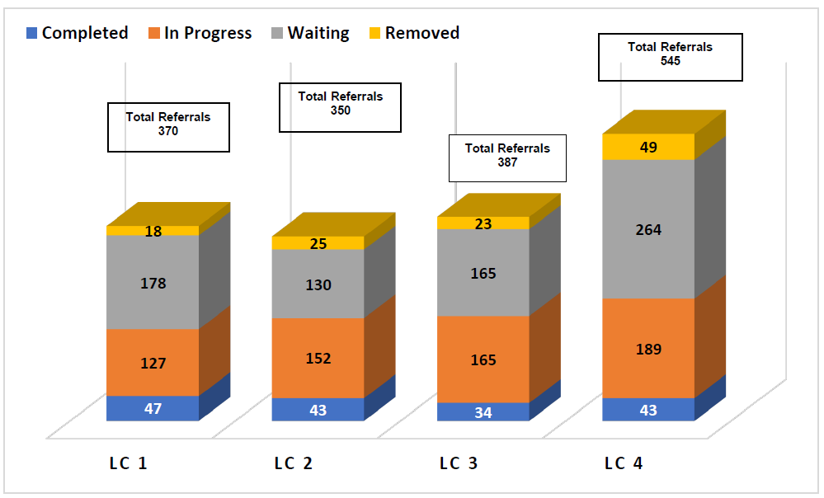

This chart showcases total referrals (Comprehensive & Gifted) for each LC.

**The waitlists do vary, and part of this variance includes the following (2021 numbers)

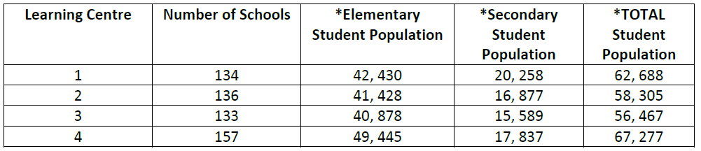

Higher referral numbers in LC4 are attributed to:
- LC4 has 20 plus schools more than the other LC’s
- LC4 has 5000-10,000 more students than the other LC’s

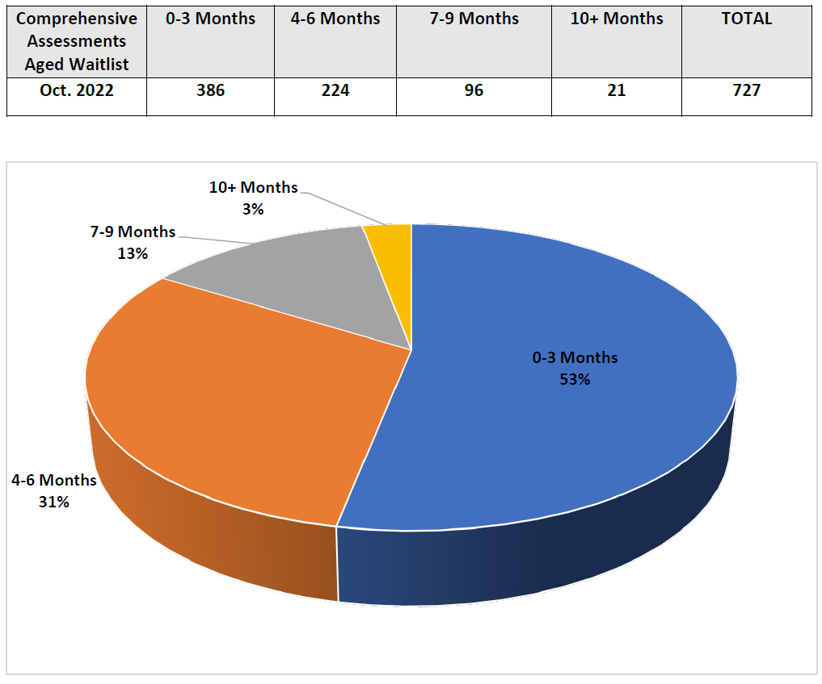

Psychological staff have worked to complete all comprehensive assessments, over 6 months, are attended to and completed, including any referrals from 2021/2022 school year that remain on the comprehensive waitlist.

Below are some rationales why 6-month comprehensive referrals remain on the waitlist:
- Parent/Guardian want to continue with the assessments and the students are in virtual school where only a portion of psychoeducational assessments can be completed virtually. These students and parents/guardians a being offered local school spaces and administrative buildings to support the completion of in person testing but have declined.
- Students who left, in between testing, to go out of the country/city/province and want to remain on the wait list.
- Student who enrolled into virtual school in between testing and want to remain on the waitlist.
- Student and parents/guardians who are not responding to the staff and staff are working with the school and Attendance Counselors to locate.

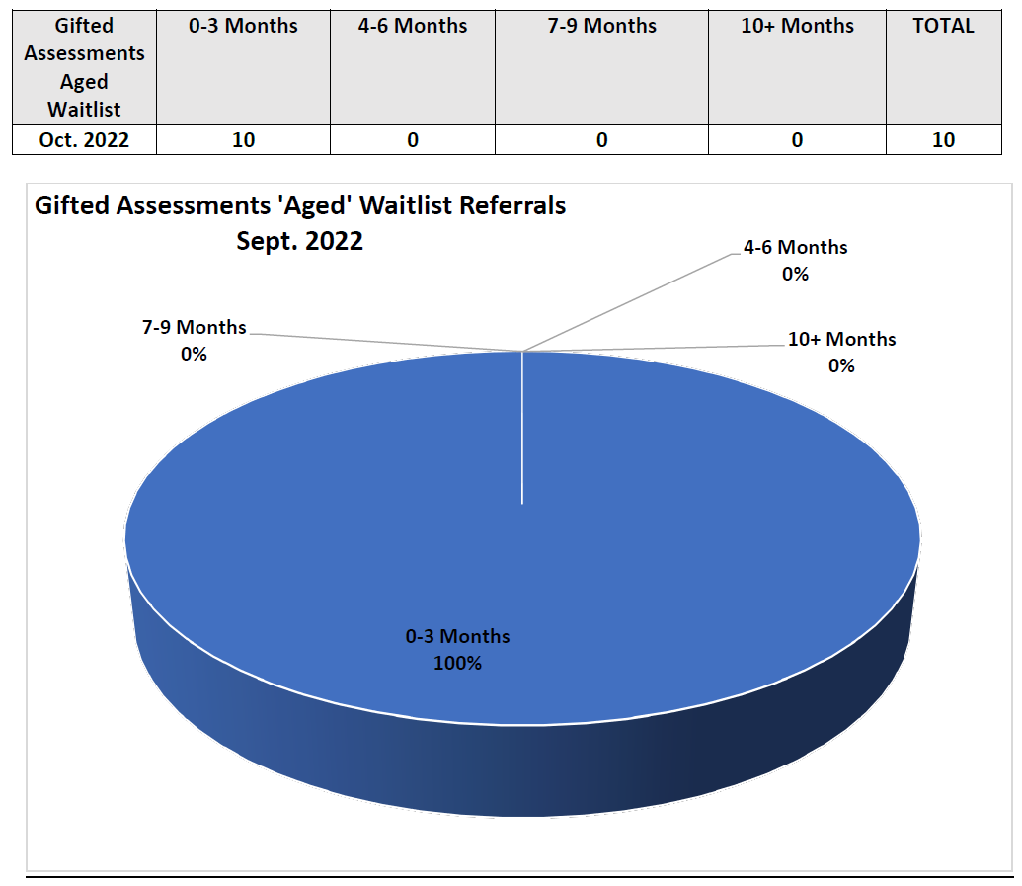

**Staff will be completing as many compressive and gifted assessments over the summer 2022
(i.e. during the summer of 2022- 0 Gifted and 102 Comprehensive Assessments were completed).

