OCTOBER HIGHLIGHTS
- Upcoming Parent/Guardian Sessions
- Check it Out Video
- Occupational Therapy and Physiotherapy Services
- Speech Language Pathology Services
- Psychological Services
- Planning for Transitions
- Learning Disabilities Awareness Month
- Dyslexia Awareness Month
- ADHD Awareness Month

Autism Regional Services - Parent/Guardian Drop-in Sessions
Join us for a drop-in session to ask questions, share insights, and receive neuro-affirming strategies and practical suggestions to support students with Autism at home and at school.
These informal sessions provide an opportunity to connect with members of the Autism Regional Services team and access information, resources, and support in a welcoming environment.
All parents, guardians, and caregivers are welcome.
- Where: Microsoft Teams
- ⏰ When: 12:00pm - 1:00pm
- Thursday October 22, 2026 (Click to join)
- Thursday November 19, 2026 (Click to join)
- Thursday December 17, 2026 (Click to join)
- Thursday January 21, 2027 (Click to join)
- Thursday February 25, 2027 (Click to join)
- Thursday March 25, 2027 (Click to join)
- Thursday April 22, 2027 (Click to join)
- Thursday May 27, 2027 (Click to join)

Join Indigenous artist Abigail Clarke in this video tutorial showing how she beads earrings using moose hide and birch bark Check it Out Video.
Special Education & Inclusion Parent/Guardian Engagement Sessions
Date | Description | Registration
October 5, 2026  6:30 PM  October 7, 2026  10:00 AM | WEBINAR  From Talking to Learning: Why Talking at Home Matters. Discover how everyday conversations at home can build strong foundations for your child’s learning and language development. | Oct 5: Registration - PM Link  Oct 7: Registration - AM Link
October 22, 2026  12:00 PM | DROP-IN  Neuro-Affirming Strategies to Support Students with Autism at Home and School.  Gain practical, neuro-affirming tools to better support your child's success, comfort, and engagement at home and school. | Link

Toronto District School Board Occupational Therapy and Physiotherapy Services from the Special Education and Inclusion Department
OTPT Newsletter October 2026
More Than a Grip!
The Hidden Secrets to Strong Printing
Printing is a whole-body activity. Consider adding activities in these skill areas to your child’s day to help improve their printing.
Stability
Core Strength & Posture: work on muscles that help with sitting upright (no slouching or leaning).
Shoulder Stability & Wrist Position: work on shoulder strength and extending the wrist so they can hold their arm steady and move their fingers.
Activity Idea: Try drawing or vertical wall mazes.
Sensory Processing
Proprioception (Body Awareness): Practice holding, squeezing, and pulling different items to learn how much pressure muscles are using.
Tactile Discrimination: Try feeling and identifying textures.
Activity Idea: Try sensory writing tasks or blindfold sensory hunt games in sand.

Visual Motor & Perceptual
Eye-Hand Coordination: play games like catch to help the eyes and hands communicate better.
Visual Spatial Awareness and Shape Recognition: play games that teach concepts needed for printing like up/down, left/right, and big/small, which help with letter sizing & spacing, and knowing an "A" is an "A" whether it's big, small, typed, or printed.
Activity Idea: Try matching games or action songs like The Hokey Pokey
Fine Motor & Hand Strength
Hand & Finger Strength: work on strengthening muscles needed to pinch and hold things.
Palmar Arches & Hand Separation: Try getting the hand to hold a curved shape while holding things with fingers, even better if they can hold the pinky and ring finger stable while using
the thumb & index.
Activity Idea: Try playdough hide and seek.
Cognitive Executive Functioning
Motor Planning: play games that get the brain to make a plan to move the body (e.g. Simon Says).
Attention & Working Memory: Try getting your child to hold an image in the mind. Then ask them to share it later without getting distracted.

Activity Idea: Try a secret agent code game (i.e. learn a code in one location and remember it to write it down in another location).
Click Here to access the TDSB OT/PT parent engagement session on Learning to Print and Write.
There may be websites linked from this site that are operated by organizations outside of the Toronto District School Board (TDSB). These organizations are solely responsible for the operation and information found on their sites. Linking from this site does not imply any endorsement of the organization or information found on the website. Any comments or inquiries regarding the linked websites should be directed to the organization operating the website.

Speech Language Pathology (SLP) Services
Fly in the Chai – During Reading – A Guide for Parents
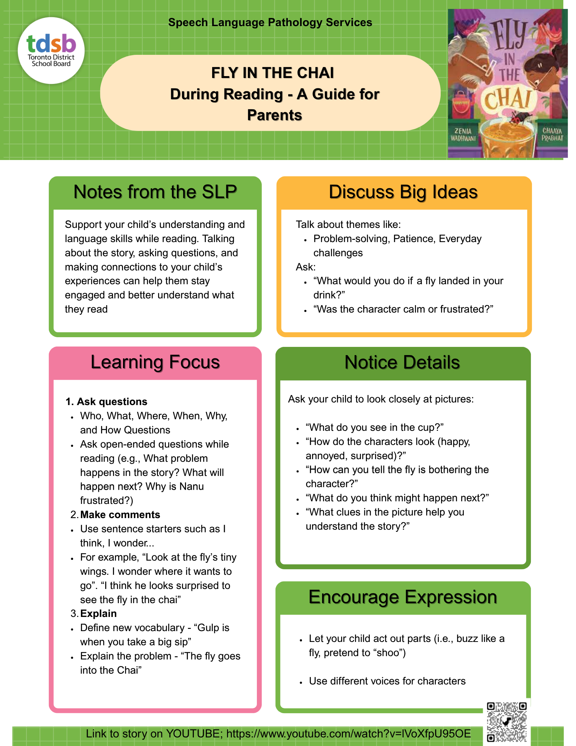

Psychological Services
October marks Learning Disabilities Awareness Month, ADHD Awareness Month, and Dyslexia Awareness Month.
Helping Students Plan, Start and Finish
Executive functions act like “the director” of a student’s to-do list, helping them choose a priority, break it into steps and finish on time. Reading or spelling may take extra effort for a student with a learning disability. A student with ADHD may find it hard to stay focused on one task when other demands compete for their attention.
Elementary: Help your child complete a task or assignment by creating a short checklist with familiar words, or drawings, with one or two small steps. You can then support them to check off steps as they complete them with check-marks, or stickers in a paper document, or by using emojis in a digital checklist.
Secondary: Help your teen work backward from an assignment due date to set smaller
steps/milestones. Assist them in blocking out time in their calendar to complete each small step. They can record these in a school-approved computer calendar or a paper planner and review progress as they complete the steps.

Remember to positively reinforce your child’s smaller accomplishments with verbal praise (e.g., "Great job finishing the small parts first - look doing this brought you to the finish!"). To help develop strong work habits, it is important to reinforce that they broke down the task into smaller parts.
Be sure to ask your child which strategy helped them the most, and share this insight with their school team.
Resources: LDAO – https://www.ldao.ca/faq-items/improving-executive-function-skills/
CADDAC – https://caddac.ca/about-adhd/ages-7-17-yrs/

ADHD Fact Sheet:

Attention Deﬁcit Hyperactivity Disorder (ADHD)  ADHD Is a medical condition involving diﬀerences in brain development and brain activity that aﬀect attention and self-regulation (Kid’s Health Website, 2023).  ADHD is one of the most common childhood neurodevelopmental disorders and it is often characterized by inattention, impulsiveness, and hyperactivity. Those with ADHD may have more diﬃculty:  - Paying attention  - Thinking or acting thoughtfully  - Exercising self-control and inhibiting responses  - Coping with feelings of frustration or other strong emotions  - Remaining settled, due to feelings of restlessness (NHS, 2021)  There are many other symptoms that go unnoticed because they’re internal and aﬀect executive functioning. Dr. Gioia and colleagues found the following speciﬁc processes involved (ldonline, 2023):  - Inhibition The ability to stop one’s own behaviour at an appropriate time (the counterpart being impulse control)  - Shift The ability to move freely from one situation to another and to think ﬂexibly in order to respond appropriately  - Emotional Control The ability to modulate emotional responses by bringing rational thought to bear on feelings  - Initiation The ability to begin a task or activity and independently generate ideas, responses, or problem solve  - Working Memory The capacity to hold information in mind for the purpose of completing a task  - Planning/Organization The ability to manage current and future-oriented task demands  - Organization of Materials The ability to impose order on work, play and storage spaces  - Self-monitoring The ability to monitor one’s own performance |  | Reframing ADHD  1.8 million Canadians have been diagnosed with ADHD, which is between 5-7% of Canadian children (CADDAC, 2023). Approximately 8% of children and 6% of adolescents have been given an oﬃcial diagnosis worldwide (Salari et al., 2023.)  While the barriers relating to ADHD are more widely discussed, many individuals with ADHD note advantages of the disorder, such as increased creativity and energy (Cimera, 2002).  Increased creativity and energy allows for strong motivation in diﬀerent domains, such as teaching, athletics, and jobs that require physical activity (Cimera, 2002).  Hyperactivity can lead to quicker reaction time/endurance (Cimera, 2002).  When those with ADHD are highly motivated and drawn to a task, it is thought that they can sometimes become very focused and can complete these tasks in a very timely manner (Adda, 2023).  One study conducted in 2018 found six main themes depicting positive traits: cognitive dynamism (naturally curious, state of ‘ﬂow’, hyper-focus), courage (being an outsider, thrill seeking, integrity), energy, humanity (persuasive abilities, humour) resilience, and transcendence (appreciation of beauty) (Sedgwick et al., 2018).  ADHD is highly manageable. When taught adaptive techniques to help with time management and organizational skills, students with ADHD are able to achieve higher levels of concentration.

Diagnosis  ADHD is diagnosed by a psychologist or paediatrician who assesses the child and observes their behaviour. There is no single test to determine if someone has ADHD (CDC, 2022). The criteria used to determine whether a diagnosis is warranted is outlined in the Diagnostic and Statistical Manual - 5th Edition (DSM-5).  To receive a diagnosis, ADHD symptoms should be persistent and have been observed over the course of the past 6 months (APA, 2022).  Disorder begins in childhood, symptoms must be present before the individual is 12 years of age. Symptoms must aﬀect multiple areas of one’s life (e.g., home, school, social events) (APA, 2022).  The psychologist or paediatrician conducting the assessment must ensure that the symptoms are not better explained by another disorder (CDC, 2022).  Subtypes (DSM-5):  Inattentive: Students who are inattentive (easily distracted) have trouble focusing their attention, concentrating, and staying on task. They may not listen well to directions, may miss important details, and may not ﬁnish what they start. They may seem absent-minded or forgetful, and lose track of their belongings.  Hyperactive: Students who are hyperactive are ﬁdgety, restless, and easily bored. They may have trouble sitting still, or staying quiet when needed. They may rush through things and make careless mistakes. They may climb, jump, or roughhouse when they shouldn't. Without meaning to, they may act in ways that disrupt others.  Combined: Criteria for both are met. |  | Truths and Myths about ADHD Truths  A strengths-based approach to ADHD is important for students.  Understanding students have strengths can make a diﬀerence in their academic careers.  A high level of energy and drive, creativity, hyper-focus, agreeableness, empathy and willingness to assist others were the most consistently reported strengths associated with ADHD (Mahdi et al., 2017).  A focus on developing assets associated with ADHD such as creativity, problem solving and hyper focus may reduce comorbid issues and allow students to focus on their own happiness, relationships and occupational success (Climie and Mastoras, 2015).  Students with ADHD are shown to have strengths in verbal abilities, logical thinking and common sense (Ek et al., 2007).  Although often helpful, medication alone does not treat all skills leading to academic and/or social impairments (CADDAC, 2023).  ADHD presents diﬀerently from one child to the next.  Myths  ADHD is not a real disorder – First study was done in 1775. Since then, 10000 studies have been published on ADHD. Research studies show similar symptom presentation from childhood to adulthood and the brain diﬀerences in children with ADHD.  ADHD is a childhood disorder. Recent studies show ADHD remains from childhood to adolescence (50-80% of cases) and into adulthood (35 – 65% of cases) (CHADD, 2023).  ADHD is overdiagnosed. Indeed, rates have increased by 5% every year 2003 -2011 (according to the National Survey of Children’s Health.  However, there are many reasons for this increase, including: a decrease in stigma, more paediatric screenings, improved awareness, availability of better treatment options, and more cases arising from suspected environmental factors (CHADD, 2023).  Girls have lower rates and less severe ADHD. Studies on female ADHD only began in the last few decades but generally show similar impairment (CHADD, 2023).

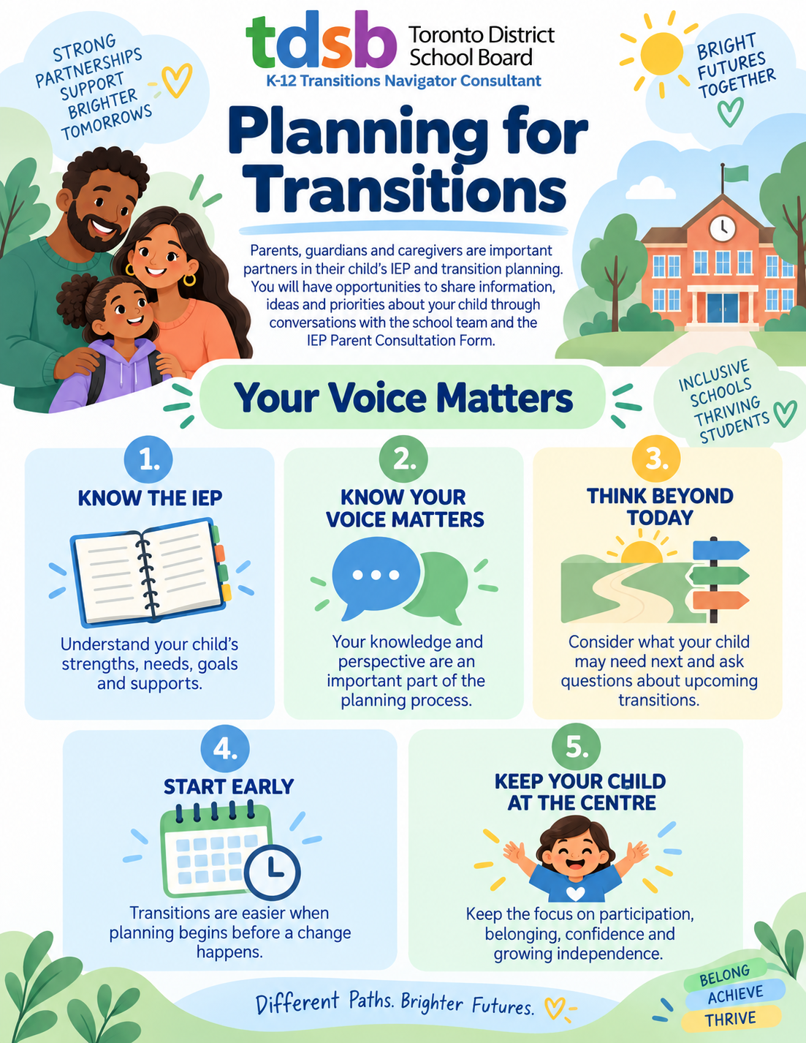

Transition planning

Awareness Events
Learning Disabilities Awareness Month
Every October, the Learning Disabilities Associations of Ontario and LD@school celebrate Learning Disability (LD) Awareness month. The goal of the campaign is to raise awareness and reduce stigma to allow individuals with LDs to get the supports they need to reach their potential.
DON’T DIS MY ABILITIES (#LDmonth)
Please click the link for a Tip Sheet with more information.

For more information click here.

Dyslexia Awareness Month
Mark it Read for Dyslexia Awareness Month 2025
For the past eight years, Dyslexia Canada has proudly celebrated Dyslexia Awareness Month each October with the Mark it Read for dyslexia campaign. Every October Mark it Read shines a light on dyslexia, a learning difference that affects 10–20% of Canadians.

ADHD Awareness Month
October marks ADHD (Attention Deficit Hyperactivity Disorder) Awareness Month, a time to build understanding, reduce stigma, and support students and families. This year, the Centre for ADHD Awareness Canada (CADDAC) is highlighting “The Many Faces of ADHD,” reminding us that ADHD does not look the same for everyone.

The ADHD Awareness Month Vision: A world where understanding ADHD leads to support, connection, and real opportunities to thrive.
The ADHD Awareness Month Mission: To raise awareness of ADHD by sharing accurate information, elevating lived experience, fostering connection, and promoting access to support across the lifespan.
Please find information on ADHD in this ADHD Fact Sheet created by members of TDSB SEAC and staff.

