NOVEMBER HIGHLIGHTS
- Parent/Caregiver Engagement Sessions
- Special Education and Inclusion Parent/Caregiver Guides
- Occupational Therapy and Physiotherapy Services
- Autism Regional Services
- Speech and Language Pathology Services
- Deaf and Hard of Hearing Services
- Blind/Low Vision Services
- IEP Accommodations
- Community Based Supports for Students with Special Education Needs
- Psychological Services
- Pathways to Success: Navigating Grade 8-9 and Post 21 Transitions

Special Education and Inclusion Parent/Caregiver Guides
The Toronto District School Board (TDSB) provides many Special Education Guides for Parent/Legal Guardian which contain information about the supports, programs and services available for students with disabilities and special education needs in the TDSB.

November Parent/Caregiver Engagement Sessions
Date | Description | Registration
Nov 10, 2026  10:00 AM  Nov 19, 2026  6:00 PM | WEBINAR  Pathways to Success: Navigating Grade 8 to 9 and Post-21 Transitions. Get guidance on planning for your child’s future, including key considerations for major school transitions and beyond. | Registration - AM Link  Registration - PM Link
Nov 24, 2026  10:00 AM  Nov 25, 2026  6:30 PM | WEBINAR  Learning Through Chores: The Daily Grind as Therapy. Learn how involving your child in daily routines and chores can provide therapeutic benefits while building independence. | Registration - AM Link  Registration - PM Link
Nov 19, 2026  12:00 PM | DROP-IN  Neuro-Affirming Strategies to Support Students with Autism at Home and School.  Gain practical, neuro-affirming tools to better support your child's success, comfort, and engagement at home and school. | Link

Toronto District School Board Occupational Therapy and Physiotherapy Services from the Special Education and Inclusion Department
OTPT Newsletter
Breathing to Stay Calm: One Skill, Three Steps
When a child becomes emotionally overwhelmed, the body shifts into a stress response: the heart races, muscles tense, and the thinking part of the brain goes offline as the survival instincts take over. Slow breathing counters this directly: an out-breath slightly longer than the in-breath signals safety, settling the heart rate and bringing the thinking brain back online. That makes breathing a powerful self-regulation skill: always available, discreet, and something a child can do on their own. Teach it in small steps. More support at first, more independence as the child is ready
Step 1: We Breathe Together
Most support. We breathe together
The caregiver leads. Sit close, breathe slowly together, and rest a soft toy on the belly to watch it rise and fall.
Step 2: I Breathe With a Picture
Some support. I breathe with a picture
The child follows a picture card: in - smell the flower; out - blow the candle.

Step 3: I Breathe On My Own
On their own. I breathe on my own
When a big feeling comes, the child breathes on their own: in for 1-2-3, out for 1-2-3-4-5.
Breathing strategies to try
A simple shape to follow gives the breath a rhythm. Trace the path slowly with a finger.
Rectangle breathing
Trace the four sides, breathe in for 3 seconds and breathe out for 5 seconds
Figure-8 (lazy 8)
Breathe in around one loop, out around the other. Repeat slowly.
A stepping stone to other self-regulation skills: Breathing can be a skill a child masters as a precursor to:
Requesting movement breaks
Identifying zones of regulation
Accessing Sensory tools (fidgets, headphones)
There may be websites linked from this site that are operated by organizations outside of the Toronto District School Board (TDSB). These organizations are solely responsible for the operation and information found on their sites. Linking from this site does not imply any endorsement of the organization or information found on the website. Any comments or inquiries regarding the linked websites should be directed to the organization operating the website.

Autism Regional Services
PAIRING: BUILDING POSITIVE RELATIONSHIPS
How to establish rapport with your student – before introducing demands.
Why Pairing Matters!
Every positive interaction is a “deposit.” Before you can place an instruction (withdraw), you need a surplus of positive associations (deposits) with you and the environment. If the environment feels safe and enjoyable, students are more likely to follow your lead, participate and try new things!
Follow the load - Sit near the student while they engage with their interest.
• Make no demands.
• Don’t ask questions (“What are you building?”) or give instructions.
• Simply be present, calm, and interested in what they’re doing.
Narrate Play - Act like a sports commentator.
• Describe what’s happening without taking over.
• “Oh, the blue car is going so fast! Look at it jump!”
• This shows you’re paying attention without interrupting the student’s focus.

Giver of Good Things
Provide access to items and activities of interest and give them freely - no work required.
• If they love movies, play a movie on a random Wednesday afternoon.
• Before you provide access to preferred items, make sure you know what your students are
interested in - seek their input!
• This makes you the “source” of the fun, and not just a bystander
Add Value
Make the activity better because you are there.
• If they love dinosaurs, make “rawr” noises or build a cave from a cardboard box.
• The goal: playing with you is more fun than playing alone.
*It is important to note that if the student is seeming to become overwhelmed or irritated by what you are adding to the activity, take a step back. Sometimes just sitting near the student adds value!
Fade in Small Instruction
Once the student is smiling and engaging, introduce one tiny instruction.
• Keep it easy: “High five!” or while watching a movie ask, “That was cool! What do you think will
happen next?”
• Immediately follow with more of the interest as reinforcement. • If they disengage or pull away,
try again at a later time.

Tips for Success
Give “Freebies.” In the beginning, give the student what they enjoy without requiring any work.
Watch for social signals. If the student turns away or stops engaging, you may be crowding their space. Back off or become quieter (narrating from a slight distance).
Let the student lead the play. If they want to line up the cars by colour instead of racing them, line them up with them! Pairing is about joining their world, not redirecting it.

Speech Language Pathology (SLP) Services
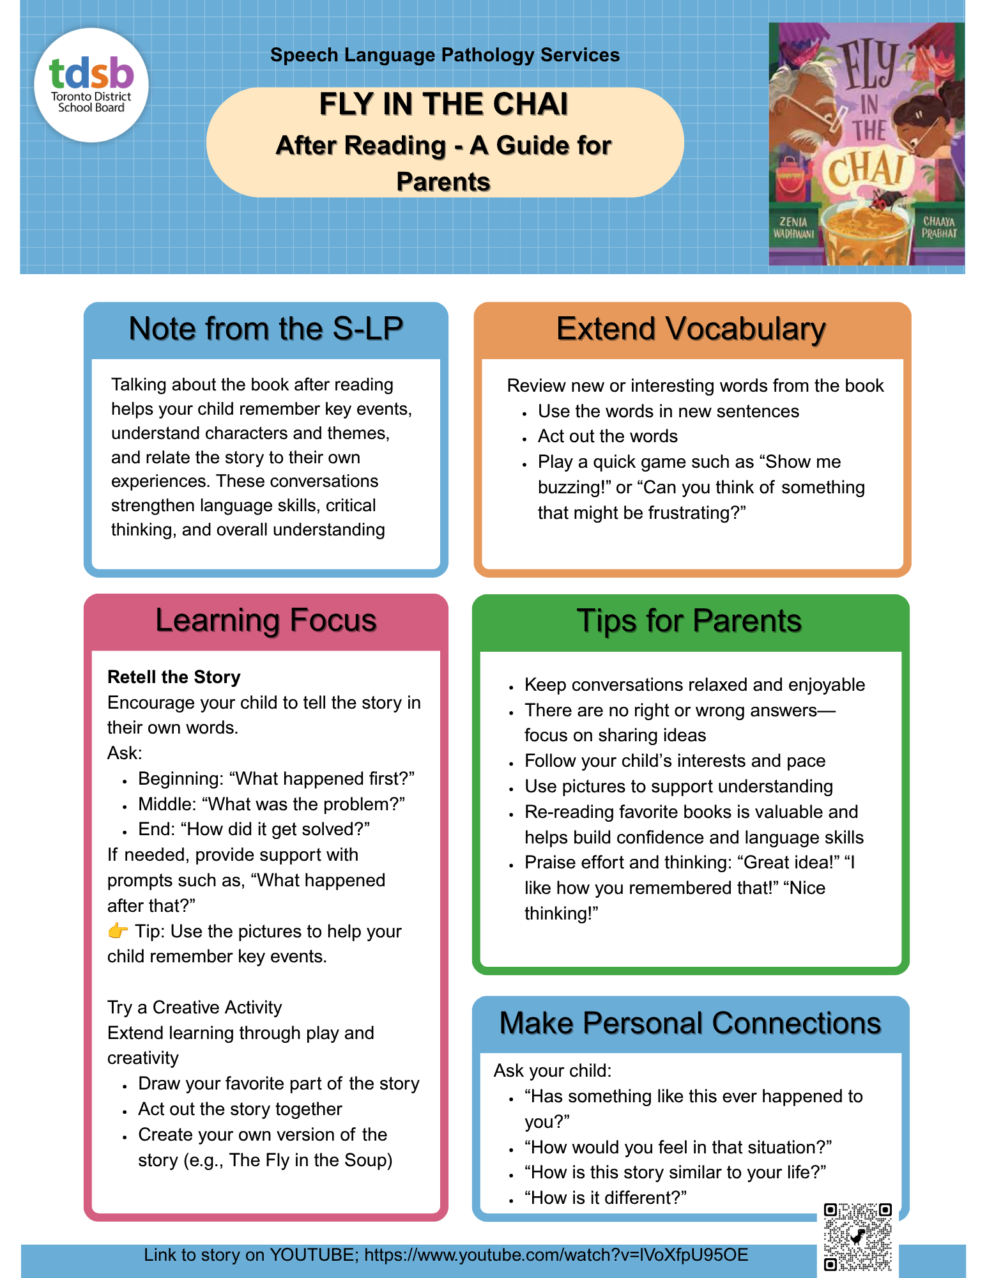
Link to FLY IN THE CHAI Story

Deaf and Hard of Hearing Services
Access Changes Everything: A DHH Student Mosaic
Deaf and Hard of Hearing (DHH) students across TDSB recently took part in a collaborative project centred on the theme Access Changes Everything.
DHH students were invited to reflect on what access means in their own lives and how it helps them participate, connect, learn and communicate. They shared their ideas through drawings, photographs and written reflections, highlighting the many ways that communication access, technology, supportive environments and self-advocacy can make a difference.
Each student created one small, individual piece. Together, their contributions became a Giant Access Mosaic, a powerful reminder that every student’s experience is unique, while each voice contributes to a larger DHH community.
The finished mosaic celebrates student voice, belonging and the importance of creating learning environments where Deaf and Hard of Hearing students have meaningful access to communication, learning and participation.
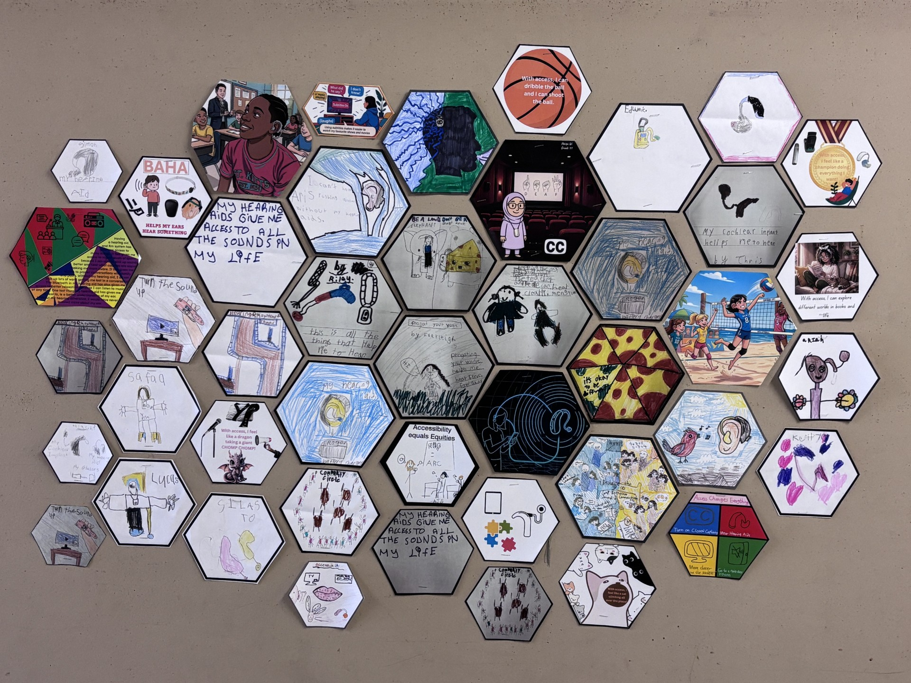

Blind and Low Vision Services
SEA Claims
Blind/Low Vision SEA equipment continues to evolve, and the BLV Team is committed to ensuring that students have access to appropriate, up-to-date technology that supports equitable access to learning. Below are some examples of equipment that you might see in the classroom setting:
Equipment to Support Visually Accessing Curricular Materials:
Tools that support near and distance viewing help students with low vision access classroom materials more independently and in real time. Devices such as the Explore 12, MagniBot, and MagniLink Zip are video magnifiers that allow students to adjust magnification, contrast, and brightness to meet their visual needs. These tools support near tasks such as reading worksheets and books, as well as viewing information at a distance such as whiteboards, anchor charts, or the classroom teacher. So much information is conveyed through facial expressions, which these devices can provide access to.
Equipment to Support Tactual Access to Curricular Materials:
Tools that support students who are blind provide accessible options for reading and writing in braille. Devices such as the Perkins Brailler, Braille Display, and BrailleNote Touch allow students to produce written work, take notes, and access curriculum materials in their primary literacy medium. The Perkins Brailler supports the development of foundational braille writing skills, the BrailleNote Touch allows students to read and write refreshable braille and access digital materials, like Google suite, and the Braille Display supports student in accessing a laptop with braille output.

Ministry of Education: Instructional Approaches
Accommodations and the IEP
Providing accommodations to students with special education needs should be the first option considered in program planning.
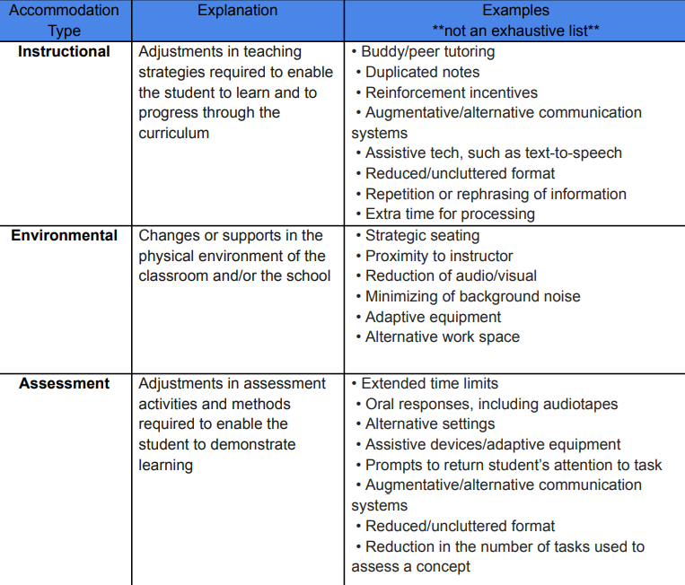

Community-Based Supports for Students with Special Education Needs
Beyond the school setting, families may also access a wide range of supports, including:
- Ontario Autism Program (OAP): Provides foundational family services, caregiver-mediated early years programs, entry-to-school supports, urgent response services, and core clinical services. Families can connect through Access Ontario Autism Program website.
- Special Services at Home (SSAH): Offers funding for respite and personal development.
- Assistance for Children with Severe Disabilities (ACSD): Provides financial support for families caring for children with significant disabilities.
- Surrey Place provides support services for children, youth, and adults with autism-services, developmental-, and sensory-related concerns.
- Holland Bloorview is Canada’s hospital for children with disabilities and developmental differences offering various inpatient and outpatient services, family workshops and resources, respite, and inclusive services promoting life skill development and community integration.
- Ontario Health at Home provides nursing, diet and nutrition counselling, and personal support services for families in the home environment.
Other programs such as Respite Services, Children’s Rehabilitation Services, and the Preschool Speech and Language Program may also be available.

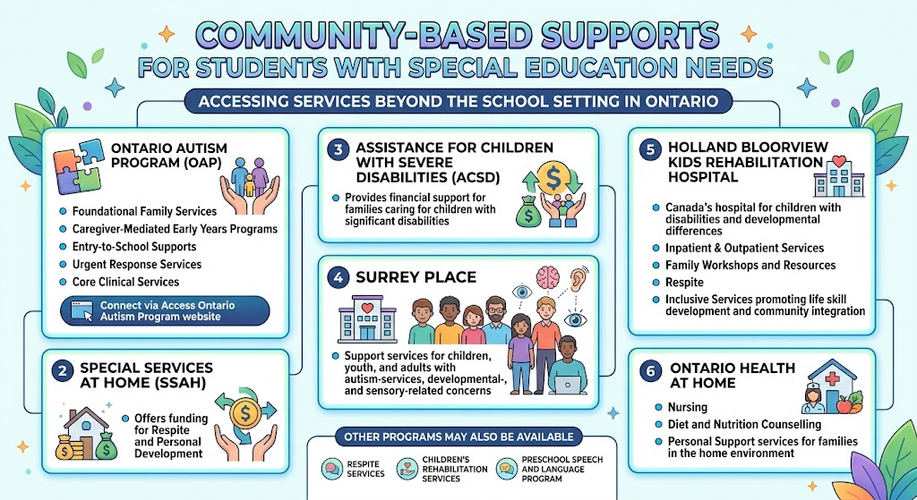

Psychological Services
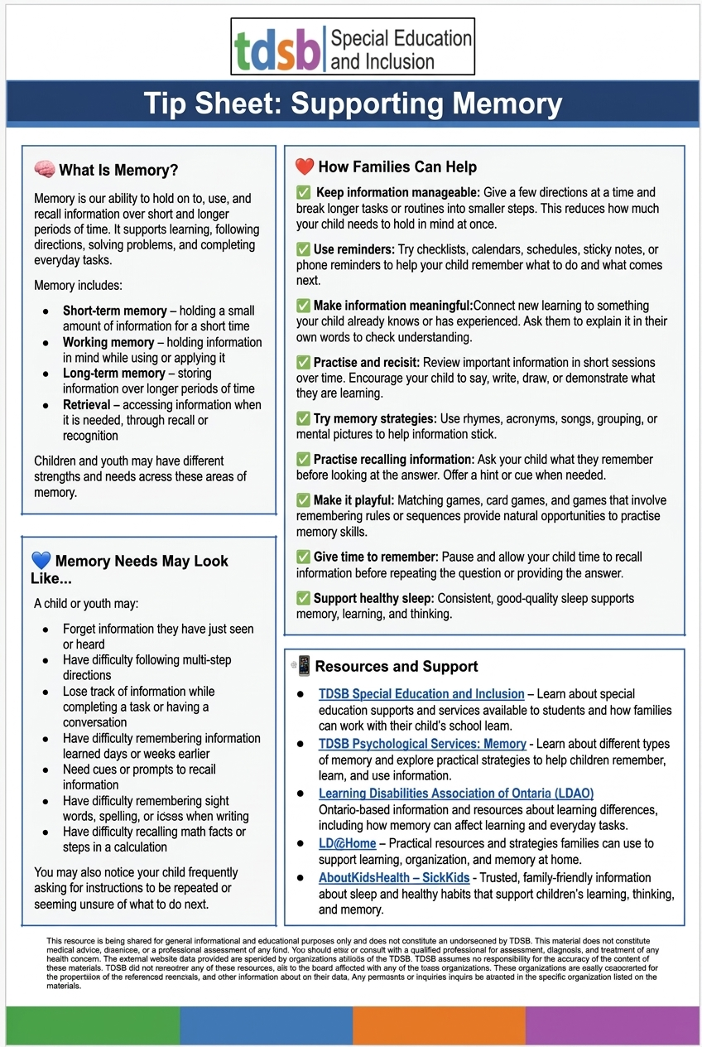,

PATHWAYS TO SUCCESS: NAVIGATING GRADE 8 TO 9 AND POST-21 TRANSITIONS
Online engagement session for parents and caregivers
Tuesday, November 10, 2026
10:00 a.m.
Click HERE to Register
OR
Thursday, November 19, 2026
6:30 p.m.
Click HERE to Register

ABOUT THE SESSION
In this online engagement session, you will gain a better understanding of two important transition points: moving from Grade 8 to Grade 9 and preparing for life beyond school.
Presented by Transition Navigator Consultants, the session will explore key areas that support successful transitions, including pathways, available supports, planning timelines, student voice, and working together with school teams.
You will leave with practical strategies to help your child build confidence, explore opportunities, and prepare for their next steps in secondary school and beyond.

WHAT YOU’LL LEARN
• Grade 8 to 9 transition planning
• Post-21 transition planning
• Pathways and available supports
• Planning timelines and student voice
• Working together with school teams

