NOVEMBER HIGHLIGHTS
- Important Dates, Special Education and Inclusion Parent/Legal Guardian Guides, ASD After School Skills Development Program
- TDSB Psychological Services: The Brain and Empathy, Autism Regional Services Monthly Parent/Guardian Drop-In Sessions Calendar
- TDSB Speech Language Pathology Services: Reading Together at Home and Kindergarten Calendar; Parent Engagement Opportunities
- Supporting Gifted Learners Tip Sheet
- TDSB OT/PT: Fine Motor Skills, Independence Skills, Mealtime Solutions and Steps to Eating
- Pathways to Adulthood: In Person Fair
- TDSB Social Work: Developmental Disabilities Virtual Connect
Important Dates:
Elementary PD Days:
November 14, 2025
January 16, 2026
February 13, 2026
June 5, 2026
June 26, 2026
Secondary PD Days:
November 14, 2025
January 29, 2026
February 13, 2026
June 25, 2026
June 26, 2026
School Year Holidays (as per Ministry)
Winter Break: December 22, 2025 – January 2, 2026
Family Day: February 16, 2026
Mid-Winter Break: March 16-20, 2026
Good Friday: April 3, 2026
Easter Monday: April 6, 2026
Victoria Day: May 18, 2026

Special Education and Inclusion Parent/Legal Guardian Guides
The Toronto District School Board (TDSB) provides many Special Education Guides for Parent/Legal Guardian which contain information about the supports, programs and services available for students with disabilities and special education needs in the TDSB. If, after reading a guide, you require additional information, please reach out to the principal of your child’s school/your neighbourhood
ASD After School Skills Development Program:
Fall/Winter Session
The Fall/Winter session of the ASD After School Skills Development Program will run from November 25, 2025 to February 24, 2026.
The program is available to students in Grades 4-10 who have been diagnosed with Autism Spectrum Disorder. This program provides an opportunity for students to develop, build, and enhance their social communication skills through weekly virtual sessions.

Please see the attached program letter which includes the link for registration.
The registration period will remain open until Friday, November 7, 2025.
Please direct any questions about this program to your school principal.

RESOURCES
The Brain and Empathy
from TDSB Psychological Services
Empathy is a biological skill, rooted in the structure of the brain. As educators help students navigate emotions and relationships, understanding the neuroscience behind empathy can open new pathways for instruction and connection.
Neuroscientists have identified key players in the empathy network:
- Mirror neurons activate when we watch someone else’s experience, allowing us to feel with them— (e.g. flinching at another’s paper cut).
- The right supramarginal gyrus keeps our emotions and others’ separate, helping us regulate emotions and respond thoughtfully.
- The medial prefrontal cortex plays a crucial role in perspective-taking—the ability to imagine what someone else is thinking or feeling.
Empathy is Trainable! Encouragingly; research shows that empathy isn’t fixed—it can grow with practice. Mindfulness, storytelling, and social-emotional learning (SEL) exercises strengthen brain pathways involved in compassion and perspective-taking. Programs that build these skills can create lasting changes in students’ behavior and brain function. Our brains are wired to empathize more with those we perceive as ‘like’ us. Educators play a critical role in expanding students’ empathy beyond their immediate circles—using diverse books, classroom conversations, and inclusive practices to build a more compassionate worldview.
Autism Regional Services
Monthly Drop-In Hours for Parents/Guardians/Caregivers
The Autism Regional Services (ARS) Team is pleased to introduce Monthly Drop-In Hours—an initiative designed to offer accessible support, guidance, and resources for families of children with Autism Spectrum Disorder (ASD). These sessions reflect our ongoing commitment to fostering meaningful collaboration between TDSB families and the school board’s ARS Team.
Each month, families are invited to join us virtually to:
- Connect with ARS Team members
- Ask questions
- Explore strategies and supports
- Strengthen the partnership between home and school
Details:
Date: Thursday, November 20, 2025
Time: 12:00 PM - 1:00 PM
Teams Link: Join the meeting now
Meeting ID: 234 244 949 562 9
Passcode: RH95vT9K
Join on a video conferencing device
Tenant key: tdsbon@m.webex.com
Video ID: 117 231 765 9
No registration is required—parents/guardians are welcome to drop in!
TDSB Speech Language Pathology (SLP) Services
TDSB Speech Language Pathology (SLP) Services focuses on the early identification and prevention of speech and language difficulties. TDSB SLP Services creates monthly Kindergarten calendars filled with activities to support oral language and literacy at home.
Download your November Kindergarten Calendar here.
Let’s Read Together! 📚✨
This month’s featured book is Jabari Jumps by Gaia Cornwall. In this heartwarming story, Jabari takes a big leap—literally—as he faces his fears and finds the courage to try something new. Our lesson helps students explore bravery, perseverance, and confidence, while strengthening their communication skills. You can continue the fun at home by asking your child to share a time when they felt proud of trying something new, or by practising “brave jumps” together—whether off a small step, into a pile of pillows, or into the deep end of a conversation!
Please view our lesson here. We hope this lesson helps your child see themselves in the story and build their confidence as both a learner and a reader.

Parent Engagement Opportunities for November 2025
Occupational Therapy and Physiotherapy Services  Practical Strategies to Support Regulation and Relationship  Webinar | This session will focus on practical strategies to support families with developing skills to manage stress while strengthening bonds and relationships.  Practical approaches will be shared to help children and families develop coping and self-soothing skills that will promote identity-affirming well-being and independence. | November 18th, 2025  November 19th, 2025 | 10:00 am - 11:00 am  6:30 pm - 7:30 pm | Nov 18 AM Session Registration  Nov 19 PM Session Registration
Autism Regional Services  Drop-In Session | The Autism Regional Services Team (ARS) is available to support families by answering questions, sharing resources, and providing guidance on strategies that promote student success and inclusion both at school and at home. | November 20, 2025 | 12:00 pm - 1:00 pm | Teams Link

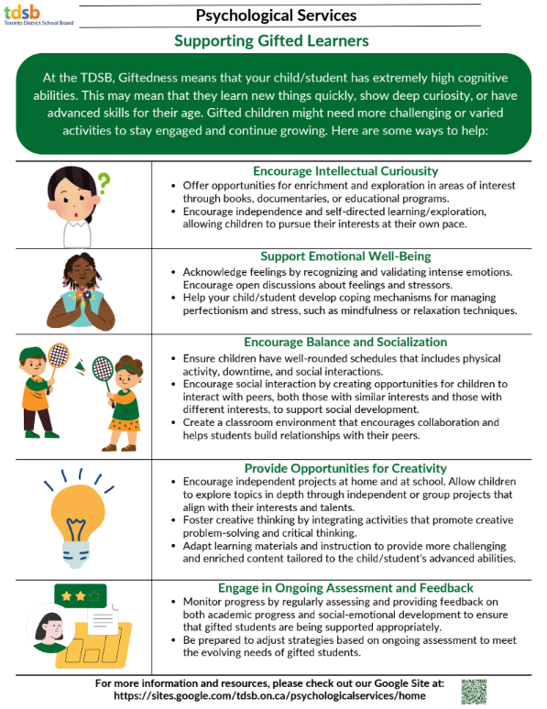
From Occupational Therapy/Physiotherapy Services
Text-only version

Toronto District School Board Occupational Therapy and Physiotherapy Services from the Special Education and Inclusion Department.

Building independence through simple tasks throughout the day, fosters self-esteem and pride. This process requires patience and dedicated time. And of course, practice, practice, practice.
Partner with your child’s school to encourage practice these skills at school as well!

Click here for tips on Building Independence for DRESSING, MEALTIMES and TOILETING
Developing fine motor skills - working the small muscles in your hands is crucial for building independence. Practice strengthening the muscles needed for everyday self-help tasks. Check out this handout to learn more about developing fine motor skills and hand strengthening activities.

Do you have a child who is developing eating skills with specific food preferences? Food sensitivities are common and some quick tips to consider can be found in this handout, Click here for Mealtime Solutions. Seeking medical attention may also be necessary to rule out any swallowing, stomach, digestive or dental issues.

Listen to a recording from one of our Virtual Office Hours on the topic of "Picky Eating and Healthy Habits"

Click on this link to steps to eating and help introduce new foods to your child.
Disclaimer: There may be websites linked from this site that are operated by organizations outside of the Toronto District School Board (TDSB). These organizations are solely responsible for the operation and information found on their sites. Linking from this site does not imply any endorsement of the organization or information found on the website. Any comments or inquiries regarding the linked websites should be directed to the organization operating the website.

