MARCH HIGHLIGHTS
- What’s New
- Important Dates
- Upcoming Virtual Webinar
- Summer Camp/Program Information
- Parent/Caregiver Guides
- TDSB Occupational/Physiotherapy Services
- Upcoming TDSB Virtual Fairs
- TDSB Psychological Services: The Adolescent Brain
- Speech and Language Pathology Services
- Deaf and Hard of Hearing Services
- ASD After School Social Skills
- World Autism Day: April 2, 2026
- World Hearing Day March 3, 2026
- World Down Syndrome Day: March 21, 2026
- Epilepsy Awareness Month and Purple Day for Epilepsy: March 26, 2026
- Easter Seals Awareness Month
- Neurodiversity Awareness Week: March 16-20
Important Dates
Elementary PA Days:
June 5, 2026
June 26, 2026
Secondary PA Days:
June 25, 2026
June 26, 2026
School Year Holidays (as per Ministry):
Mid-Winter Break: March 16-20, 2026
Good Friday: April 3, 2026
Easter Monday: April 6, 2026
Victoria Day: May 18, 2026

Upcoming TDSB Parent/Caregiver Sessions
TDSB Special Education and Inclusion Department offers a number of Parent/Caregiver sessions each month–please check for upcoming sessions: HERE.

Helping Your Child Navigate Everyday and Big School Changes
This session will help parents and caregivers understand how everyday changes (“little t”) and bigger school changes (“Big T”) can affect their child’s learning and well-being. We’ll share simple, practical ways schools support transitions and how families can help children feel more confident and prepared at home and at school.
🗓 Date: March 26th, 2026
⏰ Time: 11:30 a.m.
📍 Format: Virtual Webinar for Parents and Guardians
Summer Camp 2026
Here is a list of Summer Camps and Programs for your consideration.

Special Education and Inclusion Parent Guides
The Toronto District School Board (TDSB) provides many Special Education Guides for Parents which contain information about the supports, programs and services available for students with disabilities and special education needs in the TDSB.
If, after reading a guide, you require additional information, please reach out to the principal of your child’s school/your neighbourhood school. Videos and translated versions are also included within some of the guides.

Toronto District School Board Occupational Therapy and Physiotherapy Services from the Special Education and Inclusion Department.
OTPT Newsletter March 2026
It’s National Disability Awareness Month!
In recognition of Disability Awareness Month, we’re highlighting the empowering role of assistive and adaptive technology in supporting diversity. Accessibility tools and features on computers and iPads can support writing, reading, organization, and foster independence, engagement, communication and of course, play.
Learning to Type
For children who struggle with handwriting, using a computer for written tasks is very helpful. Remember, keyboarding takes practice. Click on the Learning To Type Handout for some free typing programs!

Strategies for Ipad Use in Schools
iPads and other tablets can support diverse learners by offering alternative ways to access technology—such as touch-based interaction, early learning apps, and tools for making choices or creating schedules. These devices are also platforms for developing communication skills. However, they can present challenges, including difficulties transitioning away from the device. Check out TDSB OT/PT Ipad Tips and Strategies for some easy helpful ideas.
Explore the TDSB Assistive Technology website - Professional Learning Series for a list of TDSB AT Software and digital learning resources with how-to tutorial videos.

Switch Use
Using a single switch can be a great way to help students access technology. There's fun software, like HelpKidzLearn, that offers simple games to teach essential skills such as switch access, making choices, timing and scanning, and early mouse skills. Connecting your switch to other electronic devices, such as blenders, fans, bubble machines is also a fun way to teach switch skills. If you'd like to explore switch use (and how to mount them) for your students, contact your TDSB OT/ PT. Here are some more ideas for Switch Access.

Have you heard of the F- WORDS in Childhood Disability? Click on the link below to find out!
Click here to listen to the Parent/ Caregiver session on “The F-words- Framework- a Strengths Based Approach to Child and Youth Development”

Disability and Sexuality
Talking to our kids about their bodies and sexual health can be a challenging conversation for many, but it's incredibly important for their safety. Providing children with accurate language and education about their bodies significantly reduces their vulnerability and promotes their overall well-being.
Click on our Parent/Caregiver Educator Session about Health Bodies for support and guidance on this vital topic.

From Occupational Therapy/Physiotherapy Services
Why "Crossing the Midline" Matters
Did you know that one of the most important milestones for your child’s physical development is crossing an invisible line?
Crossing the midline refers to the ability to reach across the middle of the body with the arms or legs to perform a task on the opposite side. It might look simple, but it’s actually a sign that the left and right sides of the brain are communicating effectively!
How it impacts your child:
- Gross Motor Skills: foundation for crawling, walking, and core stability. Without this skill, kids might "switch hands" halfway through a task instead of reaching across, which can affect coordination and balance.
- Fine Motor Skills: Crossing the midline allows a child to write across a whole page or cut with scissors without having to stop and shift their entire body.
- Self-Care: From zipping up a jacket to tying shoes, these activities depend on both hands working together across that centre line.
Strengthening this skill builds the neural pathways necessary for everything from playing sports to reading and writing. Check out this video on Crossing the Midline from TDSB Occupational Therapy and Physiotherapy Services for a deeper dive into how this works and some fun ways to practice at home!

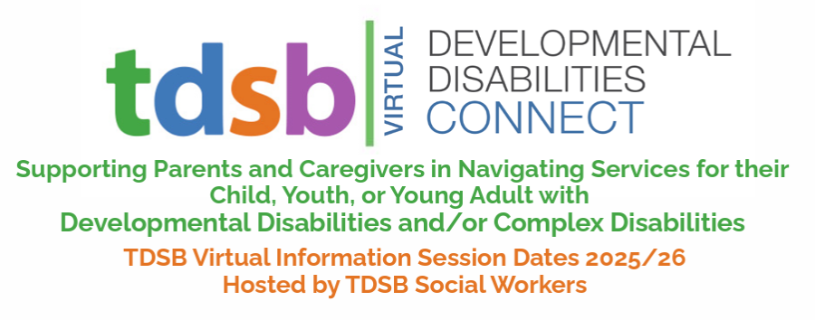
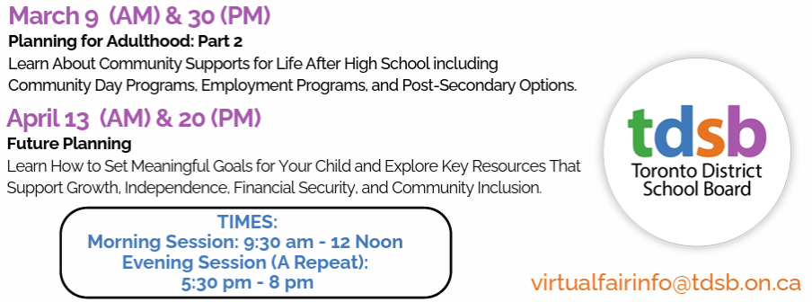
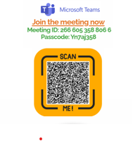
FROM TDSB PSYCHOLOGICAL SERVICES
What happens to the Brain in Adolescence?
During adolescence, the brain undergoes a dramatic transformation. The adolescent brain is highly adaptable, making it a prime time for learning and growth. Experiences during this period—positive or negative—can shape long-term mental health. Here are some of the changes that happen to the teenage brain that may shape the approaches that educators take with this age group. Educators and parents should keep in mind that these brain changes may lead to changes in teens’ behaviour. Educators may benefit by using techniques that focus on novelty and reward while also being sensitive to emotional and biological changes.
Remodeling & Refinement
- Synaptic pruning: The brain trims unused neural connections to make processing more efficient.
- Myelination: Nerve fibers get coated with myelin, speeding up communication between brain regions.
Prefrontal Cortex Development
This area—responsible for decision-making, impulse control, and planning—is one of the last to mature. Teens may struggle with long-term thinking or regulating emotions because this “executive center” is still under construction.

Limbic System Activation
The limbic system, which governs emotions and reward, develops earlier than the prefrontal cortex. This imbalance can lead to heightened emotional responses and risk-taking behaviour.
Dopamine & Reward Sensitivity
Dopamine levels spike, making teens more sensitive to rewards and novelty. This helps drive learning and exploration but can also increase susceptibility to peer pressure and thrill-seeking.
Sleep Shifts
Melatonin release happens later at night, making teens naturally inclined to stay up late and sleep in. This biological shift often clashes with early school schedules, contributing to sleep deprivation.

FROM SPEECH LANGUAGE PATHOLOGY (SLP) SERVICES
💛 Big Feelings, Calm Moments: March’s Story Spotlight
This March, our featured story is Anh's Anger by Gail Silver — a gentle and powerful book that helps children understand what anger feels like and how to calm their bodies and minds. Through Anh’s journey, children learn that big feelings are normal and that there are peaceful ways to work through them.
In this lesson, students will explore emotion vocabulary, self-regulation strategies, and ways to communicate their feelings with others.
At home, you can extend the learning by asking:
🌱 “What does anger feel like in your body?”
🌱 “What helps you feel calm when you’re upset?”
We hope that this story supports meaningful conversations about feelings and helps children build tools for calm and connection.
View the lesson here.

FROM DEAF AND HARD OF HEARING SERVICES
Classroom Acoustics: Small Changes, Big Impact
Did you know that in a typical classroom, a student with a hearing difference may miss up to 50% of what is said due to background noise and poor acoustics? While we can’t always renovate our buildings, we can make small, high-impact changes today to ensure every student has equal access to what is said in the classroom.
Top 5 Tips for a "Sound-Friendly" Classroom:
- Preferential Seating: Seat students away from high-noise areas like open doors, buzzing overhead projectors, or windows near busy streets. Positioning students near the teacher and/or centered to the whiteboard can significantly reduce listening fatigue.
- The “Tennis Ball” Trick: Hard surfaces create echoes. You can dampen “impact noise” by placing Chair Glides (specially sourced tennis balls) on the bottoms of chairs. Adding rugs or soft wall displays/student work also helps absorb sound.
- Manage Environmental Noise: Close doors and windows during direct instruction to block out hallway traffic. Be mindful of the “hum” from technology turning off equipment when not in use clears the “sound stage” for your voice.
- Use Visual Cues: Always pair spoken messages with visual aids like charts, outlines, or key terms on the board. This provides a “safety net” for students who may have missed a word due to background noise.
- Strategic Pausing: Give students extra time to process information. By pausing frequently and checking for understanding, you allow the student’s brain to “catch up” after working extra hard to filter out distractions.
Why it Matters: Good acoustics don’t just benefit Deaf and Hard of Hearing learners; they help all learners and can even protect teachers’ vocal health!

ASD After School Skills Development Program
Spring 2026 Session
The Spring Sessions of the ASD After School Skills Development Program will run from March 24 to June 9, 2026. The program is available to students in Grades 4-10 who have been diagnosed with Autism Spectrum Disorder. This program provides an opportunity for students to develop, build and enhance their social communication skills through weekly virtual sessions.
The parent information letter includes the link for registration for Grades 4-10 students with ASD.
The registration period will remain open until Friday, March 7, 2026. Please contact Special Education at SpecialEd@tdsb.on.ca with any questions.

March 3rd is World Hearing Day.
The World Health Organization hosts this day each year to promote awareness of hearing related challenges and the importance of hearing health care. The theme for 2026 is From Communities to Classroom: hearing care for all children!
To learn more about the positive impact of identification and management of ear and hearing issues visit: World Hearing Day 2026.


World Down Syndrome Day
World Down Syndrome Day WDSD is marked each year on March 21. The 21st day of the 3rd month signifies the triplication of the 21st chromosome which causes Down Syndrome.
TDSB staff and students are encouraged to participate in the ‘Lots of Socks’ campaign to raise awareness and create a single global voice advocating for the rights, inclusion, and well-being of people with Down Syndrome.
Engaging in the campaign includes wearing socks that are bold, colourful or mismatched, to stir up conversation and remind people that things that are different are still beautiful and wonderful!
Down-syndrome-fact-sheet (dsat.ca)

Epilepsy Awareness Month
Bring Epilepsy Education to your Classroom –
Celebrate Purple Day on March 26, 2026
Epilepsy Awareness Month is here, and Purple Day on March 26 is a global movement to increase awareness about epilepsy. Spread awareness in fun and creative ways - encourage students to wear purple, create purple art, bake purple treats, learn about epilepsy and show their Purple Spirit! Check out the Epilepsy Awareness Classroom Kits provided by Epilepsy Toronto, created to bring awareness to your school all month long; including lesson plans for K-12, printable posters, morning announcements and more! Let's show support for the 1 in 100 people living with epilepsy—together, we can make a difference! Share examples of your class' Purple Spirit on Instagram or X using #PurpleSpirit2026.
Easter Seals Month:
Easter Seals Ontario dedicates March to raising awareness and support for children and youth with physical disabilities through Easter Seals Month. This year, they are shining a light on the stories, perspectives, and contributions of individuals with physical disabilities. Join this March to help create a more inclusive, accessible, and equitable society for children and youth with physical disabilities at MarchIsEasterSealsMonth.org

Neurodiversity Celebration Week - March 16-20
Neurodiversity Celebration Week is a worldwide initiative that challenges stereotypes and misconceptions about neurological differences. It aims to transform how neurodivergent individuals are perceived and supported by providing schools, universities, organizations, and others around the world with the opportunity to recognize the many skills and talents of neurodivergent individuals, while creating more inclusive and equitable cultures that celebrate differences and empower every individual.
For more information and resources for schools, please visit the neurodiversity week website.

