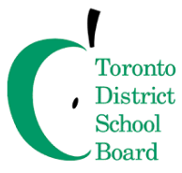

March 16, 2021

Dear Child Care Colleagues,

As you may be aware, the TDSB is in the process of outfitting all schools with institutional grade HEPA filters, for every occupied classroom that is in use by the school, including portables and Wellness rooms. This roll out of HEPA filters is for school-occupied classrooms and does not include exclusive child care space or shared spaces that are not school instructional classrooms during the core day.

We understand that some child care programs are interested in using HEPA filters as well. To support this, the TDSB has been able to work with Austin Air, our HEPA filter vendor, who will extend TDSB pricing ($679.99) to any child care interested in purchasing these units. Child care programs that wish to purchase their own HEPA filters may contact [josh@austinair.ca](mailto:josh@austinair.ca) for more information.

For more information about the roll out of HEPA filters and ventilation in TDSB schools, please visit our [Ventilation webpage](https://www.tdsb.on.ca/In-Person-Learning/Health-and-Safety/Ventilation).

Sincerely,

**Child Care Services**

**Toronto District School Board**

Tel: 416-394-2072

[ccs@tdsb.on.ca](mailto:ccs@tdsb.on.ca)

