JUNE HIGHLIGHTS
PAGE 1
- Important Dates
- Special Education and Inclusion Parent Guides
- Kids Explain Intersectionality
- TDSB Speech Language Pathology Services
- TDSB Blind and Low Vision Services
- TDSB Deaf and Hard of Hearing Services
- June is Deafblind Awareness Month
- TDSB Occupational and Physiotherapy Services
- Strategies for the Summer
- The Purple Walk: June 20, 2026
- Mindfulness for Kids
- Digital Storytelling: HA Halbert JPS
- Durham College Access and Support Transition Event

Important Dates
Elementary PA Days:
June 5, 2026
June 26, 2026
Secondary PA Days:
June 25, 2026
June 26, 2026
2026-2027 School Year:
First Day of School: September 8, 2026
Special Education and Inclusion Parent Guides
The Toronto District School Board (TDSB) provides many Special Education Guides for Parents which contain information about the supports, programs and services available for students with disabilities and special education needs in the TDSB.
If, after reading the guides, you require additional information, please reach out to the principal of your child’s school/your neighbourhood school.
Videos and translated versions are included within some of the guides.
KIDS EXPLAIN INTERSECTIONALITY

TDSB Speech Language Pathology (SLP) Services
🥞 Flipping Into Stories: June’s Wordless Wonder
This June, we’re enjoying Pancakes for Breakfast by Tomie dePaola — a charming wordless picture book that tells a complete story through pictures alone!
Without any written words, children are invited to become the storytellers. As they follow the character’s journey to make pancakes, students practice describing, predicting, and retelling events in their own words.
At home, you can join in the storytelling by:
🥞 Asking your child, “What’s happening here?” as you look at pictures together
🥞 Encouraging them to tell the story in their own way
🥞 Talking about cooking or baking experiences you’ve shared
✨ We hope this story inspires imagination, conversation, and confidence as your child discovers the joy of telling their own stories
Pancakes for Breakfast: View Lesson HERE

Blind and Low Vision Services
Summer is Coming! Supporting Students with a Visual Impairment
As summer approaches, families and educators may be considering ways to support continued learning for students who are blind or have low vision. Summer provides valuable opportunities to build skills through meaningful, real-life experiences. Here are some ideas to get you started:
Toronto Public Library provides accessible materials such as audiobooks and braille through CELA, along with summer reading programs and interactive activities, all available at your local branch.
Exploring local environments such as High Park or the Toronto Islands allows students to engage in sensory experiences, including sound exploration, tactile interaction with natural materials, and real-world orientation and mobility practice.
Simple home activities, such as daily living tasks, sensory play, and listening to audiobooks or music, can also support ongoing development. Summer learning can be both meaningful and enjoyable, supporting students in building real-world understanding that connects to their classroom learning once back at school.
CNIB Lake Joe is an accessible camp in Muskoka designed for individuals with a visual impairment. It offers programs for children, youth, and families, with activities such as swimming, boating, arts, and outdoor exploration, while promoting independence and confidence.
CNIB SCORE Scholars is a program for youth with a visual impairment ages 16–21 preparing for post-secondary education or employment. It focuses on goal setting, independence, and life skills, with opportunities to explore Toronto and participate in a campus-based experience in the Greater Toronto Area.
City of Toronto Parks and Recreation (CampTO and summer programs) offers a range of activities across community centres and parks, including arts, sports, and swimming. These programs support social skills, routines, and physical activity, and families can inquire about available accommodations for children with a visual impairment

Deaf and Hard of Hearing Services
Summer Support for Deaf and Hard of Hearing Students
Summer can be a wonderful time to rest, reconnect, and enjoy everyday moments together. It is also an important time for Deaf and Hard of Hearing children and teens to continue building language, listening, and communication skills. While school routines may pause, learning and development continue through daily life. Conversations at home, reading together, storytelling, visits with family/ friends, neighbourhood walks, errands, and shared routines can all support growth in meaningful ways. These opportunities do not need to be formal or costly to make a difference. Simple, consistent moments of connection and communication are valuable.
For D/HH students who use hearing aids, cochlear implants, or other hearing technology, summer is also an important time to keep wearing devices consistently. Hearing technology helps children stay connected to language, conversation, environmental sounds, and social interactions throughout the day. Wearing hearing technology all day, every day during waking hours supports continued access to communication and helps maintain routines that make the return to school easier in the fall. Summer is not a break from language development, so ongoing access continues to matter.
Summer can also be a good time to check in with an audiologist or hearing healthcare provider if needed. A follow-up appointment can help make sure devices are working well, settings are up to date, and earmolds or other equipment still fit properly before September begins. Because summer often brings heat, sweat, outdoor play, and water activities, families may also want to take extra care to protect hearing technology. Safe storage, regular listening checks, drying kits or dehumidifiers, and keeping devices away from water unless approved for that use can help keep equipment in good working order.
As summer moves along, it can also be helpful to begin thinking ahead to the return to school. When children and teens come back in the fall with strong routines for wearing and caring for their hearing technology, continued access to language and communication, and growing confidence in expressing their needs, they are better prepared for a smooth transition back to learning. Small steps over the summer can help D/HH learners return to school feeling confident, connected, and ready for a strong start.
The Deaf and Hard of Hearing Team wishes all families a safe, happy, and restful summer, and looks forward to supporting students again in the fall.

June is Deafblind Awareness Month
The month of June serves as a platform for raising awareness about the distinctive challenges encountered by individuals with an identified dual sensory loss.
Deafblindness, a combination of sight and hearing loss to varying degrees, profoundly impacts communication, mobility, learning, and access to information. Those who are deafblind often rely on alternative communication methods, such as tactile sign language, braille, or assistive technology.
In Ontario, students are identified as deafblind when neither sense can fully compensate for the loss of the other, meaning that neither can be used as a primary means of learning. They have unique and complex needs, requiring services and supports which are different from those designed exclusively for individuals who are blind or have low vision, are Deaf or hard of hearing, or have multiple exceptionalities. When both vision and hearing challenges exist, attention and consideration must be given to both senses simultaneously. Environmental adaptations, positioning adjustments, and modifications in information delivery are needed.
To learn more about the local deafblind community, please visit Deafblind Awareness Month | DBCS.

Toronto District School Board Occupational Therapy and Physiotherapy Services from the Special Education and Inclusion Department.
OT/PT Newsletter June 2026
June Marks a Season of Transition. As the current school year comes to a close, June is a natural time to reflect—and to look ahead. The upcoming changes in September—new classrooms, new teachers, unfamiliar peers, or even a new school—can stir up a mix of emotions. Click here to explore the TDSB OT/PT Transitions Resources available to support this change.
With summer on its way, now's the perfect time to introduce new life skills and chores to your child's routine. Summer offers a great opportunity to break down tasks, learn new responsibilities, and practice these domestic skills in various areas of the home. Click here for some suggested life skill activities for youth and teens with special needs.
Have you heard of the “Be the Change” project? The "Be the Change Project" aims to deepen students' understanding of diversity, equity, inclusion, anti-oppression, and anti-ableism, while also fostering a compassionate school community that connects students across all programs. Click on this link to browse all the amazing school projects from 2024/25.
Click on this link to listen and dive into our OT/PT Summer Toolkit to help you support your mental well-being, build on your child's strengths, and prepare for the new school year!

Strategies for the Summer!
Summer is an opportunity to enjoy the beautiful weather and engage in special activities.
(Please share this resource with families)
🌞 Summer Tips for Students with Autism
Keep a Routine (But Allow Flexibility)
- Maintain consistent wake-up, meal, and bedtime routines.
- Use visual schedules or daily planners to create a predictable day.
- Build in free time and allow for adjustments when needed to reduce anxiety.
Plan Structured Activities
- Consider camp programs that cater to neurodiverse kids
- Include daily movement, such as walks, dancing, or sensory play outdoors.
Create a Sensory-Friendly Environment
- Offer a calm corner at home with favorite calming tools
- Consider sensory friendly activities in the community
Use Visual Supports
- Make a calendar of summer events.
- Use first-then boards to show what’s next (“First breakfast, then park”).
- Prepare for new experiences with social stories or visual guides.

The Purple Walk: June 20, 2026
Mark your calendars! On Saturday, June 20, 2026, the Purple Walk takes over College Park once again for Epilepsy Toronto’s most spirited day of the year.
Now in its 12th year, the Purple Walk is more than a 5K walk through downtown Toronto; it’s a powerful celebration of community, courage, and connection. It’s where stories are shared, milestones are honoured, and hundreds of walkers come together to prove that the epilepsy community is strong, visible, and unstoppable.
Each year, more than 600 participants come together to raise funds to support life-changing programs, services, and advocacy for thousands of individuals living with epilepsy and their families.

Psychological Services
Mindfulness for Kids
Mindfulness is not just meditation! It is any practice that helps children slow down, tune in, and feel more in control of their thoughts and feelings. By practicing simple techniques like mindful breathing, body scans, and gratitude reflections, kids can develop stronger focus, emotional awareness, and resilience.
- Bringing mindfulness into the classroom can look like:
- Starting the day with a quiet moment of breath or reflection
- Encouraging students to notice and name how they feel in their body
- Grounding: Get children to notice 5 things they can see, 4 things they can hear, three things they can feel, 2 things they can smell/touch, and 1 positive affirmation
- Using movement and sensory activities to ground their attention
- Celebrating stillness, curiosity, and kindness
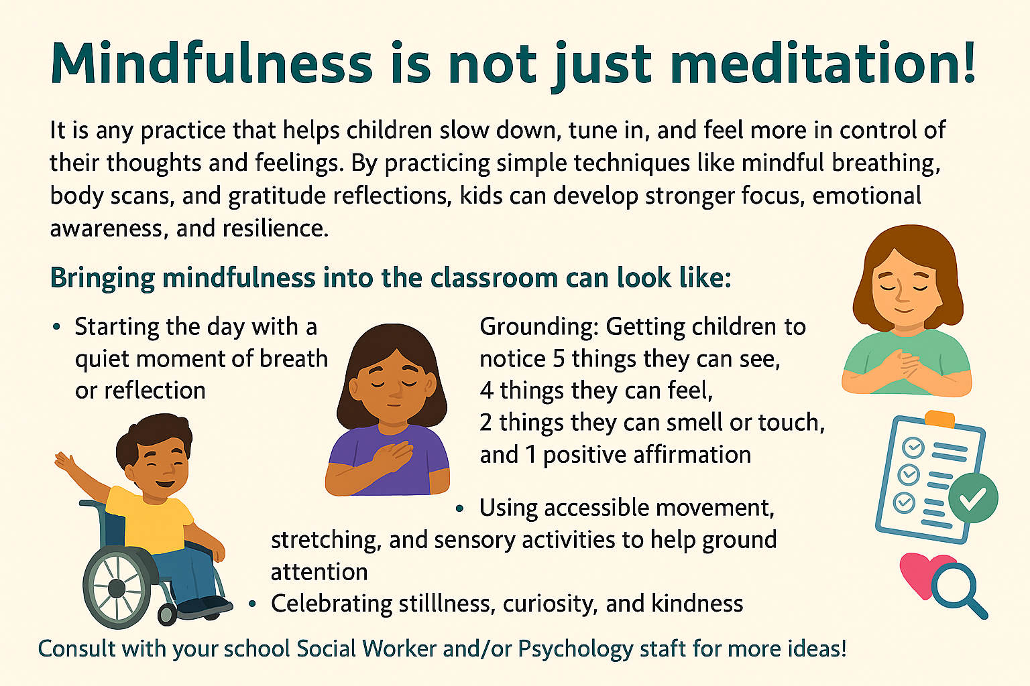

Digital Storytelling at H. A. Halbert JPS
H.A. Halbert JPS (FOS18) hosted a Digital Storytelling Viewing & Listening Party on April 28, 2026 for students, families and staff. This event celebrated incredible digital storytelling work from students in the Primary and Junior Autism Intensive Support Programs and the Be the Change student leaders. The digital projects focused on themes of identity, social inclusion, disability awareness and community.

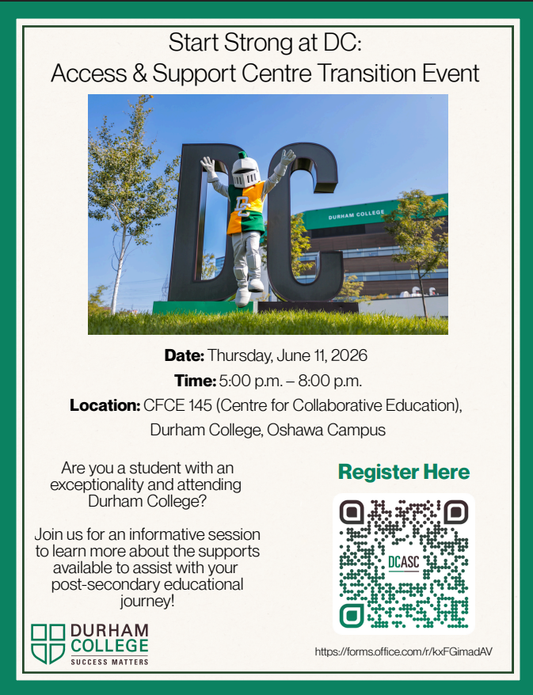
CLICK HERE

Access and Support Centre (ASC)
Frequently Asked Questions
Question: What is the Access and Support Centre?
Answer: The Access and Support Centre (ASC) supports all students who require academic accommodations for exceptionalities and other protected grounds under the Ontario Human Rights Code (OHRC). Students with exceptionalities (i.e., learning disability/ADHD, mental health diagnosis, physical injuries/illness/disabilities, such as deaf/hard of hearing or blind/low vision) or who are experiencing impacts to their studies due to creed, family, or other OHRC protected grounds are welcome to connect with the ASC for an individualized Access Plan based on their unique needs. Other services provided by the ASC include coaching on self-advocacy, assistive technology support and training, and counselling.
Question: I am a student with an exceptionality and/or had an Individual Educational Plan (IEP) in high school; where do I go if I require support?
Answer: Contact the ASC at asc@duhamcollege.ca or visit https://durhamcollege.ca/asc/contact/

Question: Do I need to have an IEP to register and receive supports through the Access and Support Centre?
Answer: No, students do not need to have an IEP to register. The ASC provides support to students identified with an exceptionality or who are temporarily impacted by physical, medical, mental health, or learning barriers.
Question: When should I reach out to the Access and Support Centre?
Answer: Students can register with ASC as soon as they accept their program offer. ASC encourages students to register prior to the start of classes to set up their supports. However, students can connect with the ASC anytime throughout the year.
Question: How do I register with the Access and Support Centre, and what kind of documentation do I need?
Answer: The steps to register and supporting documentation required can be found on the ASC website. Website link: https://durhamcollege.ca/asc/register/
Question: How can I contact ASC?
Answer: Students are welcome to call, email, or stop by in person to ask any questions. Oshawa Campus - Gordon Willey Building - SW116, Phone: 905.721.3123
Email: asc@durhamcollege.ca
Whitby Campus - Don Lovisa Building - Room 180, Phone: 905.721.2000 Ext. 4141 Email: whitbyasc@durhamcollege.ca

