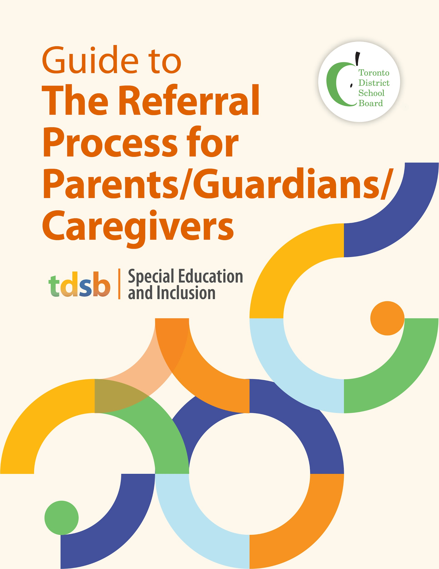

Guiding Principle
The Toronto District School Board (TDSB) is committed to providing equitable access to learning opportunities for all students. This includes our ongoing commitment to human rights, equity, anti-racism, anti-oppression, and anti-ableism. This commitment is aligned with the foundation of the TDSB Equity Policy and underpins all programming across all grade levels.

Parents as Partners
As parents/guardians/caregivers, you know your child best. You know your child’s strengths, abilities, needs, and areas for improvement. It is critical that you provide information about your child and participate in decisions that affect your child’s education. We hope that this guide will help you better understand the Referral Process for special education programs and services in the TDSB. Should you require additional information about the process, please contact your child’s teacher or principal.

Concerns About My Child
You or your child’s teacher may identify that your child is having difficulty learning. Your child’s teacher(s) may contact you to discuss their findings or you may reach out to the teacher(s) and principal with concerns you may have about your child. You may choose to involve a friend, family member or advocate at any time, and with your permission, school staff can communicate with them as well.

The Referral Process
The steps in the referral process include:
- Development of an Individual Learning Plan (ILP);
- In-School Team (IST) meetings with school-based staff;
- School Support Team (SST) meetings with school-based staff; Special Education and Inclusion and/or Professional Support Services staff;
- Identification, Placement and Review Committee (IPRC).

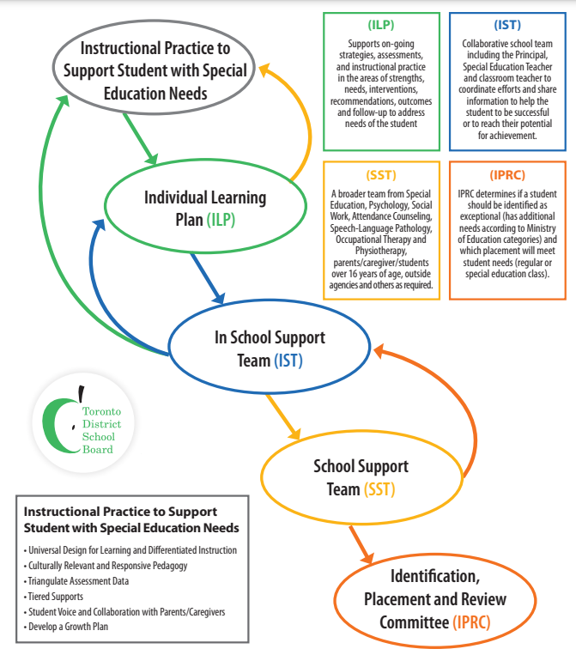

Supporting Students Through an Individual Learning Plan (ILP)
An Individual Learning Plan (ILP) is the first step in supporting students who may not be meeting their achievement goals. Developing an ILP involves parents/guardians/caregivers and the student (as appropriate) as much as possible, to allow an opportunity for student voice and agency and also parent partnership.

The ILP is a tool used by the teacher to detail, track and monitor on-going assessments, instructional strategies, interventions, recommendations, and follow-up strategies to address the needs of the student. The ILP allows the teacher to compile detailed and specific information about the student’s current abilities, strengths, and areas for growth in relation to their identity and lived experiences, based on the learning conditions provided by the teacher. It is implemented and assessed for 6-8 weeks to determine next steps. The teacher(s) continuously assesses stud​e​n​t progress, adjusts the ILP as necessary, and evaluates and reports progress to parents and appropriate staff.

If the planned interventions are successful, staff and the student will continue with those interventions. If the student is still experiencing challenges, the steps below are followed.

Referral to the In-School Support Team (IST)
If focussed interventions have been implemented but the student continues to experience challenges, the teacher(s) would present the student to the In-School Support Team (IST) where additional interventions or assistance required to support the teacher(s) and student are explored.
IST meetings are a proactive problem-solving opportunity to support programming and success for the academic, physical, social and emotional strengths and needs of the student. The school team works together to support the student, the parent, and the teacher(s) through planning and implementing supports and strategies, with regular monitoring of progress.

Members of the In-School Support Team
The members of the IST consists of a core group of individuals, including:
- the student’s teacher(s);
- the principal or vice-principal;
- the school special education teacher (if available);
- a guidance teacher/counsellor (especially at the secondary level);
- the student success teacher (especially at the secondary level).

In-School Support Team Process
The teacher(s) will have gathered information and reviewed assessment material (e.g., diagnostic assessments, recent work samples, direct observation), and recorded strategies implemented on the Individual Learning Profile (ILP) and share this information at the IST meeting. The IST will review the ILP, on-going strategies, assessments and instructional practice in the areas of strengths, needs, interventions, recommendations, outcomes and follow-up to support the student.
After the IST meeting, the teacher will work with the student to ensure additional strategies suggested by the IST are implemented. The teacher will reach out to additional staff for support as needed, including the Special Education and Inclusion Consultant for support.
Most students’ needs can be addressed by the IST. However, if the strategies recommended by the IST have been implemented with little success, the IST can refer the student to the School Support Team (SST). This process is outlined below.

Referral to the School Support Team (SST)
Only if it has been determined after careful deliberation with the In-School Support Team, the teacher and the principal that the strategies are all being implemented with limited success, the student may be presented to the School Support Team (SST).

Members of the School Support Team
In addition to the school staff listed above, this team offers additional knowledge by including:
- psychologists;
- social workers;
- attendance counsellors;
- speech-language pathologists;
- occupational therapists;
- physiotherapists; and
- parents or caregivers and students over 16 years of age.

Parents are the most valuable partner in a child’s education. Although parental attendance at the IST and SST meetings is not mandatory, you are strongly encouraged to attend. Parents who cannot attend will be informed about any plan of action recommended at the meeting to address their child’s needs. Students over 16 years of age are also encouraged to participate and must be consulted. Students 18 years of age or older must be invited to attend the SST and give permission for their personal information to be shared with their parents.
When a member of the TDSB’s Professional Support Services (PSS) such as a psychologist or social worker attends the meeting, parental permission is required if the student is to be discussed by name.
The SST may recommend PSS support, a return to the IST or a referral to the Identification, Placement and Review Committee (IPRC).

Identification, Placement and Review Committee (IPRC)
If further assessment is completed and results indicate a need for identification, an IPRC meeting is held to determine whether the student should be identified as exceptional and to determine appropriate placement. For more information on IPRCs, please refer to the Guide to Identification, Placement and Review Committee for Parents/Guardian/Caregivers.

Additional Information
- Ministry of Education’s Special Education in Ontario Kindergarten to Grade 12
- TDSB’s Guide to the Identification, Placement and Review Committee (IPRC) for Parents/Guardians/Caregivers
- TDSB’s Guide to the Individual Education Plan (IEP) for Parents/Guardians/Caregivers
- TDSB’s Special Education Plan

