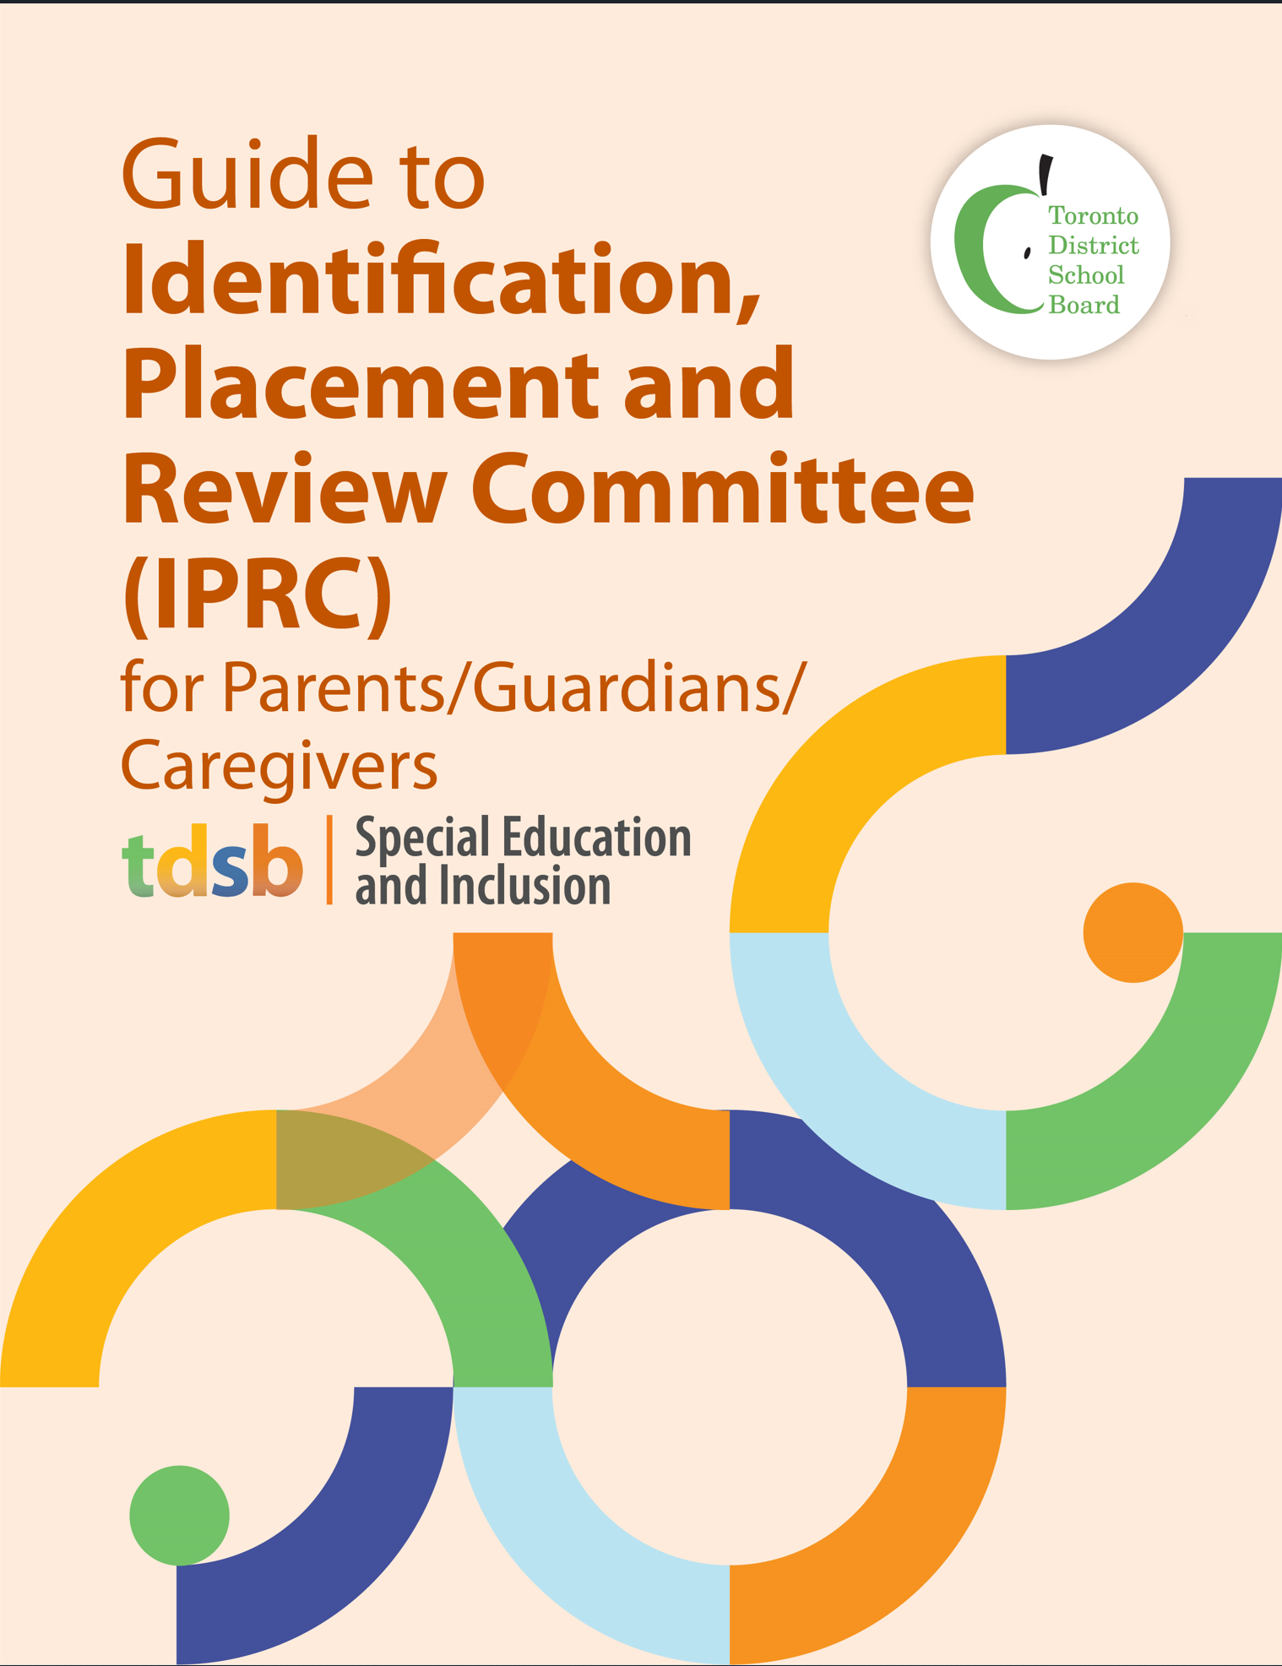
Guide to Identification, Placement and Review Committees (IPRC) for Parents/Guardians/Caregivers

Purpose of this Guide
This guide for parents/guardians/caregivers explains the role of and processes involving Identification, Placement and Review Committees (IPRCs), outlines your rights as a parent and describes how your partnership is key to ensuring the appropriate decisions are made for your child.

Guiding Principles
The Toronto District School Board (TDSB) is committed to student achievement and well being. We recognize that students develop and learn in different ways, and that some students require special education programs and services to meet their needs. TDSB staff are committed to working collaboratively with parents/guardians/caregivers and students in a respectful and transparent way, and value your partnership. We encourage you to approach your child’s teachers and principal to engage in discussions about your child in an ongoing manner. The sharing of information between yourself and school staff is critical to ensuring the success of your child.

The Special Education Department, in collaboration with all staff, is committed to providing equitable access to learning opportunities for all students. This includes our ongoing commitment to human rights, anti-oppression, equity, anti-ableism, and anti-racism. This commitment is aligned with the foundation of the TDSB Equity Policy and underpins all programming across all grade levels.

Identification, Placement and Review Committee (IPRC)
School boards must provide special education programs and services to students who are formally identified as “exceptional pupils.” This is set out in the Education Act. An exceptional pupil is a student who has behavioural, communicational, intellectual, physical or multiple exceptionalities that require them to have a special education program or service.

All school boards are required to establish Identification, Placement and Review Committees (IPRCs), composed of at least three people, one of whom must be a school principal or a school board supervisory officer.
The IPRC:
- decides if the student should be identified as exceptional;
- identifies areas of the student’s exceptionality,
- decides an appropriate placement for the student; and
- reviews a student’s identification and placement at least once in each school year.

Referral to an Identification, Placement and Review Committee
A student’s assessment findings may suggest to the School Support Team (SST) that referral to an Identification, Placement and Review Committee (IPRC) would be appropriate for possible identification as an exceptional pupil. A recommendation to consider a student for an IPRC requires careful analysis of the effectiveness of instructional interventions that have been tried with the student and thorough understanding of the student’s strengths and needs.
IPRC requests are made by the school principal on recommendation of the SST or following a written request by parents.
What to Expect at an IPRC Meeting
Parents/guardians/caregivers and students over 16 years of age are encouraged to attend and take part in the IPRC meeting, although an IPRC may proceed if the parents are not present.

Where will the meeting take place?
IPRC meetings are held virtually or in person at a TDSB school site.

Who attends the IPRC meeting?
An IPRC must have at least three people, one of whom must be a Principal or Board Supervisory Officer. Other members of the committee may include:
- Parents/guardians/caregivers and student (students are welcome to attend as appropriate and students 16 or over are entitled to attend and participate in discussions);
- Principal/Supervisory Officer of the child’s school;
- The teacher(s) who know the student best, other resource people such as special education staff, Board support staff, or an agency representative who may provide further information or clarification;
- Additional resource people if needed, arranged by the school principal or parents (e.g., Special Education and/or Professional Support Services staff such as a special education coordinator or a psychologist);
- An interpreter (when needed);
- An advocate, if invited by the parents, to provide support or speak on their behalf.

Parents unable to attend the meeting should:
- contact the principal of your child’s school to arrange an alternate date or time; or
- let the principal know that you cannot attend. The principal will contact you following the meeting to let you know the committee’s decisions, and will forward to you, for your consideration, a written statement about the IPRC’s decision concerning identification and placement.

What information will the IPRC consider?
Prior to the IPRC, the school principal will ensure that the results of any assessments have been discussed with parents. You will receive a written copy of any information about your child that the Chair of the IPRC has received such as assessment results or a summary of information. In advance of the IPRC, parents may also provide any written information they want the committee to review and consider.

Format of the IPRC Meeting
During the IPRC Meeting
The Chair of the IPRC will start the meeting by welcoming parents and introducing the committee members. Parents will then have the opportunity to introduce themselves and their guests. The IPRC Chair will outline the purpose of the meeting.
The committee will:
- review all relevant information about the student;
- consider an educational assessment of your child;
- consider a health or psychological assessment of your child, if required;
- consider any information you or your child (if over 16) submit; and
- discuss your child’s strengths and needs.

The committee may discuss any proposal made about special education programs or services for your child.

Once all the information has been presented to the committee and considered, the IPRC will decide:
- if your child should be identified as exceptional. If yes, the committee must indicate the Category and Definition of Exceptionality according to those provided by Ontario’s Ministry of Education;
- the most appropriate placement for your child who has been identified as exceptional.

The Category and Exceptionality Table and Placement Decision Table below highlight information on the category and definition of each exceptionality, and placement options.

Category and Definition of Exceptionality
Physical
Blind and Low Vision | A condition of partial or total impairment of sight or vision that even with correction affects educational performance adversely.
Physical Disability | A condition of such severe physical limitation or deficiency as to require special assistance in learning situations to provide the opportunity for educational achievement equivalent to that of students without exceptionalities who are of the same age or development level.
Communication
Autism | A severe learning disorder that is characterized by:  - disturbances in rate of educational development; ability to relate to the environment; mobility; perception, speech, and language;  - lack of the representational symbolic behaviour that precedes language.
Deaf & Hard of Hearing | An impairment characterized by deficits in language and speech development because of a diminished or non-existent auditory response to sound.
Learning Disability | One of a number of neurodevelopmental disorders that persistently and significantly has an impact on the ability to learn and use academic and other skills and that affects the ability to perceive or process verbal or non-verbal information in an effective and accurate manner in students who have assessed intellectual abilities that are at least in the average range and results in:  - academic underachievement that is inconsistent with the intellectual abilities of the student (which are at least in the average range), and/or  - academic achievement that can be maintained by the student only with extremely high levels of effort and/or with additional support.
Language Impairment | A learning disorder characterized by an impairment in comprehension and/or the use of verbal communication or the written or other symbol system of communication, which may be associated with neurological, psychological, physical, or sensory factors, and which may:  - involve one or more of the form, content, and function of language in communication; and  - include one or more of: language delay; dysfluency; voice and articulation development, which may or may not be organically or functionally based.
Speech Impairment | A disorder in language formulation that may be associated with neurological, psychological, physical, or sensory factors; that involves perceptual motor aspects of transmitting oral messages; and that may be characterized by impairment in articulation, rhythm, and stress.
Intellectual
Developmental Disability | A severe learning disorder characterized by:  - an inability to profit from a special education program for students with mild intellectual disabilities because of slow intellectual development;  - an ability to profit from a special education program that is designed to accommodate slow intellectual development;  - a limited potential for academic learning, independent social adjustment, and economic self-support.
Giftedness | An unusually advanced degree of general intellectual ability that requires differentiated learning experiences of a depth and breadth beyond those normally provided in the regular school program to satisfy the level of educational potential indicated.
Mild Intellectual Disability | A learning disorder characterized by:  - an ability to profit educationally within a regular class with the aid of considerable curriculum modification and support services;  - an inability to profit educationally within a regular class because of slow intellectual development;  - a potential for academic learning, independent social adjustment, and economic self-support.
Behaviour
Behaviour | A learning disorder characterized by specific behaviour problems over such a period of time, and to such a marked degree, and of such a nature, as to adversely affect educational performance and that may be accompanied by one or more of the following:  - an inability to build or to maintain interpersonal relationships;  - excessive fears or anxieties;  - a tendency to compulsive reaction;  - an inability to learn that cannot be traced to intellectual, sensory, or other health factors, or any combination.
Multiple Exceptionalities
Multiple Exceptionalities | A combination of learning or other disorders, impairments, or physical disabilities that is of such a nature as to require, for educational achievement, the services of one or more teachers holding qualifications in special education and the provision of support services appropriate for such disorders, impairments, or disabilities.
Retrieved from Ministry of Education Categories of Exceptionality.

Ontario Regulation 181/98 requires school boards to consider placing exceptional students into regular classes before considering placement in a special education class. If the committee decides that a special education placement is required, it will first consider whether placement in a regular class with appropriate special education support will best meet your child’s needs.

Placement Decision
Placement | Definition
Regular Classroom with Indirect Service | The student is placed in a regular class for the entire day, and the teacher receives specialized consultative services.
Regular Classroom with Resource Assistance  (Kindergarten to Grade 8) | The student is placed in a regular class for most or all of the day and receives specialized instruction, individually or in a small group, within the regular classroom from a qualified special education teacher.
Regular Classroom with Withdrawal Assistance | The student is placed in a regular class and receives instruction outside the regular classroom for part of the school day from a special education teacher.
Partially Integrated Class | The student is placed in a special education class and integrated within a regular class for part of the school day (a minimum of one instructional period daily) based on readiness.
Fully Self-Contained Special Education Class (Congregated Sites) | The student is in a self-contained special education class for the entire school day.

Other options could exist to meet your child’s needs. You can contact the principal of your child’s school to explore options such as a Provincial School for students who are Deaf, blind, or deafblind, or a Demonstration School for students who have severe learning disabilities.
Statement of Decision
A Statement of Decision will be completed at each IPRC meeting. If placement in a special education class is decided, the IPRC must cite the reasons in its written Statement of Decision. The IPRC’s written Statement of Decision will include:
- your child’s strengths and needs;
- the categories and definitions of any exceptionalities identified;
- the IPRC’s description of the student’s strengths and needs;
- the IPRC’s placement decision;
- the IPRC’s recommendations regarding a special education program and special education services; and
- if the IPRC has decided that the student should be placed in a special education class, the reasons for that decision.

Parents will be asked to sign the IPRC Statement of Decision, indicating agreement with the identification and placement decisions made by the IPRC. The Statement of Decision may be signed at the IPRC meeting, or taken home for further consideration and then returned to the child’s school principal.

After the IPRC Meeting
If the IPRC has identified your child as exceptional and you have agreed with the IPRC identification and placement decision, the principal of the school where the special education program will be provided will be notified of the need to develop an Individual Education Plan (IEP) for your child.

An IEP must be developed within 30 days of the start of a special education placement for all students identified by an IPRC. Development of the IEP will be done in collaboration with parents/guardians/caregivers and your child, where appropriate.

For more information on the IEP, please refer to the TDSB’s Parent/Guardian/Caregiver Guide to the Individual Education Program (IEP).

What can parents do if they disagree with the IPRC decision?
If you do not agree with either the identification or placement decision made by the IPRC, you may:
- within 15 days of receipt of the decision, request that the IPRC hold a second meeting to discuss your concerns and revisit the decisions; or
- within 30 days of receipt of the decision, file a notice of appeal with the school board.

If you do not consent to the IPRC decision and you do not appeal it, the Board will instruct the principal to implement the IPRC decision.

How do parents appeal an IPRC decision?
If you disagree with the IPRC’s identification of your child as exceptional or with the placement decision of the IPRC, you may, within the timelines described above, give written notification of your intention to appeal the decision. This written notice should be addressed to:
Director and Secretary Treasurer
Toronto District School Board
5050 Yonge Street
Toronto, ON M2N 5N8
The notice of appeal must:
• indicate the decision(s) with which you disagree; and
• include a statement that sets out your reasons for disagreeing.

What happens in the appeal process?
The TDSB will establish a Special Education Appeal Board (SEAB) to hear your appeal. The appeal board will be composed of three persons who have no prior knowledge of the matter under appeal. As a parent/guardian/caregiver, you select one of the appeal board’s members.

The chair of the appeal board will arrange a meeting to take place at a convenient time and place, but no later than 30 days after he or she has been selected (unless parents and board both provide written consent to a later date).

The appeal board will receive the material reviewed by the IPRC and may interview any persons who may be able to contribute information about the matter under appeal. You and your child (if he or she is 16 years old or over), are entitled to be present at and to participate in all discussions.

The appeal board must make its recommendation within 3 days of the meeting ending. It may:
- agree with the IPRC and recommend that the decision be implemented; or
- disagree with the IPRC and make a recommendation to the board about your child’s identification or placement, or both.

How are the appeal board’s recommendations implemented?
The appeal board will report its recommendations in writing to you and to the school board, providing the reasons for its recommendations.

Within 30 days of receiving the appeal board’s written statement, the school board will decide what action it will take with respect to the recommendations. Please note that school boards are not required to follow the appeal board’s recommendation.

You may accept the decision of the school board, or you may appeal to a Special Education Tribunal. You may request a hearing by writing to the Secretary of the Special Education Tribunal. Information about making an application to the tribunal will be included
with the appeal board’s decision.

IPRC Annual Reviews
Once a child has been placed in a Special Education Program, can the placement be reviewed?
An IPRC meeting is held annually for each student with special needs to determine if the support as originally outlined is still needed. Parents can also request a review any time after a student has been in a special education program for three months.

What does a Review IPRC consider and decide?
The IPRC conducting the review will consider the same kinds of information that were originally considered by the previous IPRC. It will also consider the progress your child
has made in the special education program. The IPRC will review the placement and identification decisions and decide whether they should be continued or whether a different decision should now be made.

Resolving IPRC Concerns
Parents are encouraged to contact the school principal with questions about IPRC procedures, and to clarify decisions of the IPRC. If this does not resolve the issue, parents can launch a formal appeal as outlined above.

Additional Information:
- The Ministry of Education’s Identifying Students with Special Education Needs
- The Ministry of Education’s Individual Education Plan (IEP) A Resource Guide
- TDSB Individual Education Plan (IEP) Guide for Parents/Guardians/Caregivers
- TDSB Special Education Plan

