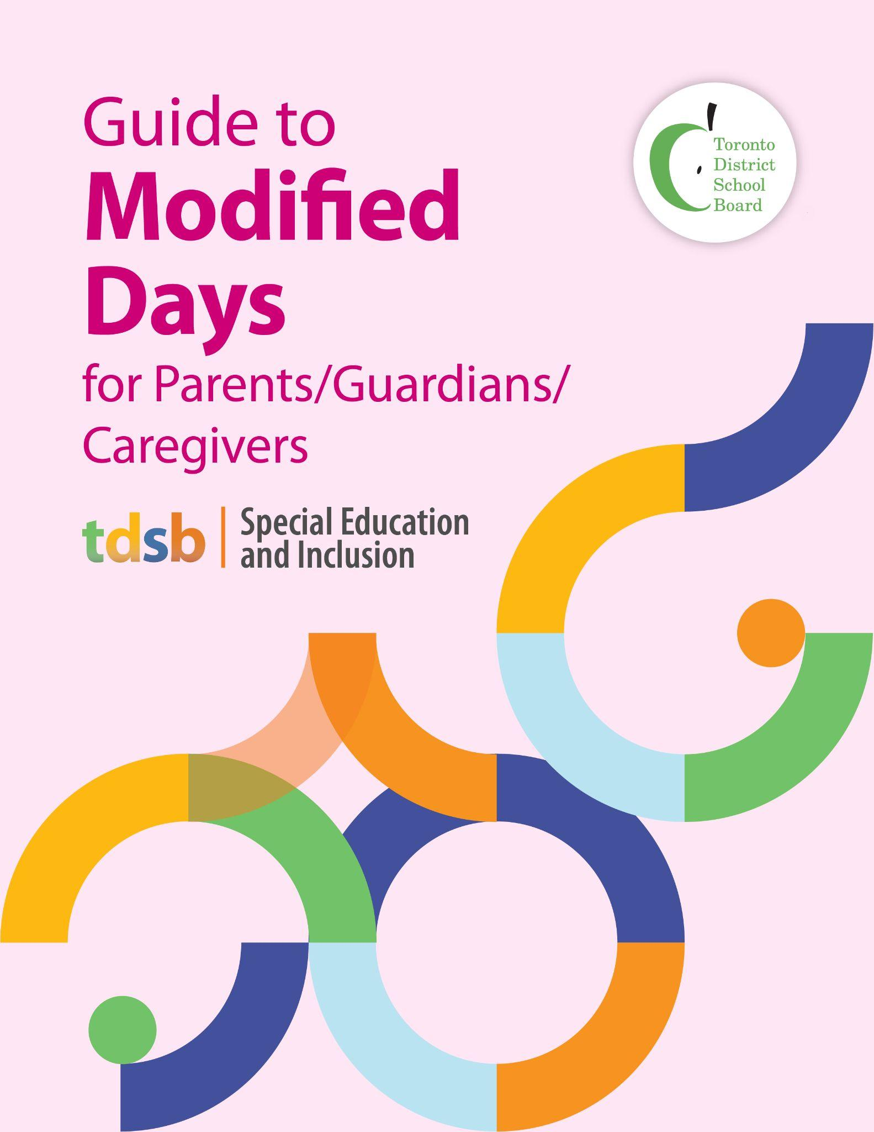
If you wish to receive this guide in large print, or another format, please contact the principal of your child’s school. Through the principal for your child’s school, you can also access translators to assist with the interpretation of this guide.
If, after reading this guide, you require more information, please contact the principal for your child’s school.
Throughout this guide, the word “parents” includes guardians and caregivers.

Purpose of This Guide
This guide for parents/guardians/caregivers explains what a modified school day schedule is, why it might be used, how it can support your child’s educational needs, and how your ongoing partnership is key to ensuring the appropriate decisions are made for your child. Staff in the Toronto District School Board (TDSB) are committed to ensuring that each student is welcomed and included every day in TDSB schools, and to each student having equitable access to learning opportunities each and every day.
Guiding Principles
The TDSB is committed to student achievement and well being. We recognize that students develop and learn in different ways, and that some students require special education programs and services to meet their needs. TDSB staff are committed to working collaboratively with parents/legal guardians and students in a respectful and transparent way, and value your partnership. We encourage you to approach your child’s teachers and principal to engage in discussions about your child on an ongoing basis. The sharing of information between yourself and school staff is critical to ensuring the success of your child.

What is a Modified School Day?
A modified school day is a temporary adjustment to your child’s school day or week schedule. This could include reducing the number of hours or the number of days your child attends school. It is only used in specific situations where a full school day is not currently appropriate due to your child’s unique needs.
NOTE: It is not a TDSB practice to put students on a modified day schedule/or ask that they stay home because they are not toilet trained or due to staff absences.

When is a Modified School Day Considered?
- Specific Needs Exist: Your child may have medical, therapeutic, behavioral, or social-emotional needs that require them to attend school on a part-time basis for a period of time.

- All Other Supports Have Been Tried: In rare circumstances, and as a short-term measure, a student may be placed on a modified school day only after all other available interventions and supports have been exhausted.

What is the Process for Implementing a Modified School Day?
- Collaboration: The school principal will work with you, teachers, and other professionals to develop a plan tailored to your child’s needs.

- Monitoring: The school principal will check in regularly to assess your child’s progress and ensure they are on track to return to a full school day as quickly as possible.

- Support: If you have questions or need assistance, please contact the principal of your child’s school. If you need additional support, please contact the superintendent of your child’s school.

How is My Child’s Absence Marked When on a Modified Day?
Students who are on a modified day schedule are not marked as ‘Absent’. There are specific attendance codes that are used for students on a modified day schedule. Specifically, Attendance Code N590 Non Instructional Time is used for students receiving ABA/IBI therapy, and Attendance Code N560 Non Instructional Time is used for all other students on a modified day schedule.

How does the TDSB support students on a modified day to return/transition to full-time learning as soon as possible?

- TDSB collects information on a monthly basis from principals to monitor any students on a modified day schedule in TDSB schools.
- School teams work with the family and central staff as needed to develop transition/return to school full time plans for students on a modified day schedule.
- School superintendents follow up with school principals each month to ensure that students are transitioning back to school full-time as quickly as possible.

How Can You Support Your Child?
- Stay Engaged: Communicate regularly with the school and share your insights about your child’s needs and progress.

- Ask Questions: If anything is unclear, don’t hesitate to ask for more information or clarification.

- Encourage Your Child: Help your child adjust to the new schedule and encourage them to stay positive and focused on their goals.

Key Points to Understand
- Not Punitive: A modified school day is not a disciplinary measure. It is a supportive strategy to help your child succeed with a plan for transitioning back to full-time learning.
- Attendance: Student absences due to modified days do not impact student attendance records and are not reflected on the report card.
- Temporary Solution: This is a short-term plan with the goal of returning your child to a full school day as soon as possible.
- Parental/Legal Guardian Involvement: Your input is essential. The school will work closely with you to ensure the plan meets your child’s needs.
- Impact on the Family: Staff recognize that a modified schedule may affect the family’s daily responsibilities and will take this into account when making decisions.

Additional Information and Resources

TDSB Special Education and Inclusion
Legislation and policy/program memoranda pertaining to students with special education needs
Steps to Address Questions and Concerns

