7-8 Literacy Read Aloud

Tuesday, September 22
Learning Goal:  - I can listen to, and understand the story.  - I can interpret texts using implied ideas to support my interpretations. | Task:  - Click on the image of the book cover and the link that comes up.  - Listen to the book “The Best Part of Me” by Wendy Ewald.  - What is the best part of you? Write a paragraph that you could share with your virtual class when you meet them.  Video: https://www.youtube.com/watch?v=XiYXGhce1X4 | 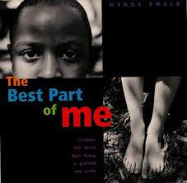

Wednesday, September 23
Learning Goal:  - I can listen to, and understand the story.  - I can use images in the book to help make meaning.  - I can summarize important ideas from a text. | Task:  - Click on the image of the book cover and the link that comes up.  - Listen to the book “Curiosity: The Story of a Mars Rover” by Markus Motum  - On a Google doc, answer the following questions: What surprised you about Curiosity? Would you travel to Mars if you were given the chance? Why or why not?  Video: https://www.youtube.com/watch?v=5EGGy67uPSQ | 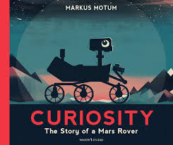

Thursday, September 24
Learning Goal:  - I can listen to, and understand the story.  - I can analyze the text to evaluate the impact of the message. | Task:  - Click on the image and the link that comes up.  - Listen to the article “Why Is Biodiversity Important?” from Wonderopolis.  - Complete a 3-2-1 reflection:  - What are 3 things you learned from the article?  - What are 2 questions that you still have about biodiversity?  - What is 1 action that you can take, big or small, to protect biodiversity locally or globally? | Video: https://wonderopolis.org/wonder/why-is-biodiversity-important

Friday, September 25
Learning Goal:  - I can listen to, and understand the story.  - I can connect ideas from texts to my own knowledge, experiences and the world around me. | Task:  - Click on the image of the book cover and the link that comes up.  - Listen to the book “Video Games Save the World” by Heather E. Schwartz  - Thinking about all the ways video games have solved problems and helped people around the world, consider one current issue (e.g., climate change, COVID-19, social injustice) and how video games could help address that issue. Write one or two paragraphs to explain your thinking. | 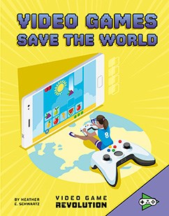  Link: https://www.mycapstonelibrary.com/login/?isbn=9781543571585&sqs=a52d0a786e117b72c4070277316403e3f540248302beeacca9d91a4599ad82f4
Reference: Adapted and used with permission from Peel District School Board Online School Resources and District School Board of Niagara Virtual School Resources:
https://sites.google.com/pdsb.net/pdsb-online-school/elementary-students/september-17
http://virtual.dsbn.org/-/assignments/

