Grades 4-6 Literacy Tasks

Tuesday, September 22
Learning Goal:  - I can listen to, and understand the story.  - I can understand and think about the stated and implied ideas from the texts  - I can demonstrate an understanding of the information and ideas in the text by summarizing and explaining the character’s experience. | Task:  - Click on the image of the book cover  - Listen to the story Look Up with Me Neil De Grasse Tyson: by Jennifer Berne  - What are the things that you like to do or discover? Write about an idea, an experience or different things you like to make or tinker with? Think about what you like that you could share with your virtual class when you meet them.  Video: https://youtu.be/Sm4j8a5widQ | 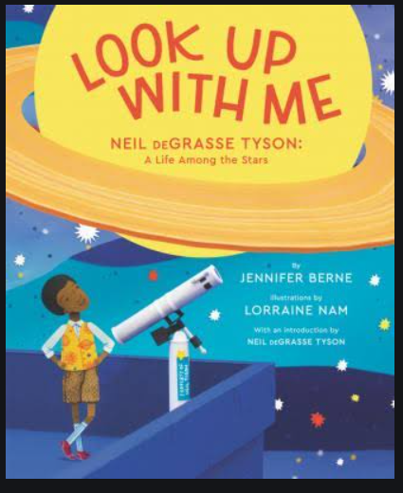

Wednesday, September 23
Learning Goal:  - I can identify word choice and sentence length as elements of style in the author’s writing..  - I can read and understand most words in the story.  - I can predict the meaning of and solve unfamiliar words using semantic (meaning) cues, syntactic (language structure), graphophonic (phonological and graphic) cues | Task:  - Click on the image of the book cover  - Listen to the story The Word Collector: by Peter H. Reynolds  - What do you collect? What if you were to collect words like Jerome? What words would you collect? What if they were all mixed up? Write a poem, a song, or a paragraph of your favourite words.  Video: https://youtu.be/NJ_MUs_MCkg | 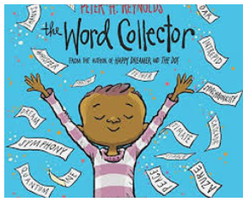

Thursday, September 24
Learning Goal:  - I can listen to, and understand the story.  - I can identify this as a story about a person's life as a biography.  - I can connect to the experiences of the character's life.  - I can identify word choice and sentence length as elements of style in the author’s writing. | Task:  - Click on the image of the book cover  - Listen to the story Radiant Child: byJavaka Steptoe  - What are some of the different experiences that Basquiat had in his childhood that shaped him as a person?  - Why do you think he liked to draw?  - Do you like to draw? What does art mean to you? How do you see art on the street?  - Draw what you see in your neighbourhood.  Video: https://youtu.be/_fi-ItvQONg | 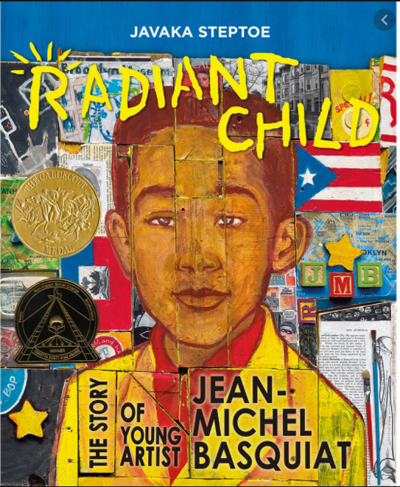

Friday, September 25
Learning Goal:  - I can listen to, and understand the story.  - I can understand how the different points of the view of the characters make meaning of the story.  - I can connect to the points of view of the characters in the story with my own life experience. | Task:  - Click on the image of the book cover  - Listen to the story The Proudest Blue by Ibtihaj Muhammad and S.K. Ali  - What do you think about Mama’s advice,”Don’t carry around hurtful words that others say. Drop them. They are not yours to keep. They belong to the people who said them.”  - What are some positive words that you think will be important to bring to your classmates when you meet them? Make a list and be ready to share them with your classmates. | 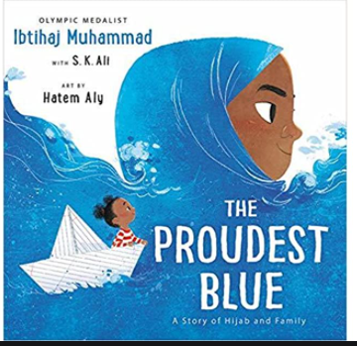  Video: https://youtu.be/XJiTBmfy-LI

Reference: Adapted and used with permission from Peel District School Board Online School Resources: <https://sites.google.com/pdsb.net/pdsb-online-school/elementary-students/september-14>

