PROGRESS OF CONSTRUCTION WORK

- Installation of re-bar, formwork, and concrete pouring of foundation walls are completed.
- Demolition at existing Kindergarten Rm 118 in progress.
- Backfilling of foundation walls are completed.
- Ground floor mechanical and electrical rough ins are completed.

UPCOMING WORK
- Site services installation
- Excavation for the Garbage Enclosure
- The sidewalk widening and the driveway.
- Second floor core slab
- Second floor mechanical and electrical rough ins are in progress

COMMUNITY UPDATE:
In October 2023, there will be construction on French Ave to remove and expand the sidewalk due to some concrete deficiencies.
CONSTRUCTION PROGRESS PHOTOS:
- Site Services Progress
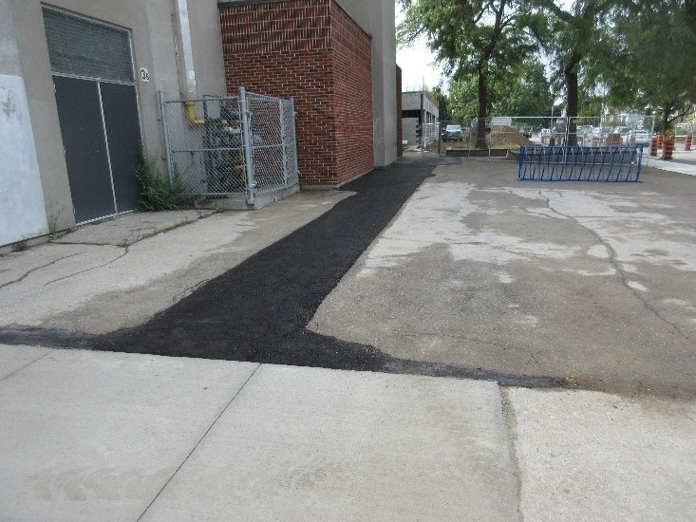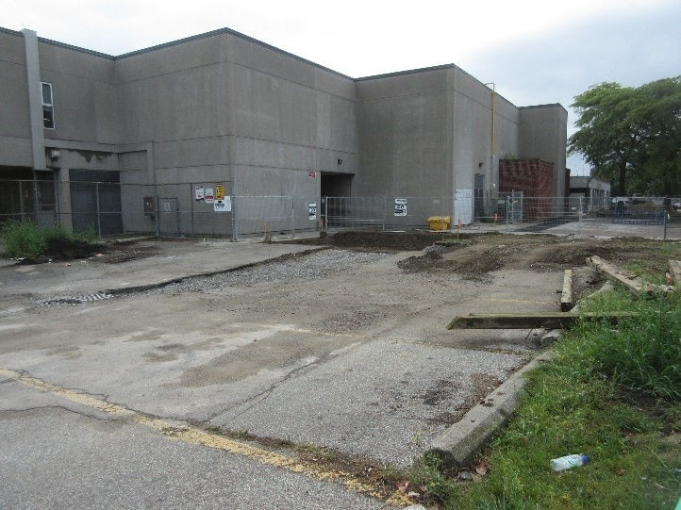

- West elevation from French Ave

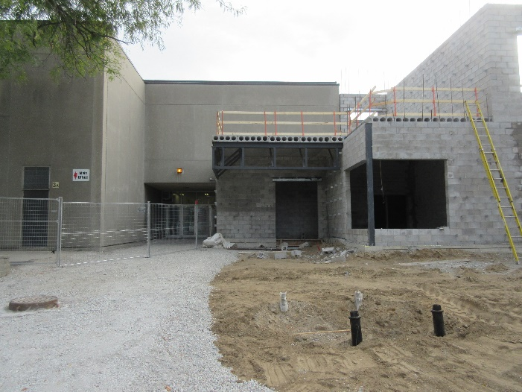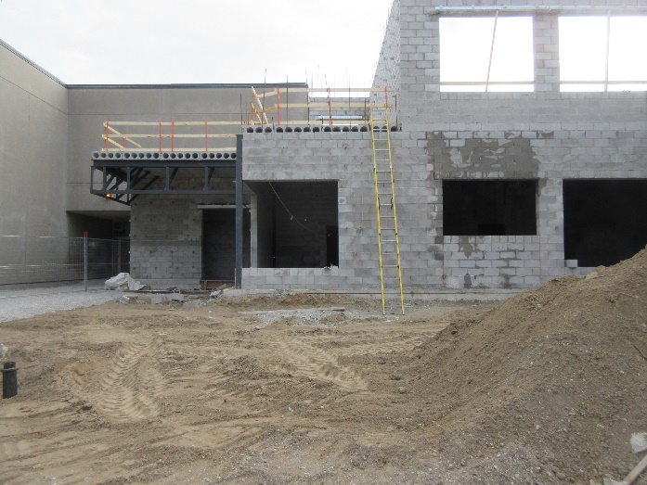
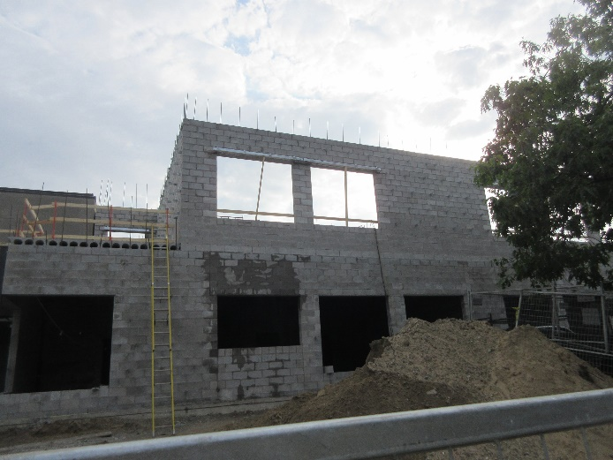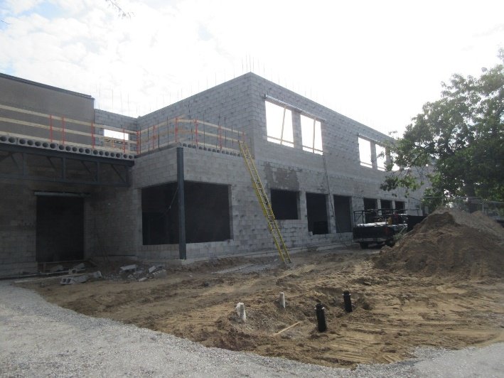
- South elevation from the school field
