PROGRESS OF CONSTRUCTION WORK

- Sidewalk widening is completed.
- Site services installation is in progress.
- Masonry work on the second floor is in progress
- Concrete pad for garbage enclosure (west parking lot) poured.

UPCOMING WORK

- Windows installation.
- Roof Top Unit.
- Brick veneer.
- Continue interior masonry walls
- Continue mechanical and electrical rough-in

COMMUNITY UPDATE:
There will be construction in the west parking lot in November 2023 to replace the old asphalt, as well as the roof build-in beginning on November 13 and continuing until the first week of December, causing unpleasant smells.
CONSTRUCTION PROGRESS PHOTOS:
- Sidewalk progress

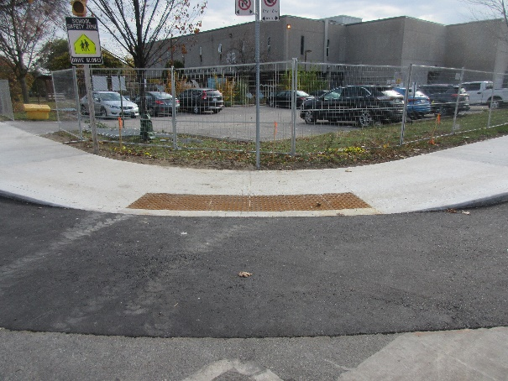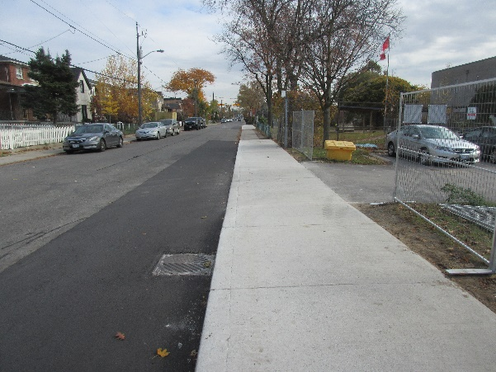

- West elevation from French Ave

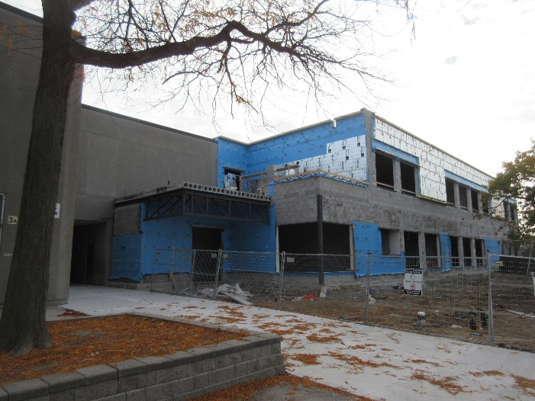

- South elevation from the school field
