PROGRESS OF CONSTRUCTION WORK

- The site servicing work is nearly complete.
- The slab-on-grade is in place.
- Back-filling of the exterior foundation wall is mostly complete, waterproofing of the exterior foundation wall has been completed.

UPCOMING WORK
- The parking lot to be paved.
- Second slab to be erected.
- Second floor walls to be erected.

COMMUNITY UPDATE:
Municipal work is to occur across Dennis Ave starting mid of October and taking two to three weeks depending on the weather.
CONSTRUCTION PROGRESS PHOTOS:
- Site Looking Southwest
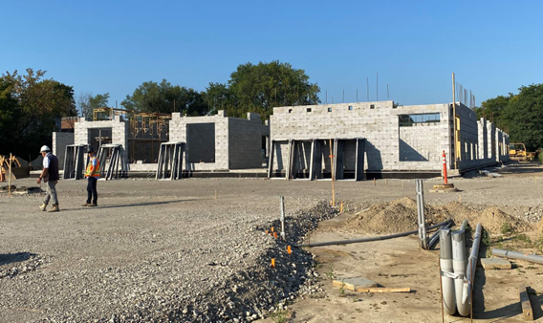

- Southwest corner Looking Northeast
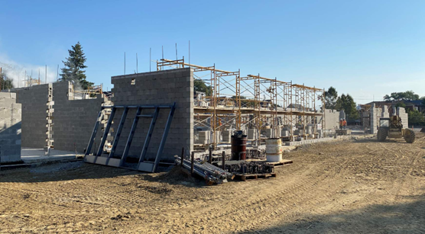

- Southwest of School looking Northwest
