DECEMBER HIGHLIGHTS
- Important Dates, Special Education and Inclusion Parent/Legal Guardian Guides, Useful Videos
- TDSB Speech Language Pathology Services: Let’s Read Together
- TDSB Occupational Therapy and Physical Therapy Services
- TDSB Deaf and Hard of Hearing Services: Supporting students with a hearing difference in the classroom
- TDSB Blind and Low Vision Services: The Centre for Equitable Library Access (CELA)
- International Day of Persons with Disabilities
- How Working Memory Affects Math
- Supporting the Grade 8-9 Transition for Students with Special Education Needs
- TDSB Social Work: Developmental Disabilities Virtual Connect
Special Education and Inclusion Parent/Legal Guardian Guides
The Toronto District School Board (TDSB) provides many Special Education Guides for Parent/Legal Guardian which contain information about the supports, programs and services available for students with disabilities and special education needs in the TDSB. If, after reading a guide, you require additional information, please reach out to the principal of your child’s school/your neighbourhood school. Videos are included within some of the guides.

Important Dates
Elementary PD Days:
January 16, 2026
February 13, 2026
June 5, 2026
June 26, 2026
Secondary PD Days:
January 29, 2026
February 13, 2026
June 25, 2026
June 26, 2026
School Year Holidays (as per Ministry):
Winter Break: December 22, 2025 – January 2, 2026
Family Day: February 16, 2026
Mid-Winter Break: March 16-20, 2026
Good Friday: April 3, 2026
Easter Monday: April 6, 2026
Victoria Day: May 18, 2026

CHECK IT OUT!
Disability Parenting: How to Build Kids’ Independence with Universal Design for Learning

Handwriting
Handwriting and fine motor skill development is multifaceted. If your child is struggling with handwriting, this quick video from Occupational Therapy and Physiotherapy Services provides strategies to promote better pencil grasp.

From Speech Language Pathology (SLP) Services
Let’s Read Together! 📚✨
This December, our featured lesson is centered on Awasis and the World-Famous Bannock by Dallas Hunt and Amanda Strong. This delightful story follows Awasis as he navigates a fun and heartwarming adventure in making bannock, highlighting themes of creativity, problem-solving, and cultural pride. Students will explore new vocabulary, storytelling skills, and communication strategies through the lesson.
At home, you can continue the fun by asking your child to share their own favorite recipes, try making a simple treat together, or talk about a time they felt proud of a personal creation.
Please view the lesson here.

From Occupational Therapy/Physiotherapy Services
Text-only version
Dressing and Toileting Skills at Home
This month, we are focusing on dressing and toileting - two important skills that help build independence and confidence.
Building independence with these tasks takes time and a lot of patience but when the skill is achieved there is so much reward! A new skill is acquired and self-esteem and pride are built. So valuable for their growing minds and spirits.
Dressing Skills
Click here for a handout on building independence that includes tips to help with dressing skills at home including:
- where to start
- considerations with type of clothing
- addressing sensory needs
- use of visual aids.

Click here for dressing and toileting visual sequence examples to use at home or try using drawings or words to make your own!

These activities of daily living skills develop gradually and can be supported through play, practice, and positive reinforcement.
See the links to the right for activity ideas and ways to encourage progress at home.
Build these tips into your day and make sure to have some FUN!

Toilet training: Timing, Tips, and Troubleshooting
Click here to watch a video from TDSB OT/PT services for more information on toilet training.
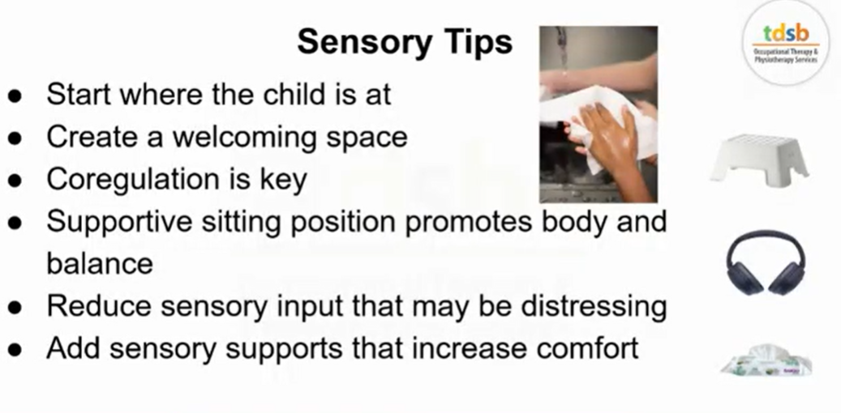
From Deaf and Hard of Hearing Services
Supporting students with a hearing differences in the classroom:
We know every child learns best when they feel supported. Here are some of the ways teachers and staff create a classroom that helps children with hearing differences thrive:
- Good seating placement: Your child will be seated where they can best see and hear the teacher and classmates.
- Reducing background noise: Teachers close doors, turn off fans or music, and encourage one person speaking at a time.
- Clear sight lines: We make sure your child can always see the teacher, support staff and classmates.
- Face-to-face communication: Teachers avoid talking while writing on the board so your child doesn’t miss important information.
- Checking understanding: Teachers pause often to make sure your child has caught the main ideas.
- Visual supports: Written instructions, diagrams, or captions are added to reinforce spoken and\or signed information.
- Flexible timing: Extra time is provided when listening or processing information takes longer.
- Written instructions: Assignments and directions are given in both spoken/ sign and written forms.
- Re-explaining key ideas: Teachers repeat or rephrase instructions or questions to support comprehension.
- Technology support: Personal hearing technology and Remote Microphone systems, and/or sign language supports are consistently used to give clear access.
Accommodations like these ensure your child has equal access to learning and feels included every day. If you ever have questions or notice something that could make learning easier for your child, please speak with your child’s teacher and/or principal.

Blind and Low Vision Services
Accessing CELA Library for Students with a Visual Impairment
The Centre for Equitable Library Access (CELA) provides free access to thousands of accessible books and reading materials for students with print disabilities, including those with visual impairments. Formats include audio, braille, e-text, and accessible PDF.
If a student has a qualifying print disability, families can register directly through CELA or the BLV Team can support with setting up an account. Materials can be borrowed online and downloaded to computers, tablets, Victor Readers, refreshable braille displays and more.
If you would like support accessing CELA or would like help identifying materials for a student with a visual impairment please reach out to the Itinerant Blind/Low Vision Teacher supporting your school.
International Day of Persons with Disabilities
Each year on December 3, we join the global community in recognising the
International Day of Persons with Disabilities (IDPD). The day was proclaimed by
the United Nations in 1992 and serves to raise awareness of the rights, dignity and full participation of persons with disabilities.
We invite you to reflect on how we can support meaningful leadership opportunities in our learning spaces, promote inclusive practices, and ensure that every learner feels valued and empowered.
As a school community, consider hosting a “Voices of Inclusion” wall or digital board where students can share ways they make their classroom or school more accessible and welcoming for all learners.
Learn more at the UN website

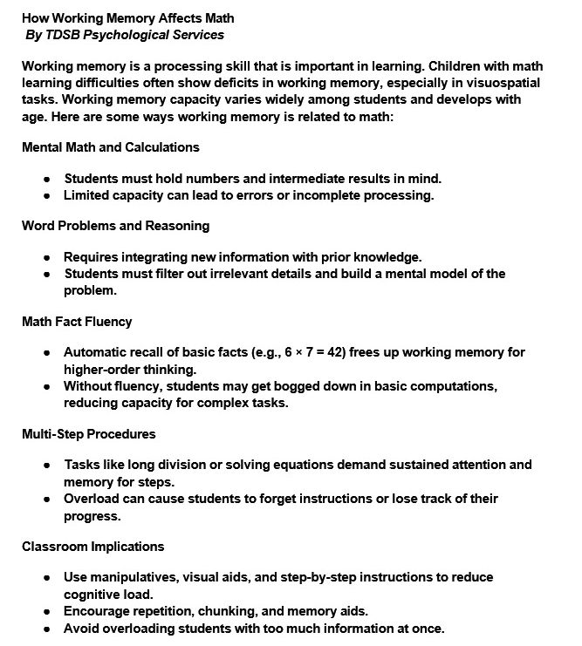

Supporting the Grade 8 to 9 Transition for Students with Special Education Needs
A virtual session for Parents/Caregivers
Please choose ONE of the following sessions to attend:
SESSION 1:
December 11th, 2025 at 11:30 AM - 12:30 PM
Register HERE or click the QR code.

SESSION 2:
January 15th, 2026 at 6:30 PM - 7:30 PM
Register HERE or click the QR code.


PARENT Session Gr 8-9 Transitions Supporting the Grade 8 to 9 Transition for Students with Special Education Needs A virtual session for Parents/Caregivers Please choose ONE of the following sessions to attend:
SESSION 1: December 11th, 2025 at 11:30 AM - 12:30 PM Register here: https://events.teams.microsoft.com/event/289a0406-07a2-4cad-bcf1-8b366506027d@c4d72 b4d-8155-4a90-9155-7705148c41ca

SESSION 2: January 15th, 2026 at 6:30 PM - 7:30 PM Register here: https://events.teams.microsoft.com/event/30889bc0-8e43-4ed2-82ed-2a7a65792197@c4d7 2b4d-8155-4a90-9155-7705148c41ca

