COMMUNITY UPDATE:
TDSB is pleased to announce that the new Bloor Collegiate Institute and ALPHA II Alternative school has opened to students for the 2025/26 school year.
The building achieved occupancy in Spring 2025, and the school was moved from Central Tech over the summer, welcoming students into the new facility in September 2025. This year also marks the 100th anniversary of Bloor Collegiate Institute.
Minor construction activities may be ongoing around the school but are being scheduled to minimize disruption to the school’s day-to-day operations.

PROGRESS OF CONSTRUCTION WORK
- Contract is substantially performed.
- Overall deficiency rectification by the General Contractor is ongoing.

CONSTRUCTION PROGRESS PHOTOS:
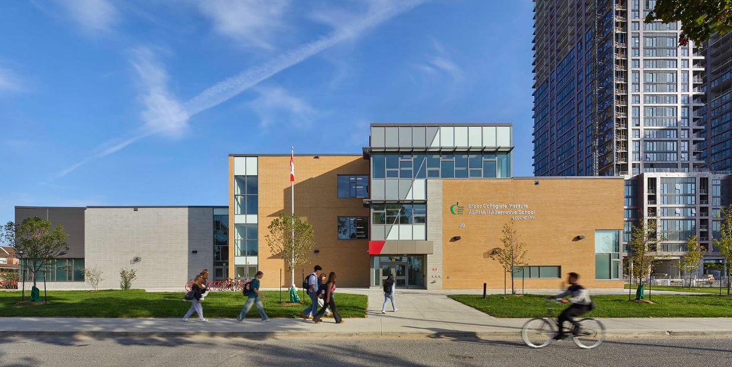
Exterior photo of the South main school entrance.

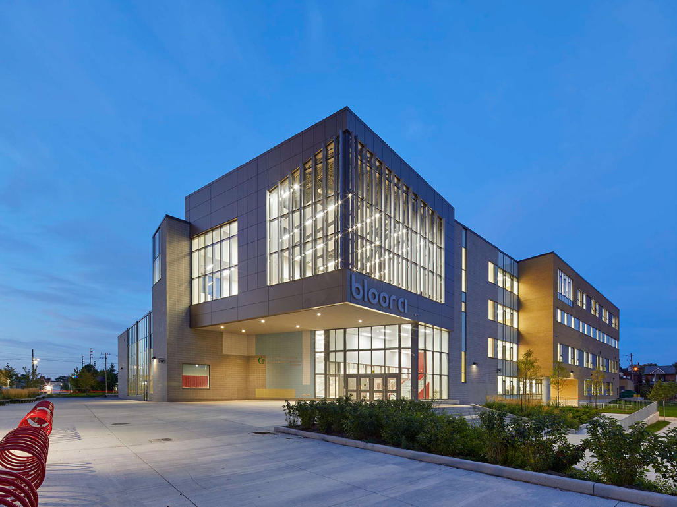
Exterior photo of the North school entrance.

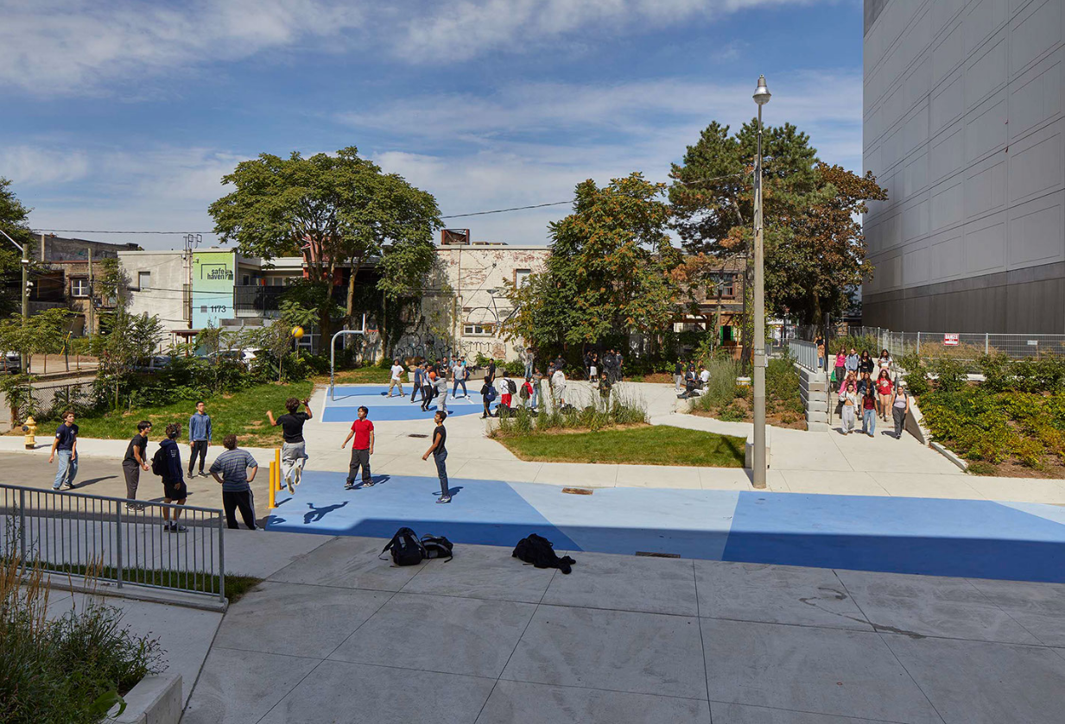
Picture of the outdoor basketball area to the North and the path to Bloor St.

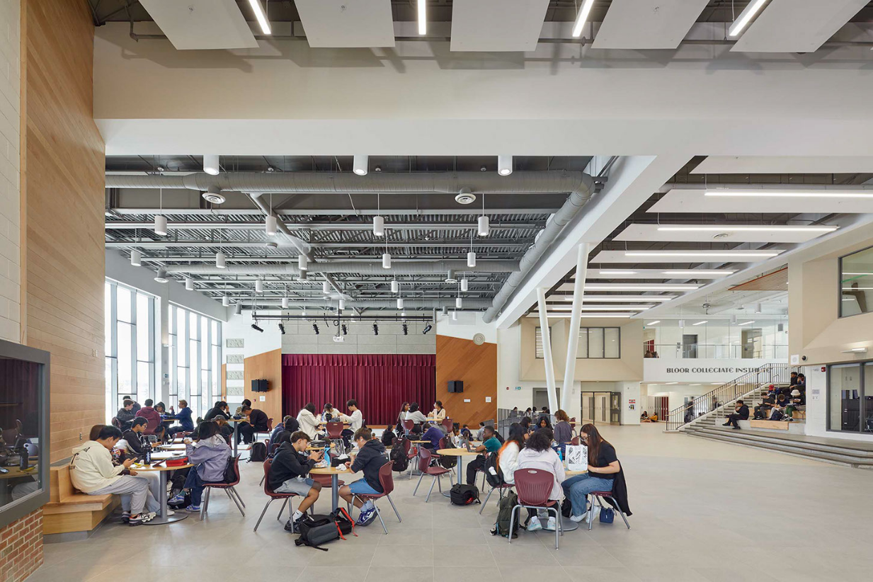
Picture of the student commons.

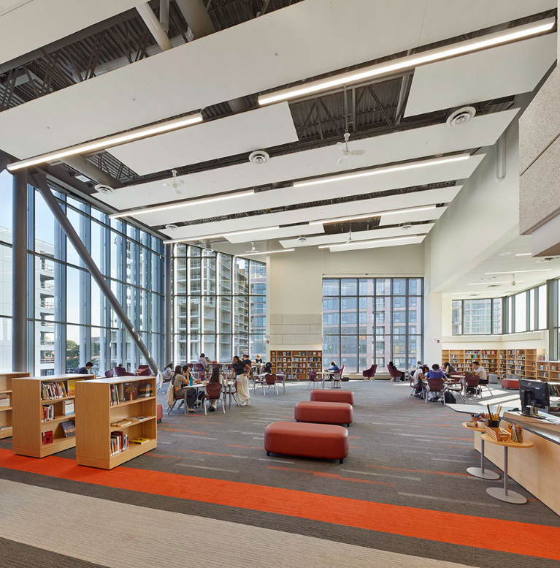
Picture of the learning commons (library).

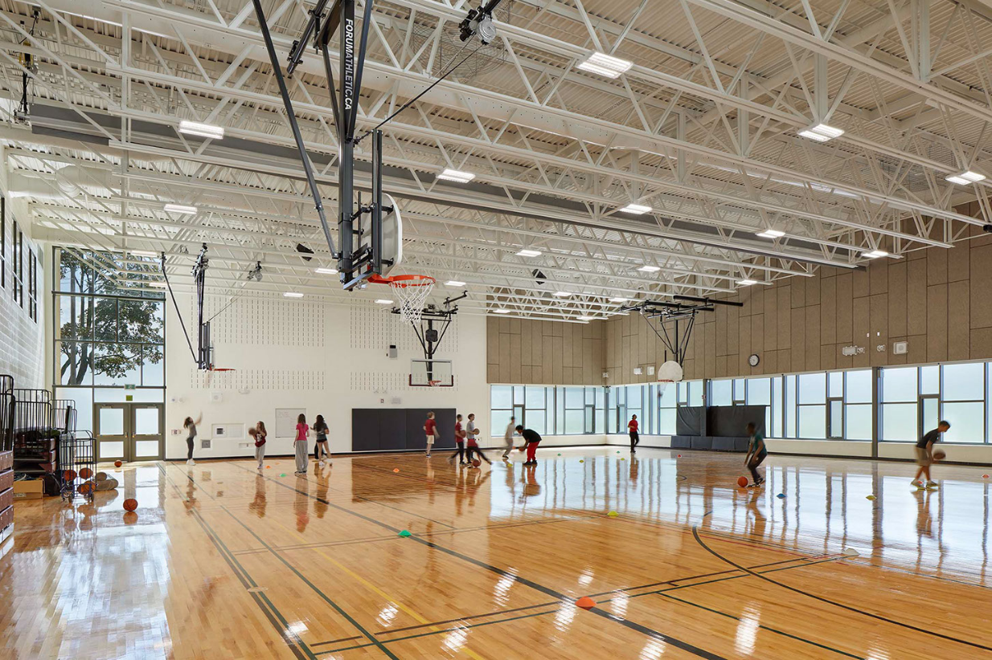
Picture of the gymnasium.

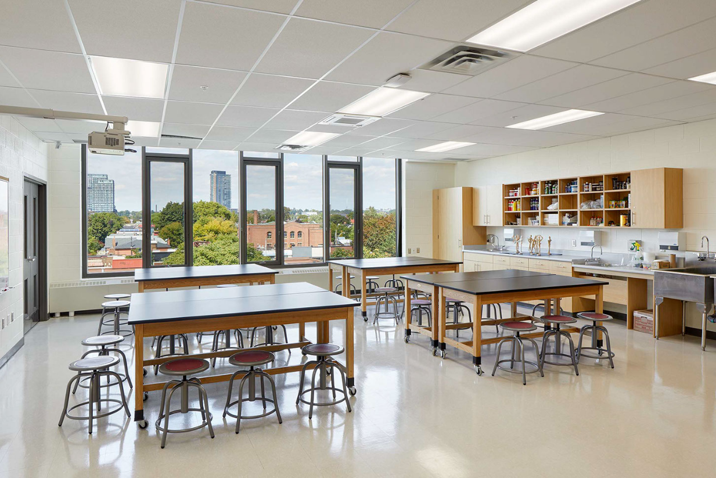
Picture of the visual art room.

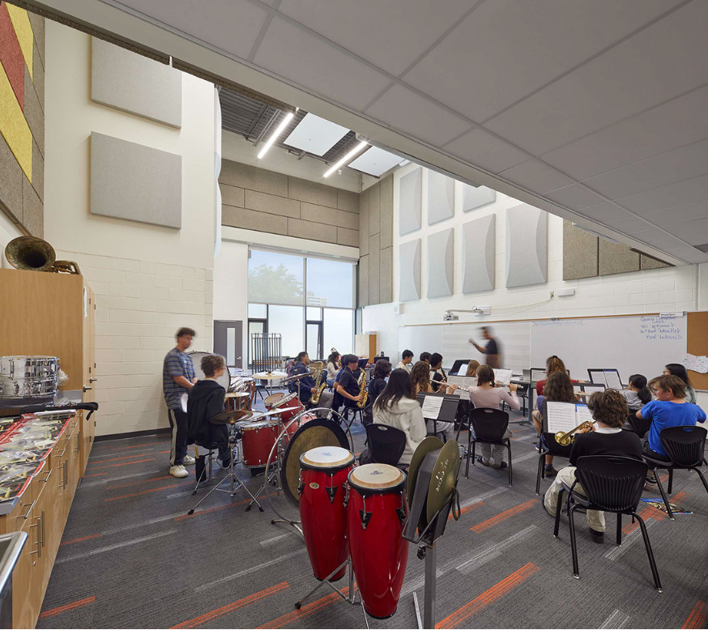
Picture of the instrumental music room.

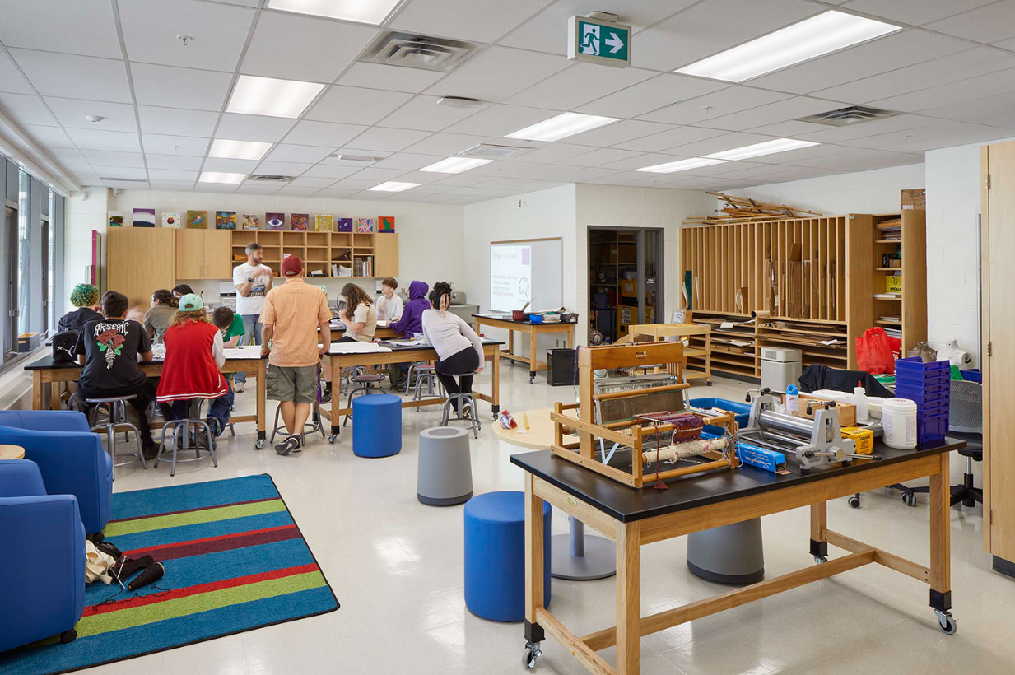
Picture of the ALPHA II Alternative school visual art room.

