APRIL HIGHLIGHTS
- What’s New
- Important Dates
- Upcoming Virtual Webinar: Preparing for High School
- Hand-Eye Coordination
- Parent/Caregiver Guides
- TDSB Occupational Therapy/Physiotherapy Services
- TDSB Speech Language Pathology Services
- TDSB Psychological Services: How to Foster Comprehension
- TDSB Deaf and Hard of Hearing Services
- TDSB Blind and Low Vision Services
- TDSB Special Education & Inclusion Summer School
- TDSB Specialized Summer Learning for Students with ASD
- World Autism Day: April 2, 2026
- TDSB Virtual Connects

Important Dates
Elementary PA Days:
June 5, 2026
June 26, 2026
Secondary PA Days:
June 25, 2026
June 26, 2026
School Year Holidays (as per Ministry):
Good Friday: April 3, 2026
Easter Monday: April 6, 2026
Victoria Day: May 18, 2026

Special Education and Inclusion Parent Guides
The Toronto District School Board (TDSB) provides many Special Education Guides for Parents which contain information about the supports, programs and services available for students with disabilities and special education needs in the TDSB.
If, after reading the guides, you require additional information, please reach out to the principal of your child’s school/your neighbourhood school. Videos and translated versions are included within some of the guides.

Upcoming TDSB Parent/Caregiver Sessions
TDSB Special Education and Inclusion Department offers a number of Parent/Caregiver sessions each month–please check for upcoming sessions: HERE.
Hand-Eye Coordination
Think of hand-eye coordination as the bridge between what a child sees and how they move. It is the secret ingredient for two major types of development Gross Motor (e.g., catching a ball) and Fine Motor (e.g., handwriting). Check out this video on Hand-Eye Coordination from TDSB Occupational Therapy and Physiotherapy Services for some ideas on how to build hand-eye coordination skills at home!

Preparing for High School and Beyond
This session will focus on how daily and major transitions affect teens as they move through high school and prepare for life after graduation. Parents and guardians will learn how transition planning supports learning, independence, and future goals, and how they can support their child through important school and life changes.
🗓 Date: April, 28, 2026
⏰ Time: 6:30 pm
📍 Format: Webinar for Parents/Guardians
🔗 Register: HERE

Toronto District School Board Occupational Therapy and Physiotherapy Services from the Special Education and Inclusion Department.
OTPT Newsletter April 2026
Sleep and Regulation
Sleep is important as it helps your child stay physically and mentally healthy. Sleep affects brain function and mental health, physical health, cognitive and emotional resilience. It’s like charging your body and brain’s battery.
How much sleep do children need on average?
- 6-12 years: 9-12 hours
- 13-18 years: 8-10 hours
Click here to access our handout on promoting healthy sleep at home.
What happens without enough sleep?
- Reduced attention and focus
- Impaired memory
- Slower problem solving
- Irritability and mood swings
- Hyperactivity/Impulsivity
- Difficulty waking up
- Poor school performance
- Decreased emotional resilience
Check out our video for additional sleep strategies to use at home.
Sleep Hygiene
Provide ample opportunities for movement during the day time and start winding down for the evening. Click here for a sleep hygiene tip sheet.
Structure/Routines
Be consistent with timing – Make bedtime and wake-up time the same for both weekdays and weekends. The amount of sleep a child needs varies depending on age.
Establish a before-bedtime routine – Have the same routine every night. To ease the transition, let your child know 7-10 minutes before the bedtime routine is to start.
Pace the bedtime routine- Allow enough time to complete the routine without rushing. Use a visual schedule so your child can see the sequence of tasks and to help keep the pace and flow of the routine steady.
April 7th is World Health Day
World Health Day reminds us that everyone has the right to be healthy, including getting enough sleep! Sleep is one of the best things you can do for your body.
There may be websites linked from this site that are operated by organizations outside of the Toronto District School Board (TDSB). These organizations are solely responsible for the operation and information found on their sites. Linking from this site does not imply any endorsement of the organization or information found on the website. Any comments or inquiries regarding the linked websites should be directed to the organization operating the website.

Speech Language Pathology (SLP) Services
🧺 Oops! Don’t Forget the Bunny: April’s Story Spotlight
This April, our featured story is Knuffle Bunny by Mo Willems — a funny and relatable tale about Trixie, her dad, and an unforgettable trip to the laundromat. When something important goes missing, Trixie tries her best to communicate her message! Through this lesson, students are building early literacy skills by playing a fun letter-matching game, talking about familiar routines like doing laundry, and practicing their storytelling skills.
You can support your child at home by asking:
🧺 How do you think Trixie felt when she couldn’t find her bunny?
🧺 Have you ever lost something special? What did you do?
🧺 What is something important you would never want to forget?
🧺 How can we help others understand us when something is wrong?
🧦 Try This 1-Minute Communication Activity at Home
Laundry Helper Game:
As you fold laundry together, pick up an item and say:
- “This is a ___.”
- “It belongs to ___.”
Then let your child take a turn telling you! This simple game helps children practice vocabulary, sentence building, and confidence expressing their ideas.
View the lesson here.

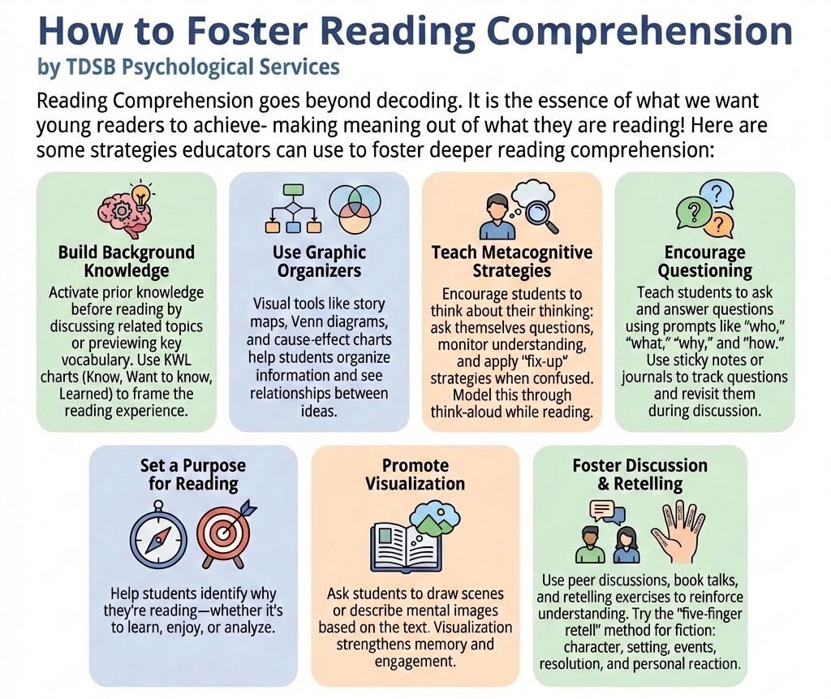
Deaf and Hard of Hearing Services
📖 The "Sounding Board" Winter Edition is Live!
The Winter Edition of Sounding Board is out now! In this latest D/HH publication, students have showcased their writing, reflections, and artwork, highlighting creativity, voice, and the many ways D/HH learners communicate and express themselves. A big thank you and congratulations to every student who submitted their incredible work, and to the staff who supported and compiled this edition.
Read it here: Sounding Board First Edition 2025-2026

Blind and Low Vision Services
UNDERSTANDING CORTICAL VISION IMPAIRMENT (CVI)
Cortical Visual Impairment (CVI) is a brain-based visual impairment. Unlike eye conditions that affect how clearly someone sees, CVI affects how the brain understands and makes sense of what the eyes are seeing. A child’s eyes may be healthy, but their visual experiences can still be inconsistent. CVI is now one of the most common causes of visual impairment in children in North America. Every child with CVI is unique, and it can look different from one child to another.
What CVI Might Look Like at School
A child with CVI may:
- Have trouble finding items on a busy page or in a cluttered space
- Look away while listening or thinking
- Need extra time to respond to something they are looking at
- Show a preference for certain colours
- Notice moving objects more easily than still ones
- Seem to see something one day but not the next
- Find busy environments like hallways, assemblies, or recess more challenging
These behaviours are related to how the brain processes visual information, not to effort or ability.
Why Reducing Visual Clutter Helps
Too much visual information at once can make it hard for a child with CVI to focus. Simplifying what they are looking at can make a big difference.
Helpful supports may include:
- Using plain, solid-coloured backgrounds
- Showing fewer items at one time
- Reducing background noise or other sensory distractions when visual attention is needed
- Choosing seating that limits visual distractions
The Importance of “Wait Time”
Children with CVI often need a little extra time to process what they see. Pausing for a few seconds after showing something can help them engage. If a child does not respond right away, it may simply mean they are still processing the information. Adding a simple verbal cue, such as naming what they are looking at, can also help make connections.

Supporting Your Child’s Visual Access
Some strategies that may support children with CVI include:
- Giving verbal previews (“We’re looking for the red circle.”)
- Pairing spoken information with simple visuals
- Keeping materials in consistent places
- Using gentle movement to draw attention
- Starting with materials close up before moving them farther away

RESOURCES
Summer Skills Development Program for Students with Autism (Grades 4-10)
Program Details:
Dates: July 6, 2026 – July 30, 2026
Format: Half Days
Delivery: Online & Limited in-person classes
Registration Information:
Please see Parent Letter. Interested parents must fill out this form with details by Friday, April 17, 2026
*Important Note: Spaces in the program are limited, and enrolment is on a first-come first-served basis.
SPECIAL EDUCATION AND INCLUSION SUMMER SCHOOL 2026 – Toronto District School Board Program - July 6 – 30th
For students currently enrolled in:
Developmental Disability, Deaf and Hard of Hearing and Physical Disabilities Intensive Support Programs (ISPs)

Program Details & Support:
- In-person at vatious TDSB locations (Half-day programs)
- Focus on developing independence
- Prgramming areas: Functional Literacy and Numeracy, Activities of Daily Living, Communication, Social Skills
Please click HERE for Summer School Application.

Celebrate the Spectrum
Endless Possibilities in Every Pattern - April 2, 2026 is World Autism Day
Each April, people from across Ontario come together to show their support for autistic people. Join the fun and Celebrate the Spectrum with us in the lead-up to World Autism Day on April 2 and throughout the month of April.
Autism: See the Potential

TDSB Vitual Developmental Disabilities CONNECT
Supporting Parents and Caregivers in Navigating Services for their Child, Youth or Young Adult with
Developmental Disabilities and /or Complex Disabilities
Learn how to set meaningful goals for your child and explore key resources that support growth, independence, financial security, and community inclusion.
DATE: April 13 (AM) & 20 (PM)
TIMES:
Morning Session: 9:30 a.m. – 12 Noon
Evening Session (a repeat): 5:30 p.m. – 8:00 p.m.
Join Microsoft TEAMs Meeting Now
OR Scan the QR Code Below:
