Leadership and Learning Department
5050 Yonge Street, Toronto, Ontario, M2N 5N8

Special Education Plan 2019

Updated July 2019

Serving Our Students, Schools, and Their Communities

Serving Our Students, Schools, and Their Communities

Serving Our Students, Schools, and Their Communities

Back of Cover Page

TABLE OF CONTENTS
Introduction to TDSB Special Education Plan 11
Inclusion and Special Education 13
Multi-Year Strategic Plan 16
TDSB Learning Centres Facilitate Inclusion 17
Accessibility 18
Background 18
TDSB Accessibility Committees 19
AODA Working Group 19
Barrier Free Committee 19
AODA Capital Committee 20
Capital Spending on Accessibility 20
Assessment 22
Educational Assessment by Teachers 22
Kinds of Educational Assessment 22
Diagnostic Assessment Tools for Teachers 23
Individual Assessment by Qualified Professionals 23
Purpose and Goals 23
Standards for the Provision of Individual Assessments 24
Occupational Therapy and Physiotherapy Assessments 25
Psychological Assessments 27
Social Work Assessment 29
Speech Language Assessments 30
Sharing Professional Assessment Information 32
Consultation 33
TDSB Consultation Process 33
Consultation on the Special Education Plan 33
Continuum of Supports, Programs and Services 34
How Student Needs Are Addressed 34
How Teachers Access Special Education Supports and Services 35
How Individual Student Needs Are Identified 36
Identification, Placement and Review Committees (IPRC) 37
Steps to Student Support and Services 38
Elementary School Community Based Resource Model (CBRM) 39
Special Education Resource 39
Home School Program (HSP) 39
Secondary School Support 40
Special Education Resource 40
Special Course Options 40
● Secondary Resource Program (RSE) 40
● Secondary Learning Strategies (GLE) 41
● Locally Developed or Optional Credit Courses 41
Special Education Classes – Elementary and Secondary 41
Early and Ongoing Identification and Intervention 43
TDSB Developmental History Form 44
Universal Screening Process for Grade 3 Students 44
Transition Planning for School Entry 45
Entry Plan for Students with Special Needs 46
Early Years Intervention Programs 48
Diagnostic Kindergarten Program (DK) 49
Eligibility for the Diagnostic Kindergarten Program 49
Kindergarten Intervention Program (KIP) 50
Eligibility for the KIP Program 50
Kindergarten Early Language Intervention (KELI) 51
Eligibility for the KELI Program 51
Exceptionalities: Categories, Definitions and Special Education Programming 52
Identifying the Needs of Exceptional Pupils 52
Behaviour Exceptionality 53
Ministry Definition 53
IPRC Determination of Exceptionality: Behaviour 53
Special Education Programming 54
Communication Exceptionalities 56
Autism 56
Ministry Definition 56
IPRC Determination of Exceptionality: Communication (Autism) 56
Special Education Programming 57
Learning Disability 59
Ministry Definition 59
IPRC Determination of Exceptionality: Communication (Learning Disability) 59
Special Education Programming 60
Language Impairment 62
Ministry Definition 62
IPRC Determination of Exceptionality: Communication (Language Impairment) 62
Special Education Programming 62
Speech Impairment 63
Ministry Definition 63
IPRC Determination of Exceptionality: Communication (Speech Impairment) 63
Special Education Programming 63
Deaf and Hard of Hearing 64
Ministry Definition 64
IPRC Determination of Exceptionality: Communication (Deaf/Hard of Hearing) 64
Special Education Programming 64
Intellectual Exceptionalities 66
Developmental Disability 66
Ministry Definition 66
IPRC Determination for Exceptionality: Developmental Disability 66
Special Education Programming 67
Giftedness 69
Ministry Definition 69
TDSB “Universal Screening Process” and Identification of Giftedness 69
IPRC Determination for Exceptionality: Giftedness 70
IPRC Determination of Giftedness for English Language Learners (ELL) 70
IPRC Determination of Giftedness (for Students with Learning Disabilities) 71
Special Education Programming 71
Mild Intellectual Disability 73
Ministry Definition 73
IPRC Determination for Exceptionality: Mild Intellectual Disability 73
Special Education Programming 74
Multiple Exceptionalities 77
Ministry Definition 77
IPRC Determination of Multiple Exceptionalities 77
Special Education Programming 77
Physical Exceptionalities 78
Blind and Low Vision 78
Ministry Definition 78
IPRC Determination for Exceptionality: Blind and Low Vision 78
Special Education Programming 78
Physical Disability 81
Ministry Definition 81
IPRC Determination of Physical Disability Exceptionality 81
Special Education Programming 81
Identification and Placement in Special Education 83
The Identification Placement and Review Committee (IPRC) 83
IPRC Decisions about Exceptionality 84
IPRC Decisions about Placement 84
Regular Class Placement 84
Special Education Class Placement 85
External Options for Full Time Support 87
IPRC Recommendations about Special Education Services or Programs 87
IPRC Structure 87
Learning Network and Original IPRCs 87
Central IPRC 88
School-Based IPRC (for the Annual Review) 88
The IPRC Process 88
IPRC Referral Steps 88
Documents Required for an IPRC 89
Attendance at the IPRC 89
Presentations to an IPRC 89
Functions of the IPRC 90
Deferral of IPRC Decisions 90
Process for Annual Review IPRCs 90
Resolving Disputes 91
Appeal Process 91
Special Education Program Recommendation Committee (SEPRC) 91
SEPRC Structure 92
The SEPRC Process 92
SEPRC Referral Steps 93
Documents Required for a SEPRC 93
Attendance at and Presentations to a SEPRC 94
Functions of the SEPRC 94
Required Follow-Up to the SEPRC 94
Appeal Process 95
In-School Team (IST) and School Support Team (SST): Consultation and Support 96
Addressing Student Needs 96
A Tiered Approach to Prevention and Intervention 97
Individual Learning Profile (ILP) 98
The In-School Team and School Support Team (IST/SST) 98
Role of Professional Support Services at SST Meetings 99
Parental and Student Involvement in IST/SST Processes 100
Secondary School Team Meetings 101
Individual Education Plan (IEP) 102
Accommodations, Modifications and Alternative Expectations 102
Consultation in IEP Development 103
Ministry Standards for Implementation 104
TDSB Guidelines for Individual Education Plans 104
IEP Accommodations and Modifications in Secondary School Settings 105
The IEP Transition Plan 106
Requirements for Transition Plans 106
A Tiered Approach to Transition Planning 106
Education Transitions 107
Filing and Storage of the IEP 108
Process for Dispute Resolution 108
Ministry of Education 110
Special Education Roles and Responsibilities 110
The Ministry of Education: 110
The District School Board: 110
The School Principal: 111
Special Education Advisory Committee (SEAC): 111
The Teacher: 112
The Special Education Teacher: 112
The Parent(s)/Guardian(s): 112
The Student: 112
Provincial Schools and Demonstration Schools 113
Demonstration Schools 113
Provincial Schools for the Deaf 114
Provincial School for Visually Impaired, Blind and Deafblind Students 114
Partnerships 115
Coordination of Services with Other Ministries and Agencies 115
TDSB Early Intervention Initiatives 115
Kindergarten Early Language Intervention (KELI) Program 115
Toronto Partnership Autism Services (TPAS) Community Services 115
Connections: Supporting Seamless Transitions for Students with ASD 116
Transition from Toronto Preschool Speech and Language Services (TPSLS) 116
External Partnerships with Community Agencies and Services 117
Professional Learning 123
Framework for Professional Learning 123
Overview of Staff Professional Learning 123
2019-2020 Priorities for Professional Learning 124
Safety – Management of Risk-of-Injury Behaviours 127
Special Education Advisory Committee (SEAC) 128
The Role of SEAC 128
2019 - 2020 Meeting Dates and Times 128
SEAC Membership 128
Membership Selection Procedures 128
SEAC Input for 2019 - 2020 129
SEAC Recommendations to the Board 129
SEAC Input into the 2019 TDSB Special Education Plan 129
Communication with SEAC 130
SEAC Association Representatives 131
SEAC Community Representatives 134
Requesting Regional Support Services 135
Regional Autism Team Services 135
Requesting Regional Autism Team Services 136
ASD Professional Learning (PL) 136
Tiered E-Learning Opportunities 136
Tier 1 – Suggested for ALL 136
Behaviour Regional Services (BRS) Team 137
Blind and Low Vision Itinerant Support 139
Deaf and Hard of Hearing Itinerant Support 139
Care, Treatment, Custody, and Corrections (CTCC) 140
Structure of TDSB Care and Treatment 140
Special Equipment Amount (SEA) 142
Special Incidence Portion (SIP) 143
Specialized Health Support Services 144
Special Needs Strategy 144
Toronto Region Coordinated Service Planning Model 144
Policy/Program Memorandum No. 81 (PPM 81) 144
Clarification of PPM 81 Re: Catheterization and Suctioning 145
Model for Provision of Specialized Health Support Services 147
Staff Allocation for Special Education 150
Background 150
Staff Allocation Process 150
Opening a Special Education Class (Intensive Support Program) in a School 150
Moving a Full Time Special Education Class 151
Closing a Full Time Special Education Class 151
Special Education Staff Allocation for 2019-2020 151
Allocation of Special Education Support Staff 152
Allocation of Special Needs Assistants 152
Placement of Staff in Special Education Programs 153
Targets and Standards for Special Education ISP Staffing 154
Special Education Staff Allocation as of July 31, 2019 155
Professional Support Services Staff Allocation as of June 30, 2019 157
Staff Organization and Responsibilities 158
Learning and Leadership Department Roles and Responsibilities 159
Associate Director - Leadership, Learning and School Improvement 159
Superintendent – Special Education Services 159
Centrally Assigned Principal – Central 160
Centrally-Assigned Principal – Special Education Learning Centre 161
Centrally Assigned Principal - CTCC 162
Vice Principal – CTCC- Elementary and Secondary 163
Central Coordinator – Autism Services 164
Central Coordinator – Processes, Practices and Procedures (SEA/SIP) 165
Special Education Coordinator – CTCC 166
System Coordinators – Deaf/Hard of Hearing, Blind/Low Vision 167
Special Education Inclusion Coordinators 167
Consultants 168
Special Education Inclusion Consultant 168
Special Education Consultants – ASD Team 169
Special Education Consultant – Assistive Technology (SEA) 170
Special Education Itinerant Teachers 171
Special Education Itinerant Teacher – Behaviour (Elementary & Secondary) 171
Special Education Itinerant Teacher – Assistive Technology (SEA) 171
Special Education Itinerant Resource Teachers – Secondary Alternative Programs 172
School-Based Special Education Teaching Staff 173
Paraprofessional Support Staff 174
Professional Support Services Department Roles and Responsibilities 176
Occupational Therapy and Physiotherapy Services 178
Psychological Services 179
Social Work and Attendance Services 180
Speech-Language Pathology Services 183
Transportation for Students in Special Education 184
TDSB Transportation Policy and Procedures 184
Method of Transportation Service 184
Requirements and Responsibilities 185
Changes to Transportation Arrangements 185
Pick-up and Drop-off 186
Driver Responsibilities 186
Seat Belts, Seat Belt Covers, Car Seats, Booster Seats, Safety Vests 187
Transportation for Students in Wheelchairs or with Severe Mobility Limitations 187
Cancellation of Service Due to Inclement Weather 188
September Start-up 188
Transportation Safety 189
Appeal Process 189
Transportation Company Contact Information 189
Appendices 190
Appendix A: Guide to Special Education for Parent(s)/Guardian(s) 190
Appendix B: Individual Education Plan 199
Appendix C (1): Consent for Release of Confidential Information 205
Appendix C (2): Individual Learning Profile (Elementary) 208
Appendix C (3): Individual Learning Profile (Secondary) 213
Appendix C (4): Professional Support Services Referral Form 218
Appendix D: Parent Concern Protocol 220
Appendix E: Glossary of TDSB Terms 223
Appendix F: Special Education Acronyms 225
Appendix G: TDSB Approved List of Diagnostic Assessment Tools 228
Appendix H: TDSB Special Education Brochures 230

Introduction to TDSB Special Education Plan
The Toronto District School Board Special Education Plan is intended to provide both an overview and reference for Special Education Services. Each school board is required to maintain a Special Education Plan, to review it annually, to amend it from time to time to meet the current needs of its exceptional pupils and to submit any amendment(s) to the Ministry for review each year. (Regulation 306). This plan is meant to provide information about Special Education Services in TDSB and to summarize and highlight key system initiatives, projects, and processes that support students with special needs and their families.
Contained within this plan are provincial and Ministry of Education expectations, which include the Identification Placement Review Committee (IPRC), placement options, transition planning, and information about the Individual Education Plan (IEP). There is also information about approaches and philosophies for special education such as inclusion. Further specific details about equipment, transportation, assessment processes, and coordination with community partners is also included. The key takeaway is that we are governed by Ministerial mandates, we have a philosophy for our work which informs decision making and processes and procedures that contribute to transparency and clarity, and our projects and initiatives are the “how”. They are the ways in which we continue to move these expectations and beliefs forward in support of students with special needs and their families.
The various academic and clinical departments that make up Special Education Services are represented in this document. Academic, Social Work, Psychology, Speech and Language Pathology, and Autism Services work in collaboration to support students, and are reflected in this Special Education Plan. The TDSB’s Special Education Advisory Committee (SEAC) also plays a key role in contributing to this document by providing feedback throughout the year on presentations and discussions at SEAC meetings pertaining to our work, as well as through a Special Education Plan Standing Sub-Committee. Input from SEAC is an important part of the development of the Special Education Plan as members of SEAC represent local organizations and bring an important lens to both the content and clarity of the plan.
This plan should always be considered as it is intended: an overview of provincial mandates and expectations, and the processes, projects, and initiatives that we utilize in the Toronto District School Board to meet the needs of students with special needs and their families. Conversations specific to students are usually best resolved at the school level with the appropriate staff and administration in the spirit of collaboration and positive relationships that exist throughout the TDSB.

Our Special Education Plan is guided by the Toronto District School Board Equity Foundation Statement:
The TDSB Mission is to enable all students to reach high levels of achievement and to acquire the knowledge, skills, and values they need to become responsible, contributing members of a democratic and sustainable society.
We value:
Each and every student’s interests, strengths, passions, identities and needs
A strong public education system
A partnership of students, staff, family, and community
Shared leadership that builds trust, supports effective practices and enhances high expectations
The diversity of our students, staff and our community
The commitment and skills of our staff
Equity, innovation, accountability, and accessibility
Learning and working spaces that are inclusive, caring, safe, respectful and environmentally sustainable

“We believe that equity of opportunity, and equity of access to our programs, services and resources are critical to the achievement of successful outcomes for all those whom we serve, and for those who serve our school system…The Board is therefore committed to ensuring that fairness, equity, and inclusion are essential principles of our school system and are integrated into all our policies, programs, operations and practices.”

In our Plan, fairness and equity refer to equitable access to programs, services and appropriate resources, as much as is feasible in the neighbourhood school. Inclusion is an attitude and practice that is shaped by every student’s need and right to belong within one’s home school community. These ideals align not only with Ontario Regulation 181/98 S17 (1) which guides IPRC decision-making around regular class placement for exceptional students, but also with the Convention on the Rights of Persons with Disabilities (2006) and the Ontario Human Rights Code (OHRC).

Our plan also supports ideals outlined in the Ontario Human Rights (OHR) Policy on Accessible Education for Students with Disabilities, which provides guidance on interpreting provisions of the Ontario Human Rights Code in an educational context. The OHR Commission interprets Disability as including physical, developmental and learning disabilities and Accommodation as a means of preventing and removing barriers that impede students with disabilities from participating fully in the educational environment. It also describes accommodation as involving three factors:

Dignity: Students with disabilities have the right to receive educational services in a manner that is respectful of their dignity, which encompasses both self-respect and self-worth.

Individualization: Every student with a disability is unique. Although many accommodations will benefit large numbers of students with similar needs, two students with the same disability may call for different kinds of accommodation and instructional approaches.

Inclusion: While there are times when the best way to ensure the dignity of persons with disabilities may be to provide separate or specialized services, education providers must first make efforts to accommodate students with disabilities in a way that promotes their inclusion and full participation.

The TDSB Special Education Plan continues to build on inclusionary education beliefs and practices, so that, in alignment with the OHRC Guidelines:
“To the maximum extent appropriate, children with disabilities...are educated with children who are not disabled, and special classes, separate schooling, or other removal of children with disabilities from the regular educational environment occurs only when the nature or severity of the disability of a child is such that education in regular classes with the use of supplementary aids and services cannot be achieved satisfactorily.” (p. 8)

Every effort has been made to ensure that the TDSB Special Education Plan complies with all legislation governing its content, including: the Canadian Charter of Rights and Freedoms, the Ontario Human Rights Code, the Education Act and Regulations made under the Act and any other relevant legislation. Special Education is also addressed in the TDSB School Improvement Process.

In the 2018/19 academic year, TDSB approved the Multi-Year Strategic Plan (MYSP). This plan, and the accompanying Action Plans outline a plan for the board that focuses on all students reading by the end of grade 1, mathematics, suspensions and expulsions, academic pathways, and inclusive education to the greatest extent possible for students. One of the key commitments from the MYSP is Inclusion.

Special Education Services are part of the Leadership, Learning, and School Improvement. Special Education staff support and expertise reside in Leadership, Learning and School Improvement.

Inclusion and Special Education
Inclusion is not simply the physical placement of a student within a regular classroom. It is a multi-pronged approach, shaped by student need as opposed to a student’s identification of exceptionality. It includes positive classroom climate with active removal of attitudinal barriers, as well as the provision of integrated support geared to student needs, through Differentiated Instruction and Universal Design for Learning (UDL). The purpose of education is to provide students with the opportunity to realize their potential and develop into highly skilled, knowledgeable, caring citizens who contribute to their society. Inclusive Education is the belief that all students, including those students with special learning needs, should receive their education to the fullest extent possible in the local community school.

Over the past few years, the TDSB Research Department has identified a number of issues regarding placement of students in settings based on ability grouping:
- Ability grouping often imposes low expectations on students
- Ability groups often mirror social, ethnic and class divisions
- Assignment of a student to an ability group is often a permanent destination
- Students placed in lower ability groups are further disadvantaged based on lack of access to behaviour/learning models and social stimulation
- Students placed in lower ability groups encounter significant barriers in accessing any form of post-secondary education
Additionally, the findings in a TDSB report by Gillian Parekh entitled A Case for Inclusive Education (2013) and follow-up research on the merits of adopting an inclusive education model have informed our vision for special education.:

Students are successfully included, supported and empowered when:
- They experience a sense of belonging and social citizenship
- The learning environment is modified to fit the student, not the student to fit the environment
- All identities and cultures are celebrated within the learning environment
- The right to participate and establishing a positive climate that promotes social engagement and friendships is prioritized
- Deficit thinking is rejected and students are not organized within/outside the classroom by perceived ability
Adopting a more inclusive model can maintain or improve academic outcomes for students with special education needs, with no negative impacts on more typically developing students. Positive benefits from inclusion for all students in the classroom include:
- A more welcoming, positive school environment with increased collaboration and participation and higher academic expectations
- Access to a wider range of school resources and shared learning opportunities
- Increased social network and greater opportunities for friendships with increased safety through reduced isolation and readiness for inclusion beyond school
On the other hand, in its Policy on Accessible Education for Students with Disabilities, the Ontario Human Rights Commission recognizes the fact that students within an exceptionality grouping may have vastly different needs, with some requiring more specialized or intensive programming and supports.
“While integration should be recognized as the norm of general application because of the benefits it generally provides, a presumption in favour of integrated schooling would work to the disadvantage of pupils who require special education in order to achieve equality. Integration can be either a benefit or a burden depending on whether the individual can profit from the advantages that integration provides.”
Recognizing all of the above considerations, the Vision of the Toronto District School Board’s Special Education Plan is that students identified with exceptionalities be welcomed, accepted, included and supported within well-resourced neighbourhood schools. The goal remains to provide appropriate program options and the most enabling learning environments consistent with parental choice, to maximize the potential of all TDSB students.

Multi-Year Strategic Plan

In the fall of 2018, the TDSB Board of Trustees approved the Multi-Year Strategic Plan (MYSP). The five key foci of the plan include:
- Transform Student Learning: We will have high expectations for all students and provide positive, supportive learning environments. On a foundation of literacy and math, students will deal with issues such as environmental sustainability, poverty and social justice to develop compassion, empathy and problem solving. Students will develop an understanding of technology and the ability to build healthy relationships..
- Create a Culture for Student and Staff Well-Being: We will build positive school and workplace cultures that support mental health and well-being — free of bias and full of potential. Educators will be equipped with the tools necessary to teach, assess, support and relate to students. We will create the conditions for every student in every school to experience the support of a caring adult. All staff will have access to professional learning opportunities that build healthy relationships and develop leadership capacity. .
- Provide Equity of Access to Learning Opportunities for All Students: We will ensure that all schools offer a wide range of programming that reflects the voices, choices, abilities, identities and experiences of students. We will continually review policies, procedures and practices to ensure that they promote equity, inclusion and human rights practices and enhance learning opportunities for all students.
- Allocate Human and Financial Resources Strategically to Support Student Needs: We will allocate resources, renew schools, improve services and remove barriers and biases to support student achievement and accommodate the different needs of students, staff and the community.
- Build Strong Relationships and Partnership with School Communities to Support Student Learning and Well-Being: We will strengthen relationships and continue to build partnerships among students, staff, families and communities that support student needs and improve learning and well-being. We will continue to create an environment where every voice is welcomed and has influence.

TDSB Learning Centres Facilitate Inclusion

The TDSB continues to act on community feedback to improve school effectiveness and student achievement for all students. The establishment of four Learning Centres prioritized student learning needs and parent engagement. Special education staff is allocated to each Learning Centre to assist all schools in identifying and responding to students’ learning needs.
Each Learning Centre has a Centrally Assigned Principal of Special Education to assist in the coordination of Special Education programs and services.

The Centres have teams of Special Education Inclusion Coordinators, Early Reading and K-12 Coaches, and professional support services, including psychologists, social workers, counsellors and other education workers, to support kindergarten to Grade 12 teaching/learning. By placing resources closer to schools, TDSB superintendents and school administrators are better positioned to identify the supports required for classroom teachers and students, with direct impact on classroom instruction and student achievement.

While following an action plan that we believe will have a very positive outcome for student learning and achievement levels, we will continue to focus on providing exemplary special education programs, supports and services. In partnership with our families, communities, Special Education Advisory Committee (SEAC) and other TDSB departments, we will continue to search out and implement effective practices to better serve our students. Any changes to our special education delivery model will be implemented thoughtfully, based on extensive research, and our goals as outlined in the MYSP and accompanying Action Plans with an understanding of best practices and with a consistent focus on student achievement and well-being.

Accessibility
The Toronto District School Board (TDSB) is committed to maintaining learning and working environments which actively promote and support human rights and accessibility for persons with disabilities. We are committed to actively removing barriers to inclusion so that all members of our community can fully participate in TDSB activities.

Background
1999 The TDSB Barrier Free Committee was established to address the need for equitable access for students and staff with mobility challenges. Given limited funding for barrier free renovations, the committee developed a Barrier Free Classification System for use in selecting designated sites for barrier free access. They also established a process for prioritizing the needs of the system and providing cost-effective, barrier-free access for students with a physical disability.
2003–2004 The TDSB Accessibility Committee and Accessibility Working Group were established. The Work Group and TDSB Research and Information Services Department developed a voluntary online survey to identify disabilities of staff/students and barriers encountered, and to collect suggestions for overcoming the barriers. The data revealed that there was a broad range of disabilities for which the TDSB must provide services, beyond the need for wheelchair accessibility.
2005 The Accessibility for Ontarians with Disabilities Act, 2005 (AODA) was enacted. The goal of the AODA is to have an accessible Ontario by 2025. Accessibility is to be achieved through implementation of accessibility standards in Customer Service, Built Environment, Employment and Information and Communications. The TDSB Policy PO69 Accessibility Policy was approved, requiring compliance by January 2010 which also established the framework for the Board's AODA compliance.
2005 on The Accessibility Working Group became the AODA Working Group, tasked with on-going responsibility for reviewing the requirements of the Toronto District School Board (TDSB) to ensure compliance with the AODA and the Integrated Accessibility Standards Regulations. This group created an online portal at www.tdsb.on.ca/Accessibility which provides information pertaining to the AODA at the TDSB (such as the Multi-Year Accessibility Plan, and resources, policies and procedures). The page is accessible from every TDSB webpage via a permanent icon, the international symbol for disability – a wheelchair. An accessibility webpage was created for staff specific resources on the internal TDSB website, providing links to training guides, resources, policies and procedures.
2015 The AODA Capital Spending Committee was established. Its mandate is to act as stewards for the Board, given limited funds, to improve accessibility for school, community and services in the TDSB. It prioritizes system needs (i.e., requirements of designated sites, issues identified by the Barrier Free Committee, emerging projects requiring attention and unforeseen contingencies), and allocates funds to begin repairs and upgrades in designated school sites.
2017 The position of Accessibility Coordinator was created to coordinate and ensure compliance with AODA legislation, Integrated Accessibility Standards (IASR) and the Ontario Human Rights Code.
2018 A review of The Accessibility Policy (P069) was completed and is a result of consolidation of three accessibility related policies: Accessibility Standards for Customer Service (P069), Accessibility for Persons with Disabilities (P083) and Integrated Accessibility Standards (P084). The policies were adopted in response to initial regulations under the Accessibility for Ontarians with Disabilities Act (AODA), some of which have now been repealed and/or consolidated. The proposed consolidation of policies is consistent with the governing legislation and will provide clarity and enhanced knowledge on accessibility related matters as the system can turn to one comprehensive Policy instead of three policies which appear to have duplicate content in some areas.

2019 An equity and inclusion communications consultant was hired to create a communications plan for the Accessibility Coordinator and related stakeholders. The plan will align with Accessibility master plans goals and the requirements of the AODA.

TDSB Accessibility Committees
There are currently three TDSB Committees focused on accessibility in the TDSB:
- AODA Working Group
- Barrier Free Committee
- AODA Capital Committee

AODA Working Group
The AODA Working Group is comprised of representatives from a number of TDSB business functions, as well as school principals and superintendents. Its major focus is to provide ongoing updates to the Multi-Year Accessibility Plan, prioritizing initiatives for AODA compliance.

Barrier Free Committee
The Barrier Free Committee continues to work in addressing the need for equitable access across the system for students and staff with physical mobility issues. There are approximately 100 designated sites in the TDSB. An ongoing review of designated sites is being undertaken to ensure equitable distribution across the system. All schools have been given a rating of A to F and given one of three classifications:
- Accessible (No significant vertical access barriers, no significant horizontal barriers and have at least a universal washroom or male and female common washrooms)
- Somewhat accessible (Accessible universal or common washrooms on entry level, may have some barriers horizontally and/or vertically, but allows students access to all special program spaces)
- Not accessible (Neither universal nor common accessible washroom, sites that are wholly or partially inaccessible vertically and horizontally, sites that are barrier-ridden, especially those where horizontal access in to building is restricted.)
A 5 year plan was developed to increase the number of accessible schools. All barrier-free requests from designated sites are submitted to the committee for consideration and are vetted through the regional Special Education Low Incidence Coordinators. Consideration of the barrier-free requirements for all special education congregated programs is a factor when planning special education class locations for all exceptionalities.

AODA Capital Committee
This Committee prioritizes system needs and allocates budgeted funds according to three categories of requests:
- Barrier Free Committee requests
- Planned Program Priorities requests for designated sites
- In-Year Special requests, emerging projects and unforeseen contingencies
Requests are sent to the Chair of the AODA Capital Spending Committee and are reviewed by the Committee. Factors considered for approval include current degree of accessibility, alternative solutions (i.e., a nearby designated site), age of building and whether the improvement will necessitate additional upgrades.

Accessibility Coordinator
The board has created a position to address consistency and integration of practices across the TDSB and to provide leadership in all matters related to implementation and compliance with the Accessibility for Ontarians with Disabilities Act (AODA) and related regulations. Reporting to the Executive Superintendent Human Rights and Indigenous Education, the Accessibility Coordinator provides system leadership to ensure awareness of and compliance with AODA legislation, Integrated Accessibility Standards (IASR) and the Ontario Human Rights Code. Providing subject matter expertise, the Accessibility Coordinator also acts as a system advocate for all aspects related to AODA. Responsibilities include but are not limited to research and analysis of best practices in accessibility standards, developing, reviewing and updating policies and procedures in accordance with AODA legislation and best practices, as well as fostering equity and inclusiveness in the development and implementation of programs and services.

Capital Spending on Accessibility
In 2015-2016, TDSB fully expended the Special Education Accessibility Grant. New barrier-free projects identified as priorities must be funded through the Renewal Grant, which supports facility condition projects.

 | 2016 | 2017
Allocation | $10 million  for 92 projects | $10 million  for 45 projects
Barrier  Free  Funding  Requests | $ 6 million budgeted  15 projects planned:  - Upgrading washrooms to be fully accessible  - Renovations of existing barrier free washrooms  - Installation of power door operators and hold open device  - Addition of front entrance ramps/sloped pathways | $ 3.5 million budgeted  4 projects planned for designated sites:  - Install elevator  - Provide exterior barrier free access for main and side entrances  - Installation of power door operators and hold open device  - Barrier free washroom upgrades
Planned  Program  Priorities | $ 2 million budgeted to add door operators to schools rated A1 (Accessible to All) and B1 (Accessible to Students), increasing the number of accessible schools from 80 to 146. | $ 5 million budgeted to add door operators, hold open devices and area of safe refuge in 36 schools.
In-Year  Special  Requests | $ 2 million allocated for individual requests to update facilities that are non-designated sites. 13 projects are currently approved or under consideration. | $ 1.5 million allocated for individual requests to update facilities that are non-designated sites. 5 projects approved or under consideration.

Assessment

The primary purpose of student assessment and evaluation is to improve learning. Assessment has the greatest potential to improve student learning when it is an integral part of all classroom activities and when it is used to identify students’ strengths and needs to determine the next steps for learning. The Ontario Ministry of Education policy documents Growing Success: Assessment Evaluation and Reporting in Ontario Schools (2010) and Growing Success – The Kindergarten Addendum provides guidance to schools on policies and procedures for assessment, evaluation, and reporting for grades 1 to 12. The policies outlined in Growing Success (and described below) reflect the current state of continuously evolving knowledge about learning.

Educational Assessment by Teachers
Assessment findings provide information relevant for classroom programming, Individual Education Plans, the Provincial Report Card and Identification Placement and Review Committees. Teachers collect assessment information in a variety of ways: formal and informal observations, discussions/conversations/questioning during the learning process, student-teacher conferences, homework, group work, demonstrations/performances, projects, portfolios, developmental checklists/continua, peer and self-assessments/reflections, essays and tests. Assessment is planned at the same time as instruction, to determine what needs to be taught, guide next steps and help both teachers and students monitor and evaluate progress towards achieving learning goals.

Kinds of Educational Assessment
Teachers carry out educational assessment as part of their on-going work with all students and for students with special education needs, throughout the development, implementation and review of Individual Education Plans (IEP). Teachers use terms such as diagnostic, formative and summative to describe the kinds of educational assessment that can be used for different purposes: assessment FOR learning, assessment OF learning, and assessment AS learning.

- Assessment FOR learning is the process of collecting information to decide where learners are in their learning, where they need to go and how best to get there. It is integral to the IEP process and can be diagnostic and/or formative in its use:
- Diagnostic assessment occurs before instruction begins so teachers can determine students’ readiness to learn new knowledge/skills and identify their instructional needs. Teachers use the information to determine what students already know and can do with respect to the knowledge and skills outlined in the curriculum expectations. Teachers then work with students to set appropriate learning goals and plan differentiated and personalized instruction/assessment.
- Formative assessment is frequent and ongoing, carried out while students are gaining knowledge and practising skills. Teachers use the information to monitor students’ progress towards achieving expectations, to provide students with descriptive feedback and coaching for improvement, to plan next steps and to differentiate instruction and assessment in response to student needs.
- Assessment OF learning is the process by which teachers record and report on student learning. This assessment is summative, occurring at or near the end of a period of learning. The information gathered is used by teachers to evaluate and communicate achievement at a given point in time, on the basis of pre-set criteria. It may also be used to plan further instruction.
For most students in Grades 1 to 12, this kind of assessment looks at achievement of the provincial curriculum expectations against Ministry established rubrics.
- For students with special education needs and for English language learners who require accommodations but do not need to have grade expectations modified, evaluation of achievement is based on the Ministry grade/course expectations and achievement levels.
- When students require modified or alternative expectations, evaluation of achievement is based on the expectations outlined in their IEPs. For this reason, it is important that IEP goals be expressed as specific and measureable outcomes.
- Assessment AS learning is the process by which teachers help students learn how to be their own best assessors, to become independent learners. This assessment is formative, requiring teacher support, modelling and guidance and structured opportunities for students to assess themselves. Students learn how to monitor their own progress, recognize when they need help, advocate for themselves, adjust their approaches to learning and set new goals. These are increasingly important skills for students with special education needs as they progress through the grades.

Diagnostic Assessment Tools for Teachers
The Ministry of Education released Policy Program Memorandum No. 155: Diagnostic Assessment in Support of Student Learning to outline how diagnostic assessment tools may be used in support of student achievement. It specifies the shared and individual responsibilities of teachers, principals, and school board staff and their collective accountability for student achievement.
PPM 155 guidelines are focused on the effective use of diagnostic assessment tools to inform teaching and learning practices in the classroom. The guidelines direct that teachers must use diagnostic assessment during the school year, selecting tools from the board’s approved list (Appendix I) and are to use their professional judgment[8] when selecting and using diagnostic assessment tools.
PPM 155 guidelines do not apply to:
- Individual educational and/or professional assessments conducted to determine the special education programs and/or services required by students with special education needs
- Large Scale Assessments like EQAO (Grade 3, 6, 9 and OSSLT), Program for International Student Assessment (PISA), Trends in International Mathematics and Science Study (TIMSS), Progress in International Reading Literacy Study (PIRL), Pan-Canadian Assessment Program (PCAP) and other Ministry mandated assessments.

Individual Assessment by Qualified Professionals

Purpose and Goals
Some students experience difficulty meeting the academic and/or social/behavioural expectations of the school environment, in spite of accommodations and modifications to their programs. Their needs as learners can best be understood and addressed through detailed, standardized individual assessments. These assessments are offered by a range of qualified professionals – psychologists, psychological associates, social workers, speech-language pathologists, occupational therapists, and physiotherapists (all members of regulated professional colleges).
An individual assessment provides an accurate baseline for tracking future development and academic progress. Individual assessments typically include classroom observation, and according to the concerns indicated, can focus on:
- Academic skills (using standardized assessment instruments such as the WIAT-III or the KTEA-3),
- Cognitive levels (using instruments such as the WISC-IV, the WISC-V, the KABC-II, the SB-V, or the WJ-III),
- Social-adaptive skills (using clinical observation and/or standardized instruments such as the BASC-3 or ABAS-II or 3),
- Sensory motor skills (using instruments such as the Beery VMI)
- Communication skills (using clinical observation and standardized instruments such as the CELF-4 or PLS-4).
Community diversity makes it essential that students and their families be sensitively involved in any assessment process. Close collaboration between assessment professionals and persons familiar with particular languages and cultures is integral to achieving this goal.
The TDSB provides equitable practices in individual assessment by ensuring that assessments meet professional standards of reliability, validity, fairness, and consistency, and are aligned with the Ontario Curriculum expectations. Alternative strategies and/or assessment materials are used to ensure assessments are barrier free for students with disabilities.
It is recommended that TDSB professionals provide assessment services for TDSB students because of their understanding of and ability to work within the school environment and through School Support Teams (SST). Parent(s)/Guardian(s) may supply a report from an outside, qualified professional for consideration by TDSB Professional Support Services (PSS) staff (from Psychology, Social Work, Speech-Language Pathology, and Occupational and Physiotherapy).

Standards for the Provision of Individual Assessments
The School Support Team (SST) discusses a student’s needs and if appropriate, makes a recommendation for an individual assessment by PSS staff. The SST also considers requests for assessments from parent(s)/guardian(s), qualifying students (of age and with the cognitive capacity to understand) or outside agencies.
A recommendation for individual assessment requires the agreement of parent(s)/guardian(s) or qualifying student. A referral form can be completed and signed either at or following the SST, giving permission for the professional to contact the parent(s)/guardian(s) or qualifying student, to seek “informed consent” before beginning the assessment. This ensures shared understanding of the reasons for the assessment, the nature of the assessment, the risks, benefits and possible outcomes of the assessment, as well as how information from the assessment will be managed and shared. Issues of where and how the record will be stored and the limits to confidentiality are outlined. The informed consent process and permission form can be found in Appendix C (1).
Throughout the PSS assessment process, parent(s)/guardian(s) or qualifying student are involved and at the conclusion, they are offered verbal and written feedback about the assessment findings. A cultural or communication facilitator will be offered where necessary. Written reports are provided to the parent(s)/guardian(s) or qualifying student at, or close to the time of verbal feedback.

Occupational Therapy and Physiotherapy Assessments
Physiotherapists / Occupational Therapists (OT/PT) collaborate with regular and special education teachers to provide therapeutic programming support and accommodation strategies, for students with physical and/or developmental disabilities. They also conduct assessments of students’ adaptive skills and of their gross motor, fine motor and sensory motor functions. They can provide physical-management recommendations and assist schools with referrals to Local Health Integration Networks (LHIN).For a full list of specific OT/PT supports and services, see Occupational Therapy and Physiotherapy Services under Engagement and Well-Being Department Roles and Responsibilities.
Referrals for OT/PT Assessments
Occupational Therapy and Physiotherapy assessments are accessed through the School Support Team (SST) (which includes the OT/PT staff member), using a referral process that requires the informed consent of the parent(s)/guardian(s) or student 18 years or older. The informed consent process ensures a shared understanding of the reasons for the assessment, the nature of the assessment, the risks, benefits and possible outcomes of the assessment, the types of OT/PT service that may be provided to the student and how information from the assessment will be managed and shared. The assessments are conducted under the Regulated Health Professions Act by occupational therapists and physiotherapists registered in the College of Occupational Therapists of Ontario and College of Physiotherapists of Ontario, respectively.

OT/PT assessments may include, but are not limited to:
- A review of the student’s school records
- Classroom observations
- An interview with parent(s)/guardian(s) to obtain developmental and relevant family and medical history
- An interview with school personnel, the student, and support service colleagues
- Contact with hospitals, rehabilitation centres, and community agencies
- Provision of specific gross/fine motor function, mobility (school/community), sensory motor / behaviour and visual motor skills
- Assessment of activities of daily living skills (e.g., feeding, dressing, personal care)
- Assessment for equipment needs (Assistive Devices Program (ADP) and Special Equipment Amounts (SEA))

Average waiting times for OT/PT assessments vary. Assessments are prioritized relative to the nature and complexity of student need and in consultation with the School Support Team (SST).For students with needs that may require more immediate attention, whether in integrated or intensive support settings, the wait times can vary from no wait up to six weeks. For less urgent needs the wait time for a referral may vary from two to three months. Staffing levels, service delivery changes and growing numbers of students with complex, multiple needs and diverse cultural-linguistic backgrounds may affect waiting times.
Management of Assessment Results
The results of the occupational and physiotherapy assessment are communicated with parent(s)/guardian(s) through an interview. Written reports are provided to the parent(s)/guardian(s) or qualifying student, at or close to the time of verbal feedback. Reports include recommendations for physical management (e.g., mobility, seating and positioning for function), activities of daily living skills and sensory integration. As outlined during the informed consent process, the results may be discussed with relevant teachers and professional support staff for educational planning and programming purposes.
Records from an OT/PT assessment are kept in confidential files, which are maintained in accordance with the regulations and provisions of the Professional Colleges and the Regulated Health Professions Act. Locations of copies of the report are discussed with parent(s)/guardian(s). The consent of parent(s)/guardian(s) is required for referral to community services for which the student may be eligible (e.g., Community Care Access Centre: School Health Support Services) or for a student’s physical management and registration report to be released to an outside agency.
Standardized Test Measures
COPM Canadian Occupational Performance Measure
DVPT-2 Developmental Visual-Perceptual Test
ETCH Evaluation Tool of Children's Handwriting
Gross Motor Function Measure
Handwriting Without Tears – Print Tool
HELP Hawaii Early Learning Profile
Miller-FUN
Motivational Assessment Scale
MVPT Motor Free Visual Perceptual Test
Peabody Developmental Motor Scales
School Companion Profile
Sensory Behaviour Analysis
School Function Assessment
Sensory Processing Measure
Sensory Profile
VMI Beery Buktenica Visual Motor Integration Test
Numerous non-standardized test measures not stated in this document

Psychological Assessments
Psychological Services staff includes Psychologists, Psychological Associates and Psychoeducational Consultants, who consult with teachers and School Support Teams (SST) about effective classroom programming and behaviour-management techniques to prevent and remediate learning and behaviour problems. With the required permission, they conduct comprehensive individual psychological assessment of students’ learning and social-emotional development to diagnose disorders, identify students’ learning strengths and needs, and recommend effective intervention strategies. They also play an important role on Identification Placement and Review Committees (IPRC) in identifying exceptionalities and recommending program support. For a full list of how they support students and schools, see Psychological Services under Engagement and Well-Being Department Roles and Responsibilities.
Referrals for Psychological Assessments
The purpose of a psychological assessment is to better understand the learning and/or socio-emotional strengths and needs of the student, in order to help in the delivery of the most appropriate programming while the student is at the Toronto District School Board.
Psychological assessments are accessed through the School Support Team (SST) (which includes a Psychological Services professional) using a referral process that requires the informed consent of the parent(s)/guardian(s) of a student under the age of 18, or of a student who is 18 years or older and has the appropriate level of cognitive ability to understand. The informed consent process ensures a shared understanding of the reasons for the assessment, the nature of the assessment, the risks, benefits and possible outcomes of the assessment, as well as how information from the assessment will be managed and shared.
The staff conducting the assessment is either a member of the College of Psychologists of Ontario or works under the direct supervision of a member of the College of Psychologists. Psychological Services staff are governed by the Psychology Act, the Regulated Health Professions Act, the Health Care Consent Act, the Personal Health Information Protection Act, and the Education Act when working in a school board.

A psychological assessment may include the following:
- A review of the student's school records
- Interviews with the parent(s)/guardian(s) to obtain developmental, family, and medical history
- Interviews with school personnel and the student
- Classroom observation
- An assessment (standardized and informal measures) of the student’s cognitive abilities to assess learning strengths and needs
- An assessment (standardized and informal measures) of the student’s social-emotional functioning to assess strengths and needs
- An assessment (standardized and informal measures) of the student’s academic skills to assess academic strengths and needs

The length of wait for a psychological assessment varies. The average wait time for a psychological assessment once a referral has been initiated is typically less than one year. The SST determines the priority in which students will be seen relative to the nature and complexity of student need and all referral requests from the school.

Management of Assessment Results
As outlined during the informed consent process, the results and recommendations of a psychological assessment are discussed with the parent(s)/guardian(s) or qualifying student and with staff of the TDSB who are directly involved with the student. A cultural or communication facilitator will be offered and arranged, if necessary. A copy of any written report is provided to the parent(s)/guardian(s) or qualifying student, at or close to the time of verbal feedback. A copy is also given to the school, to be placed in the student’s OSR.

The original written report, assessment measures, notes, and other information obtained during the assessment are maintained in the confidential files of Psychological Services in accordance with the Psychology Act and the Regulated Health Professions Act. Psychological Services will not release any information to persons or facilities outside of the TDSB without written consent, except as may be required by law.

Social Work Assessment
School Social Workers are closely affiliated with schools to provide a variety of supports to students, families and school staff. They participate on School Support Teams (SST), contributing specialized knowledge and resources to aid deeper understanding of the connections between social-emotional development, mental health and wellness, home life and student achievement. They also conduct assessments to identify social, emotional and behavioural factors that can impact a child’s ability to make the most productive use of the learning environment. For a full list of Social Work supports and services, see the section on Social Work and Attendance Services under Engagement and Well-Being Department Roles and Responsibilities.
Referrals for Social Work Assessments
A referral to Social Work can be initiated through the School Support Team (SST) (which includes a social worker), or at any other time on an as needed basis, through referrals from principals, staff, parents, or self-referral by students themselves. Social Work assessments require the informed consent of the parent(s)/guardian(s) or of a student who is 16 years of age or older. The informed consent process ensures a shared understanding of the reasons for the assessment, the nature of the assessment, the risks, benefits and possible outcomes of the assessment, the types of service that may be provided to the student, as well as how information from the assessment will be managed and shared.
School Social Workers possess a Master of Social Work degree, with a minimum of three years post-graduate experience working with children and youth, under the supervision of an M.S.W. Clinical Supervisor. All Ontario Social Workers are regulated by the Ontario College of Social Workers and Social Service Workers and subscribe to a set of professional ethics and standards of practice.

A Social Work assessment may include:
- Interviews with the student
- An interview with the parent(s)/guardian(s), to obtain relevant family and social history
- Interviews with Support Services colleagues and school personnel
- A review of school records
- With consent, contacts with community agencies
- Classroom observations
Waiting times are not an issue since service is initiated as soon as possible upon receipt of a request for service. A referral form is completed, and informed consent is obtained of the parent(s)/guardian(s) or of students older than 16.
Management of Assessment Results
As outlined during the informed consent process, recommendations and reports are discussed with the parent(s)/guardian(s) and/or student (dependent on the nature of the referral, the age of the student or where professionally determined as appropriate by the social worker). With permission, relevant information is shared with school personnel and, where applicable, professional staff from community agencies.
Standards of Practice of the Ontario College of Social Workers and Social Service Workers regulating Social Work records are adhered to. Registered Social Workers ensure that records are current, accurate, contain relevant information about students, and are managed in a manner that protects the student's privacy. Social Work records are stored in confidential Social Work files in secure locations at the regional Education Offices.

Speech Language Assessments
Speech Language Pathologists participate on School Support Teams (SST), contributing specialized knowledge and resources to aid deeper understanding of the connections between communication, learning, literacy, and social development. They also conduct assessments and collaborate with regular and special education teachers to design language, literacy, and social communication programming. Services are prioritized to support younger students from Kindergarten through the primary grades who have oral language delays and disorders that may affect literacy, academic, and social development. For a full list of available supports and services, see the section on Speech and Language Services under Engagement and Well-Being Department Roles and Responsibilities.
Referrals for Speech and Language Assessments
Speech Language assessment evaluates students’ communication skills in the areas of oral language (e.g., comprehension, expression, vocabulary, phonological awareness), speech (e.g., articulation, stuttering, voice/resonance) and related difficulties in literacy development and functional social communication, distinguishing second-language issues (e.g., ESL, ELD) from language disorders.

Speech Language assessment is initiated through the School Support Team (SST) (which includes the speech language pathologist) using a referral process that requires the informed consent of the parent(s)/guardian(s), or of the student when aged 18 years or older. The informed consent process ensures a shared understanding of the reasons for the assessment, the nature of the assessment, the risks, benefits and possible outcomes of the assessment, the types of service that may be provided to the student as well as how information from the assessment will be managed and shared.

Assessments are conducted by speech-language pathologists, registered in Ontario under the Regulated Health Professions Act and may include the following:
- A review of the student's school records
- Interviews with the parent(s)/guardian(s) to obtain developmental, family, and medical history
- Interviews with school personnel and the student
- Classroom observation
- An assessment (standardized and informal measures) of the student’s receptive and expressive language skills to assess learning strengths and needs
- An assessment (standardized and informal measures) of the student’s articulation, fluency and voice skills to assess strengths and needs
- An assessment (standardized and informal measures) of the student’s reading and writing skills to assess strengths and needs in these areas

Average waiting times vary anywhere from a few months to a year, although the majority of students are seen within 6 months. Assessments are provided for students according to prioritized needs. The SST determines the priority in which students will be seen relative to the nature and complexity of student need and all referral requests received.

Management of Assessment Results

Speech and language reports are stored in confidential speech language pathology files in the Education Offices, according to the Records Regulation of the College of Audiologists and Speech-Language Pathologists of Ontario (CASLPO). The results of speech and language assessments are communicated with parent(s)/guardian(s) through an interview. A copy of any written report is provided to the parent(s)/guardian(s) or qualifying student, at or close to the time of verbal feedback.

As outlined during the informed consent process, the results of the speech and language assessment will be discussed with relevant teachers and professional support staff for educational planning and programming purposes. A copy of the report is kept in the OSR. The consent of parent(s)/guardian(s) is required for referral to community services for which the student may be eligible or to release a student’s speech and language report to an outside agency.

Sharing Professional Assessment Information
The Personal Health Information Protection Act (PHIPA) requires that Professional Support Services staff receive explicit written or verbal consent from parent(s)/guardian(s) or student (when of age and with the cognitive capacity to understand), to share information that they collect with school staff (e.g., educational assistants, teachers, principals). This permission is discussed during the informed consent process.
The sharing of assessment findings or information with persons outside of the school board will only occur with the expressed written permission of the parent(s)/guardian(s), or qualifying student, except as required by law. Further information about the privacy rights of parent(s)/guardian(s) is detailed in a PHIPA Privacy Statement, posted on the Board’s public website under Professional Support Services.
Finally, the TDSB Policy PR 677 Recorded Information Management requires that Professional Support Services files are retained for a minimum of ten years after graduation age (which in most cases is either 18 or 21). This requirement is in accordance with professional guidelines.
Students who are referred for an assessment are often seen within the school year in which the request is made. Referrals not seen by the conclusion of the school year will be prioritized on a wait list for assessment in the following school year. A variety of factors, such as length of time on the wait list, nature of the referral question, age of the student and urgency for assessment results, will be used to prioritize referrals on a wait list.

Consultation

TDSB Consultation Process
When developing and modifying the board’s Special Education Plan, many sources of input and feedback are taken into consideration on a continuous basis throughout the year. A statement on the Special Education pages of the TDSB website invites written public input into the Special Education Plan between September and March. Annual sources of input include: individual parents with concerns about system wide policies, processes and procedures, school councils (on matters impacting the school), the Special Education Advisory Committee (SEAC), members of other board Community Advisory Committees (CAC), community organizations, special education advocates and secondary school students. Input was received in such venues as department hosted Parent Information Nights, trustee hosted Ward Forums, regional Special Education Parent Forums, public consultations on Program Accommodation Reviews, TDSB CAC meetings, the system-wide TDSB Parent Conference, and parent meetings with department staff about personal concerns related to special education. These kinds of opportunities will continue in 2019 - 2020.

Consultation on the Special Education Plan
The TDSB values its working relationship with its Special Education Advisory Committee (SEAC) and meets with SEAC to share information and to consult on special education budget, programs and services. Throughout the special education staff allocation process, the previous year’s input into the Special Education Plan was reviewed and addressed as directed by the board. Additional input collected during the course of the year was carefully considered and where possible, woven into the plan. In addition to individual member input received at meetings, SEAC put forward four major motions to the board as input into the Plan. For a full report on SEAC input, see the section on SEAC Input for 2018-2019.

SEAC members took an active role in collecting input from parents across the system. With support from the TDSB Research Department, SEAC developed an on-line parent survey to collect perspectives on how TDSB is delivering its special education programs and services. In May 2018, results of the survey were presented in a report to SEAC and referred to Trustees. A copy is posted on the SEAC website. In March 2019, SEAC collaborated with the TDSB Parent Involvement Advisory Committee (PIAC), TDSB Mental Health and Well Being, the Inner City Advisory Committee and other TDSB Community Advisory Committees to plan and host the annual TDSB Parents as Partners Conference. Many workshops offered were devoted to topics in special education, with SEAC members and special education and professional support services staff as workshop leaders.

Continuum of Supports, Programs and Services

Addressing its commitment to meeting the needs of all students, the TDSB implements a full continuum of special education programs and services and a needs-based delivery model. Interventions are tiered, offering different kinds of assistance to help students be more successful, preferably in the neighbourhood school. A tiered approach to intervention is a systematic approach to providing high-quality, evidence-based assessment, evaluation, instruction and appropriate interventions that respond to students’ individual needs. The nature, intensity, and duration of interventions may be decided by teachers individually or in collaboration with a school team, always on the basis of evidence derived from monitoring student achievement.

How Student Needs Are Addressed
Providing accommodations to students is the first option considered for program support in all TDSB schools. Most students can be appropriately supported in the regular classroom setting. The Special Education Department offers professional learning opportunities for all employee groups to support them in applying principles of Universal Design for Learning and Differentiated Instruction, which focus on well-designed instructional strategies and accommodations to meet the diverse needs of all learners.

Universal Design for Learning (UDL) means finding or designing innovative ways to make curriculum accessible in any learning situation/context, for individual learners with different backgrounds, learning styles, abilities and disabilities. Principles of UDL focus on adapting teaching, learning, curriculum and assessment to suit the learner rather than the other way around. It means creating flexible materials and methods before they are offered to students, understanding that the kinds of support needed by one student can be beneficial for all the students. For example, if one student needs colour coding as a method of organizing notes, all students in the class may find this strategy helpful. UDL means planning learning opportunities that will extend the learning of all students, whatever their level of achievement, and help each one reach his or her potential. (Rose & Meyer, 2002)

Differentiated Instruction (DI) is based on the idea that, because students differ significantly in their strengths, interests, learning styles, and readiness to learn, instructional approaches need to be adapted to match these differing characteristics and provide multiple learning paths for students. The learning content, process, products and environment can be differentiated in any learning situation to support student learning to achieve greater success. (Tomlinson, 2004)

Instructional interventions are monitored by the classroom teacher. When a student begins to show signs of persistent learning difficulties, full understanding of how a student learns is needed to decide the best ways to use student strengths to address areas of need. This is obtained through a review of classroom support strategies, educational assessment and consultation with parent(s)/guardian(s) and/or student.
Information is gathered and reviewed by teachers through development of an Individual Learning Profile (ILP) and consultation at a variety of In-School Support Team (IST) and School Support Team (SST) meetings. With parental permission, information from existing professional assessments and/or community-based resource people is also collected and reviewed. Teachers use this information to plan the best way to help students learn.
Finally, special education supports and services play important roles in meeting the wide range of learning needs in schools. These can include the development of an Individual Education Plan (IEP) identifying the kinds of accommodations and/or modifications and/or alternative curriculum expectations required by a student, support from a school-based special education teacher and where warranted, a variety of professional supports and services available to all TDSB schools on a referral basis. The goal is to provide enabling learning environments and supports to maximize student success in school.

How Teachers Access Special Education Supports and Services
Special Education supports and services build on the expertise of teachers and include:
- Educational Assistants, Child and Youth Workers, Child and Youth Counsellors, Special-Needs Assistants, Noon-Hour Assistants, Lunchroom Supervisors
- Blind/Low Vision Itinerant Staff
- Deaf/Hard of Hearing Itinerant Staff
- Itinerant Teachers and Child and Youth Workers for Behaviour
- Autism Spectrum Disorder (ASD) Teams
- Assistive Technology Teachers
- Special Education Consultants and Coordinators
- Occupational Therapists and Physiotherapists
- Psychology Staff
- Social Work and Attendance Staff
- Speech-Language Pathologists
- Safe and Caring Schools Staff
- Guidance Teachers
- Special Education Advisory Committee (SEAC) representatives and its member associations
Classroom teachers are able to access additional supports for meeting the needs of their students, whether or not they have been identified as exceptional:
- Blind and Low Vision or Deaf/Hard of Hearing resources are available as soon as concerns are raised about a student, through direct contact with the appropriate Central Coordinator, who acts immediately to ensure required supports are in place.
- Teachers consult school-based special education staff through the In-School Team (IST), to develop an action plan of helpful strategies to support a child.
- If concerns continue following an appropriate period of time implementing these strategies or for more complex challenges, teachers consult their School Support Team (SST). SST membership may include Professional Support Services (PSS) staff such as Psychologists, Social Workers, Occupational Therapists, Physiotherapists, Child and Youth Workers/Counsellors and Speech/Language Pathologists. With parental consent, these resource people are able to provide consultation about a specific student.
- PSS staff assists with school action-planning and staff skill development to meet student needs.

The IST or SST may recommend the development of an Individual Education Plan (IEP) for a student. An IEP is a written plan describing the accommodations, modifications, alternative expectations and/or special education services needed to assist the student in achieving the learning expectations. Parent(s)/Guardian(s) must be consulted in the development of an IEP.

In elementary schools, the IST or SST may recommend that a student begin to receive special education “Resource” assistance from teachers attached to the school’s Community Based Resource Model (CBRM). The CBRM at each school is staffed by special education teachers who can be consulted about supportive programming for students in the regular class or who can provide (by IST/SST recommendation and with parental consent) in-class or withdrawal support to students who are having difficulty. Support processes introduced in elementary schools have a different look in secondary grades, described later in more detail under Secondary School Support.

Additional supports include Special Education Consultants who work collaboratively with other Learning Centre based personnel, such as Teaching and Learning Coaches, Community Support Workers, Professional Support Services (PSS) personnel and Itinerant Special Education Teachers to provide guidance to teachers in classroom instructional strategies, implementation of accommodations and targeted professional learning. After tier 1 and 2 strategies have been implemented, the SST may request the involvement of teams specializing in Autism (ASD Team) and Behaviour (Behaviour Regional Services – BRS Team) who are able to assist with staff professional learning and/or in determining, planning and implementing targeted interventions for students who need them.

Learning Centre based Special Education Coordinators support consultants, school staffs and students as exceptionality specialists, who address system needs in Behaviour, Communication (Autism, Learning Disabilities, Speech and Language), Intellectual (Giftedness, Mild Intellectual Disabilities), Low Incidence (Physical and Developmental Disabilities). System leadership is provided by Coordinators for Blind/Low Vision, Deaf/Hard of Hearing and CTCC programs, Autism Services and Special Equipment Amount (SEA).

How Individual Student Needs Are Identified
If a student continues to struggle in spite of the involvement of TDSB resource staff and the implementation of recommended strategies for an adequate period of time and there remain puzzling questions around a student’s persistent learning difficulties, a professional assessment may be recommended by the School Support Team (SST). This kind of assessment is used to better understand a student’s persistent learning difficulties so that effective programming and required supports can be put in place. The informed consent of parent(s)/guardian(s) is required for professional assessments.
A student’s assessment findings may suggest to the SST that referral to an Identification, Placement and Review Committee (IPRC) would be appropriate for possible identification as an “exceptional pupil”. A recommendation to consider a student for an IPRC requires careful analysis of the effectiveness of instructional interventions that have been tried with the student and thorough understanding of the student’s learning strengths and needs. IPRC requests are made by the school principal on recommendation of the SST or following a written request by parent(s)/guardian(s).

Identification, Placement and Review Committees (IPRC)
The request for an Identification, Placement and Review Committee (IPRC) meeting does not mean that a student requires placement in a special education class, nor is an IPRC necessary for a student to begin to receive support. In a 2007 memorandum to school boards, the Ministry of Education directed that “…special education programs and services were to be provided as soon as possible for students with special education needs, while waiting for an IPRC meeting or for additional assessments”. The Ministry reminded boards that “…an IPRC is not required when both the school and the parents agree that the student should be placed in a regular classroom.” Rather, the Ministry suggested “…it is considered to be good practice to hold an IPRC when the parents/school/board are considering a placement in a self-contained or partially integrated special education class”.

The general function of an IPRC is to identify the specific nature of the student’s learning strengths and needs and, on the basis of the evidence presented and discussions held at the meeting, to:
- Decide whether or not the student should be identified as exceptional
- Identify the areas of the student’s exceptionality, according to the categories and definitions of exceptionalities provided by the Ministry of Education and the TDSB criteria set out in this Plan
- Decide an appropriate placement for the student, giving first consideration to placement in a regular class with appropriate special education programs and services and taking parental preferences into account
- Discuss recommendations for programs and/or services
- Review the identification and placement at least once in each school year

The following page outlines in flow chart form, the path for accessing supports and services for students.

Steps to Student Support and Services
Teacher or Parent Concern for Student’s Learning
STAGE 1: Classroom Screening and Interventions
The teacher confers with parents and other teachers and gathers information about areas of student strength and need, through classroom observation, work samples, record of achievement, parental information about vision, hearing and/or other medical issues, etc.

Has Enough Information  The teacher plans and implements interventions. If interventions are effective, continue and monitor.  → No additional support is required. | OR | Interventions are Insufficient  If, after an appropriate trial period, the interventions are not effective, prepare an Individual Learning Plan (ILP)  → Need additional support

STAGE 2: Referral to In-School Team
In-School Team (IST) Consultation  IST meeting includes school administrator, child’s teacher(s), school-based Special Education/Guidance staff, and others – parent(s)/guardian(s), student (of age), advocate, etc. |  |  |  |  | Reviews Information  Background information, classroom screening results, effectiveness of interventions |  |  |  |  | Defines the Problem  Review the Individual Learning Plan (ILP)
IST Has Enough Information  – Brainstorms interventions  – Selects interventions and plans implementation  – Plans monitoring and follow-up meetings  – May begin Individual Education Plan (IEP)  – Keeps parent(s)/guardian(s) informed |  |  |  | OR |  | IST Requires Additional Information  – Identifies information needed  – Identifies personnel  – May refer to School Support Team for consultation with professional support staff
STAGE 3: Follow-Up Consultation with School Support Team
School Support Team (SST)  SST consultation includes school administrator, child’s teacher(s), school/central Special Education staff, Professional Support Services staff, and others as indicated by student need.  Parents must be invited. |  | The SST Reviews  The ILP and effectiveness of interventions in place, and:  – If effective, continue and monitor  – If ineffective, may recommend: CBRM support, new strategies, support referrals, assessment  – Begins IEP if not begun already  – Plans monitoring and follow-up  – If assessments are necessary, parental permission is requested |  |  |  |  | OR | The SST Reviews  Any new information and/or assessment results and:  – Recommends interventions: CBRM support, new strategies, support referrals  – May recommend additional assessment  – May recommend IPRC
STAGE 4: Referral to an Identification, Placement and Review Committee (IPRC)
The principal acts on the School Support Team’s recommendation to request an IPRC meeting, based on the results of: – ongoing program interventions
– educational assessment
– other assessments (as requested and/or presented)
The principal also refers a student to an IPRC on receipt of a written request from parent(s)/guardian(s).

Elementary School Community Based Resource Model (CBRM)
Most students experiencing difficulties can be appropriately supported in the regular classroom setting through the Community Based Resource Model (CBRM) available in TDSB elementary schools. CBRM is an inclusionary model of special education support delivery, designed to support the special education needs of identified and non-identified students within their neighbourhood schools. Since schools vary in size, grade configuration, timetable requirements and staffing complement, a school’s CBRM is meant to be flexible. Schools adjust their CBRM structure and delivery strategies to address the varying needs of their student community.
The CBRM at each elementary school includes Special Education Resource, and for each elementary school with students in grades 5 - 8, a Home School Program (HSP). The associated special education teacher(s) can provide indirect, in-class and withdrawal support to students. They can also be consulted by school staff about programming support for students.

Special Education Resource
The Special Education Resource component of CBRM supports exceptional students (by IPRC Decision) and non-exceptional students (by IST/SST recommendation) in the neighbourhood school. It serves the requirements of the three IPRC Regular Class placement decisions for students – Regular Class with Indirect Support, Regular Class with Resource Assistance or Regular Class with Withdrawal Assistance. Students receive Special Education Resource support for less than 50 % of the school day from a special education teacher on staff. They have an Individual Education Plan and receive most of their instruction in age-appropriate regular classroom settings. The profile of students who receive Special Education Resource includes:
- For exceptional students (by IPRC Decision) – Identification with a Communications, Mild Intellectual Disability or Behaviour Exceptionality
- For exceptional students (by IPRC Decision) and non-exceptional students (by SST recommendation):
- The need for modified expectations in literacy and/or numeracy (minimally 1 year below grade level) or for significant, ongoing accommodations in order to access the grade level curriculum or for alternative expectations that address social, emotional or behavioural concerns
- A demonstrated need for instruction/support in a smaller group for part of the school day

Home School Program (HSP)
The Home School Program (HSP) component of CBRM is used to provide support to elementary school students in their neighbourhood school for at least 50% of the school day and can serve the IPRC placement decision or SST recommendation of Special Education Class with Partial Integration. HSP offers a small group setting and needs-targeted instruction from a special education teacher in the neighbourhood school. It supports a mix of exceptional and non-exceptional students and focuses instruction primarily in Language and Mathematics. Class composition and size varies based on school organization and clustering of student programming needs.
The profile of students placed in HSP includes:
- For exceptional students (by IPRC Decision) – Identification with an exceptionality
- For exceptional students (by IPRC Decision) and non-exceptional students (by SST recommendation):
- The need for modified expectations in at least numeracy and literacy (minimally two grade levels behind but typically three grade levels behind) or alternative expectations that address significant social, emotional and behavioural concerns
- A demonstrated need for instruction/support in a smaller group, beyond that provided through Special Education Resource for a specific timed period
In 2016-2017 as part of the Integrated Equity Framework Action Plan, the Home School Program (HSP) underwent a review. Feedback from SEAC and community consultation was in support of a remodel and examples of inclusive HSP models were developed by school administrators. For 2017-2018 the delivery model was more flexible in its application. For example, some HSP classes that are currently withdrawing students became more integrated with the regular program, with a special education teacher providing support in the regular classroom for at least 50% of the instructional day. In other instances, some students with special education needs who required that a portion of their learning day was in a small group setting. In 2018/19 HSP will support Junior and Intermediate students (Grade 5 to 8).

Secondary School Support
Secondary schools have similar In-School Team and School Support Team processes for consultation and developing action plans to help students meet learning expectations. The teams include school-based special education staff – the Special Education Curriculum Leader (CL) and/or Special Education Assistant Curriculum Leader (ACL), who assume additional responsibility for overseeing supports for students with special education needs. Professional Support Services and Guidance staff are also members of the teams.

Most secondary school program support is delivered through principles of Universal Design for Learning and Differentiated Instruction. Providing accommodations within the regular classroom is the first option considered in programming for secondary students who are experiencing difficulties. In consultation with the school team, modifications are considered when classroom teacher observation and on-going assessments reveal that the accommodations and supports in a student’s Individual Education Plan (IEP) are not enough for successful achievement of curriculum expectations.

Modifications can impact on credit acquisition and attainment of a high school diploma. In order to maintain the integrity of the course and not place credit-granting in jeopardy, modifications are made mostly to the Specific Expectations of the course, with few of the Overall Expectations modified.

Special Education Resource
Special Education Resource supports exceptional students (by IPRC Decision) and non-exceptional students (by IST/SST recommendation). It serves the requirements of the three IPRC Regular Class placement decisions for students – Regular Class with Indirect Support, Regular Class with Resource Assistance or Regular Class with Withdrawal Assistance. Students receiving Special Education Resource have an Individual Education Plan and receive most of their instruction in regular classroom settings.

Special Course Options
Special Education support is also provided through special course options for students on IEPs:

Secondary Resource Program (RSE)
RSE is a non-credit-bearing assignment provided for students to receive support particular to a student’s needs (as reflected in the IEP). The support is determined in collaboration with subject teachers.

Secondary Learning Strategies (GLE)
GLE is a credit-bearing course which only students with IEPs may take, whether or not they have been identified by an IPRC as exceptional. It has a specific, Ministry mandated curriculum. The student must meet a specified proportion of the course expectations to receive the credit. Students with an IEP may earn up to four GLE credits in their secondary career.
As set out in the revised Guidance and Career Education document - http://www.edu.gov.on.ca/eng/curriculum/secondary/guidance910currb.pdfand http://www.edu.gov.on.ca/eng/curriculum/secondary/guidance1112currb.pdf, the prerequisite for any GLE course is on the recommendation of the Principal (Secondary).

Locally Developed or Optional Credit Courses
Secondary students can also access school-based locally developed, compulsory and/or optional credit courses designed to provide an opportunity for students to upgrade knowledge and skills. These courses are intended for students who require greater flexibility and support to meet the compulsory credit requirements in English, Mathematics and Science, for the Ontario Secondary School Diploma or Ontario Secondary School Certificate. The courses may review and reinforce the elementary curriculum expectations of knowledge and skills necessary for further study at the secondary level and may be offered when students have significant gaps in knowledge, conceptual understandings and skills.

Special Education Classes – Elementary and Secondary
The TDSB continuum of support includes special education classes at all grade levels. These intensive support programs (ISP) are designed to support communities of exceptional students who have similar kinds of instructional program and resource needs. Access to this level of support is by an IPRC placement decision of Special Education Class, either “with Partial Integration” or “Full Time”. In most cases, student need for Special Education Class placement is expected to be of limited duration and is reviewed annually, with an eye to successful reintegration into the regular program as soon as is feasible.

Special Education Class placements provide longer periods of small group instructional support than Special Education Resource and most have appropriate support staff personnel. They offer targeted instruction and specialized resources/services designed to address specific needs. The number and location of TDSB special education programs are determined by the profiles of students requiring them. They are located mostly in integrated school settings. A small number of full time classes are located in special education “congregated” school sites. When placement occurs outside a regular classroom, school staff is expected to include the student in all aspects of school life.

A student with the IPRC placement of Special Education Class with Partial Integration attends a special education class for at least 50% of the school day and is integrated with a regular class for at least one instructional period daily. This requires placement at an integrated site with both special education programs and regular programs. For elementary students, this placement is either in the Home School Program (HSP) or an Intensive Support Program. For secondary students, support may include the Resource course options, modifications that permit credit accumulation and access to available locally developed, compulsory and/or optional credit courses mentioned earlier. During opportunities for integration, regular teachers support students through strategies outlined in the IEP.

IPRC placement in a Special Education Class Full Time is for the entire school day and is typically in integrated settings. Opportunities for successful integration in regular programs are carefully planned for students in these programs. In some cases, IPRC placement in a Special Education Class Full Time may be in a congregated school setting. These programs support communities of learners whose complex educational needs require alternative curriculum and specialized services, facilities and resources. The goal is to maximize student independence.

Early and Ongoing Identification and Intervention

Early and ongoing identification and intervention are recognized by the TDSB as contributing to the well-being of all children. The standard of practice includes early identification of learning needs, use of appropriate teaching strategies, ongoing assessment and open communication with parent(s)/guardian(s) and students. Following their registration in the TDSB, most children will attend the regular classroom in the neighbourhood school, where ongoing assessment and monitoring is expected to be a continuous process. Strategies to identify each student’s level of development, learning abilities and needs are expected to be implemented in all classrooms. Through ongoing assessment, teachers are expected to identify needs in a timely way and design educational programs to accommodate those needs while facilitating each student’s growth and development.
As stated in Ministry of Education Policy/Program Memorandum No. 11:
“These procedures are a part of the continuous assessment and program planning process which should be initiated when a child is first enrolled in school and no later than the beginning of the program of studies immediately following Kindergarten and should continue throughout a child’s school life.”
“These procedures are a part of the continuous assessment and program planning process which should be initiated when a child is first enrolled in school and no later than the beginning of the program of studies immediately following Kindergarten and should continue throughout a child’s school life.”

TDSB procedures for early and ongoing identification:
- Comply with Ministry of Education PPM No.11 and the requirements of the TDSB Special Education Plan
- Ensure that schools are able to identify each student’s level of development, learning abilities, and needs upon entering the TDSB
- Support successful transitions to school
- Enable teachers to use the information to plan appropriate instruction for all students
- Provide the starting point for ongoing identification and tracking of students at risk
- Provide relevant data related to student development and needs, which can be used to track students over time
- Provide schools with information to identify trends and patterns in the school community
The TDSB believes it is critical that early and ongoing identification and intervention strategies for students at risk be a priority in all grades, not just the primary grades, enabling the development and implementation of appropriate Individual Education Plans (IEP) and Transition Plans when needed. This is especially important as students make the transition to secondary school, since students who have difficulty achieving curriculum expectations are at risk of not completing their diploma requirements and dropping out of school.

TDSB Developmental History Form
Operational Procedure PR 512 explains use of the TDSB New Student Registration: Developmental History Form in early identification, providing a system-wide process for gathering important information from parent(s)/guardian(s). The form is completed by the parent(s)/guardian(s), or can be completed with the assistance of the teacher or other school staff. The school principal ensures there is a scheduled time for parents to meet with the child’s teacher to discuss the kinds of information addressed in the Developmental History Form. Translators are also arranged by the principal when needed.
Parent(s)/Guardian(s) are asked to share with the school their knowledge about their child’s pre-school development, family background and health history. The information collected is used by teachers to support program planning when students first enter school (up to and including Grade 2). The Developmental History Form is filed in the child’s OSR and the principal/vice-principal and child’s teacher(s) have access to the information in the form. The principal is expected to ensure that school staff review the information and use it to support the learning needs of students.
When completing the form or meeting with the teacher, parent(s)/guardian(s) may indicate that their child has special education needs and they are encouraged to share any pertinent documents or assessments from doctors and other professionals. This requires an Informed Consent for the Release of Confidential Information, (Appendix C1), signed by parent(s)/guardian(s).

Universal Screening Process for Grade 3 Students
The TDSB uses a universal screening process for all students in Grade 3 as part of its early identification procedures. The purpose of this universal screening is to:
- Provide information to classroom teachers about the strengths and learning needs of each student in order to better support programming and differentiated instruction for students
- Help teachers to know when to bring a student forward to the In-School Team (IST) or School Support Team (SST) for programming suggestions and, in some cases, for referrals to psychology in light of a unique cognitive functioning profile
- Improve equity of access for all students to differentiated programming
- Make the process of identification for students with differing profiles clearer for the teacher, by providing them with general information about cognitive needs of these students
- Make the process of identification for giftedness more comprehensive and equitable across all socio-economic and cultural groups, while reflecting best practices and aligning with the processes of other GTA boards.

Transition Planning for School Entry
At any grade level, some children with special education needs may require transition planning prior to school entry or before attending a new school. Transition planning generally involves the principal or a designate, the teacher, special education staff and the parent(s)/guardian(s). It may require involvement of the School Support Team (SST) to determine the kinds of supports a student will need on entering school. If appropriate, other Board professional staff and agency personnel may be consulted.
Transition planning occurs for a child who is:
- Receiving service through Preschool Initiative programs
- Receiving specialized support in a preschool child care, nursery school, hospital program, at home, or through private consultants
- Returning from a specialized placement, such as a diagnostic setting
- Exiting an Intensive Behaviour Intervention Program (IBI) to enter full time school (Connections Initiative)
A Transition Plan may recommend the development of an Individual Education Plan (IEP). It may recommend referral to the School Support Team (SST) to consider the student’s needs. The SST has access to TDSB Professional Support Services staff to assist the teacher in successfully programming for a student with special education needs and for determining appropriate next steps.
A child who has required a school-entry Transition Plan will be monitored through a school team process involving the In-School Team (IST) and/or School Support Team (SST). A child may also be referred to the IST or SST based on information in the Developmental History Form. The school teams may:
- Recommend strategies for in-class and/or home support
- Develop a plan for in-school support
- With parental permission, request additional information (e.g., assessments) from professional support services to clarify the child’s strengths and needs (SST only)
- Initiate the process for an Identification, Placement and Review Committee (IPRC) meeting (SST only)
For a small number of eligible students who are registered but not yet attending a TDSB school and present with extremely complex needs, the SST may request a Special Education Program Recommendation Committee (SEPRC) meeting. If parents are in agreement, a SEPRC recommendation can facilitate placement in a full time special education class designed to address more complex needs.

Entry Plan for Students with Special Needs
Some students with special education needs which are extremely complex, who are newly registered but not yet attending a TDSB school, may, through a Special Education Program Recommendation Committee (SEPRC) receive a recommendation for placement in a full time special education class upon enrolment. When approaching a TDSB school for registration, parent(s)/guardian(s) are encouraged to share all pertinent information with the school principal about the special educational needs of their child. With parental permission, principal consultation with the School Support Team (SST) will determine whether or not a referral to a Special Education Program Recommendation Committee (SEPRC) is appropriate.

Entry Plan for Students with Special Education Needs |  | Person Responsible |  | Timeline
If parents want consideration for immediate special education class placement when their child starts to attend a TDSB school, the child is pre-registered (registration “on paper”) in the home school by address, as early as possible in the year prior to the year of school entry. Parents do not have to proceed to SEPRC if they prefer regular class placement. |  | Home school  Parent/Guardian |  | Up to 9 to 12 months before attendance in school for those students who are entering TDSB in JK/SK. Ongoing and throughout year for all other students
School welcomes family and supports family throughout the pre-registration and with parental permission, the SEPRC process. |  | Home school |  | Ongoing
Parent(s)/Guardian(s) provide school with pertinent documentation with consents (as appropriate) to share information and confer with others. |  | Parent/Guardian |  | As soon as possible and ongoing
Parent(s)/Guardian(s) are given a copy of the TDSB Guide to Special Education for Parent(s)/Guardian(s). |  | Home school |  | At least 10 days prior to the SEPRC meeting.
The principal confers with the Special Education Consultant and other members of the SST as appropriate. Special Education staff may observe those students who fall within the Low Incidence category of needs (i.e., Developmental Disability, Physical Disability). |  | Special Education staff  Principal |  | Ongoing after registration occurs
Where it is determined that a SEPRC meeting will proceed by the SST, including the Special Education Consultant, a referral is completed by the home school and submitted to Special Education staff for scheduling. |  | Home school |  | Submit complete SEPRC package as soon as possible
SEPRC meeting will be completed prior to school attendance. |  | Special Education Coordinator |  | Completed prior to school attendance
Where a full time special education class placement is recommended by the SEPRC and agreed to by the parent(s)/guardian(s), a specific Special Education program, with location noted, is offered. A visit to the program is arranged for parent(s)/guardian(s) prior to their signing final permission. |  | Special Education Coordinator, Home School |  | Subsequent to SEPRC
Where a full time special education class placement is not recommended or is declined by parent(s)/guardian(s), paper registration is finalized in the home school by address and the child will attend that school. The school-based special education resources will be available to provide support as recommended through a school support team (IST or SST). |  | Special Education Coordinator  Home School |  | Subsequent to offer of placement
A transition planning meeting will occur to address the special needs that a student may have upon school entry, whether or not SEPRC placement is accepted. Parent(s)/Guardian(s) and agency staff as appropriate may be involved. |  | Receiving School  Special Education Staff |  | After school placement; the meeting will involve school administration, parents, Special Education staff, school staff and agency staff, as appropriate
Entry Plan for Students with Special Education Needs | Person Responsible |  | Timeline
Transition planning strategies will be developed, as required. An entry process for September will be shared with families, including transportation arrangements. A written action plan is completed and shared with all participants. Follow up meeting(s) are scheduled, as needed. | Principal (or designate) |  | May-June
Where a full time special education class placement has been accepted by parent(s)/guardian(s), an Identification, Placement and Review Committee (IPRC) will be convened within approximately 6 to 9 months. Students in the kindergarten intensive support programs have IPRCs in the spring of their senior kindergarten year. | Principal (or designate) |  | 6 to 9 months after placement in the program for students in grades 1 and 2  Spring of senior kindergarten
In addition to the above procedures the following also occurs for students who fall within the TDSB “Low Incidence” category of needs (developmental disabilities, physical disabilities) as well as for blind/low vision and deaf/hard of hearing.

Entry Plan for Students with Special Education Needs | Person Responsible | Timeline
Presentations are made annually to outside agencies regarding the entry process for students new to TDSB. | Special Education Staff.  Professional Support Services | January
TDSB will send a letter regarding pre-registration to selected preschool programs serving students with special needs. | Special Education Staff | January
Letter will also be distributed through the Early Years Advisory Committee and the Child Care Committee. Principals will be informed. | Early Years Advisory Committee  Child Care Committee | January
Preschool programs/agencies forward names of potential students to Special Education Low Incidence Coordinators. | Preschools/Agencies | Upon receipt of TDSB letter
Special Education Low Incidence Coordinators will notify TDSB schools of pending pre-registrations. | Special Education Staff | Upon receipt of information
Please note the following:
Children who have attained the age of three years and who have a significant hearing loss, may qualify for a special education class placement in our Deaf and Hard of Hearing programs. | Coordinator – Deaf and Hard of Hearing |  | Ongoing
Children who have an Autism Spectrum Disorder may receive additional transitional support (e.g., Connections for Students). | Central Coordinator – Autism Services |  | Ongoing
Schools can contact their Special Education Consultant for further information.

Early Years Intervention Programs
Following through on its commitment to meet the needs of all students, the TDSB implements a needs-based delivery model within a full continuum of special education programs and services. Interventions are tiered, offering differing degrees and kinds of assistance to help students be more successful.
Full understanding of a student’s learning profile is necessary to determine appropriate programming and services to address learning needs. For all students, including students in kindergarten, teachers collect information through classroom observation and assessment, a review of support strategies and consultation with parent(s)/guardian(s) and special education staff. With parental permission, information from professional assessments and/or community-based resource people is also reviewed. Teachers use this information to plan the best way to help students learn.

Interventions and their success are monitored by the classroom teacher, with consultative assistance available to every school. Teachers can consult their In-School Team (IST) for teaching and classroom management strategies to meet the needs of their students. For more complex or persistent issues they can consult their School Support Team (SST), to access specialized consultation, action-planning, targeted intervention and staff coaching to meet a wide variety of student needs. Teachers are required to keep parent(s)/guardian(s) informed about difficulties experienced by their child and the kinds of supportive interventions put in place.

In a very few cases, the support available in a special education class is sometimes recommended for children of kindergarten age who struggle with the kindergarten curriculum for a variety of reasons. TDSB offers three highly specialized, early intervention programs that may be needed by a small number of kindergarten students. They include:
- Diagnostic Kindergarten Program (DK)
- Kindergarten Intervention Program (KIP)
- Kindergarten Early Language Intervention Program (KELI)
The following pages provide more information about eligibility criteria and placement processes for each of these programs.

Diagnostic Kindergarten Program (DK)
The Diagnostic Kindergarten Program (DK) is a program serving age-appropriate students who lack the required readiness skills for the Kindergarten curriculum because of very limited development in a combination of intellectual, communication, social, self-regulation, and fine/gross motor skill domains, in addition to persistent challenges in daily living. The Diagnostic Kindergarten Program is designed to provide careful planning and teaching of specifically targeted and alternative curriculum.
Diagnostic Kindergarten programs have one teacher, an educational assistant and a noon hour assistant. A partnership between Professional Support Services and outside agencies is a valued component in the provision of support to staff and parent(s)/guardian(s).
The recommended DK class size is 8, however, enrolment may be impacted by students who are in partial attendance due to their participation in non-TDSB programs [e.g., Intensive Behavioural Intervention (IBI), medical treatment] or who are integrated for parts of the day in the regular kindergarten program.

Following placement in Diagnostic Kindergarten and prior to grade 1, students are referred to an Identification, Placement and Review Committee (IPRC) to determine if the student is an exceptional learner and to recommend the required supports for the upcoming school year.

Eligibility for the Diagnostic Kindergarten Program
Kindergarten aged students are offered placement in Diagnostic Kindergarten programs following either a decision by an Identification, Placement, and Review Committee (IPRC) or, for students not yet attending a TDSB school, the recommendation of a Special Education Program Recommendation Committee (SEPRC). For DK placement consideration, an IPRC or SEPRC referral is completed and submitted by the school following the established TDSB processes and the following documentation must be provided:
- Developmental History Form
- At least one of the following:
- Medical assessment/diagnosis
- A developmental assessment
- A psychological assessment
- A comprehensive speech/language assessment
- A current observational summary, which includes information around academic skills, activities of daily living, fine and gross motor skills and other relevant information
For students not yet attending school, a preschool/daycare report may also be included.
For students already attending school, the following are also required (as appropriate):

- Individual Learning Profile form indicating recommendation to go to IPRC
- Kindergarten Communication of Learning, if there has been a reporting period
- Individual Education Plan (IEP) if the student has been in school long enough for its development

Kindergarten Intervention Program (KIP)
The Kindergarten Intervention Program (KIP) is a special education program serving age-appropriate students enrolled in a Junior Kindergarten or Senior Kindergarten program. These students are able to learn the Kindergarten curriculum, but their consistent success is impacted by their ongoing interpersonal/intrapersonal and/or self/regulation behavioural challenges, which require the development and implementation of alternative curriculum expectations.
The goal of KIP is to put in place specifically targeted interventions that will help the students develop and practice more appropriate behaviours, so they can participate more positively and with greater success in the regular program. To be eligible for the program, students must show the ability to participate in the Kindergarten curriculum but have needs in the area of following classroom rules and routines, developing social skills and/or socially appropriate behaviours. Students demonstrate an ability to learn the Kindergarten Curriculum however experience challenges with their learning that cannot be traced to intellectual, sensory or other health factors or any combination thereof.
KIP classes have up to seven students with one teacher, one Child and Youth Worker and a lunchroom supervisor to provide support during lunch.

Eligibility for the KIP Program
Kindergarten students are offered placement in Kindergarten Intervention Programs as the result of a decision made by an Identification, Placement, and Review Committee (IPRC) or following a recommendation by a Special Education Program Recommendation Committee (SEPRC). Due to the range of possible antecedents to the behaviours and difficulty in assessing very young children, the IPRC may defer exceptionality and KIP placement may be offered. Dependent on continued student need for on-going support, a Review IPRC may make a decision about exceptionality as the student exits KIP.

For KIP placement consideration, the following required documentation must be provided:
- Developmental History Form
- Professional reports, if available
- If the child has attended school:
- School Support Team documentation (i.e., Individual Learning Profile)
- An Individual Education Plan (IEP) with alternative program pages addressing interpersonal/intrapersonal and/or behavioural challenges
- Kindergarten Communication of Learning if available
- A behaviour analysis tool and a summary of the Antecedent, Behaviour, Consequence (ABC) data recording charts and other data to show the frequency, intensity and duration of the targeted behaviour
- Evidence of how ABC Chart data has been used to modify programming for a student for a minimum of one reporting period (in most cases)
- Safety Plan for students who present with risk of injury behaviours, if available
- Observation Report completed by central staff

Kindergarten Early Language Intervention (KELI)
The Kindergarten Early Language Intervention (KELI) Program is a special education program that provides intensive oral language and literacy enhancement for Senior Kindergarten children with significant delays in oral language processing and expressive language. The KELI Program focuses on oral language, literacy and social communication, with a goal to reduce the impact of the delays on young students’ social development and on their early literacy skill development.
The majority of students eligible for the KELI Program comprise low achieving, “at risk” Senior Kindergarten children, who may be affected by a combination of factors. Factors include significant speech and language delays at age 4–5 years, the challenges of living in economically and socially disadvantaged conditions and the lack of a solid foundation in their first language (and/or limited exposure to English).

The KELI Program is offered at ten host schools across the TDSB. Host schools are located within a short travel distance from a cluster of identified high-needs schools, selected according to the 2011 TDSB Learning Opportunities Index of socio-­economic factors. Each KELI program accepts eligible students from a total Junior Kindergarten population of about 1000 students attending the satellite schools. Students are transported by bus, except for those students registered at host schools.
Each KELI program serves a total of 32 students in four groups of eight, from mid-October to mid-May of the Senior Kindergarten year. Admitted students continue to attend their home school kindergarten, except for two half-days per week during their regular school program time, when they attend the KELI Program. Ongoing communication between KELI staff and regular classroom teachers ensures that the programs are mutually supportive. The KELI teachers work in instructional teams with the speech-language pathologists, who assess the students at the beginning and end of the program.

Eligibility for the KELI Program
Formal identification at an IPRC is not required. Kindergarten teachers of the selected high-needs schools use a specific checklist to nominate students at the end of the Junior Kindergarten year. Written permission of parent(s)/guardian(s) is required for a KELI speech-language pathologist to screen the nominated student for admission to the program. Students who best meet the program criteria are admitted only with parental permission. Parent(s)/Guardian(s) of eligible students must attend an initial meeting to receive complete information about the program and its expectations for their involvement. At the meeting, parent(s)/guardian(s) will be asked to give written permission for assessments by speech-language pathologists, program evaluation, and videotaping for professional development purposes.
Eligible students:
- Are age appropriate for Senior Kindergarten (i.e., 5 years of age)
- Demonstrate significant delays/difficulties in oral language comprehension and/or expression
- Demonstrate ability to learn from group instruction
- Demonstrate language difficulties in their first and second languages, if English is their second language
- Have attended school regularly during the previous academic year
- Do not demonstrate serious behavioural or attention challenges
- Do not have severe communication problems related to medical diagnoses (e.g., Autism Spectrum Disorders, Global Developmental Delay)

Exceptionalities: Categories, Definitions and Special Education Programming
Some students have special needs that may require support beyond those ordinarily received through regular instructional and assessment practices. Students who have behavioural, communication, intellectual, physical or multiple exceptionalities, may require special education programs and /or services to benefit fully from their school experience. These primarily consist of kinds of instruction and assessments that are different from those provided to the general student population. They take the form of accommodations (such as specific teaching strategies, preferential seating, and assistive technology) and/or modifications from the age-appropriate grade level expectations in a particular course or subject. Such students may be formally identified by an Identification, Placement and Review Committee (IPRC) as “exceptional pupils”.
According to the Ministry of Education:
An EXCEPTIONAL PUPIL is one whose behavioural, communicational, intellectual, physical, or multiple exceptionalities are such that he or she requires placement in a special education program.
A SPECIAL EDUCATION PROGRAM is defined as an educational program that is based on and modified by the results of continuous assessment and evaluation and that includes a plan containing specific objectives and an outline of educational services that meets the needs of the exceptional pupil.
SPECIAL EDUCATION SERVICES are defined as facilities and resources, including support personnel and equipment necessary for developing and implementing a special education program.

Identifying the Needs of Exceptional Pupils
Students do not have to be formally identified with an exceptionality to receive school-based special education supports and services through the Community Based Resource Model (CBRM) in elementary schools and the Resource Program in secondary schools. For many students, this degree of support is sufficient to meet their learning needs. Students who require more support than the Elementary CBRM or Secondary Resource Program can provide may benefit from special education intensive support programming available in Special Education Class placements. Decisions about exceptionality and placement are made through the Identification, Placement and Review Committee (IPRC) process.
The Ministry of Education sets out categories and definitions of exceptionalities that must be used by school boards when determining a student is “exceptional”. If a student is deemed to be exceptional, the IPRC will decide the appropriate “placement” for the student, using TDSB criteria and taking into account parental preference. The goal of the IPRC is to determine the most appropriate learning environment to maximize the student’s potential. See other sections in this Plan for more detailed information about the IPRC process and placements (Regular Class or Special Education Class).
The following pages present information about TDSB special education programming related to each category of exceptionality, including:
- The Ministry of Education definition for the exceptionality
- The evidence considered for IPRC determination of an exceptionality and placement
- The general profile of students for whom special education class placement may be recommended
- Special education programming in elementary and secondary schools
Behaviour Exceptionality

Behaviour Exceptionality

Ministry Definition
A learning disorder characterized by specific behaviour problems over such a period of time and to such a marked degree, and of such a nature as to adversely affect educational performance and that may be accompanied by one or more of the following:
a) An inability to build or to maintain interpersonal relationships
b) Excessive fears or anxieties
c) A tendency to compulsive reaction or
d) An inability to learn that cannot be traced to intellectual, sensory, or other health factors, or any combination thereof

IPRC Determination of Exceptionality: Behaviour
In making its determination, a TDSB IPRC will consider the following:
Classroom Documentation
- An Individual Education Plan (IEP) with alternative programming for teaching intrapersonal and interpersonal skills
- Evidence of how behavioural data analysis has been used to modify programming for the student for a minimum of one reporting period, in most cases
- Student work samples and anecdotal comments that describe difficulty in any of the following areas:
- Focussing and/or maintaining attention to activities or tasks
- Regulating anxiety
- Self-advocacy
Educational Assessment
- A profile of learning strengths and needs
- A behavioural assessment including use of a behaviour analysis tool and a summary of the Antecedent Behaviour Consequence (ABC) Chart data and other data to show the frequency, intensity and duration of the targeted behaviours
- The most recent Provincial Report Card (and where the most recent report card is the Progress Report Card, the previous Provincial Report Card)
- A completed Individual Learning Profile (ILP) from the most recent School Support Team meeting, containing a recommendation to proceed to IPRC
Input of Parent(s)/Guardian(s)
- In addition to information shared at the IPRC meeting, any documents that parent(s)/guardian(s) may deem relevant
Professional Assessment
- Psychological assessment to identify possible underlying factors with implications for programming (e.g., cognitive functioning) and where deemed appropriate by psychology staff, considering the child’s ability to be reliably and formally assessed. If not appropriate to conduct a formal psychological assessment prior to identification, then observational data collected by the classroom teacher will be considered. A psychological assessment is desirable prior to a student being presented for a Behaviour Exceptionality, to better understand programming needs and strategies. However, such an assessment may not be available or appropriate at the time, in which case information about classroom functioning from teacher assessments is necessary·
- Professional reports as available

Special Education Programming
Special education programming for Behaviour addresses the full range of a student’s academic, emotional and social development while maintaining a focus on student achievement. In the TDSB, special education support for behaviour concerns is tiered, with different kinds of classroom interventions and supports available. Through a Learning Centre referral process, schools have access to resources and professional services through the Behavioural Regional Services (BRS) Team, to support students and assist teachers with programming. A number of special education placement settings are also available through the IPRC process to meet the varying abilities and challenges of students.
When making a decision about placement, the IPRC considers a student’s cognitive learning profile, as well as social/emotional and behavioural needs. Regular Class with support is the first placement consideration. Where more intensive support is required, placement in a Special Education Class may be the decision of the IPRC. It is expected that such a placement will be of limited duration and will be reviewed with an eye to successful reintegration in the regular class with a reduced level of support, as soon as is feasible. In this case, first consideration would be given to a placement in the Home School Program (HSP)

Typically, students who are eligible for Special Education Class placement with intensive program support for Behaviour:
- Are identified with a behaviour exceptionality at an IPRC
- Demonstrate evidence of significant challenges in interpersonal, social and/or emotional development
- May need to develop social skills, coping strategies, self-regulation
- Demonstrate lack of success in a regular classroom setting or Home School Program (HSP), despite sustained efforts to implement the academic and behavioural interventions outlined in the IEP
- Have exhausted all appropriate local in-school supports which may include accessing the Special Education Resource Teacher, the Behaviour Regional Services (BRS) Team, the Social Worker assigned to the school, Restorative Practice, etc.

In Elementary Schools
The elementary Special Education Class placement is characterized by small class size, Child and Youth Worker support and targeted behaviour instruction. It is designed to address the full range of a student’s academic, emotional, and social development, while maintaining a focus on student achievement. Increasing opportunities for successful integration of students with regular programs is expected. The recommended class size is 8.

In Secondary Schools
Regular subject teachers liaise with the school Curriculum Leader for special education and are expected to support students through strategies outlined in the Individual Education Plan (IEP). In addition to the Secondary Resource Program (RSE) and Secondary Learning Strategies (GLE) courses, behaviour support may include course modifications that permit credit accumulation and access to locally developed, compulsory and/or optional credit courses.

Regardless of the form of program intervention, the goals for students identified with Behaviour exceptionality are to:
- Decrease inappropriate behaviour and increase positive behaviour
- Acquire new skills (problem-solving, conflict resolution, self-advocacy)
- Transfer skills to other settings
- Increase opportunities for successful integration
External Supports
At any grade level, a student with very complex needs may be eligible for support over and above that offered in a TDSB special education class placement. In such cases, staff assists parent(s)/guardian(s) in connecting with community agencies, where the appropriate programming or treatment may be available. For more information, see the section on Special Education – CTCC – Care, Treatment, Custody and Correctional Programs.

Communication Exceptionalities

Communication Exceptionalities

Autism

Ministry Definition
A severe learning disorder that is characterized by:
a) Disturbances in:
- rate of educational development
- ability to relate to the environment
- mobility
- perception, speech, and language
b) Lack of the representational symbolic behaviour that precedes language

IPRC Determination of Exceptionality: Communication (Autism)
In making its determination, a TDSB IPRC will consider the following:

Classroom Documentation
- An Individual Education Plan
- Student work samples
- Evidence that demonstrates difficulty in any of the following areas:
  - Environmental accommodations related to sensory needs
  - Transitions
  - Self-advocacy
Educational Assessment
- A profile of learning strengths and needs that demonstrates difficulty with academics and verbal and non-verbal communication and alternative programming requirements
- A summary of the Antecedent Behaviour Consequence (ABC) Chart data and other data to show the frequency, intensity and duration of targeted behaviours where appropriate
- The most recent Provincial Report Card (and where the most recent report card is the Progress Report Card, the previous Provincial Report Card)
- A completed Individual Learning Profile (ILP) from the most recent School Support Team meeting, containing a recommendation to proceed to IPRC

Input of Parent(s)/Guardian(s)
- In addition to information shared at the IPRC meeting, any documents that parent(s)/guardian(s) may deem relevant

Professional Assessments
- Diagnosis of Autism Spectrum Disorder (ASD) or Autism, PDD-NOS or Asperger (considered by DSM5 as ASD) by a regulated, qualified practitioner. · Psychological assessment to include cognitive scores, where deemed appropriate by psychology staff, considering the child’s ability to be reliably and formally assessed. If not appropriate to conduct a formal psychological assessment prior to identification, then observational data collected by the classroom teacher will be considered. Students can be identified with an Autism exceptionality in the absence of a cognitive assessment
- Language assessment (where deemed appropriate)

Special Education Programming
All individuals with a diagnosis of Autism Spectrum Disorder (ASD) share key features that include qualitative impairments in social interactions, verbal and non-verbal communication, and behaviours/interests that are restricted and often stereotypical or repetitive. However, each individual diagnosed with ASD is unique and can have moderate to severe symptoms requiring varying kinds and degrees of support.

In the TDSB, special education support for students with a diagnosis of ASD is tiered. Partnerships such as Connections: Supporting Seamless Transitions for Students with ASD help with transitions and program strategies. Through the Learning Centre referral process, schools have access to regional services such as the Regional Autism Services Team to support students and assist teachers with their programming. A number of special education placements are also available through the Identification, Placement and Review Committee (IPRC) process to meet the varying cognitive abilities/challenges and instructional needs that students present.

Special education programming for ASD addresses the full range of a student’s academic, emotional and social development while maintaining a focus on student achievement. When making a decision about placement, the IPRC considers a student’s cognitive learning profile as well as social/emotional and behavioural needs. Regular Class with support is the first placement consideration. Where more intensive support is required, placement in a Special Education Class may be the decision of the IPRC. Special Education Class placements are meant to be of limited duration and will be reviewed with an eye to successful reintegration in the regular class with a reduced level of support, as soon as is feasible. In this case, first consideration would be given to a placement in the Home School Program (HSP). Since a student’s cognitive profile is so closely related to instructional programming needs, it is a crucial factor in placements for students with ASD. Depending on the developmental and instructional needs, a student with ASD may be considered for placements other than a Communication (Autism) ISP.
Typically, students who are eligible for Special Education Class placement in a Communication (Autism) program:
- Are identified with the Autism exceptionality at an IPRC
- Have psychological assessment results indicating at least average thinking and reasoning skills. Evidence that the student can access the curriculum similarly to most children his or her age. This information may be obtained from a psychological assessment or, if this is not available or if testing is not deemed appropriate given the complexity of assessment at a young age or at that time, teacher observation or assessment is required.
- Demonstrate evidence of alternative programming needs such as severely impaired social, communication, and behavioural skills, as shown through professional and/or teacher assessments and the IEP
- Demonstrate lack of success in a regular classroom setting or Home School Program, despite Indicators of average or above average intellectual development and sustained efforts to implement the interventions outlined in the Individual Education Plan

In Elementary Schools:
The elementary Special Education Class placement for Communication (Autism) is characterized by small class size, Child and Youth Worker support and instruction targeted to the specific individual needs of the students. It is designed to address the full range of a student’s academic, emotional, and social development, while maintaining a focus on student achievement. Increasing opportunities for successful integration of students with regular programs is an important goal. The number and location of programs is determined by the profiles of students requiring intensive support. The recommended class size is 6.
In Secondary Schools:
The IPRC decision of Special Education Class with Partial Integration recommends placement in a Communication (Autism) program at an integrated site with both special education and regular programs. This kind of support is run similarly to the Secondary Resource program. The students have a designated room with consistent staff who are able to support them in a variety of ways throughout the day. The special education teacher provides program support and also offers GLE instruction. There is an understanding that in any one period the student to staff ratio does not exceed 6:1. The students have the opportunity to be fully integrated for their credits and additional support staff is allocated to facilitate their integration. During periods of integration, subject teachers support students through strategies outlined in the Individual Education Plan (IEP).
External Supports:
At any grade level, a student with very complex needs may be eligible for support over and above that offered in a TDSB special education class placement. In such cases, staff assist parent(s)/guardian(s) in connecting with community agencies or services. Partnerships such as Connections: Supporting Seamless Transitions for Students with ASD also help with transitions and program strategies.

Learning Disability

Ministry Definition
In its 2014 Policy/Program Memorandum No. 8 the Ministry of Education defines Learning Disability as one of a number of neurodevelopmental disorders that persistently and significantly has an impact on the ability to learn and use academic and other skills and:
- Affects the ability to perceive or process verbal or non-verbal information in an effective and accurate manner in students who have assessed intellectual abilities that are at least in the average range
- Results in (a) academic underachievement that is inconsistent with the intellectual abilities of the student (which are at least in the average range) and/or (b) academic achievement that can be maintained by the student only with extremely high levels of effort and/or with additional support;
- Results in difficulties in the development and use of skills in one or more of the following areas: reading, writing, mathematics, and work habits and learning skills;
- May typically be associated with difficulties in one or more cognitive processes, such as phonological processing; memory and attention; processing speed; perceptual-motor processing; visual-spatial processing; executive functions (e.g., self-regulation of behaviour and emotions, planning, organizing of thoughts and activities, prioritizing, decision making);
- May be associated with difficulties in social interaction (e.g., difficulty in understanding social norms or the point of view of others); with various other conditions or disorders, diagnosed or undiagnosed; or with other exceptionalities;
- Is not the result of a lack of acuity in hearing and/or vision that has not been corrected; intellectual disabilities; socio-economic factors; cultural differences; lack of proficiency in the language of instruction; lack of motivation or effort; gaps in school attendance or inadequate opportunity to benefit from instruction.

IPRC Determination of Exceptionality: Communication (Learning Disability)
In making its determination, a TDSB IPRC will consider the following:
Classroom Documentation
- An Individual Education Plan (IEP)
- Student work samples
- Evidence that demonstrates difficulty in any of the following areas:
- Focussing and/or maintaining attention to activities or tasks
- Regulating anxiety
- Self-advocacy
Educational Assessment
- A profile of learning strengths and needs that demonstrates a meaningful discrepancy between age appropriate expectations and academic achievement in literacy and/or numeracy and alternative programming requirements
- The most recent Provincial Report Card (and where the most recent report card is the Progress Report Card, the previous Provincial Report Card)
- A completed Individual Learning Profile (ILP) from the most recent School Support Team meeting, containing a recommendation to proceed to IPRC

Input from Parent(s)/Guardian(s)
- In addition to information shared at the IPRC meeting, any documents that parent(s)/guardian(s) may deem relevant
Professional Assessment
A psychological assessment providing clear evidence that the student has:
- Indicators of average or above average intellectual development
- Processing deficits
- Academic deficits logically related to the processing deficits

Special Education Programming

Each individual diagnosed with a Learning Disability is unique and can have moderate to severe impediments to learning that require varying kinds and degrees of support. Special Education programming for Learning Disabilities addresses the full range of a student’s academic, emotional, expressive and receptive communication and social development, while maintaining a focus on student achievement. Regardless of the form of program intervention, the goal for these students is generally to fill the academic gaps that have developed due to the nature of a student’s specific learning disabilities, to build on student strengths while addressing areas of weakness and to address the kinds of social-emotional, behavioural and confidence-related needs that can be brought about by a student’s persistent academic struggles. Additional support for students identified with language and speech impairment is provided through Speech and Language Services.

When making a decision about placement, the IPRC considers a student’s developmental and cognitive learning profile. Regular Class with support is the first placement consideration. Where more intensive support and targeted instruction to address needs is required, placement in a Special Education Class may be the decision of the IPRC. It is expected that Special Education Class placements will be of limited duration and will be reviewed with an eye to successful reintegration in the regular class with a reduced level of support, as soon as is feasible. In this case, first consideration would be given to a placement in the Home School Program (HSP).

Typically, students who are eligible for Special Education Class placement with intensive program support for Communication (Learning Disability):
- Are identified with a Learning Disability, Autism, Speech Impairment or Language Impairment exceptionality at an IPRC
- Are assessed as having at least average intellectual development (e.g., thinking and reasoning skills)
- Demonstrate evidence of other factors affecting learning, that is, any combination of alternative program needs such as attention and executive function difficulties, receptive and expressive language difficulties, anxiety, social/emotional needs, etc.), as shown through professional and/or teacher assessments and the Individual Education Plan
- Demonstrate lack of success in a regular classroom setting or Home School Program (HSP), despite sustained efforts to implement the interventions outlined in the Individual Education Plan
Generally, assessments show evidence of a need for intensive support programming in a classroom setting with a reduced pupil teacher ratio and additional Educational Assistant support. Teacher assessments, in conjunction with the IEP, show the students are functioning academically below grade level in both numeracy and literacy by a minimum of:
- Three years in the primary grades
- Three to four years in the junior grades
- Four years in the intermediate/senior grades

In Elementary Schools
The elementary Special Education Class placement is characterized by a smaller class size and Educational Assistant support. It is designed to address the full range of a student’s academic, emotional, and social development, while maintaining a focus on student achievement. Planned opportunities for successful integration with regular programs are an important goal. Student need for special education class placement is expected to be of limited duration, to be reviewed annually with an eye to successful reintegration in the regular class with a reduced level of support, as soon as is feasible. The recommended class size varies by school division: Primary (10 – 12); Junior (12 – 14); Intermediate (14 – 16).
In Secondary Schools
At the secondary level, there are no Special Education Class Full Time placements for students with the exceptionality Communication (Learning Disability). Special Education Class with Partial Integration continues to be an option where students have select subjects delivered in a smaller class environment. The students will take some of their courses in special education classes for students with a Learning Disability exceptionality and they are integrated with students in regular classes for other courses.

Students in Grade 9 and 10 are required to take four special education courses. The recommended courses for schools to offer are: English, Math, Science, and Geography/History.

Students in Grade 11 and 12 are required to take two special education courses. The recommended courses for schools to offer are: English and Math.
For students placed in regular class, regular subject teachers liaise with the school Curriculum Leader for special education and are expected to support students through strategies outlined in the Individual Education Plan (IEP). Special course options for students on IEPs include Secondary Resource Program (RSE) and Secondary Learning Strategies (GLE). Support can also include course modifications that permit credit accumulation and access to locally developed, compulsory and/or optional credit courses designed to provide an opportunity for students to upgrade knowledge and skills. Withdrawal assistance can be provided by a special education teacher on staff as part of school-based Resource assistance.
External Supports
At any grade level, a student with very complex needs may be eligible for support over and above that offered in a TDSB special education class placement. In such cases, staff assists parent(s)/guardian(s) in connecting with services providing the appropriate programming or treatment. For more information, see the section on Ministry of Education – Provincial and Demonstration Schools, or Special Education – CTCC – Care, Treatment, Custody and Correctional Programs.

Language Impairment

Ministry Definition
A learning disorder characterized by impairment in comprehension and/or use of verbal communication or the written or other symbol system of communication, which may be associated with neurological, psychological, physical, or sensory factors, and which may:
- Involve one or more of the form, content, and function of language in communication
- Include one or more of…
- Language delay
- Dysfluency
- Voice and articulation development, which may or may not be organically or functionally based

IPRC Determination of Exceptionality: Communication (Language Impairment)
In making its determination, a TDSB IPRC will consider the following:
Classroom Documentation
- An Individual Education Plan (IEP)
- Work samples and/or other evidence illustrating academic concerns related to language
Educational Assessment
- A profile of learning strengths and needs
- The most recent Provincial Report Card (and where the most recent report card is the Progress Report Card, the previous Provincial Report Card)
- A completed Individual Learning Profile (ILP) from the most recent School Support Team meeting, containing a recommendation to proceed to IPRC
Input from Parent(s)/Guardian(s)
- In addition to information shared at the IPRC meeting, any documents that parent(s)/guardian(s) may deem relevant
Professional Assessment
- A professional assessment by a qualified speech-language pathologist that determines the primary concerns to be receptive and expressive language levels, which significantly interfere with communication and academic achievement
- A psychological assessment that identifies average or above average cognitive development and the range of needs of the student and that determines whether language difficulties can be better explained by other factors, such as overall cognitive ability or Autism Spectrum Disorder.

Special Education Programming
For students identified with the exceptionality Communication (Language Impairment), Regular Class with support provided through Speech and Language Services is the first placement consideration. However, an IPRC placement decision for an exceptional student is based on the full profile of the student’s cognitive and learning needs. Where intensive, targeted support is needed to address other learning needs in addition to severe language difficulties, placement in a Special Education Class may be the decision of the IPRC. In this case, first consideration would be given to a placement in the Home School Program (HSP). TDSB does not have classes solely for students with Language Impairment. Intensive support programming options are included under Communication (Learning Disability), covered in the preceding pages.

Speech Impairment

Ministry Definition
A disorder in language formulation which may be associated with neurological, psychological, physical, or sensory factors that involves perceptual motor aspects of transmitting oral messages and that may be characterized by impairment in articulation, rhythm, and stress.

IPRC Determination of Exceptionality: Communication (Speech Impairment)
In making its determination, a TDSB IPRC will consider the following:
Classroom Documentation
- An Individual Education Plan (IEP)
- Evidence demonstrating academic concerns related to communication
Educational Assessment
- A profile of learning strengths and needs
- The most recent Provincial Report Card (and where the most recent report card is the Progress Report Card, the previous Provincial Report Card)
- A completed Individual Learning Profile (ILP) from the most recent School Support Team meeting, containing a recommendation to proceed to IPRC
Input from Parent(s)/Guardian(s)
- In addition to information shared at the IPRC meeting, any documents that parent(s)/guardian(s) may deem relevant

Professional Assessment
A professional assessment by a qualified speech-language pathologist that determines the primary concern to be an impairment in speech production, which significantly interferes with the student’s communication and academic achievement

Special Education Programming
An IPRC placement decision for an exceptional student is based on the full profile of the student’s cognitive and learning needs. For students identified with the exceptionality Communication (Speech Impairment), the first placement consideration is Regular Class with support provided through Speech Language Services, in collaboration with Local Health Integration Networks (LHIN). TDSB does not have classes solely for students with Speech Impairment. Where intensive, targeted support is needed to address a student’s additional learning needs, placement in a Special Education Class may be the decision of the IPRC. In this case, first consideration would be given to a placement in the Home School Program (HSP). Intensive support programming options are included under Communication (Learning Disability), covered in the preceding pages.

Deaf and Hard of Hearing

Ministry Definition

An impairment characterized by deficits in language and speech development because of a diminished or non-existent auditory response to sound.

IPRC Determination of Exceptionality: Communication (Deaf/Hard of Hearing)
In making its determination, a TDSB IPRC will consider the following:
Classroom Documentation
- An Individual Education Plan (IEP)
- Student work samples of school-aged children or other relevant evidence collected in collaboration with school personnel, agencies, classroom teacher, parent(s)/guardian(s) and student
Educational Assessment
- A profile of learning strengths and needs that includes both academic and functional factors
- The most recent Provincial Report Card (and where the most recent report card is the Progress Report Card, the previous Provincial Report Card), where applicable
- A completed Individual Learning Profile (ILP) from the most recent School Support Team meeting, containing a recommendation to proceed to IPRC
Input from Parent(s)/Guardian(s)
- In addition to information shared at the IPRC meeting, any documents that parent(s)/guardian(s) may deem relevant
Professional Assessment
- An audiology assessment indicating a permanent bilateral hearing loss within the mild to profound range
- A speech and language assessment (when deemed appropriate by the School Support Team)

Special Education Programming

Students who are Deaf and Hard of Hearing may demonstrate needs in language and speech development and in gaining auditory access to the curriculum. TDSB Deaf and Hard of Hearing programs offer a variety of supports to meet these needs, including itinerant support and special class placement.

There are varying levels of service available under the umbrella of Special Education Hearing Itinerant. Many students who are Deaf and Hard of Hearing can be served in Regular Class placements with support. On a referral basis, schools have access to Hearing Itinerant teachers who can recommend the necessary accommodations and/or programming modifications to meet the educational needs of students who are Deaf and Hard of Hearing. They are also available to consult on appropriate assistive technology for students with unilateral, minimal and fluctuating hearing losses as well as for students diagnosed with Auditory Neuropathy Spectrum Disorder (ANSD) or an Auditory Processing Disorder (APD).

The TDSB recognizes the importance of early intervention and can support students who are Deaf and Hard of Hearing from the age of 3, through either a preschool class or home-visiting program. Upon entry to school, students who are Deaf and Hard of Hearing have access to the support of a Specialist Teacher of the Deaf and Hard of Hearing. These itinerant teachers have specialized qualifications approved by the Ministry of Education that enable them to recommend the necessary accommodations and/or programming modifications to meet the educational needs of students who are Deaf and Hard of Hearing. Based on student need, these teachers work closely with the TDSB Educational Audiologist to determine the appropriate FM technology that works with the student’s Hearing Assistive Technology (HAT). When warranted, itinerant teachers facilitate access to the curriculum through direct instruction from Kindergarten to completion of secondary school.

Where more intensive support is required, placement in a Special Education Class may be the decision of the IPRC, based on the student’s learning profile and severity of hearing loss. In this case, first consideration would be given to a placement in the Home School Program (HSP). Typically, students who are eligible for Special Education Class placement with intensive program support for Deaf/Hard of Hearing students:
- Are identified with a Deaf and Hard of Hearing exceptionality due to a significant hearing loss, through a TDSB IPRC
- Are assessed as having expressive and receptive language delays due to a significant hearing loss, requiring modification and/or accommodations, instruction by a specialist teacher of the Deaf and Hard of Hearing and a smaller student teacher ratio.

In Elementary Schools:
Elementary Special Education Class placements for students who are Deaf and Hard of Hearing are available from pre-school to the completion of grade 8. There are a variety of communication options used in the classes, including oral, oral with sign language support, and American Sign Language (ASL). Classes are taught by Specialist Teachers of the Deaf and Hard of Hearing. Recommended class sizes vary: 8 for Kindergarten, 10 for Deaf and 12 for Hard of Hearing.
In Secondary Schools:
Placement in a Special Education Class Full Time and Special Education Class with Partial Integration for students who are Deaf and Hard of Hearing is available to the completion of secondary school. There are a variety of communication options used in the classes, including oral, oral with sign language support, and American Sign Language (ASL). Classes are taught by Specialist Teachers of the Deaf and Hard of Hearing. Class composition and size varies based on school organization and student program needs. The students have the opportunity to be fully integrated for their credits and additional support staff is allocated to facilitate their integration. During periods of integration, subject teachers support students through strategies outlined in the Individual Education Plan (IEP).
External Supports:
At any grade level, a student with very complex needs may be eligible for support over and above that offered in a TDSB special education class placement. In such cases, staff assists parent(s)/guardian(s) in connecting with services providing the appropriate programming or treatment. For more information, see the section on Ministry of Education – Provincial and Demonstration Schools.
Intellectual Exceptionalities

Intellectual Exceptionalities

Developmental Disability

Ministry Definition
A severe learning disorder characterized by:
a) An inability to profit from a special education program for students with mild intellectual disabilities because of slow intellectual development
b) An ability to profit from a special education program that is designed to accommodate slow intellectual development
c) A limited potential for academic learning, independent social adjustment, and economic self-support.

IPRC Determination for Exceptionality: Developmental Disability
In making its determination, a TDSB IPRC will consider the following:
Classroom Documentation
- An Individual Education Plan (IEP) incorporating areas of alternative curricula
- Student work samples

Educational Assessment
- A profile of learning strengths and needs demonstrating very limited academic and adaptive skills, which are significantly below the range expected for age-appropriate placement
- The most recent Provincial Report Card (and where the most recent report card is the Progress Report Card, the previous Provincial Report Card)
- A completed Individual Learning Profile (ILP) from the most recent School Support Team meeting, containing a recommendation to proceed to IPRC

Input from Parent(s)/Guardian(s)
- In addition to information shared at the IPRC meeting, any documents that parent(s)/guardian(s) may deem relevant

Professional Assessment
- A psychological assessment that indicates that the student’s functioning in meaningful intellectual and adaptive domains lies at or below the 1st percentile.
- Diagnoses of Global Developmental Delay or Intellectual Disability (Unspecified) and adaptive domains at or below the 1st percentile are considered in lieu of a psychological report for those students who are unable to participate in a psychological assessment, or when degree of cognitive impairment cannot be determined.

Special Education Programming

Special Education programming for students identified with the exceptionality of Developmental Disability is designed to address the full spectrum of their needs. Students with developmental disabilities demonstrate very limited cognitive and adaptive skills, requiring alternative curriculum expectations designed to maximize student independence. Instructional needs typically include functional academics, activities of daily living, communication, social skills, self-regulation, motor skills and experiential learning. Some aspects of an alternative curriculum may be addressed in Regular Class placement. A program devoted to alternative curriculum is available in a Special Education Class placement. The number and location of special education classes is determined by the profiles of students requiring intensive support. Some of the programs are in congregated special education schools where highly specialized supports and staff expertise required by some students are available. A collaborative partnership between special education staff in intensive support settings, Professional Support Service, parents/guardians and outside agencies is an important factor in meeting the diverse needs of these students.

When making a decision about placement, the IPRC considers a student’s developmental and cognitive learning profile. Where more intensive support is required, placement in a Special Education Class may be the decision of the IPRC. In this case, first consideration would be given to a placement in the Home School Program (HSP). Typically, students who are eligible for Special Education Class placement with intensive program support for Developmental Disability:
- Are usually identified with the exceptionality of Developmental Disability by a TDSB IPRC. (Students identified under other exceptionalities, but with a similar cognitive profile, may qualify for the same kind of placement.)
- Usually function at an intellectual and adaptive level at or below the 1st percentile in a recent psychological assessment and experience significant difficulty in functional academics, communication, activities of daily living, motor skills, social skills, self-regulation, and/or behaviour, as indicated through professional assessments such as speech and language assessment, psychological assessment, occupational/ physiotherapy assessment, or teacher assessment

Regardless of the form of program support, opportunities to be included in the culture of the school are essential to build student confidence and self-esteem. Students with developmental disabilities transition age appropriately from division to division throughout the school years. Their secondary school alternative curriculum is non-credit-bearing. The students complete their secondary schooling and transition out in June of the calendar year in which they turn 21 years of age [Education Act, S33(1)]
In Elementary Schools:
The elementary Special Education Class placement is characterized by a smaller class size with a reduced pupil teacher ratio and educational assistant support, including a noon hour assistant. These programs provide longer periods of small group instruction in alternative curriculum than is available through the Community Based Resource Model in neighbourhood schools. The programs have consultative support of Professional Support Services staff, such as an occupational therapist/physiotherapist (OT/PT), speech-language pathologist, psychologist and social worker, who provide input regarding programming strategies to address the often complex needs of this community of learners. The recommended class size is 10.
In Secondary Schools:
Special Education Class Full Time placements for secondary students with Developmental Disabilities are characterized by a smaller class size with a reduced pupil teacher ratio and educational assistant support, including a noon hour assistant. They provide targeted instruction in alternative curriculum. While regular class integration is not offered, planned opportunities for students to be included in the life of the school are expected. The programs have consultative support of Professional Support Services staff, such as an occupational therapist/physiotherapist (OT/PT), speech-language pathologist, psychologist and social worker, who provide input regarding programming strategies to address the often complex needs of this community of learners. The recommended class size is 10.

Giftedness

Ministry Definition

An unusually advanced degree of general intellectual ability that requires differentiated learning experiences of a depth and breadth beyond those normally provided in the regular school program to satisfy the level of educational potential indicated.

TDSB “Universal Screening Process” and Identification of Giftedness
In 2016, the TDSB introduced an annual Universal Screening Process for all Grade 3 students. The purpose of the process is to provide comprehensive information to classroom teachers about the learning strengths and needs of all students and to assist in identification and program planning. Another objective in adopting this universal screening process is to make the process of identification for giftedness more comprehensive and equitable.
Under the new Universal Screening Process, the pathway for Gifted Identification will include the following steps:
- STEP 1: Universal screening of all Grade 3 students through a group test, using the Canadian Cognitive Abilities Test (CCAT-7)
This test is administered in October and is used to assist teachers in developing a classroom profile of student functioning to support program planning. Discussion around any required accommodations for students takes place before testing, through the In-School Team (IST) process. All students in grade 3 will participate in the test unless the parent/guardian requests an exemption in writing. All parents will be informed of the test and this option in September with an information letter..
- STEP 2: Administration of the Gifted Rating Scale – School Age Record Form (GRS-S) with students who meet the CCAT-7 criteria for potential Giftedness
GRS is a teacher measure of academic performance, creativity and motivation. It is supported by a great deal of cross-cultural research and has excellent validity and reliability. It enables staff to capture a broader range of characteristics than can’t be realized in IQ testing alone.
- STEP 3: School Support Team consideration of CCAT-7 and GRS-S test results
The test results from the CCAT-7 and the GRS-S are considered by the School Support Team (SST) to determine if further assessment is warranted. Depending on the findings, the SST may recommend referral of a student for an individual intellectual assessment. One purpose for such an assessment is for possible identification of Giftedness at an Identification, Placement and Review Committee (IPRC) meeting.

Information about the process is posted at http://www.tdsb.on.ca/Leadership-Learning-And-Special-Education/Special-Education/Universal-Screening and includes a Q & A about the Universal Screening Test, additional Information for Parents and a copy of the Parent/Guardian Information Letter regarding the CCAT-7 administration.

For students who did NOT participate in the Universal Screening Process – Grade 3 (e.g., students in Grade 3 who missed the screening or students in Grades 4 and up), requests for psychological testing must follow the established In-School Team and School Support Team process. Consideration of an existing or external psychological assessment in contemplation of an IPRC, as well as parent requests for an IPRC, must follow the regular IST/SST process.

IPRC Determination for Exceptionality: Giftedness
In making its determination, a TDSB IPRC will consider the following:
Classroom Documentation
- Student work samples
Educational Assessment
- The most recent Provincial Report Card (and where the most recent report card is the Progress Report Card, the previous Provincial Report Card)
- Standardized educational assessments (e.g., Developmental Reading Assessment, PRIME, etc.)
- Results from the Universal Screening Assessment (Canadian Cognitive Abilities Test – 7th Edition (CCAT7)
- Results from the Gifted Rating Scale – School Age Record Form (GRS-S) for students aged up to 13 years, 11 months (the upper limit of the GRS-S norms)
- A completed Individual Learning Profile (ILP) from the most recent School Support Team meeting, containing a recommendation to proceed to IPRC
Input from Parent(s)/Guardian(s)
- In addition to information shared at the IPRC meeting, any documents that parent(s)/guardian(s) may deem relevant
Professional Assessment
An individual psychological assessment that the student is functioning at or above the 98th percentile on the General Ability Index (GAI) on a recently administered Wechsler Intelligence Scale for Children – 5th Edition (WISC-V), Canadian norms.
With regards to assessments for Giftedness, please note:
- Due to practice effects, TDSB will not accept assessments where the same intelligence test has been used twice in a 12 month period.
- An overall maximum of two test administrations will be provided by TDSB Psychological Services during the student’s school years within the TDSB.
- TDSB Psychological Services staff will not reassess within a 12 month period, except under special circumstances and after consultation with a TDSB Manager of Psychological Services.
- The WISC-V is administered when the child was at least of grade three age appropriately placed in and attending grade three.
- The WISC-V is the preferred choice for gifted screening. Other intelligence test results and their criteria will only be accepted pending approval by a TDSB Manager of Psychological Services.

IPRC Determination of Giftedness for English Language Learners (ELL)
In addition to the considerations noted above under Professional Assessment, when factors of ELL* or cultural background are considered to have a substantial impact on the measurement of intellectual development, the TDSB IPRC will use the following criteria:
- A score at or above the 98th percentile on the General Ability Index (GAI), Verbal Comprehension Primary Index Scale, VIsual-Spatial Primary Index Scale, or Fluid Reasoning Primary Index Scale on the WISC-V, Canadian norms.
*PLEASE NOTE: To qualify for ELL consideration, there must be evidence that the student has received ELL support over three consecutive reporting periods within the last three years. This support must be substantiated by ELL Tracking Sheets and/or report cards with the ELL box marked. Only the IPRC can determine when the ELL criteria will be used based on documentation and consultation with those who know the student.

IPRC Determination of Giftedness (for Students with Learning Disabilities)
In addition to the considerations noted above under Professional Assessment, for students identified with Learning Disability*, the TDSB IPRC will use the following criteria:
- Assessment information will provide clear evidence that the student has:
- Indicators of above average intellectual development
- Information-processing deficits
- Academic deficits as a result of the processing deficits
- A profile of learning strengths and needs that demonstrates a meaningful discrepancy between age appropriate expectations and academic achievement in literacy and/or numeracy and alternative programming requirements
- The assessment information, along with IEP information, report card information, and consultation, will lead to the student being designated as exceptional (Communication: Learning Disability), prior to considering the use of the Giftedness/Learning Disability criteria to identify the student with the Giftedness exceptionality
AND
- A score at or above the 98th percentile on the General Ability Index (GAI), Verbal Comprehension Primary Index Scale, VIsual-Spatial Primary Index Scale, or Fluid Reasoning Primary Index scores on the WISC-V, Canadian norms.
*PLEASE NOTE: Only the IPRC can determine when the Learning Disability criteria for Giftedness identification will be used, based on documentation and consultation.

Special Education Programming
Students who meet the criteria for identification of Giftedness may receive a Regular Class or a Special Education Class placement through the IPRC process. Many students identified with Giftedness can have their learning needs met in the regular class in their neighbourhood school with opportunities for enrichment. Others may opt to remain in the regular program and take advantage of specialized TDSB education opportunities open to all TDSB students, such as French Immersion and a variety of specialized programs (e.g., International Baccalaureate Program, Talented Offerings in Physical Sciences (TOPS), Advanced Placement, Elite Athlete Programs, Schools for the Arts). IPRC placement in a Special Education Class Full Time for Giftedness is available for students entering Grade 4 and up.

When making a decision about placement, the IPRC considers a student’s learning profile. Where more intensive support is required, placement in a Special Education Class may be the decision of the IPRC. In this case, first consideration would be given to a placement in the Home School Program (HSP). Students who are eligible for Special Education Class placement with intensive program support for Giftedness, in addition to demonstrating an unusually advanced degree of general intellectual ability by meeting the criteria for the exceptionality of Giftedness, may also meet one of the following criteria:
- May demonstrate a significant need for enrichment programming, and/or alternative programming (e.g., thinking, awareness of self/others) requiring differentiated learning experiences of a depth and breadth beyond those normally provided in the regular school program to satisfy the student’s level of educational potential
- May demonstrate evidence of significant challenges in interpersonal, social, emotional, and/or self-regulation development in the school setting
- May have a Gifted Rating Scale – School Age Record Form (GRS-S) T score of 60 or higher in one of the 6 scales

When placement in a Special Education Class for Giftedness is offered and declined, attendance in the home school continues in the regular class. An Individual Education Plan (IEP) is developed in which provision is made for the accommodations required to address the student’s learning needs. A plan for some school-based enrichment opportunities can also be developed. Regardless of classroom placement, an annual Review IPRC meeting is held for all identified students and it is crucial that development and careful monitoring of the IEP take place.

PLEASE NOTE: Once an offer of placement to a Special Education Class for Giftedness has been declined and a student is attending the regular class, a later requested change in level of support from the regular program to a Special Education Class placement must be done through a Central or Learning Centre Review IPRC.
In Elementary Schools:
For elementary students, a Special Education Class Full Time placement for Giftedness begins in Grade 4. It is characterized by a prescribed pupil teacher ratio and targeted instruction to address the full range of a student’s academic, emotional, and social development. The program offers differentiated learning experiences within the student’s appropriate age/grade level curriculum, but at a greater depth and breadth than is normally provided in the regular school program. The recommended class size is 25 for Junior and Intermediate divisions.

The number and location of these programs is determined by the profiles of students requiring Special Education Class placement and programs are located to ensure equitable access throughout the TDSB. Eligible students are placed in the program closest to the student’s home school where there is available space. A program in any given site can reach capacity, which may result in some students being directed to the next closest site location with available program space. Only one offer is provided – at the nearest location with available space. There are no waitlists.
In Secondary Schools:
In Secondary Schools, the IPRC placement for students identified with Intellectual Giftedness is Special Education Class with Partial Integration. The students will take some of their courses in special education classes for students with intellectual giftedness and they are integrated with students in regular classes for other courses.

Students in Grade 9 and 10 are required to take four special education courses offered for the intellectually gifted. The recommended courses for schools to offer are: English, Math, Science, and Geography/History.

Students in Grade 11 and 12 are required to take two special education courses for the intellectually gifted. The recommended courses for schools to offer are: English and Math.
Courses for students who are intellectually gifted follow the Ontario curriculum, but offer greater breadth and depth to the topics under study.
Secondary School Boundaries for Students with Giftedness Exceptionalities
After students have been recommended to a Special Education Class for Giftedness, parents can find the closest Secondary Gifted program site location through the link posted on the TDSB website at: http://www.tdsb.on.ca/Findyour/School/GiftedProgramSchoolFinder.aspx .

PLEASE NOTE: It is possible that a program in any given site can reach capacity, which may result in some students being directed to another site location with available program space. When placement in a Special Education Class for Giftedness is offered and declined, attendance in the home school continues in the regular program. For more information about student placement in TDSB Secondary programs for Giftedness, see the Q and A posted on the TDSB website. Only one offer is provided – at the location indicated according to the student's home address according to the Secondary School Boundaries for Students with Giftedness Exceptionalities. There are no waitlists.

Mild Intellectual Disability

Ministry Definition
A learning disorder characterized by:
- An ability to profit educationally within a regular class with the aid of considerable curriculum modification and supportive service
- An inability to profit educationally within a regular classroom because of slow intellectual development
- A potential for academic learning, independent social adjustment, and economic self-support

IPRC Determination for Exceptionality: Mild Intellectual Disability
In making its determination, a TDSB IPRC will consider the following:
Classroom Documentation
- An Individual Education Plan (IEP)
- Student work samples and/or anecdotal notes describing adaptive functioning
Educational Assessment
- A profile of learning strengths and needs demonstrating academic and social performance below the range expected for age-appropriate placement
- The most recent Provincial Report Card (and where the most recent report card is the Progress Report Card, the previous Provincial Report Card)
- A completed Individual Learning Profile (ILP) from the most recent School Support Team meeting, containing a recommendation to proceed to IPRC
Input from Parent(s)/Guardian(s)
- In addition to information shared at the IPRC meeting, any documents that parent(s)/guardian(s) may deem relevant
Professional Assessment
- A psychological assessment indicating that the student’s functioning, in meaningful intellectual and adaptive domains lies between the 5th percentile and the 1st percentile in at least two meaningful adaptive domains.

Special Education Programming

Cognitive skills and intellectual ability involve varying degrees of sensory awareness, attention, processing, memory, and concept development. Students who demonstrate cognitive skills below age expectations usually require program accommodations and modifications to meet their varied learning needs. Their cognitive abilities may vary widely and can be measured by a qualified practitioner using norm-referenced individual assessments and an adaptive measures tool. The determination of needs is based not only on the degree of intellectual strengths or weaknesses, but also on the ability of the student to be successful in his or her learning environment.
When making a decision about placement, the IPRC considers a student’s developmental and cognitive learning profile. Regular Class placement in an age-appropriate classroom setting, with the appropriate Individual Education Plan and IPRC recommended special education support, is the first placement consideration. Where more intensive support is required to meet a student’s specific needs, placement in a Special Education Class may be the IPRC decision. It is expected that Special Education Class placements will be of limited duration and will be reviewed with an eye to successful reintegration in the regular class with a reduced level of support, as soon as is feasible.

A number of placements are available to meet the variety of abilities and challenges of this exceptionality grouping. Students with mild intellectual disabilities often require alternative curriculum involving functional numeracy, literacy and adaptive skills oriented towards life and the workplace. Flexibility in scheduling, as well as planned opportunities for relevant, concrete learning are important in designing a functional and meaningful program for them. They may also have additional needs (i.e., social-emotional, physical), which must be addressed and may require a flexible ratio or a specialized setting. The program goal for students with Mild Intellectual Disability is the development of skills that will lead them to become independent, active and contributing members of society. While interactions among intellectual peers can provide a positive and enriching learning environment, regular opportunities for authentic involvement in the life of the school is very important to build student confidence and self-esteem and for transition to the community and life after school.

When making a decision about placement, the IPRC considers a student’s cognitive learning profile. Where more intensive support is required, placement in a Special Education Class may be the decision of the IPRC. In this case, first consideration would be given to a placement in the Home School Program (HSP). Typically, students who are eligible for Special Education Class placement with intensive program support for Mild Intellectual Disability:
- Are identified with the exceptionality of Mild Intellectual Disability by a TDSB IPRC. (Students identified under other exceptionalities, but with a similar cognitive profile and instructional needs, may qualify for the same kind of placement.)
- Show evidence of lack of academic and social success in the regular classroom setting with appropriate accommodations, modifications, alternative programming and Resource or Home School Program support, including an appropriate period of time during which professional report recommendations have been implemented.
- Assessments show evidence of need for intensive support programming in a classroom setting with a reduced pupil teacher ratio and Educational Assistant support.
- Teacher assessments show the students are functioning academically below grade level in both numeracy and literacy by a minimum of:
- Three years in the primary grades
- Three to four years in the junior grades
- Four years in the intermediate/senior grades

In Elementary Schools:
The elementary Special Education Class placement is characterized by a smaller class size, Educational Assistant support and a lunchroom supervisor to provide support during lunch. Instruction is targeted to address the full range of a student’s academic and adaptive skills, as well as emotional and social development. Planned opportunities for successful integration with regular programs are an important component. The recommended class size varies by school division: Primary (10 to 12); Junior (12 to 14) and Intermediate (14 to 16).
In Secondary Schools:
Secondary school Special Education Class placements are limited in number, located in some secondary schools and in a small number of regionally-based congregated settings. The IPRC decision of Special Education Class with Partial Integration is recommending placement in a special education program at an integrated site with both special education and regular where students have select subjects delivered in a smaller class environment. The students will take some of their courses in special education classes for students with a Mild Intellectual Disability exceptionality and they are integrated with students in regular classes for other courses.

Students in Grade 9 and 10 are required to take four special education courses. The recommended courses for schools to offer are: English, Math, Science, and Geography/History.

Students in Grade 11 and 12 are also required to take four special education courses. Two of the recommended courses for schools to offer are: English and Math.

For students placed in regular class, regular subject teachers liaise with the school Curriculum Leader (CL) for special education and are expected to support students through strategies outlined in the Individual Education Plan (IEP). In addition to the Secondary Resource Program (RSE) and Secondary Learning Strategies (GLE) courses, behaviour support may include course modifications that permit credit accumulation and access to locally developed, compulsory and/or optional credit courses, designed to provide an opportunity for students to upgrade knowledge and skills.

Some secondary students identified with Mild Intellectual Disability may require more intensive support through fully alternative programming and a curriculum of functional numeracy and literacy oriented towards vocational and life skills. For TDSB secondary students, the IPRC decision of Special Education Class Full Time is recommending placement in a congregated setting. These programs are characterized by smaller class sizes with a prescribed pupil-teacher ratio. The programs in these settings build student confidence and self-esteem while developing basic skills that will lead to functional independence, an OSSC or a Certificate of Completion. The recommended class size for this community of learners is 16.
External Supports:
At any grade level, a student with very complex needs may be eligible for support over and above that offered in a TDSB special education class placement. In such cases, staff assist parent(s)/guardian(s) in connecting with community agencies, where the appropriate programming or treatment may be available. For more information, see the section on Special Education – CTCC – Care, Treatment, Custody and Correctional Programs.

Multiple Exceptionalities

Multiple Exceptionalities

Ministry Definition
A combination of learning or other disorders, impairments, or physical disabilities that is of such a nature as to require, for educational achievement, the services of one or more teachers holding qualifications in special education and the provision of support services appropriate for such disorders, impairments, or disabilities.

IPRC Determination of Multiple Exceptionalities
When a student has more than one exceptionality, a TDSB IPRC identifies each exceptionality.

Special Education Programming
The definition for “Multiple Exceptionality” describes students with two or more exceptionalities, whose instructional, compensatory and/or medical remediation needs require both intensive support from one or more special education teachers and the kinds of services provided by professional support services personnel.
TDSB has phased out congregated programs for “Multiple Exceptionalities”. The IPRC placement for students with documented needs in several exceptionality areas, one of which is cognitive impairment, may be Special Education Class. Other needs may include one or more of the following:
- Communication
- Physical
- Behaviour
A Special Education Class placement for a student with needs in several exceptionality areas may be with partial integration or full time. Following an IPRC placement decision of Special Education Class for a student with more than one exceptionality, the Special Education Department looks for the closest match between the documented needs of the student and the kinds of instruction, supports and resources provided to different instructional groupings of exceptional learners.

Physical Exceptionalities

Physical Exceptionalities

Blind and Low Vision

Ministry Definition
A condition of partial or total impairment of sight or vision that even with correction affects educational performance adversely.

IPRC Determination for Exceptionality: Blind and Low Vision
In making its determination, a TDSB IPRC will consider the following:
Classroom Documentation
- An Individual Education Plan (IEP)
- Student work samples
- Student, parental and school personnel questionnaire and consultation related to vision
Educational Assessment
- A functional assessment (visual or tactile) conducted by the TDSB Vision Program staff
- The most recent Provincial Report Card (and where the most recent report card is the Progress Report Card, the previous Provincial Report Card)
- A completed Individual Learning Profile (ILP) from the most recent School Support Team meeting, containing a recommendation to proceed to IPRC
Input of Parent(s)/Guardian(s)
- Parental questionnaire related to vision
- Any other documents that parent(s)/guardian(s) may deem relevant to an IPRC
Professional Assessment
An eye report from an optometrist or ophthalmologist, that indicates a visual field of 20 degrees or less, or visual acuity of 20/70 or worse, after best correction in the better eye. The deficit in visual functioning is the result of an ocular or neurological condition that affects the visual system. This does not include students with visual perceptual or visual processing difficulties unless they also have an identified visual impairment as described above.

Special Education Programming
The TDSB Vision Program promotes the acquisition of age-appropriate independence skills for students with visual impairment. Students who are Blind or have Low Vision may require various types of accommodations (rather than modifications) to access the curriculum. The kind and degree of vision support required by students is based on their needs, assessed through Functional Vision Assessment, Functional Tactile Assessment and/or Learning Media Assessment and Orientation & Mobility Assessment. Support is provided through the TDSB Vision Program by an Itinerant Vision Teacher and/or Orientation & Mobility Specialist.

Itinerant Vision Teachers hold specialized qualifications through the Ontario College of Teachers in “Teaching Students who are Blind/Low Vision”. This specialized training enables them to make recommendations to support grade or subject teachers regarding curricular and instructional accommodations for the student who is visually impaired. It also qualifies them to determine a student’s literacy medium (braille, enlarged print, digital) and assistive technology needs. Generally, as students acquire skills from the Expanded Core Curriculum (a disability-specific curriculum for learners with visual impairment), typically reflected in the Individual Education Plan (IEP), they develop greater independence and rely less on direct intervention by Itinerant Vision Teachers.

Support for students who are blind or who have low vision is tiered according to need, offering differing degrees and kinds of assistance. Students who require minimal (“Tier 1”) support receive 2 to 3 visits a year from an Itinerant Vision Teacher, who plans interventions in consultation with the classroom teacher. Students who require slightly more individualized accommodations for their blind/low vision-related needs (“Tier 2”), receive an increased number of visits, such as one visit or more per month (as needed). Students who require more intensive (“Tier 3”) support for their blindness or low vision-related needs (e.g., braille, visual efficiency training) are typically identified as Blind/Low Vision through the IPRC process and receive direct instruction from an Itinerant Vision Teacher. These students are working on developing disability-specific skills, which are documented in their IEP as Alternative Curriculum. Progress in the area of alternative curriculum is reported in the Blind/Low Vision Alternative Report Card Addendum to the Provincial Report Card.

Some students with visual impairment require additional instruction in age-appropriate travel skills to ensure safety within the school and in the local community. Orientation and Mobility Specialists hold specialized certification that enables them to instruct students with visual impairment to travel as independently and safely as possible, with or without the use of a white cane or dog guide.

Use of assistive technology is of growing importance to the Vision Program. For instance, the staff of the Vision Program can teach students with low vision how to maximize their remaining vision to access the curriculum, using a laptop computer with screen enlargement program. Other advances in assistive technology (such as speech output, braille embossers (printer), scanners, portable braille note-taking devices, etc.) are helping students who are visually impaired access the curriculum more independently and quickly.
In Elementary and Secondary Schools:
The TDSB does not have Special Education Class placements solely for students with the Blind and Low Vision exceptionality. All students who receive support through the TDSB Vision Program attend their local schools or, when placed by IPRC, may attend another specialized program that addresses an additional special education exceptionality-related instructional or support need. As of June 2018, TDSB is serving 396 students with Blind/Low Vision special education needs.

External Supports:
At any grade level, a student with very complex needs may be eligible for support over and above that offered in a TDSB special education class placement. In such cases, staff assist parent(s)/guardian(s) in connecting with services providing the appropriate programming or treatment. For more information, see the section on Ministry of Education – Provincial and Demonstration Schools.

Physical Disability

Ministry Definition
A condition of such severe physical limitation or deficiency as to require special assistance in learning situations, to provide the opportunity for educational achievement equivalent to that of pupils without exceptionalities who are of the same age or developmental level.

IPRC Determination of Physical Disability Exceptionality
In making its determination, a TDSB IPRC will consider the following:
Classroom Documentation
- An Individual Education Plan (IEP) outlining accommodations and/or modifications addressing the student’s physical needs
- Student work samples or other kinds of evidence to illustrate student needs
Educational Assessment
- The most recent Provincial Report Card (and where the most recent report card is the Progress Report Card, the previous Provincial Report Card)
- A completed Individual Learning Profile (ILP) from the most recent School Support Team meeting, containing a recommendation to proceed to IPRC
Input from Parent(s)/Guardian(s)
- In addition to information shared at the IPRC meeting, any documents that parent(s)/guardian(s) may deem relevant
Professional Assessment
- A medical and/or occupational therapy/physiotherapy assessment

Special Education Programming

TDSB provides a continuum of supports for students with the exceptionality of Physical Disability. An IPRC decision about placement for a student with the exceptionality of Physical Disability will depend on the full profile of the student’s needs. For this reason, consideration of barrier free requirements is a factor when planning locations of all special education programs serving the needs of all exceptionalities. Additionally, a close partnership between Professional Support Services and outside agencies can be an important factor in providing support for staff and parent(s)/guardian(s) in meeting student physical disability needs.

Some students with a physical disability may not meet the criteria for identification of an exceptionality. Some may only require an accessible learning environment to meet their mobility needs and enable them to access all aspects of school life. For those students, an IPRC placement decision may be Regular Class in a designated site. Other students with a physical disability may need additional special education instruction, resources, supports and/or services. For example, they may be identified with a second exceptionality, such as a Communication or Intellectual exceptionality, and require additional programming support from a special education teacher. For those students, the IPRC placement decision may be Special Education Class. When offering placement, the Special Education Department looks for the closest match between the documented needs of the student and the kinds of instruction, supports and resources provided in the different special education programs.

In Elementary and Secondary Schools:
Designated Sites
TDSB has selected schools throughout the Board as ‘designated sites’. Designated sites are accessible for students with physical disabilities who only require barrier-free access to a school environment, to meet their mobility and safety needs. Students may be placed at a designated site by the special education department, with or without an IPRC. A current medical or OT/PT report outlining needs is required.
- Regular Class in a Designated Site
An IPRC placement of Regular Class is in age-appropriate classroom settings, with an Individual Education Plan and with the kind and degree of resource support and/or special education services recommended by the IPRC. Students placed at a designated site may attend a regular class or may receive special education support through the school’s Community-Based Resource Model (CBRM). They may need to access occasional special education support for mobility and activities of daily living.
- Special Education Class with Partial Integration
This is a Special Education Class placement in which students spend a portion of each day in a regular class setting. Educational assistance is provided to support student needs related to mobility, activities of daily living, health and personal care. These classes are supported by Professional Support Services personnel, who offer consultative input. They include an occupational therapist/physiotherapist, as well as a speech-language pathologist, psychologist and social worker.
- Special Education Class Full Time (in a special education school)
Students with very complex physical needs, in addition to intellectual, learning, medical and/or communication challenges, may be offered placement in a Physical Congregated School where seamless support is provided to meet both academic and personal care needs related to mobility and activities of daily living.
External Supports:
At any grade level, a student with very complex needs may be eligible for support over and above that offered in a TDSB special education class placement. In such cases, staff assist parent(s)/guardian(s) in connecting with the appropriate community services. For more information, see the section on Specialized Health Support Services.

Identification and Placement in Special Education
Some students have needs that may require support beyond those ordinarily received through regular instructional and assessment practices. The use of Universal Design for Learning and Differentiated Instruction in all classrooms can address most of these needs successfully. However, some students who have behavioural, communication, intellectual, physical or multiple exceptionalities may require access to additional instructional programs and/or services available through special education. These may include similar kinds of accommodations used in Differentiated Instruction (such as specific teaching strategies, preferential seating, assistive technology, etc.). They may also include modifications from the age-appropriate grade level expectations in a particular course or subject, instruction from teachers with more specialized training or experience in meeting exceptionality specific needs, smaller instructional groupings and supports or services available from Professional Support Services personnel.

Such students may be formally identified by an Identification, Placement and Review Committee as “exceptional pupils”.

The Identification Placement and Review Committee (IPRC)
Ontario Regulation 181/98 of the Education Act provides information about the Identification, Placement, and Review Committee (IPRC). It sets out the procedures involved in identifying a pupil as “exceptional”, deciding the pupil’s placement and appealing such decisions when the parent does not agree with the IPRC.
The general function of an IPRC is to identify the specific nature of the student’s learning strengths and needs and, on the basis of the evidence presented and discussions held at the meeting, to:
- Decide whether or not the student should be identified as exceptional
- Identify the areas of the student’s exceptionality, according to the categories and definitions of exceptionalities provided by the Ministry of Education and the TDSB criteria set out in this Plan
- Decide an appropriate placement for the student, giving first consideration to placement in a regular class with appropriate special education programs and services and taking parental preferences into account
- Discuss recommendations for programs and/or services
- Review the identification and placement at least once in each school year

Parent(s)/Guardian(s) and students aged sixteen or older, have the right to attend the IPRC meeting and will receive an invitation. In making its decisions, the IPRC will consider a package of information prepared at the sending school by teachers who work with the student, as well as information contributed by anyone attending the meeting. Parent(s)/Guardian(s) receive a copy of the IPRC package in advance, as well as a copy of the TDSB Guide to Special Education for Parent(s)/Guardian(s), which answers frequently asked questions about the IPRC process.
In determining a student’s exceptionality and placement, the IPRC considers the following:
- The student’s documented cognitive profile, learning strengths and needs and/or medical diagnoses
- The categories of exceptionality defined by the Ministry of Education and the TDSB criteria set out in this Plan
- The placement settings (Regular Class with Indirect Support, Regular Class with Resource Assistance, Regular Class with Withdrawal Support, Special Education Class with Partial Integration or Special Education Class Full Time) and degrees of support required by the student
- Parental preference

IPRC Decisions about Exceptionality
At the IPRC meeting, the specific nature of the student’s learning strengths and needs are identified. On the basis of evidence presented and discussions held at the meeting, the IPRC will decide whether or not the student is an exceptional pupil, according to the categories and definitions of exceptionalities provided by the Ministry of Education. The categories are:
Behaviour | Communication | Intellectual | Multiple | Physical
Behaviour | - Autism  - Learning Disability  - Language Impairment  - Speech Impairment  - Deaf/Hard of Hearing | - Developmental Disability  - Giftedness  - Mild Intellectual Disability | - Multiple Exceptionalities | - Blind/Low Vision  - Physical Disability
For detailed information about the Ministry definitions of exceptionalities and placement criteria used in the TDSB, please see the section: Exceptionalities – Categories, Definitions and TDSB Special Education Programming.

IPRC Decisions about Placement
When a student is identified as exceptional, the IPRC will also decide placement for the student, using Toronto District School Board criteria and taking into account parental preference. The goal of special education placement is to determine the recommended learning environment, supports and services to maximize the individual student’s potential. In making a placement decision, the IPRC will consider placement in Regular Class or Special Education Class.
Under Regulation 181/98 of the Education Act, placement in a special education class, either full or part time, is not the first choice of an IPRC. The IPRC must first consider whether more inclusive placement in a regular class with appropriate special education programs and services would meet the student's needs and be consistent with the parent's preferences. The TDSB Community-Based Resource Model (CBRM) in the home school satisfies the requirements of the majority of IPRC placement decisions.

Regular Class Placement
Most students identified as exceptional learners can be appropriately supported in a regular classroom setting through the development of an Individual Education Plan, school-based special education teacher support and when required, professional support services available to schools on a referral basis.

Regular Class with a specified support setting describing appropriate special education services is the IPRC placement decision for students with special education needs for whom more than 50% of instructional time is delivered by a regular class teacher in a regular classroom. The IPRC can choose from three Regular Class support settings – Indirect Support, Resource Assistance and Withdrawal Assistance.

- Regular Class with Indirect Support The student is placed in a regular class for the entire school day and receives direct instruction from a regular classroom teacher, who receives specialized consultative services from a special education teacher.
- Regular Class with Resource Assistance The student is placed in a regular class and receives direct, specialized instruction, individually or in a small group from a special education teacher within the regular classroom.
- Regular Class with Withdrawal Assistance The student is placed in a regular class and receives instruction outside the regular classroom for less than 50% of the school day from a special education teacher.
For elementary school students, Regular Class placement is at the neighbourhood school with support delivered through the Community Based Resource Model (CBRM). Indirect support and in-class or withdrawal assistance is provided by a special education teacher on staff. The model of resource assistance can vary from school to school dependent on school configuration and student needs. Sometimes, where instructional groupings permit, withdrawal assistance is delivered by the special education teacher in the CBRM Home School Program (HSP) classroom.

In secondary school settings, regular subject teachers liaise with the school’s Special Education Curriculum Leader (CL) or Assistant Curriculum Leader (ACL) about student needs and are expected to support students through strategies outlined in their Individual Education Plan (IEP). Special course options for students on IEPs include Secondary Resource Program (RSE) and Secondary Learning Strategies (GLE). Withdrawal assistance can be provided by a special education teacher on staff as part of school-based Special Education Resource. Support can also include course modifications that permit credit accumulation and access to locally developed, compulsory and/or optional credit courses designed to provide an opportunity for students to upgrade knowledge and skills. For more information, see Secondary School Support.

Special Education Class Placement
While the IPRC must first consider Regular Class placement, placement in a special education class may be considered when the IPRC determines that a child’s needs can be met more effectively by a teacher trained in special education in a learning environment with a smaller pupil teacher ratio, and an instructional program targeted to meet the student’s specific learning needs. The new OHRC Policy on Accessible Education for Students with Disabilities confirms the need for special education setting options:
“At the primary and secondary levels, before considering placing a student in a self-contained or specialized classroom, education providers must first consider inclusion in the regular classroom.[200] In most cases, appropriate accommodation will be accommodation in the regular classroom with supports. However, every student with a disability is unique. To provide appropriate accommodation to all students with disabilities, education providers must, with the assistance of parental input, assess each student’s particular strengths and needs, and consider these against a full range of placements, programs and services. Ultimately, appropriate accommodation will be decided on an individual basis.
Special Education Class is the IPRC placement decision for those students with special education needs for whom 50% or more of instructional time is delivered by a special education teacher in a special education classroom, where the pupil-teacher ratio conforms to Regulation 298 (R.R.O.1990, Section 31).
There are two settings for Special Education Class placement – with Partial Integration or Full Time.
- Special Education Class with Partial Integration The student is placed in a special education class and is integrated with a regular class for parts of the student’s instructional program (a minimum of one instructional period daily).
In TDSB elementary schools for students in grades 4 to 8, this placement can be delivered in the neighbourhood school for at least 50% of the day through the Home School Program (HSP) or through placement in a special education class “Intensive Support Program (ISP)” with daily opportunities for integration.
In 2016/2017, the Home School Program underwent a review and as a result, the model of delivery can be more flexible. For example, some HSP classes that are currently withdrawing students may become more integrated with the regular program, with a special education teacher providing support in the regular classroom for at least 50% of the instructional day. In other instances, some students with special education needs may require that a portion of their learning day may be in a small group setting. Changes to the model include:
- In 2017/18 no Grade 1 students were placed in the HSP.
- In 2018/19 HSP only supported Junior and Intermediate students (Grade 4 to 8).
- In 2019/2020 HSP will only support students in Grades 5-8.
In TDSB secondary schools, an IPRC decision for Special Education Class with Partial Integration is recommending placement in a special education program at an integrated site with both regular and special education programs. In addition to the Secondary Resource Program (RSE) and Secondary Learning Strategies (GLE) courses, this placement may include access to locally developed, compulsory and/or optional credit courses, developed at the school to provide students with the opportunity to upgrade their knowledge and skills.
- Special Education Class Full Time The student is placed in a special education class for the entire school day.
For TDSB elementary school students, these “Intensive Support Programs (ISPs)” are characterized by small class sizes (with prescribed pupil-teacher ratios) and appropriate support staff personnel. They serve instructional groupings of learners who have large skill and knowledge gaps and similar kinds of specialized, exceptionality-related resource and/or service needs. They offer programming and instruction targeted to the individual and shared needs of the students in the class and the specialized resources/services designed to address those needs. The location for a full time special education class may be other than the student’s home school.

In most cases, student need for Special Education Class placement is expected to be of limited duration, to be reviewed annually with an eye to successful reintegration into the regular program as soon as is feasible. Throughout a full time placement, efforts are made to increasingly integrate the student in the regular school programs and activities.

Special Education Class placements are typically located in neighbourhood schools. The number and location of the classes are determined by the profiles and numbers of students requiring them across the system. In some cases, IPRC placement in a Special Education Class Full Time may be in a “congregated” school setting. These programs support communities of learners whose complex educational needs require alternative curriculum and specialized services, facilities and resources. The goal is to maximize student independence.

Sometimes a student’s combined cognitive and learning profiles will result in dual-exceptionality identification by the IPRC. For example, a student could be identified with the exceptionalities of Intellectual Giftedness and Communication (Learning Disability). Based on the nature of the instructional supports required by the student and the best instructional grouping match to meet the student’s learning needs, the Special Education Department may offer placement for either Giftedness or Learning Disability and will make program recommendations on how both exceptionalities are to be supported.

For more information about the special education classes serving the needs of the different exceptionalities, see Exceptionalities – Categories, Definitions and TDSB Special Education Programming.

External Options for Full Time Support
For students with very complex learning needs that require highly specialized instructional expertise, the IPRC may suggest that the student be referred to a provincial committee for admission to one of the Provincial Schools. These include Provincial Schools for Blind, Deaf or Deafblind students and Provincial Demonstration Schools for students with severe learning disabilities. Referrals to Provincial and Provincial Demonstration Schools are coordinated by the school board in conjunction with parent(s)/guardian(s).

In some very complex cases that meet specified admission criteria, parent(s)/guardian(s) may choose to investigate other options to meet their child’s needs. Special Education – CTCC Programs can provide different kinds of care or treatment appropriate to a student’s condition. Parent(s)/Guardian(s) make direct applications for admission to CTCC care and treatment facilities. School board staff may be able to assist in gathering the required documentation.

IPRC Recommendations about Special Education Services or Programs
The committee may make additional recommendations regarding special education programs and special education services. These recommendations may include referral to a School Support Team for consideration of additional assessment information, resources and strategies to support the educational programming of the student.

IPRC Structure
The TDSB has different IPRC structures depending on the kind of IPRC meeting being held.

Learning Network and Original IPRCs
Each of the four regional Learning Centres in the TDSB is organized into clusters of schools called Learning Networks. Within each Learning Network, a team is established to meet as the Identification, Placement and Review Committee (IPRC) for the other schools within the Networks in that Learning Centre. These IPRCs meet when students are being considered for the first time (an Original IPRC) or for Review IPRCs, when a change in exceptionality, a move between schools, or a substantial increase or change in support may be needed for a student.
Principals who are knowledgeable about special education policy and procedures are invited by the Special Education Department to be the Chair of a Learning Network IPRC. At times, a supervisory officer may join the IPRC as an additional member or as Chair designate. Meetings take place in one of the Learning Network schools.

The Learning Network IPRC is made up of the following members:
- Principal (Chair) not associated with the student or the student’s school
- Special Education Coordinator (associated with the Learning Network)
- Psychological Services Professional (not associated with the student)

Central IPRC
Central IPRCs (Original or Review) are arranged when identification issues of greater complexity or involving unusual circumstances arise. The Chair of a Central IPRC is a Centrally Assigned Principal for Special Education. Meetings take place at the Learning Centre.
The Central IPRC is made up of the following members, all of whom are attached to the Learning Centre:
- Centrally Assigned Principal of Special Education (Chair)
- Special Education Coordinator (associated with the Learning Centre)
- Manager of Psychological Services (associated with the Learning Centre)

School-Based IPRC (for the Annual Review)
Annual Review IPRC meetings must be planned for all identified students. These “Level 1” Review IPRCs are held at the student’s current school when the current placement is on-going and there are NO expected changes in exceptionality, moves between schools, or substantial increases in support required. The Chair of the Review IPRC is the School Principal or Vice Principal designate.

The School-Based Review IPRC is made up of the following members:
- School Principal (Chair) or Vice-Principal (designated Chair)
And any two of the following:
- Special Education Consultant (associated with the school)
- School Special Education Teacher
- School Classroom Teacher

The IPRC Process
Only resident students enrolled in and already attending a TDSB school are eligible for consideration by a TDSB IPRC. The TDSB conducted approximately 3,102 original IPRCs during the 2018-2019 school year.

IPRC Referral Steps
Parent(s)/Guardian(s) or the principal may request an IPRC:
- The principal makes a request on recommendation of the School Support Team. Parental requests must be made in writing to the principal.
- The principal completes the IPRC Referral and submits all the required documentation to the appropriate special education representative, using the web-based SAP CRM application
- Where new documentation becomes available after the initial submission, the principal ensures that it is shared with the IPRC
- Within 15 days of a written request by parent(s)/guardian(s) for an IPRC, the principal must provide parent(s)/guardian(s) with a copy of the TDSB Guide to Special Education for Parent(s)/Guardian(s) and a written statement of approximately when the Committee will meet
- At least ten days before an IPRC meeting, parent(s)/guardian(s) must receive a written invitation, with notice of the time and place of the meeting and a copy of all documentation to be considered at the IPRC
- Principals must inquire in advance of the meeting whether the parent(s)/guardian(s) have any additional documentation for the consideration of the IPRC. The principal must then forward this documentation to the IPRC, to be received at least five days prior to the meeting

Documents Required for an IPRC
The following documentation is generally required:
- An educational assessment (as per Regulation 181/98: Subsection 15 [1])
- The most recent Provincial Report Card/Kindergarten Communication of Learning (and where the most recent report card is the Progress Report Card, the previous Provincial Report Card must also be included.)
- An Individual Education Plan (IEP)
- A psychological assessment (with respect to most exceptionalities) and/or other relevant professional assessments (i.e., medical diagnosis, audiology report)
- A completed Individual Learning Profile (ILP) from the most recent School Support Team meeting, containing a recommendation to proceed to IPRC
- Other relevant information gathered by the School Support Team
- Student work samples (part of the school presentation)
- Any documents which parent(s)/guardian(s) may deem relevant to an IPRC
- A record of consultation with parent(s)/guardian(s)

Attendance at the IPRC
- Parent(s)/Guardian(s) and students 16 years of age or older are invited to attend and participate. Every effort is made to accommodate the schedules of all attendees.
- The school principal arranges for an interpreter to assist the parent(s)/guardian(s) where appropriate.
- A referring school administrator and the teacher(s) who know(s) the student best and who can speak about the student’s strengths, needs, programming, interventions and assessments must attend.
- Resource people may attend where clarification of information is required. Typically, the TDSB Professional Support Services staff who have authored a report do not attend the IPRC.
- An advocate for the parent(s)/guardian(s) may provide support or speak on their behalf.

Presentations to an IPRC
- The IPRC Chair ensures introductions of all in attendance are made and invites parent(s)/guardian(s) and any other attendees to participate throughout the discussions about the student.
- The student’s school administrator provides context for the IPRC through a general overview of the student’s educational history. The student’s OSR should be available.
- The school staff provides a detailed summary of the student’s current strengths and needs, academic performance and presenting issues. Teaching strategies and interventions implemented are shared indicating their degree of success, along with current assessment data. Edited and unedited work samples must be available to provide a sense of the student’s potential and ongoing classroom performance.

Functions of the IPRC
The IPRC will:
- Describe and provide a statement of the student’s strengths and needs
- Determine whether a student is exceptional and specify the area(s) of exceptionality
- Decide an appropriate placement for the student—Regular Class or Special Education Class
- Decide the support setting for the student based on the placement:
- Regular Class – with indirect support, resource assistance or withdrawal assistance
- Special Education Class – with partial integration or full time
- Discuss and make written recommendations regarding any additional special education programs and services needed
- Where the committee has decided that the student should be placed in a special education class, state the reason for that decision
- Provide in writing a “Decision of the IPRC” outlining the decisions of the IPRC and any program/services recommendations made.
IPRC decisions are determined by a simple majority, in the presence of all attendees.

Deferral of IPRC Decisions
On rare occasions, the IPRC may defer its decision(s). A deferral is possible if the IPRC needs more time to review information, receive new information or consider its decision. This sometimes happens when there is new information introduced or professional reports pending (i.e., medical, psychological, speech/language, occupational therapy or physiotherapy, etc.) which have implications for IPRC decision-making.

Process for Annual Review IPRCs
Review IPRCs are planned annually for all students who have been identified by an IPRC as exceptional. Level 1 and Level 2 Reviews are held at the student’s own school. Level 3 Reviews are generally held through a Learning Network IPRC. Typically, Central Reviews are held at an Education Centre.

- A Review IPRC meeting must be held within the school year, unless the principal of the school at which the special education program is being provided has given the parent(s)/guardian(s) the option to waive the annual review and has received written notice from the parent(s)/guardian(s) waiving the annual review.
- Parent(s)/Guardian(s) may request a Review IPRC be held any time after a student has been in a special education program for three months.
- The most recent Provincial Report Card/Kindergarten Communication of Learning and other current educational or professional assessments constitute the documentation given consideration at the Annual Review. It is expected that the student’s progress, strengths and needs will be discussed within the context of the IEP, where parental permission has been provided.
- As indicated in the Ministry of Education document, Learning for All (2013), educational assessments may include a range of tools, including: classroom observation, classroom assessments, commonly used school board assessments and teacher-created assessments.
The TDSB conducted approximately 12,500 IPRC Reviews (including Level 1, Level 2 and Central Reviews) during the 2017-2018 school year.

Resolving Disputes
In situations where there is disagreement, effective communication is essential to clarify information and resolve issues. The goal is to have the best interests of the student foremost in all discussions. The Ministry of Education document Shared Solutions is an excellent resource for all parties to reference should disputes arise. TDSB also has a Parent Concern Protocol (Appendix D) that outlines steps to be taken in addressing concerns with the school staff and administration.

As part of the IPRC process, the following kinds of communication take place:
● Principals ensure that parent(s)/guardian(s) receive a copy of the TDSB Guide to Special Education for Parent(s)/Guardian(s) (Appendix A)
● Parent(s)/Guardian(s) can consult with the school principal and/or special education staff to clarify decisions of the IPRC
● The Centrally Assigned Principal of Special Education for the appropriate region can provide information to all parties to assist with procedures and protocols

Where parent(s)/guardian(s) would like reconsideration of a decision made by an IPRC, they may ask to have the IPRC reconvened to present new information or clarify the IPRC findings. Should resolution not be achieved, the parent(s)/guardian(s) may proceed with a formal appeal.

Appeal Process
The appeal process is fully detailed in Regulation 181/98, Part VI, Subsection 26, “Appeals from Committee Decisions.” As part of the IPRC process, principals ensure that parent(s)/guardian(s) receive a copy of the Guide to Special Education for Parent(s)/Guardian(s) which outlines the entire IPRC process, including how to appeal decisions.

Special Education Program Recommendation Committee (SEPRC)
The Toronto District School Board (TDSB) is committed to making sure that students with special education needs receive the appropriate programs and/or services to meet those needs from the day they first begin attending a TDSB school. Some students new to the TDSB with extremely complex needs may be considered for immediate placement in an intensive support special education program. Usually, these are children who have been receiving intensive, full time special education class support in other school systems prior to their arrival in the TDSB.

Special Education Class placement normally requires an Identification, Placement and Review Committee (IPRC) decision, which cannot take place until the child has been attending for sufficient time to permit school staff to collect the required information and documentation. To address this delay and avoid the disruption to a student’s schooling that would be caused by a program move part way through the year, the TDSB developed a process for expedited (but conditional) placement of students who are newly pre-registered (on paper) but not yet attending a TDSB school. Subject to parental preference, the principal may consult with members of the School Support Team to determine if a referral to a Special Education Program Recommendation Committee (SEPRC) is appropriate to consider the child for possible Special Education Class placement.

If a referral to a SEPRC is deemed appropriate, it presumes that the student, when taken to IPRC, would meet one or more Ministry criteria for identification with an exceptionality and TDSB criteria for placement in an intensive support Special Education Class Full Time or with Partial Integration. It also requires that the child’s parents would prefer special education class placement over regular class in the neighbourhood school with special education supports and services. A SEPRC meeting should not be arranged when parental preference is for their child to attend the neighbourhood school.

SEPRC Structure
The membership of a SEPRC is the same as for an IPRC. The TDSB has the following SEPRC structures:
- Membership for Learning Network SEPRCs
Each of the four regional Learning Centres in the TDSB is organized into clusters of schools called Learning Networks. Within each Learning Network, teams are established to meet as the SEPRC for schools within the Network. Principals who are knowledgeable about special education policy and procedures are invited by the Special Education Department to be the Chair of a Learning Network SEPRC. The committees are made up of the following members:
- Principal (Chair) who is not associated with the student or the student’s school
- Special Education Coordinator
- Psychological Services Representative
- Membership for a Central SEPRC
The Central SEPRC is made up of the following members, all of whom are attached to the Learning Centre:
- Centrally Assigned Principal of Special Education (Chair)
- Special Education Coordinator
- Manager of Psychological Services

The SEPRC Process
A SEPRC can only be initiated by a school principal following consultation with the Special Education Consultant and recommendation by the School Support Team (SST). Generally, qualifying students have learning profiles suggesting that their extremely complex needs cannot be addressed adequately in the home school with special education supports, for even a short period of time.

A SEPRC meeting is optional. A SEPRC should only be initiated when parents believe that placement in a TDSB special education class (Intensive Support Program) would better meet their child’s needs and when the child is likely to qualify for that level of support when an IPRC is eventually held. Parent(s)/Guardian(s) may refuse the opportunity for a SEPRC meeting and have their child attend their neighbourhood school. The school will then consider and address the special education needs of the student, through the usual In-School Team (IST) and School Support Team (SST) processes. When parents decline participation in a SEPRC, they do not forgo their right to request an IPRC once their child is attending school. When parents agree to participate in a SEPRC, they can still decline a recommended placement and have their child attend the neighbourhood school.
The SEPRC / IPRC processes are sequential. If a SEPRC recommendation for a Special Education Class Full Time placement is accepted by parent(s)/guardian(s), the placement is conditional until a formal Identification, Placement and Review Committee (IPRC) meeting can take place, usually within 6 to 9 months of placement. SEPRC recommendations are tracked by the Special Education Department so that follow-up IPRCs can be planned.

As of June 30, 2018, the TDSB conducted approximately 580 SEPRC meetings during the 2018-2019 school year.

SEPRC Referral Steps
Parent(s)/Guardian(s) pre-register the student in the home school by address and may share information about the special education needs of their child. Depending on the nature of those needs, the opportunity for a SEPRC meeting may be offered to parent(s)/guardian(s). They can decline this offer and their child will attend the home school. If parents support the possibility of special education class placement immediately upon enrolment and would like a SEPRC meeting to be arranged, the following steps are followed:
- The principal requests that the parent(s)/guardian(s) provide any educational, behavioural, medical/health (hearing, vision, physical, neurological), psychological, speech/language, occupational/physiotherapy assessments or other relevant documentation about the student
- The Special Education Consultant is notified
- The principal consults with the parent(s)/guardian(s) and/or student (where appropriate) and School Support Team (SST) members, to review (with parental permission) the documentation provided, to ascertain the student’s strengths and needs and to determine if a SEPRC meeting is appropriate
- The principal may request access to central resources for the purpose of carrying out an observation, gathering additional information about the child’s needs or clarifying existing documentation.
- If the SST determines that the student may qualify for placement in a special education class immediately upon enrolment in TDSB, the principal initiates a SEPRC meeting by completing a referral to a SEPRC, which is forwarded to the Special Education Consultant
- Once the referral package is approved by the Special Education Consultant and Coordinator, an invitation letter to a SEPRC meeting is prepared and sent by the Office Administrators in the Special Education Department to the parent and a copy is sent electronically to the home school principal
- Parent(s)/Guardian(s) return the response form to staff at their home school or confirm their attendance by telephone to staff of the home school, who then notifies the appropriate Special Education Coordinator
- Parent(s)/Guardian(s) receive a copy of all documentation to be considered at the SEPRC with the letter of invitation and a copy of the TDSB Guide to Special Education for Parent(s)/Guardian(s)

Documents Required for a SEPRC
The documentation presented to the SEPRC mirrors that required for students who are presented to an Identification, Placement and Review Committee (IPRC) seeking a similar placement and may include:
- An educational assessment
- The most recent Provincial Report Card (and where the most recent report card is the Progress Report Card, the previous Provincial Report Card is also included)
- An Individual Education Plan (IEP)
- A psychological assessment
- Other relevant professional assessments (e.g., speech-language, OT/PT, medical)
- A Developmental History Form (for Junior Kindergarten to Grade 2 aged students)
- A current professional observation
- Student work samples (part of the presentation)
- Any documents which parent(s)/guardian(s) may deem relevant to a SEPRC

Attendance at and Presentations to a SEPRC
Since students presented to a SEPRC are not yet TDSB students, parent(s)/guardian(s) must be in attendance for the SEPRC meeting to proceed:
- The principal from the referring school arranges for an interpreter to assist the parent(s)/guardian(s) where appropriate
- An administrator from the referring school must attend to provide a general overview of the student’s history and to understand the full context of the SEPRC discussion and recommendation to guide follow-up action at the school
- Parents are encouraged to invite any resource people currently involved with the student to attend the SEPRC meeting
- The SEPRC Chair invites parent(s)/guardian(s) and any other attendees to participate in discussions about the student, to determine current strengths, needs, academic performance and presenting issues. Work samples, if available, are reviewed to provide a sense of the student’s potential and performance in the current setting

Functions of the SEPRC
When parent(s)/guardian(s) are in agreement, a SEPRC is arranged to determine eligibility for special education class placement of a pre-registered but not yet attending student and to make a recommendation about such placement. The SEPRC will:
- Determine whether the support available in a special education class would be appropriate for a student when starting to attend a TDSB school
- For programming purposes only, note whether the student meets the requirements for an exceptionality based on TDSB criteria. (An IPRC decision is required to formally identify a student as exceptional.)
- Provide a written statement of recommendations outlining the student’s strengths and needs and any program/services recommendations of the SEPRC

SEPRC recommendations are determined by a simple majority, in the presence of all attendees. Parent(s)/Guardian(s) make the final decision about accepting or declining SEPRC recommendation(s).

Required Follow-Up to the SEPRC
Where special education class placement has been recommended and accepted by parent(s)/guardian(s), the student will be offered placement and a visit will be arranged. Referral for a follow-up Identification, Placement and Review Committee meeting must be made at the school where the special education class is located. The IPRC should be convened after the student has been in the program for a period of approximately 6 to 9 months. An exception to the 6 to 9 month provision involves students in kindergarten intensive support programs (e.g., Kindergarten Intervention Program, Diagnostic Kindergarten). Students in junior kindergarten will have their program recommendation re-evaluated in the spring at an SST meeting, to determine if the recommended full time support should continue for senior kindergarten and have an IPRC during their final kindergarten year in preparation for the primary division.

Appeal Process
There is no formal appeal process for SEPRC recommendations. The students under consideration are not yet attending school under the jurisdiction of the school board. The SEPRC function does not provide a decision about exceptionality and can only make a recommendation about conditional placement in a special education class, requiring a follow-up IPRC (whose decisions can be appealed).

When the parent(s)/guardian(s) decide not to accept a SEPRC recommended placement, or when special education class placement is not recommended by the SEPRC, the student attends the neighbourhood school and the school’s special education resources will be available to provide support. The nature of support will be determined through the school’s IST (In-School Team) or SST (School Support Team) process. Parent(s)/Guardian(s) continue to have the right to request (in writing to the principal) that the student be considered for special education class placement by an Identification, Placement and Review Committee.

In-School Team (IST) and School Support Team (SST): Consultation and Support

In planning an educational program for a student with special education needs, the teacher begins by considering the student’s strengths, needs, approach to learning and instructional levels. These are usually determined through teacher observation and in-class educational assessment. Teachers also take into account other professional assessment data (when available and appropriate to do so). The primary purpose of assessment and evaluation is to improve student learning.

When working with students, teachers use a variety of educational assessment strategies and tools, including (but not limited to) direct observation, portfolios, journals, rubrics, standardized and diagnostic tests, projects, and self- and peer assessment. These strategies assist in collecting the kinds of information required to support evidence-based program delivery:
- Identifying the student’s strengths, needs and learning style
- Supporting accurate decisions about the student’s program and/or services
- Determining a range of options relating to instructional planning (strategies, resources, accommodations, etc.) and possible next steps (i.e., referrals)
- Selecting necessary interventions/technology to enable the student to demonstrate achievement

Addressing Student Needs
The majority of students’ needs can be met within the neighbourhood school with the use of Universal Design for Learning (UDL), differentiated instruction, appropriate accommodations and a tiered approach to intervention.

Universal Design for Learning (UDL) means finding or designing innovative ways to make curriculum accessible, in any learning situation/context, for individual learners with different backgrounds, learning styles, abilities and disabilities. Principles of UDL focus on adapting teaching, learning, curriculum and assessment to suit the learner rather than the other way around. It means creating flexible materials and methods before they are offered to students, understanding as well that the kinds of support needed by one student can be beneficial for all the students. For example, if one student needs colour coding as a method of organizing notes, all students in the class may find this strategy helpful. UDL means planning learning opportunities that will extend the learning of all students, whatever their level of achievement, and help each one reach his or her potential. (Rose & Meyer, 2002)

Differentiated Instruction (DI) is based on the idea that, because students differ significantly in their strengths, interests, learning styles, and readiness to learn, instructional approaches need to be adapted to match these differing characteristics and provide multiple learning paths for students to be successful. The learning content, process, products and environment can be differentiated in any learning situation to support student learning and greater success. (Tomlinson, 2004)

A Tiered Approach to Prevention and Intervention
TDSB uses a systematic approach to providing high-quality, evidence-based assessment and instruction, with appropriate interventions that respond to students’ individual needs. The nature, intensity, and duration of interventions may be decided by teachers individually or in consultation with a school team. Decisions are based on ongoing assessment and evaluation and interventions are tiered. Some approaches are used with ALL students, such as Universal Design for Learning and differentiated instruction. Additional strategies for instruction and assessment are used with SOME students who require more personalized support. A FEW students will require more intensive or specialized interventions. Interventions are in place only so long as they are effective in meeting the needs of the student and result in measureable success.

TIER 3 – For FEW

FEW

SOME

ALL
▪ More intensive/specialized interventions
▪ Ongoing involvement of system supports
▪ Involvement of external agencies and/or resources
▪ Referral to IPRC
TIER 2 – For SOME
▪ School Support Team (SST) consultation
▪ Enhanced accommodations and modifications
▪ Additional assessments
▪ Access to professional/regional support services
▪ Review of strategies in existing reports
▪ Targeted professional learning
TIER 1 – For ALL
▪ Universal Design for Learning (UDL)
▪ Differentiated Instruction (DI)
▪ Accommodations as needed
▪ Consultation with parent(s)/guardian(s)
▪ In-School Team (IST) consultation
▪ Peer coaching/professional learning

Individual Learning Profile (ILP)
When students have persistent learning challenges, the need for more and different kinds of instructional support is considered. Teachers are expected to collect, maintain and use assessment information to guide programming decisions and identify learning needs. For students who are experiencing difficulties in school the information is recorded in an Individual Learning Profile (ILP). The ILP enables teachers to compile a more detailed and specific collection of information about the student’s current abilities, strengths and needs. The ILP tracks on-going assessments, instructional levels, interventions, recommendations, outcomes and follow-up strategies to address the needs of the student. Based on this information, the teacher(s) can provide instruction that is personalized, targeting the critical skills that the student requires. For a look at the elementary ILP form see Appendix C (2) and for secondary, see Appendix C (3).

The ILP is reviewed during consultation with school-based teams called In-School Team (IST) and School Support Team (SST), established to assist teachers in meeting those needs. In preparation for a consultation meeting, the teacher instructs and assesses the student in a variety of learning situations to gain understanding of the student’s development (e.g., academic, physical, social, emotional, language, and intellectual).The significant details of the student’s development, growth and learning are recorded in the Individual Learning Profile (ILP) and presented at the meeting. At the meeting, a more comprehensive examination of a student`s needs is carried out and interventions are recommended. The nature, intensity and duration of interventions are based on evidence recorded in the ILP. This approach promotes the early identification of students who are at risk and facilitates planning of specific assessment and instructional interventions.

The In-School Team and School Support Team (IST/SST)
The In-School Team (IST) and School Support Team (SST) are part of a consistent, system-wide process to address the needs of students. Opportunities for team consultation facilitate open discussion of student-related strengths and needs within the context of the local school. The teams collaboratively develop, review, monitor, and evaluate coordinated plans of action and appropriate interventions designed to meet student needs. Effective In-School and School Support Teams establish:
- Regular and efficient meetings for presenting and analyzing students’ strengths and needs, discussing a range of support strategies and/or interventions and developing implementation plans. (It is recommended that the IST meets monthly.)
- Clear goals, timelines and staff responsibilities
- Ongoing evaluation of team effectiveness by monitoring and evaluating recommended interventions, supports and follow-up
- A school-based professional learning plan
- Open communication and partnerships among home, school, and community resources
- TDSB schools are required to have an IST/SST process in place and a school administrator must participate in IST/SST meetings.

The In-School Team (IST)
The IST provides initial (Tier 1) support to the classroom teacher, through collaboration among staff within the school. IST consultation helps teachers who work with the student to better understand the student’s needs and decide on appropriate strategies to address them. Team members share knowledge and a sense of ownership for meeting the needs. The IST is comprised of school-based staff including an administrator and special education teacher – the Methods and Resource Teacher (MART) or Resource teacher in elementary schools. In secondary schools, the IST may include the school-based special education Curriculum Leader (CL) or Assistant Curriculum Leader (ACL), who have responsibilities related to the management and delivery of support to students with IEPs.
Referral to an IST presupposes that sound classroom instruction based on successful practice for all students, (including principles of Universal Design for Learning and Differentiated Instruction), has been unsuccessful for the student whose needs are being discussed. Team members review the ILP and collaborate to develop an action plan of intervention strategies and to coordinate efforts among all staff that interact with the student. When an extremely urgent or exceptional situation arises, immediate discussion with the appropriate Support Services or Special Education professional should occur.

The School Support Team (SST)
Most student needs can be addressed by the IST. When the teacher has implemented the strategies recommended by the IST to address the student’s needs and the IST subsequently determines that more support is required, the student should be referred to the SST. All students must be reviewed at an IST prior to a referral to an SST.
Referral to the SST enables the concerns about the student to be discussed by a broader team of representatives from Special Education, Psychology, Social Work, Attendance Counselling, Speech-Language Pathology, Child and Youth Services, Occupational Therapy and Physiotherapy. Parent(s)/Guardian(s) and students over 16 years of age are invited to attend. With their permission, caregivers and outside agencies can participate as required. All SST participants bring complementary skills and knowledge to the team consultation, to meet the student’s special education needs. The SST can access support from the Autism Services Team and Behaviour Regional Services through the Learning Centre referral process, for consultation and more targeted interventions.

Parent(s)/Guardian(s) or students (who are 16 and older) must give written or oral permission to discuss the student’s needs when a member of Professional Support Services is in attendance at an SST and identifying student information (e.g., name) is used. This practice is in compliance with privacy legislation, the Personal Health Information Protection Act (PHIPA) the Municipal Freedom of Information and Protection of Privacy Act (MFIPPA) and TDSB procedures.

Role of Professional Support Services at SST Meetings
At School Support Team meetings, members of Professional Support Services bring knowledge, experience and expertise to the table, to assist the teacher in meeting a student’s educational needs and to determine when referrals for additional professional assessments would be helpful. Each service professional is able to assist in the following specific ways:
Child and Youth Services Staff contribute specialized knowledge regarding the connections between social/emotional development, mental health and well-being, behaviour and student achievement and contribute to the development of classroom programming interventions and behaviour management techniques..
Occupational Therapists and Physiotherapists (OT/PT) contribute specialized knowledge of physical and developmental disabilities and sensory integration disorders – interpreting medical health issues and their effect on learning and providing programming suggestions and curriculum/environmental modification and accommodations to ensure full participation and achievement of students.
Psychologists and other Psychological Services professionals contribute to the development of effective classroom programming interventions and behavior management techniques, especially for high-needs or at-risk students, by providing information about learning profiles, mental health and well-being issues and behavioural strategies.
Social Workers contribute specialized knowledge regarding the connections between social/emotional development, mental health and well-being, family involvement and student achievement. Their connections with outside agencies provide an additional source of potential assistance.
Speech-Language Pathologists (SLP) contribute specialized knowledge and resources regarding the connections between language, communication, learning, literacy and social development.
Pre-existing assessment information shared by parents with school staff at SST meetings is useful in helping determine relevant educational goals and effective intervention strategies based on the student’s unique learning profile. With parental permission, attending support service professionals can help staff understand assessment findings found in professional reports and interpret critical information that can be used in SST consultation.

Parental and Student Involvement in IST/SST Processes
The active involvement of parent(s)/guardian(s) and students (who are 16 and older) enhances the effectiveness of the IST/SST process and they are valued partners, with an invaluable perspective on the student’s development, strengths, weaknesses and interests.

While parental permission and/or attendance at the meeting is not mandatory for In-School Team consultation to take place, parent(s)/guardian(s) should be informed by the classroom teacher about the teacher’s concerns, the student’s perceived needs and the kinds of instructional interventions being used. If parent(s)/guardian(s) do not participate in the IST consultation, the teacher or principal should inform them about the plan of action recommended at the meeting.

Parent(s)/Guardian(s) must receive a written invitation to the SST. An invitation to the SST is notice to parent(s)/guardian(s) that their child is having difficulty or being considered for referral to special education programs or services. While it is hoped that parent(s)/guardian(s) will attend the SST meeting, their permission is not required for teachers to consult with special education teachers about a student’s needs and discuss strategies to meet them.

As mentioned earlier, parental permission IS required to discuss a student’s needs in the presence of a member of Professional Support Services when identifying student information (e.g., name, grade, classroom) is used in the discussion.
If parent(s)/guardian(s) are NOT in attendance at an SST meeting, the outcome of the meeting must be shared with them by the principal (or principal designate) along with a copy of the ILP and information about any recommendations made (i.e., referral for an assessment or an IPRC).

To facilitate participation and ensure parents are accurately informed, interpreters must be provided if requested by the family or deemed necessary by the principal. Once a student reaches the age of 16 years of age, he/she must be consulted. Students over 18 years of age must be invited to attend the SST and give permission for their personal information to be shared with their parents.

Secondary School Team Meetings
Secondary schools have similar support team meetings for consultation and developing action plans to help students meet learning expectations. The teams include the school-based special education Curriculum Leader (CL) and/or Assistant Curriculum Leader (ACL), who are responsible for overseeing special education support for students. Professional Support Services and Secondary Guidance staff are members of the school teams. As with elementary grades, the SST can access support from the Autism Services Team and Behaviour Regional Services through the Learning Centre referral process, for consultation and more targeted interventions.

Individual Education Plan (IEP)

An Individual Education Plan (IEP) is a written plan describing the special education program and/or services developed for a particular student. It reflects the school board’s and the principal’s commitment to provide, within the resources available to the school board, the special education program and services needed to meet the identified strengths and needs of the student. The IEP helps teachers monitor the student’s progress and provides a framework for communicating information about the student’s progress to parent(s)/guardian(s) and student. Regulation 181/98 governs Ministry of Education expectations for the development of IEPs for students.

Accommodations, Modifications and Alternative Expectations
The IEP outlines any accommodations and special education services needed to assist the student in achieving his or her learning expectations. It also identifies specific, measurable learning expectations that are modified from or alternative to the expectations given in the curriculum policy document for the grade level subject or course.

Accommodations are the special teaching and assessment strategies, individualized equipment, technology and environmental adjustments that are required, in order for the student to access the curriculum and demonstrate learning. Accommodations allow a student to participate in learning without any changes to the knowledge and skills the student is expected to demonstrate. There are three types of accommodations:
- Instructional – adjustment in teaching and assessment strategies (differentiated instruction)
- Environmental – change or support to the physical environment of the classroom and/or school
- Assessment – adjustment in assessment activities/ methods/timing to enable the student to demonstrate learning
Modifications are changes made in the age-appropriate, grade-level expectations for a subject or course in order to meet a student’s learning needs. Such changes involve either selecting expectations from a different grade level or altering the number and/or complexity of the grade level expectations. Students may still require accommodations to help them achieve the learning expectations in subjects or courses with modified expectations.
Some decisions about modifications can impact on student educational pathways.
It is important that there be clear communication between parent(s)/guardian(s) and school staff about their use and impact. For example, modifications in secondary grades can impact on credit attainment.
Alternative Curriculum Expectations are learning expectations that are not represented in the Ontario curriculum. Examples include ‘self-regulation’, ‘facilitating transitions’ and ‘organizational skills’. Secondary school “K courses” are considered alternative curriculum.
Reasons for an IEP
It is the principal’s responsibility to ensure that parent(s)/guardian(s) are informed about interventions used to assist a student who is having difficulty meeting the grade-level expectations. That communication may include the introduction of an Individual Education Plan (IEP) at some point. IEPs are developed for the following reasons:
- Students identified by an Identification, Placement, and Review Committee (IPRC) must have an IEP completed within 30 school days of placement in a special education program (Regulation 181, Section 3).
- An IEP is developed when the principal, in consultation with members of the In-School Team (IST) or School Support Team (SST) determines that a student, who has not been formally identified as exceptional:
- regularly requires accommodations for instructional or assessment purposes, and/or
- will be assessed on the basis of modified and/or alternative expectations.
The TDSB position is that students who are not exceptional are entitled to receive Resource support for one reporting period without the development of an IEP. If the recommendation of the In-School Team (IST) or School Support Team (SST) is for continued support beyond that, then an IEP must be developed.
An IEP is…
- A written plan for a student who requires accommodations, modifications to the learning expectations of the age-appropriate grade level, and/or an alternative curriculum
- A written plan describing the special education program and/or services required by a particular student, based on a thorough assessment of the student’s strengths and needs that affect the student’s ability to learn and demonstrate learning
- A written plan developed in consultation with parent(s)/guardian(s) teachers, other professionals, and where appropriate, agency personnel and/or the student
- An ongoing record by which teachers monitor, assess, evaluate, and review a student’s program and ensure continuity of program
- A flexible, working document that must be reviewed and updated at least once in every reporting period and used in conjunction with the Progress Report Card and the Provincial Report Card
- An accountability tool for the student, parent(s)/guardian(s), and everyone who has responsibilities for helping the student meet the IEP goals and expectations
An IEP is not…
- A daily lesson plan itemizing every detail of the student’s education or a description of everything that will be taught to the student
- An educational program or set of expectations for all students
- A means to monitor the effectiveness of teachers

Consultation in IEP Development
When an IEP is to be developed, Regulation 181/98 requires that parent(s)/guardian(s) and students 16 years of age and older be consulted in its development. The opportunity to consult must be offered at the beginning of the IEP development process and any parental/student input must be given due consideration as the IEP is being written. Students younger than 16 may also be involved as appropriate. Where the student is working with agency personnel and written parental permission is given, the consultation process should include the agency staff as well. The standard TDSB consultation letter and response form should be sent home within the first week of a new school year, or of a student’s placement in a new program. While development of the IEP is a collaborative process, there are sometimes disagreements. The process for dispute resolution is addressed later in this section.

Ministry Standards for Implementation
The school principal is responsible for ensuring the development, implementation and review of a student’s IEP, is in compliance with all Ministry and board requirements, as follows:
- An IEP is developed for every student who has been identified as exceptional by an IPRC. The principal will ensure that an IEP is developed for non-identified students who require a special education program and/or services for a period longer than one reporting period
- An IEP is developed within 30 school days after placement of the student in a special education program (described as Regular Class with Indirect Support, Resource Assistance or Withdrawal Assistance or Special Education Class and a setting of Partially Integrated or Full Time)
- For students identified as exceptional by an IPRC, the strengths and needs outlined in the IEP are based on and consistent with the description contained in the IPRC’s statement of decision
- The parent(s)/guardian(s) and the student (if 16 or older) are consulted in the development of the student’s IEP and receive a copy
- Applied Behaviour Analysis (ABA) methods are incorporated into the IEPs of students with Autism Spectrum Disorder (ASD) where appropriate, and relevant school board personnel and community personnel, either previously or currently working with the student, are invited to provide input and participate in the IEP process
- A Transition Plan must be considered for every student on an IEP and developed unless no action is currently required
- A copy of the IEP is included in the Ontario Student Record (OSR), unless the parent(s)/guardian(s) object in writing (Regulation 181/98, S.8)

TDSB Guidelines for Individual Education Plans
At the current time Ministry documents entitled Special Education in Ontario, Kindergarten to Grade 12: Policy and Resource Guide (2017), The Individual Education Plan: A Resource Guide (2004) and Individual Education Plans: Standards for Development, Program Planning and Implementation (2000) continue to be source references for TDSB guidelines for IEP implementation. Guidelines require that:
- Expectations should be written in measurable goals and are usually few in number
- There should be a clear link between the learning expectations outlined on the various program pages of the IEP and what is reported on the Progress Report Card and the Provincial Report Card
- If a student is working on modified and/or alternative expectations, a representative sample of the student’s learning expectations in each subject, course or skill area must be recorded in the IEP.
- The IEP must be reviewed and updated at least once in every reporting period, to record any needed changes in the student’s special education program and services, as a result of continuous assessment and evaluation of the student’s achievement of annual goals and learning expectations.
- The June update focuses on providing key information to assist teachers as they begin to program for students in September.
All TDSB schools are using a web-based application to develop IEPs. The application continues to bring more efficiency to IEP development and allows monitoring of the stages of IEP development, which has significantly improved compliance with the expectation that the IEP be completed within 30 school days of a student’s placement in a program. (See Appendix B for a facsimile of a blank IEP.)

IEP Accommodations and Modifications in Secondary School Settings
In secondary schools, providing accommodations to students with special needs should be the first option considered in program planning. Instruction based on principles of Universal Design for Learning and Differentiated Instruction are used to meet the diverse needs of learners. If classroom teacher observation and ongoing assessments reveal that, students on IEPs with accommodations alone cannot demonstrate achievement of the expectations even to a limited degree, then modifications are considered.

Modifications in secondary grades can impact on credit attainment.

Teachers are expected to craft appropriate modifications that are effective in helping improve individual student success and support credit accumulation. However, some subject/course expectations cannot be modified and an entire course cannot be modified without impact on credit attainment. For more about secondary course planning see Choices Course Selection and Planning Guide.

For most secondary school courses, modified expectations will be based on the regular curriculum expectations for the course, but will reflect changes by decreasing the number of regular curriculum expectations, and/or decreasing the complexity of the regular curriculum expectations for the course.
- Some Specific expectations considered to be minor can be deleted.
- A selection of the Specific expectations can be modified in terms of their breadth or depth and other measures of complexity.
- As a general rule, very few Overall expectations can be omitted entirely from a course, but selected Overall expectations can be modified in terms of breadth or depth, etc.
- A student must meet most of the Overall expectations of a specific course, including those modified, to be eligible for the credit.
- Expectations cannot be modified if in doing so it would jeopardize the student’s ability to enroll in the next level course; i.e., the modification does not undermine its status as a prerequisite.
- All secondary courses can be modified with the exception of The Ontario Secondary School Literacy Credit Course (OSSLC). Achievement of the expectations in this course represents achievement of the literacy requirement for graduation; consequently, no modifications of the expectations are permitted.
Students may still require accommodations to help them achieve the learning expectations in subjects or courses with modified expectations.

The final decision as to whether or not a credit will be granted is made by the principal.

Credit granting is determined by a number of factors, including judgments about the degree of complexity of the modified expectations and the number of expectations through which the student has demonstrated achievement in the course.

The IEP Transition Plan
As a part of the IEP, any provisions of the regulation that apply to the IEP also apply to the transition plan. The TDSB adheres to Ministry of Education Policy/Program Memorandum (PPM) No. 156, Supporting Transitions for Students with Special Education Needs, which came into effect on September 2, 2014. PPM 156 directs that transition plans be considered for ALL students who have an IEP and developed when needed, whether or not the students are deemed to be exceptional. At the Board’s discretion, transition plans MAY be developed for students who receive special education programs and/or services but do not have an IEP and/or have not been identified as exceptional. The school principal is responsible for ensuring that student transition plans are developed, implemented and maintained in accordance with the requirements.

Requirements for Transition Plans
Effective transition plans provide the foundation for successful transitional experiences that build student resiliency. As part of the IEP, transition plans must be personalized for students; developed and reviewed in consultation with the parent(s)/guardian(s) or student (as appropriate). Consultation should also involve relevant community agencies and/or partners (as necessary) and/or a post-secondary institution (where appropriate). Every transition plan must include the following elements:
- Specific and realistic transition goals and required support needs. The goals must reflect the strengths, needs and interests of the student.
- The actions required, now and in the future, to achieve the stated goals. The actions must build on the student’s identified strengths, needs and interests.
- Roles and responsibilities – The person or agency responsible for or involved in completing each of the identified actions. (i.e., the student, parents, educators, providers of specialized support and services, community agencies)
- Timelines for the implementation and/or completion of each of the identified actions.
If a student does not need a transition plan, the plan should state that no action is required at this time.

A Tiered Approach to Transition Planning
Transition planning is targeted and uses a tiered approach to address context variables and individual student needs. Planning for transitions is incorporated into the program pages of the IEP with specific goals and strategies to facilitate the transition(s).
Differing kinds of school-based transitions require different degrees of support. Simpler transitions might involve a student transitioning from activity to activity within a classroom or between locations within the school. More complex transitions might involve changes to students’ pathways in terms of location, school and/or program and may require significant support from adults.

For
FEW

For SOME

Transition Planning for ALL students

For FEW
▪ Increased number and complexity
▪ Individualized timetables, tours, visits and materials
For SOME
▪ Increased degree and specificity
▪ Partnering with a ‘buddy’, following a timetable
▪ Transition materials, summer transition program
For ALL
▪ Broadly held and common needs
▪ School visits, orientation nights,
▪ Tours, teacher transition meetings
A tiered approach to transition planning means that transition plans will vary from student to student as well as over time, based on student need and the context for transitions. A student’s IEP must also address planning for life after school – to further education, from school to work and for life in the community. Examples include:

Education Transitions
- School Entry – new to school, new to Board, school to school, entry to school in JK, from an outside agency to school
- Within School – between grades, from one program area or subject to another
- Exit to post-secondary – pathways to college, university, work, etc.
Community Transitions
- Links to Resources – transition to agencies, services, funding and/or respite
- Recreation and Leisure – support to access after school programs, summer camps
- Managing in the Community – TTC training, mobility in the community, life skills beyond school (e.g., cooperative work experience placements; preparing for independent or assisted living)
Employment Transitions
- Unpaid Volunteer – various opportunities that would allow students to meet the criteria of 40 volunteer hours for graduation and/or develop experiences for future pathways, co-op placements
- Paid – part-time work, apprenticeships

Filing and Storage of the IEP
The year-end IEP is maintained in the Ontario School Record (OSR) for all of a student’s years in elementary school. As students leave elementary school the principal determines whether to maintain in the OSR any IEPs previous to the current school year. This decision is either for the purpose of improving instruction or to maintain a history of strategies used to provide appropriate interventions and support. At the secondary level, all semester or year-end IEPs should be maintained in the OSR until students leave the school system.

If parent(s)/guardian(s) do not want the IEP stored in the OSR, they must make a written request to the principal for it to be removed (as per Regulation 181/98, s. 8).

Process for Dispute Resolution
Parental collaboration in IEP development provides invaluable perspective on a student’s interests, strengths and needs. Parental support for IEP content and implementation is equally important. However, parent(s)/guardian(s) may not agree with everything proposed in an IEP. It may not have everything parent(s)/guardian(s) want or the focus in some areas may differ from parental requests. There may even be instances where parent(s)/guardian(s) do not agree with the initiation of an IEP. In these situations, effective communication is essential to clarify information and resolve issues. The Ministry document Shared Solutions is an excellent resource.

Ultimately, the school principal is responsible for the initiation, development, implementation and review of a student’s IEP and for ensuring there is opportunity for consultation with the parent(s)/guardian(s) prior to its completion. With the support of the In-School Team or School Support Team, the principal determines whether or not to introduce an IEP and communicates to the parent(s)/guardian(s) the reasons why. The principal is also responsible for the appropriateness of a student’s IEP, as stated in the Ministry IEP Standards document:
“Although the IEP is developed collaboratively, the principal is ultimately responsible for each student’s plan. The principal must sign the IEP to indicate his or her assurance that the plan is appropriate to the student's strengths and needs and that it meets all of the standards outlined in this document.”
While the principal is not obliged to accept every/any parental suggestion for the content of the IEP, the principal must give due consideration to parental suggestions/requests. The principal must also inform the parent(s)/guardian(s) of the reason(s) for not including a suggestion or request.
When a disagreement about the IEP occurs between parent(s)/guardian(s) and Board staff, the goal is to have the best interests of the student foremost in all discussions. As per the TDSB Parent Concern Protocol (Appendix D), resolution of the issues will take place through the principal of the school and may include the following sequence of steps:
- Discussions with the parent(s)/guardian(s), student (if 16 or older) and teacher(s) to identify the areas of concern and to determine appropriate solutions.
- Scheduling of a School Support Team meeting with the parent(s)/guardian(s), including appropriate staff to discuss issues or concerns, answer questions and seek mutual understanding.
- If the dispute regarding the IEP remains unresolved, a meeting may be arranged by the school principal, to include the parent(s)/guardian(s). The Learning Network Superintendent may also be consulted.

If all avenues have been exhausted, the Ministry of Education may be contacted for assistance, upon a written request from the parent(s)/guardian(s).

Ministry of Education

Special Education Roles and Responsibilities
The Ministry of Education has defined the roles and responsibilities in elementary and secondary education in several key areas:
- Legislative and policy framework, through the Education Act, associated Regulations and Policy/ Program Memoranda (PPM)
- Funding
- School system management
- Programs and curriculum
It is important that all involved in special education understand their roles and responsibilities, which are outlined below.

The Ministry of Education:
- Defines, through the Education Act, regulations, and policy/program memoranda, the legal obligations of school boards regarding the provision of special education programs and services, and prescribes the categories and definitions of exceptionality
- Establishes the funding for special education through the structure of the funding model, which consists of the Foundation Grant, the Special Education Grant, and other special-purpose grants
- Requires school boards to report on their expenditures for special education
- Sets province-wide standards for curriculum and reporting of achievement
- Requires school boards to maintain special education plans, review them annually, and submit amendments to the Ministry
- Requires school boards to establish Special Education Advisory Committees (SEACs)
- Establishes Special Education Tribunals to hear disputes between Parent(s)/Guardian(s) and school boards regarding the identification and placement of exceptional pupils
- Establishes a provincial Advisory Council on Special Education to advise the Minister of Education on matters related to special education programs and services
- Operates Provincial and Demonstration Schools for students who are deaf, blind, or deafblind, or who have severe learning disabilities

The District School Board:
- Establishes school board policy and practices that comply with the Education Act, regulations, and policy/program memoranda
- Monitors school compliance with the Education Act, regulations, and policy/program memoranda
- Requires staff to comply with the Education Act, regulations, and policy/program memoranda
- Provides appropriately qualified staff to provide programs and services for the exceptional pupils of the board
- Obtains the appropriate funding and reports on the expenditures for special education
- Develops and maintains a special education plan that is amended from time to time to meet the current needs of the exceptional pupils of the board
- Reviews the plan annually and submits amendments to the Minister of Education
- Provides statistical reports to the Ministry, as required and as requested
- Prepares a parent(s)/guardian(s) guide to provide parent(s)/guardian(s) with information about special education programs, services, and procedures
- Establishes one or more IPRCs to identify exceptional pupils and determine appropriate placements for them
- Establishes a Special Education Advisory Committee
- Provides professional development to staff on special education

The School Principal:
- Carries out duties as outlined in the Education Act, regulations, and policy/program memoranda, and through Board policies
- Communicates Ministry of Education and school board expectations to staff
- Ensures that appropriately qualified staff are assigned to teach special education classes
- Communicates board policies and procedures about special education to staff, students, and parent(s)/guardian(s)
- Ensures that the identification and placement of exceptional pupils, through an IPRC, is done according to the procedures outlined in the Education Act, regulations, and board policies
- Consults with parent(s)/guardian(s) and with school board staff to determine the most appropriate program for exceptional pupils
- Ensures the development, implementation, and review of a student’s Individual Education Plan (IEP), including a Transition Plan for students over the age of 14 and who are not identified solely as gifted, according to provincial requirements
- Ensures that parent(s)/guardian(s) are consulted in the development of their child's IEP and that they are provided with a copy of the IEP
- Ensures the delivery of the program as set out in the IEP
- Ensures that appropriate assessments are requested, if necessary, and that parent(s)/guardian(s) consent is obtained

Special Education Advisory Committee (SEAC):
- Makes recommendations to the board with respect to any matter affecting the establishment, development, and delivery of special education programs and services for exceptional students of the Board
- Participates in the board’s annual review of its Special Education Plan
- Participates in the board’s annual budget process as it relates to special education
- Reviews the financial statements of the board as they relate to special education
- Provides information to parent(s)/guardian(s) as requested

The Teacher:
- Carries out duties as outlined in the Education Act, regulations, and policy/program memoranda
- Follows board policies and procedures regarding special education
- Maintains up-to-date knowledge of special education practices
- Where appropriate, works with special education staff and parent(s)/guardian(s) to develop the IEP for an exceptional pupil
- Provides the program for the exceptional pupil in the regular class, as outlined in the IEP
- Communicates the student's progress to parent(s)/guardian(s), and works with other school board staff to review and update the student’s IEP

The Special Education Teacher:
- Fulfills the responsibilities listed above for the teacher
- Holds qualifications, in accordance with Regulation 298, to teach special education
- Monitors the student’s progress with reference to the IEP and modifies the program as necessary
- Assists in providing educational assessments for exceptional pupils

The Parent(s)/Guardian(s):
- Become familiar with and informed about board policies and procedures in areas that affect the child
- Participate in IPRCs, parent/teacher conferences, and other relevant school activities
- Participate in the development of the IEP
- Become acquainted with the school staff working with the student
- Support the student at home
- Work with the school principal and teachers to solve problems
- Are responsible for the student’s attendance at school

The Student:
- Complies with the requirements as outlined in the Education Act, regulations, and policy/program memoranda
- Complies with board policies and procedures
- Participates in IPRCs, Parent/Teacher conferences and other activities, as appropriate
- Participates in the development of the IEP, where appropriate

Provincial Schools and Demonstration Schools
The Ministry of Education operates Provincial Schools and Demonstration Schools throughout Ontario for deaf, blind, deafblind, and severely learning-disabled students. Access is usually by way of an IPRC recommendation. Provincial Schools and Provincial Demonstration Schools provide the following:
- Education for students who are deaf, blind, deafblind, or students who have severe learning disabilities
- An alternative education placement option
- Regional resources for students who are deaf, blind or deafblind
- Preschool home visiting services for students who are deaf or deafblind
- Learning materials/media for students who are deaf or deafblind (and to develop these resources)
- School board teachers with resource services and teacher training for teachers in Ontario school boards
- Alternative format materials through Alternative Education Resources for Ontario (AERO)
The schools operate primarily as day schools with transportation provided by school boards. Residential programs are offered at the schools from Monday to Friday for students who live too far from school to travel daily.

Demonstration Schools
Demonstration schools include Sagonaska School (Belleville), Trillium School (Milton), Amethyst School (London) and Centre Jules Leger (Ottawa). Each school provides intensive, one-year programs for forty students with severe learning disabilities, including learning disabilities associated with Attention-Deficit/Hyperactivity Disorder (ADD/ADHD). Eligible students are aged 5 to 21 years and are significantly underachieving in some or all of the academic areas. The Trillium School also operates Learning for Emotional and Academic Development (LEAD), a special program for those LD students who require an additional level of socio-emotional support. An in-service teacher education program is offered at each Demonstration School.
Application for admission is made by the school board, with parent consent and eligibility is determined by the Provincial Committee on Learning Disabilities.
Sagonaska School 350 Dundas Street West, Belleville, ON K8P 1B2 Tel: 613-967-2830
Trillium School 347 Ontario Street South, Milton, ON L9T 3X9 Tel: 905-878-8428
Amethyst School 1090 Highbury Avenue, London, ON N5Y 4V9 Tel: 519-453-4408
Centre Jules-Léger (for French-speaking students) Tel: 613-761-9300
281 rue Lanark, Ottawa, ON K1Z 6R8 TTY: 613-761-9302/9304
The TDSB presently has three students attending the Trillium School.

Provincial Schools for the Deaf
These include Ernest C. Drury School (Milton), Robarts School (London), Sir. James Whitney School (Belleville), and Centre Jules-Leger (Ottawa). They provide programs for deaf students from preschool level to high school graduation and resource services for families, school boards and other agencies. Programs follow the Ontario curriculum in parallel with courses and programs offered by school boards. Students have their needs met as set out in their Individual Education Plan. Admittance is determined by the Provincial Schools Admission Committee in accordance to requirements set out in Regulation 296. Provincial schools operate primarily as day schools with transportation provided by school boards. Residential facilities are offered from Monday to Friday for students who live too far from the school for daily travel.
Ernest C. Drury School 255 Ontario Street South Milton, ON L9T 2M5 Tel: 905-878-2851 / TTY: 905-878-7195

Robarts School 1090 Highbury Avenue, P.O. Box 7360,
Station E, London, ON N5Y 4V9 Tel/TTY: 519-453-4400

Sir James Whitney School 350 Dundas Street West, Belleville, ON K8P 1B2 Tel/TTY: 613-967-2823

Centre Jules-Léger (French-language school for the deaf)
281 rue Lanark, Ottawa, ON K1Z 6R8 Tel: 613-761-9300 / TTY: 613-761-9302/9304
Fourteen TDSB students are attending E.C. Drury School.

Provincial School for Visually Impaired, Blind and Deafblind Students
W. Ross Macdonald School (Brantford) is a residential school operated through the Ministry of Education. It provides an educational alternative placement for students who are blind, visually impaired, or deafblind. The school:
- Provides a provincial resource centre for students who are visually impaired and deafblind
- Supports local school boards through consultation and the provision of special learning materials, such as braille materials, electronic texts, and large-print textbooks
- Offers professional services and guidance to interprovincial ministries of education
The programs are designed to help students learn to live independently. Delivered by specially trained teachers, programs follow the Ontario Curriculum and are tailored to student needs and individualized to offer a comprehensive “life skills” program. A full range of secondary courses are offered, along with courses in special subject areas such as music, broad-based technology, family studies, physical education, and orientation and mobility training. Home visiting for parent(s)/guardian(s) and families of preschool deafblind children provides assistance in preparing these children for future education.
W. Ross Macdonald School 350 Brant Avenue, Brantford, ON N3T 3J9 Tel: 519-759-0730
Seven TDSB students are currently attending W. Ross Macdonald School. For more information about Demonstration Schools or Provincial Schools contact:
Ministry of Education Provincial Schools Branch
255 Ontario Street, South Milton, ON L9T 2M5
Tel: 905-878-2851 Fax: 905-878-5405

Partnerships

Coordination of Services with Other Ministries and Agencies
In September 2009, the Ministry of Education issued Policy/Program Memorandum No.149: Protocol for Partnerships with External Agencies for Provision of Services by Regulated Health Professionals, Regulated Social Services Professionals and Paraprofessionals to provide direction to school boards concerning the review and/or development of a local protocol for partnerships with external agencies for the provision of services in Ontario schools by regulated health professionals, regulated social services professionals, and paraprofessionals. It outlines the requirements for reviewing and/or developing a local protocol, and specifies the requirements for implementing the protocol and for reporting the protocol to stakeholders.
The TDSB Operational Procedure PR.578 External Partnerships: Supplemental Support provides schools with a framework for implementing partnerships with external agencies, professionals or paraprofessionals, who provide mental health, physical health or social services, which involve assessment, counseling, therapy or treatment.

TDSB Early Intervention Initiatives
In a June 2000 Memorandum to Directors of Education, the Ministry of Education provided additional, ongoing funding for special education (JK-to Grade 3) to school boards. This enhanced funding supports early interventions, additional specialist teachers, professional supports, and, in particular, helps fund effective early interventions that improve outcomes for students with special needs. This funding is being used by the TDSB to support early intervention programs for primary students.
- Kindergarten Early Language Intervention (KELI)
- Transition to School Protocol, to support Toronto Partnership for Autism Services (TPAS)
- Entry Plan for Students with Special Needs establishing entry procedure, roles, responsibilities, and timelines. (See Entry Plan Chart in section on Early and Ongoing Identification and Intervention.)
TBSB has also used additional funding to support other government initiatives, including:
- Connections: Supporting Seamless Transitions for Students with ASD
- Transition from Toronto Preschool Speech and Language Services (TPSLS)

Kindergarten Early Language Intervention (KELI) Program
The KELI program is a special education program that provides intensive oral language and literacy enhancement for Senior Kindergarten children with significant delays in oral language processing and expressive language. More about the KELI Program is provided under Early Years Intervention Programs.

Toronto Partnership Autism Services (TPAS) Community Services
The TDSB collaborates with several service providers for the Toronto Partnership Autism Services (Surrey Place, Adventure Place, Aisling Discoveries Child and Family Centre, Etobicoke Children’s Centre, and the Geneva Centre for Autism) in planning for a smooth and effective transition to school for students being served through this initiative.
A Transition to School Protocol has been developed between Toronto Preschool Autism Services – Community Partnership, the TDSB, and the Toronto Catholic District School Board (TCDSB).

Connections: Supporting Seamless Transitions for Students with ASD
Connections is a joint initiative between the Ministry of Children and Youth Services and the Ministry of Education. This initiative supports the transition of students from TPAS to full time school. This approach is meant to add to the existing transition processes that are already in place, including supporting TDSB with some special training projects related to Connections.

Transition from Toronto Preschool Speech and Language Services (TPSLS)
The Toronto Preschool Speech and Language Services (TPSLS) was established in 1998, funded through the Ministry of Health and Long-Term Care. The mission of the TPSLS is to provide speech and language services to preschool children up to school entry in kindergarten.
The communication needs of students transitioning from the TPSLS to school services vary from mild to severe or profound. These children often have comprehensive educational programming and planning needs. Early and ongoing information sharing and collaboration between TPSLS staff and school board staff are advised. For preschool children with mild communication needs, transition may be handled through written reports and telephone consultation. With the consent of parent(s)/guardian(s), transition discussion should be initiated as early as possible by TPSLS staff for children in Junior Kindergarten whose communication needs are significant.
- The family contacts the principal of the local school about their child’s needs and provides written consent for the exchange of information between Toronto Preschool Speech and Language Services and the TDSB
- TPSLS then forwards reports to the school principal and the school speech-language pathologist to assist with planning for the child’s needs
- Transition planning takes place to discuss the child’s progress, needs and current TPSLS programs and services received
- The principal identifies the next steps and accesses appropriate and available services and programs for the child
Local Community Resources
· The Blue Book
· 211 Toronto
Government Resource Documents
- Making Services Work for People
- Healthy Babies, Healthy Children
- Preschool Speech and Language Initiatives
- Autism Intervention Program: Program Guidelines
- School Support Program – Autism Spectrum Disorder
- A Shared Responsibility: Ontario’s Policy Framework for Child and Youth Mental Health
Current external partnerships are listed on the following page

External Partnerships with Community Agencies and Services
Partnerships with Special Education as Lead Department
Partner | Program
Anthony Lue | Turning Tragedy into Triumph: The Story of a Para-Athlete
Community Living Toronto | Spinclusion
Extend-A-Family | Friendship Circles
Centennial College School of Community and Health Studies | DSW, PSW, RPN and SSW Field Placements
George Brown College – Community Services and Health Sciences | Behavioural Science and SSW Field Placements
Humber College School of Social and Community Services | DSW & SSW Field Placements
Reach Toronto Autism Services for Youth | Financial LIteracy Training for Special Needs
Rick Hansen Foundation | Rick Hansen Foundation School Program
Seneca College School of Community Services | Community Services Student Placements
StopGap Foundation | Accessibility & Inclusion: Building Awareness

Partnerships with Professional Support Services as Lead Department
Partner | Program
Aisling Discoveries Child and Family Centre | Helping Hands at School
 | Partners for Success Program
Behaviour Matters Inc. | Cool Tools
B.E.L.L.A.S Inspired by Coco | The B.E.L.L.A.S Project
Big Brothers Big Sisters of Toronto | BBBST Mentoring Programs
BOOST Child and Youth Advocacy Centre | Child Victim Witness Support Program  Human Trafficking: Supporting Students
 | PEP Talk
Breakaway Addiction Services | Harm Reduction and Substance Use Education and Counseling
Brown, Ian | The Lighter Side of Mental Health
Camp Quality Canada | Good Friends Puppet Show
Canadian Mental Health Association | The Opening Doors Project
Centennial College School of Community and Health Studies | Child and Youth Care (CYC) Field Placements
Earlscourt-Creche Child Development Institute (CDI) | Integra Program
 | Intensive Community and Home Services
 | School Liaison Program
Earlscourt-Creche Child Development Institute (CDI) | SNAP Program (Stop Now And Plan)
 | Start Right Social Skills Program
Common Compass | Common Compass
Covenant House | Youth Homelessness Awareness and Prevention
Epilepsy Toronto | Teaching Awareness Through Puppetry
Friendship In Action | Kids Helping Kids Manage Stress
Forever Yoga | Mindful Movement
Full Circle - Art Therapy Centre | Artful Wellbeing (Art Therapy Workshops)
George Brown College School of Community Services and Health Sciences | Child and Youth Care (CYC) Field Placement
Griffin Centre | Intensive Child and Family Services ReachOUT
 | School Focused Workers (SFW)
 | Whatever It Takes (WIT)
 | Youth Outreach Worker Program
Humber College  Ian Brown, The Lighter Side of Mental Health | OTA/ PTA Field Placements
KIDFIX, Psychotherapy for Children and Youth | Child and Youth Care (CYC) Field Placements
Jack.Org | Jack talk
Joan Barrington  Joanne Weitzman, Let It Go! Mindfulness Services | Light Hearts-Healing Play
Lifted By Purpose GiftEd | LIft Yourself
Living Rhythm | Drumming to Well Being
Meet The Self | Mindfulness in Schools
Method To Mindful | Mindfulness and Meditation In School
Mindful Bodies | Yoga, Mindfulness & Wellness
Mindfulness Everyday | Mindfulness Everyday
Mindfulness Without Borders | Mindfulness Ambassador Program
ModernDay Yoga | Mind, Body, Soul
New Leaf Foundation | Yoga and Mindfulness-based Life Skills Program
North York General Hospital | Transitional Aged Youth Substance Abuse
Picasso’s Garage | Creating Art as a Tool for Mental Health
Plan International Canada Inc. | Gender Equality Workshops
Project ASSIST | The Healing Tree Project
Regent Park Duke of York Foundation | Creative Art and Play Programs
Righteoussun | Yoga: Restoring Body and Mind
Ryerson University School of Social Work | MSW Field Placements
Scarborough Women’s Centre  Scott Ste Marie, Depression to Expression | Building Strong Futures
Sivananda Yoga Vedanta Organization | From Yoga Mat to Peaceful Classroom
South Riverdale Community Health Centre | Pediatric Health Initiative Clinic
Starts With Me Inc. | State of Mind
Stand Up for Student Well Being Inc. | Stand Up for Student Well Being
Sunnybrook Health Sciences Centre | Using Literature as an Innovative Tool for Teaching Mental Health Literacy Tool
Thinking Forward | Thinking Forward Leadership Program
ThriveKids | Fit.Focus.Fearless
Tools for All Teens | Tools for All Teens
The Umbrella Effect Inc., The Umbrella Project
University Health Network | Body Pride
University of Calgary | Masters School Psychology Field Placements
University of Guelph | Masters School Psychology Field Placements
University of Toronto | MSW Field Placements
University of Toronto | Masters School Psychology Field Placements
University of Toronto | Speech-Language Pathology (SLP) Field Placements
University of Western Ontario – King’s School of Social Work | MSW Field Placements
University of Windsor School of Social Work | MSW Field Placements
UPower Inc. | Healthy Resilient Minds Matter
Wilfred Laurier University – Lyle S Hallman Faculty of Social Work  The Wynford Group Inc., Build Character, Build Success | MSW Field Placements
Yoga Project (The) | Normalizing Yoga & Mindfulness in Education
York University School of Social Work | MSW Field Placements
York University Psychology Department | Masters Clinical Psychology Field Placements
Young Yogis Toronto | Breathe-Stretch-Rest-Repeat
Youth Wellness Network/Michael Eisen | Youth Wellness Leaders Program
Youth Without Shelter | One Youth at a Time: Homelessness and Breaking the Barrier
YouthSpeak Performance Charity | YouthSpeak Presentations

Professional Learning

In the TDSB, we believe that we are all members of a professional learning community, where everyone takes responsibility for their own learning and the learning of others. Staff professional learning standards are essential to building capacity within our organization. High quality professional learning ensures that schools focus on improved student achievement, and departments focus on improved service to schools and the system in their efforts to improve student achievement.

Framework for Professional Learning
The organization shares responsibility with all employees to improve performance by enhancing their skills and enabling them to pursue their own learning. Leaders in the system, department, school, and classroom are key change agents in improving learning. TDSB professional learning sessions are developed and implemented based on needs and the following guiding principles:
- The design, implementation, and evaluation of all professional learning for staff incorporates the principles in the Equity Foundation Statement
- Providing professional learning that fosters
- Inclusion for all students with special education needs is a collaborative process
- Decision making around professional learning ensures that resources are accessible, equitable, and needs driven
- Technology is utilized to enhance and expand the learning opportunities and effectiveness of professional learning for all staff, based on recognized standards

Overview of Staff Professional Learning
Professional learning sessions are offered throughout the year for elementary and secondary teachers, principals and vice-principals, support staff and occasional teachers, largely facilitated by Special Education staff from the Learning Centres and central offices, so that programs offered are responsive to specific local school and student needs.
Staff is made aware of the Board’s Special Education Plan and professional learning opportunities through department meetings, posters, and internal electronic postings on Direct Line, Key to Learn and the Special Education intranet and through direct contact with special education staff.
Partnerships with the Professional Learning, Training, Leadership Development Unit, Professional Support Services staff and other employee groups result in jointly facilitated collaborative professional learning sessions where best practices are shared. Audiences included:
- Teachers, Support staff, and Administrative staff
- Methods and Resource Teachers (MARTs), Home School Program (HSP) and special education Intensive Support Program (ISP) staff
- Beginning Teachers
- Curriculum Leaders (CL) and Assistant Curriculum Leaders (ACL)
- Principals, Vice Principals and Superintendents of Education
- Special Education Department staff, including Vision Program staff, Professional Support Services Professionals (PSSP) and CTCC Program staff
Professional learning is offered through a variety of models that includes: informal study groups, collaborative professional development sessions, online and multimedia format, exploration classrooms, and ongoing Professional Learning Communities (PLC) involving teacher inquiries.

2019-2020 Priorities for Professional Learning
For 2019-2020 the priority continues to be, realizing the Special Education commitments in the Vision for Learning and the TDSB Integrated Equity Framework Action Plan to engage in learning that supports student achievement, equity and well-being. This will be accomplished through:
- A focus on practical, evidence-based strategies to support student achievement, from an inclusionary education perspective.
- Developing and conducting on-going professional learning sessions on Ministry of Education PPM 156 (on Transitions) and Regulation181/98 (developing and implementing Individual Education Plans) and on the IPRC process
- Collaboration with the Early Years department, to assist teachers and early childhood educators (ECE) in kindergarten programs in using a tiered approach to meet the special education needs of students in kindergarten programs.
- Classroom visit opportunities to highlight how exemplary teachers address the learning of students with special education needs in the regular kindergarten program, as well as special education programs.
- Emphasis on providing professional learning based on the analysis of school data and collaborative school-based opportunities that reflect local school needs within Learning Centres.
A wide range of professional learning opportunities continues to be available and is also generated by school needs. Professional learning for 2019-2020 will focus on the following:
For School Administrators
- ABA Strategies/ PPM 140
- ABC Logs and Behaviour Analysis Tool
- Assistive Technology
- CBRM
- IEP
- IEP/IST/SST
- Inclusive Classrooms
- Independence Rubric
- IPRC Chair PL
- IPRC Reviews
- IPRC/SEPRC
- Overview of Supports and Services
- PPM 156/ Supporting Transitions for all Students with Special Education Needs
- PR 699
- PR 575
- Safety Plan
- SAP CRM – IEPs/Program Placement
- SAP CRM – IPRCs
- SEA Claim Working Sessions
- SIP Claim Working Sessions
- Tiered Approach
- UDL/Differentiated Instruction
- Universal Screening
For Teachers
- ABA Strategies/ PPM 140
- ABC logs and Behaviour Analysis Tool
- Assistive Technology in Special Education Support
- Exceptionality Learner Profiles
- IEP – Accommodations and Modifications
- IEP – Alternative Programming
- ILP
- Independence Rubric
- Inclusive Classrooms
- IPRC/SEPRC Referral Packages
- Positive Behaviour Supports
- PPM 156 Supporting Transitions for all Students with Special Education Needs
- PR 699
- PPM8/Learning for All
- Safety Plans
- SAP CRM – IEPs/Program Placement
- SAP CRM – IPRCs
- SEA Claim Working Sessions
- SIP Claim Working Sessions
- Supporting Students with ADHD
- Supporting Students with LD
- Tiered Approach
- UDL/Differentiated Instruction
- Universal Screening
- Zones of Regulations
For Support Staff
- PR 699
- ABC Logs and Behaviour Analysis Tool
- Activinspire
- Boardmaker
- Developing Independence for Students with Developmental Disabilities
- Exceptionality Learner Profiles
- Google Voice Typing
- Inclusive Classrooms
- Meeting Various Needs in the Kindergarten Classroom
- Read and Write Self-Regulation (Sensory Needs)
- Supporting Students with ADHD
- Teaching Functional Skills with Hands-On Materials
- Tiered Approach
- UDL/Differentiated In
- Zones of Regulation
For Office Staff
- SAP/EMD – Error Resolution
- SAP CRM – IPRC Review Scheduling
- PR 699

Safety – Management of Risk-of-Injury Behaviours

Operational Procedure - PR699
TDSB Operational Procedure PR.699: Students With Special Needs: Management Process For Risk-Of-Injury Behaviours is a procedure to support staff in their response to the safety and behavioural needs of students with special education needs. The purpose of the procedure is to provide staff with guidelines and information for the small number of students who, for varying reasons have a current history of aggressive and/or violent behaviour that presents a risk of injury to self and/or others, including those who support them.

Special Education Advisory Committee (SEAC)

The Role of SEAC
Regulation 464/97 of the Education Act establishes the SEAC as a statutory committee that advises the Board on matters relating to special education and sets out its structure and mandate. TDSB SEAC adopted Part IV of the TDSB Bylaws (2016) for its operating procedures.
Under Regulation 464/97, SEAC:
- May make recommendations to the district school board or school authority respecting matters affecting the establishment, development, and delivery of special education programs and services for exceptional pupils of the board.
- Is provided with opportunities to participate in the annual review of the board's Special Education Plan
- Participates in the board's annual budget process as it relates to special education.
- Reviews the financial statements of the board as they relate to special education.

The members of SEAC represent students with special education needs who attend schools in the Toronto District School Board. During the monthly SEAC meetings, they provide input into the Board’s annual program and budget planning processes as they pertain to special education.

2019 - 2020 Meeting Dates and Times
TDSB SEAC meetings are open to the public. Meetings are usually held at the Board Office, 5050 Yonge Street in the boardroom, from 7:00 p.m. to 9:00 p.m. Dates of meetings, as well as meeting agendas, minutes and all related documentation are posted on the SEAC pages of the TDSB website at www.tdsb.on.ca/seac. The tentative schedule for 2019-2020 is listed below:
Monday, September 9, 2019 Monday, February 3, 2020
Monday, October 7, 2019 Monday, March 2, 2020
Monday, November 4, 2019 Monday, April 6, 2020
Monday, December 2, 2019 Monday, May 4, 2020
Monday, January 13, 2020 Monday, June 1, 2020

SEAC Membership
The Committee currently consists of 10 representatives from local associations, 8 community representatives from four Learning Centres of the TDSB and 3 Trustees, Several alternate representatives attend meetings regularly and participate in discussions but do not vote unless substituting for the official representative. Most SEAC members are parent(s)/guardian(s) of TDSB students with special education needs. In December 2018, the board appointed new SEAC membership for the 2019 - 2022 term. For September 2019, there continues to be two association vacancies.

Membership Selection Procedures
Eligibility requirements for representatives on SEAC are outlined in Regulation 464/97 of the Education Act. SEAC appointments are for a 4-year term and are renewed at the time of municipal elections. Instructions for applying are posted on the TDSB web site at www.tdsb.on.ca/seac . All SEAC representatives must:
- Be qualified to vote for members of the TDSB Board of Trustees (a Canadian citizen over the age of 18 and resident in the jurisdiction)
- Not be employed by the TDSB
Regulation 464/97 permits a Board to appoint community representatives to SEAC. In 2010, trustees increased this membership component from three to eight with an equal number of alternates. Candidates for community representative self-nominate. New nominations will be considered in the fall and spring of each year. When making community representative appointments, the board gives additional consideration to:
- Diversity
- Geographical representation from across the TDSB
- Parent(s)/Guardian(s) with children receiving special education programming in the Toronto District School Board

SEAC Input for 2019 - 2020
SEAC provides input on any matter pertaining to special education directly to department staff and through formal recommendations, which proceed as motions to the board, through the board’s Program and School Services Committee (PSSC). At SEAC’s request, board staff provided information at SEAC meetings and/or gave presentations related to the discussion/input topics listed below. See the Meeting Minutes (found on the SEAC main page at www.tdsb.on.ca/seac) for discussion notes and specific input provided by SEAC members at those meetings.

SEAC Recommendations to the Board
This year, SEAC made recommendations to the board around key issues in special education and passed motions to support these recommendations. SEAC provided input around the budget process and consulted with board staff around key policies and procedures, including Caring and Safe School, School Dress Policy and Community Involvement. All SEAC motions are listed by date on the SEAC Recommendations page of the TDSB website at www.tdsb.on.ca/seac.

SEAC Input into the 2019 TDSB Special Education Plan
While all of the SEAC motions are received as input to the Special Education Plan, discussion during the SEAC meetings also provided input of a more in-depth nature about special education program and service delivery. These topics of discussion addressed:
- How to make the information in the Special Education Plan more accessible and user friendly for the public
- In-depth discussion followed by a letter to the Minister of Education and all Ontario SEAC Chairs regarding Refusal to Admit policies and attendance codes
- How SEAC should be consulted more effectively
- How Special Education Budget is determined
- Special Education Experiential Learning (SPEEL) - Opportunities for students with special needs
- Community Involvement
- IPRC (Identification, Placement and Review Committee) process - ensuring consistency and parent voice
- Staff Allocation – guidelines for additional staffing and assignment
- Communication strategy
- Mental Health Presentation to SEAC members
- The need for more support for families during special education processes such as IEP (Individual Education Plan) development and IPRC (Identification, Placement and Review Committee) to assist in decision-making
Collaborating in a TDSB Parents as Partners Conference
With funding support from the TDSB and Ministry of Education, SEAC collaborated with several TDSB Community Advisory Committees to plan and deliver a conference “by parents, for parents”. Partners included advisory committees for Mental Health and Well Being, Parent Involvement, Aboriginal Communities, Inner City, French as a Second Language and Equity, as well as central staff from departments of Special Education and Professional Support Services. Through this annual conference, SEAC addresses several goals, including to seek greater inclusion for children with special education needs and to empower their parents to become informed, proactive and effective advocates for their children. Many workshops were provided by SEAC members and TDSB Special Education staff. A SEAC information table was set up and staffed by SEAC members to answer parent questions and share information.

Communication with SEAC
TDSB informs the public about SEAC through postings on the SEAC pages of the TDSB website, found at www.tdsb.on.ca/seac.

The public may contact SEAC members directly (as listed on the following pages) or by email through the TDSB SEAC Liaison, who will forward all communications to the appropriate SEAC contact. Liaison contact information:

SEAC Liaison: Lianne Dixon
Email: Lianne.dixon@tdsb.on.ca
Mailing Address: Toronto District School Board
Special Education
5050 Yonge Street, 2nd Floor
Toronto, ON M2N 5N8

SEAC Association Representatives
SEAC Associations and Contact Information | Members | Alternates
Association for Bright Children  ABC provides information to parent(s)/guardian(s) about the social, emotional, and intellectual needs of bright and gifted students.  www.abcontario.ca | Melissa Rosen  mel_r@rogers.com
Autism Society of Ontario  This association promotes awareness and understanding of Autism Spectrum Disorder, providing information, referral and support services.  www.autismontario.com | Lisa Kness  knesslisa@gmail.com
Community Living Toronto  Community Living supports families with children and adults who are developmentally disabled. Services address preschool and school inclusion, residential alternatives, job placements, behaviour management, vocational, industrial, and recreational programs.  www.communitylivingtoronto.ca | Tracey O’Regan  toregan@cltoronto.ca | Cecilia McIntyre  cemacintyre@gmail.com
Down Syndrome Association  This association works to dispel myths and promote a positive, accurate image about Down Syndrome. It pursues equality of opportunity and appropriate services for persons with Down syndrome.  www.dsat.ca | Richard Carter  seac@dsat.ca  (Chair) | Elaine Dodsworth-Lever  seac@dsat.ca
Easter Seals Ontario  Easter Seals is dedicated to helping children with physical disabilities achieve their full potential and independence. It offers direct services, programs, research, advocacy, and public education.  www.easterseals.org | vacancy | Adebukola Adenowo-Akpan  bukyadea@aol.com
Epilepsy Toronto  Epilepsy Toronto is a non-profit community agency that promotes independence and optimal quality of life for people with epilepsy and their families, through support services, information, counseling and public education.  www.epilepsytoronto.org | Steven Lynette  slynette@sympatico.ca | vacancy
Integration Action for Inclusion in Education and Community  IAI is a non-profit charitable organization dedicated to educational inclusion and living in the community. It believes that the best way to prepare children who need extra support for community life is to educate them alongside their peers, through individualized programming and support.  http://www.integration-inclusion.com/who-we-are.html | Tania Principe  taniaprincipe@gmail.com | Margarita Isakov  misakov@cltoronto.ca
Learning Disabilities Association (Toronto)  Students with a learning disability have difficulties in communication (reading, writing, mathematics, speaking, etc.), which can prevent them from reaching their learning potential. This organization promotes their educational and welfare by providing support, guidance and resources.  www.ldatd.on.ca | Patrick Smith  psmith@centennialcollege.ca | vacancy
VIEWS for the Visually Impaired  VIEWS is a provincial, incorporated parent organization providing advocacy and support for children, youth and young adults who are blind or have low vision.  http://viewson.ca | David Lepofsky  mdl.seac@gmail.com | vacancy
VOICE  VOICE works to ensure that hearing-impaired children have the right to develop their ability to listen and speak and have access to the support and services that will enable them to do so. VOICE provides families with support, auditory-verbal therapy, educational programs, information resources, and advocacy.  www.voicefordeafkids.com | Paul Cross  Paulcross.seac@gmail.com | Rosary Kwak  rosarykseac@gmail.com
Association Vacancy | vacancy | vacancy
Association Vacancy | vacancy | vacancy

SEAC Community Representatives
Learning Centre | Members | Alternates
Learning Centre 1 | Nora Green  Nora.seac@gmail.com
Aline Chan
alinechan.seac@gmail.com
Learning Centre 2 | Jordan Glass  jordan.glass.seac@gmail.com
Jean-Paul Ngana
NE.CommunityRep@gmail.com
Learning Centre 3 | Olga Ingrahm  Olga.Ingrahm@gmail.com
Kirsten Doyle
kirsten.doyle@bell.net
Learning Centre 4 | Diane Montgomery  SEAC@studysmart.ca
 | vacancy

Ward | Trustee | Phone
Ward 16 | Michelle Aarts  Michelle.aarts@tdsb.on.ca | 416) 395-8787
Ward 5 | Alexandra Lulka  Alexandra.lulka@tdsb.on.ca
Ward 12 | Alexander Brown  Alexander.brown@tdsb.on.ca
Special Education – Regional Support Services
The Special Education Department provides a number of regional team services to assist teachers in working with children in need of specialized knowledge and support. Kinds of support offered vary among the services and may target needs of the whole school, individual classroom, staff and/or student. When support is student specific, signed parental permission is required.
Regional Support Services include:
- Regional Autism Services (ASD Team)
- Behaviour Regional Services Team
- Blind/Low Vision Itinerant Services
- Deaf/Hard of Hearing Itinerant Services
- Low Incidence Consultant Services

Requesting Regional Support Services
Access to Regional Support Services is considered when school staff has exhausted all available school-based supports and resources and significant student challenges remain. Before a referral is initiated, the Special Education Consultant should be the first contact. The Consultant will participate in referral decision-making at the School Support Team (SST) meeting, so their early involvement and active consultation at the school is very important. To move forward with a student specific referral, parent(s)/guardian(s) must be aware of and in agreement with it.
With the exception of Blind/Low Vision (B/LV) and Deaf/Hard of Hearing (D/HH) services, regional services are usually initiated by recommendation of the SST. An SST referral is not necessary for students exhibiting BLV or D/HH, needs. The appropriate central coordinator should be contacted directly as soon as a concern about vision or hearing is raised.
School requests for Regional Support Services (including B/LV or D/HH) are made through the Learning Centre referral process, which involves completion of an online “Access” form. The Access form is an information-gathering tool that outlines the school’s concerns about a student in the context of the services and supports provided to date. Once the Access form is submitted online, it is reviewed by regional Special Education Department staff, who may recommend preliminary steps before a regional service is involved. Steps could include a general classroom consultation, staff professional learning or training, or additional instructional resources.
An Access form is not needed to consult with a Special Education Consultant or Coordinator.

Regional Autism Team Services
A priority for Special Education and Support Services is the development of a comprehensive, interdisciplinary service for students with Autism Spectrum Disorder (ASD). This is delivered by a coordinated, multi-disciplinary Team, whose function is to assist staff in supporting students diagnosed with an Autism Spectrum Disorder. The mission of the ASD Team is partnering with schools, to empower school staff to provide effective and appropriate programming for students with ASD. A Central Coordinator for Autism Services provides direction and leadership for team. Members of the team are aligned with each of the four Learning Centres.
Disciplines represented on the Regional Autism Team Services Team include:
- Central Coordinator
- Special Education Teacher Consultant
- Psychologist/Psychological Associate
- Speech-Language Pathologist
- Training Assistant
- Physical/Occupational Therapist
- ABA Facilitator
- Child and Youth Counsellor
- Social Worker

Requesting Regional Autism Team Services
Requests for the Regional Autism Services Team are decided by the School Support Team and are generally made to address Tier 3 student needs, once all available supports at the school level have been exhausted. Requests to access the Team are forwarded electronically through the Learning Centre’s Special Education Department to the Central Coordinator of Autism Services. When the support being sought is specific to a student, parental permission is required and the school will be provided with the Autism Services Referral Form for parent/guardian signature. The completed referral form is submitted to the appropriate Team Consultant and assigned to the Team for follow up.
The Regional Autism Services Team offers a range of consultative services, which may include:
- Modelling of strategies based on Applied Behaviour Analysis (ABA) principles, as per PPM 140
- Program support to the classroom to promote wellness, equity and achievement
- Individual Education Plan (IEP) and Safety Plan support
- Transition planning as per PPM 156
- Professional development in partnership with special education staff (i.e., consultants, coordinators)
- Liaison with community partners
- Parent engagement
- Support with behaviour assessment
- Consultation with Professional Support Services (PSS)

ASD Professional Learning (PL)

Tiered E-Learning Opportunities
Previously, school staff was able to access professional learning (PL) through the TDSB/Surrey Place Centre Partnership – School Support Program (ASD), which is no longer funded by the Ministry of Education. A selection of professional learning opportunities are still available to meet teacher needs, tiered according to differing degrees of teacher experience and expertise in working with students with Autism Spectrum Disorder.
The following e-learning sessions are currently available:

FEW

SOME

ALL

Tier 1 – Suggested for ALL
An Introduction to ASD was developed by Surrey Place Centre and is a 30 minute on-line module available to all staff through the TDSB professional learning website, KEY TO LEARN. This practical session is suitable for all TDSB employees interested in a foundational understanding of Autism Spectrum Disorder. The course is a prerequisite for all future ASD Professional Learning sessions and is listed as SpEd Central - Online Course "An Introduction to Autism Spectrum Disorder (ASD)”
Tier 2 – Suggested for SOME
Free e-learning sessions from Geneva Centre for Autism provide multiple offerings under Introduction to Autism: Free Online Series for Educators. Courses include: What is Applied Behaviour Analysis?, Using Reinforcement, Understanding Sensory Needs, Using Visual Supports, Understanding Stress and ASD, Transitions and Transition Planning. Access to these free courses requires registration and an “enrollment key number” available through the Learning Network Special Education Consultant.
Tier 3 – Suggested for a FEW
A small number of advanced professional learning opportunities are available for TDSB staff specializing in working with students with ASD. Online Certificate Courses for Educators provided by Geneva Centre for Autism are in-depth courses accessed through the Central Coordinator for Autism Services. (Cost factors limit their availability.) Courses include:
- Charting a Path to Success in Your Classroom: An Introductory Autism Certificate Course for Educators
- Online Applied Behaviour Analysis Certificate Course for Educators, Part 1 and Part 2
Interested staff should speak to their Learning Network Special Education Consultant for more information.
School-Based Professional Learning
When schools require support to plan and deliver more targeted professional learning (PL) sessions based on individual school needs, a request can be initiated by the school administrator through the Learning Network Special Education Consultant, who can collaborate with and involve the Autism Services Team as needed.

Behaviour Regional Services (BRS) Team
The mission of the Behaviour Regional Services (BRS) Team is to assist in the understanding and management of challenging behaviour, so that all students may benefit from learning opportunities that contribute to overall academic, social-emotional and behavioural success and enhanced quality of life. BRS promotes the use of positive behaviour supports, an approach to behaviour that is data-driven and relies on the collaboration of all staff to provide a continuum of support with two main goals:
- Preventing the development or the escalation of challenging behaviours
- Teaching and reinforcing appropriate school learning and social behaviours across all school settings.
BRS Team members are aligned with each of the four Learning Centres. On a referral basis, the BRS Team provides a continuum of services, ranging from individualized, student-and family-centered support to classroom consultations and professional learning. Services are delivered by a coordinated, multi-disciplinary team, which offers specialized services to schools in the area of behaviour assessment, intervention and support. The multi-disciplinary nature of the team allows for greater understanding and skilful management of the complex programming needs of at-risk and high-risk students. BRS Team members include:
· Itinerant Teachers
· Child and Youth Workers
· Social Workers
· Psychologists
The BRS Team implements the methods of Applied Behaviour Analysis (ABA) and will model these practices in the classroom in order to help the adults who work with these students increase their ability to use the methods themselves. For high-risk students whose intense needs require specific interventions for safe management, the team will work with staff to carry out a functional assessment of behaviour, and assist in the development of an appropriate Safety Plan.
In addition to providing specific individual student-centred strategies, the Team assists schools in re-engineering their classroom environments to more effectively support, teach and reinforce positive, pro-social behaviours in general.
Requesting BRS Team Services
Every school in the TDSB has equal access to the BRS Team through the Learning Centre referral process. Requests for BRS Team services are decided by the School Support Team in consultation with the school’s special education consultant and are forwarded electronically to the Learning Centre Special Education Department. Such requests are generally made to address Tier 3 student needs, once all available supports at the school level have been exhausted. When the requested support is student specific, the school is provided with the Behaviour Regional Services Consent Form for parent/guardian signature. The completed form is submitted to the appropriate BRS Team member and assigned to the team for follow up.
Services are developed in collaboration with school-based staff and delivered with a focus on enhancing confidence and capacity to manage challenging student behaviour(s), as follows:
- For Individual Students
The BRS Access request is reviewed by the Special Education team at the Learning Centre. As appropriate, the team responds to the school with BRS staff assignment and a BRS Consent Form to be forwarded to parent(s)/guardian(s). When parental informed consent is confirmed by the assigned BRS team member, the team can work with a student.
- For Classroom Consultations, Professional Learning or Small Group Work
Classroom consultation services offer an opportunity for classroom staff to receive support and direction about class-wide positive behaviour supports and programming strategies for a particularly challenging group of students.
Following consultation with Special Education Consultant/School Support Team, principals can contact the Special Education staff for further information about classroom consultation or professional learning.
Specific Supports Provided by the BRS Team
The BRS Team provides the following supports, in collaboration with school staff:
- Observing the student at school and review of the OSR
- Consulting with teaching and other staff­ and parent/guardian
- Assisting staff in completing a functional assessment of behaviour (and the appropriate use of the ABC/Data Recording Chart/Behaviour Log) and in analysing behavioural data gathered by staff
- Goal-setting for student academic and social-emotional achievement
- Recommending environmental changes required to reduce undesired behaviour
- Identifying appropriate replacement behaviour and/or skills that need to be taught
- Assisting in the development of alternate programming for academic and/or intra/inter-personal skills in the IEP (e.g., appropriate accommodations, goals, expectations, strategies, on-going assessments)
- Assisting with the development of Safety Plans
- Helping staff design positive reinforcement systems
- Team-teaching with classroom staff and modelling recommended strategies in the classroom
- Providing resources and literature to support programming recommendations
- Providing transition support (for complex cases and when the student moves from one school or setting to another)
- Delivering professional learning sessions on topics related to behavioural challenges
- Supporting parent(s)/guardian(s) or family in understanding the factors contributing to the behaviour challenges, interpreting professional assessments, developing transition plans and accessing community supports
- Practising Life-Space-Intervention with students, and coaching them to perform or adopt a new replacement behaviour
- Helping family/care providers access community agencies, if requested and where appropriate
- Delivering training and support for school staff in the development of classroom and school-wide Positive Behaviour Supports

Blind and Low Vision Itinerant Support
School staff may make a direct referral to Blind/Low Vision support services for students who are visually impaired. Requests through completion of an online Access Form should be made as soon as a concern is raised, without waiting for an SST referral. For more information about these services, please refer to the section in this Plan on Exceptionalities – Categories, Definitions and TDSB Special Education Programming.

Deaf and Hard of Hearing Itinerant Support
School staff may make a direct referral to Deaf/Hard of Hearing support services for students who are deaf and hard of hearing. Requests through completion of an online Access Form should be made as soon as a concern is raised, without waiting for an SST referral. For more information about these services, please refer to the section in this Plan on Exceptionalities – Categories, Definitions and TDSB Special Education Programming.

Care, Treatment, Custody, and Corrections (CTCC)
Often informally referred to as “Section 23”, the CTCC Schools serve students who benefit from intensive wraparound supports in order to attain equitable outcomes in achievement and well-being. The focus of CTCC schools and programs is to serve students whose primary need or needs reside outside of education. Each program is offered in partnership with a treatment centre, health care, or clinical partner to address the primary need of the student. Education is provided throughout this care and treatment by the TDSB. CTCC provides individualized programming in classrooms within hospitals, agency centres and community schools. Students in CTCC are day treatment clients of the agency, taught by TDSB teachers using the Ontario Ministry of Education curriculum. Admission is initiated through a centralized intake process initiated by the student’s home school or through direct contact by families with agencies.
TDSB staff partner with agency teams to provide continuity in education, care and treatment. We align goals for students in individual education plans and agency treatment plans, as we collaborate to holistically meet the complex needs of each of our students.
Transition planning begins upon intake to support smooth transitions into care and treatment; once their treatment is completed, students are supported to have successful transitions back to TDSB schools. All TDSB schools play a crucial role in the transition process by creating a welcoming and inclusive learning environment.

Structure of TDSB Care and Treatment
Toronto District School Board | Community Agency
- A Host School (sometimes)  - A Principal to facilitate the partnership and to oversee the educational program  - A Vice-Principal for day-to-day contact with the teacher and agency staff  - A Teacher and possibly an EA to deliver individualized instruction | - An Agency Site (sometimes)  - An Agency Director to facilitate the partnership  - A Program Manager to oversee the treatment program  - Agency staff work in concert with the TDSB teacher to deliver individualized support
Intensive Support Program | CTCC Program
- Staffed by TDSB and the primary focus is education  - Teacher responsible for behaviour plan if needed so students can access curriculum  - Teacher responsible for the whole curriculum, modified if needed through an IEP  - Access through IPRC process and demission through IPRC or parent/guardian withdrawal | - Staffed by TDSB and agency and dual focus is education and treatment  - Agency is responsible for a treatment plan so student can reintegrate into home, school and community  - Elementary teachers responsible for transdisciplinary programming  - Secondary teachers responsible for subject specific curriculum.  - Access through central intake or agency process and demission through agency process or parent/guardian withdrawal, followed by an IPRC or a case conference
For more information visit: Overview and purpose of Care, Treatment, Custody and Corrections Programs (CTCC)
ELEMENTARY (JK – 8)
ADVENTURE PLACE CHILD AND FAMILY CENTRE | CHILD DEVELOPMENT INSTITUTE
AISLING DISCOVERIES CHILD AND FAMILY CENTRE | ETOBICOKE CHILDREN’S CENTRE
CROSS PANEL (JK – 12)
APTUS TREATMENT CENTRE | HOSPITAL FOR SICK CHILDREN
EAST METRO YOUTH SERVICES | HUMBER RIVER HOSPITAL
GEORGE HULL CENTRE FOR CHILDREN AND FAMILIES | JEROME D. DIAMOND ADOLESCENT CENTRE - JEWISH FAMILY AND CHILD SERVICES OF TORONTO
GRIFFIN CENTRE | TRE-ADD (at SURREY PLACE)
THE SICK KIDS CENTRE FOR COMMUNITY FOR MENTAL HEALTH (CCMH) | YOUTHDALE TREATMENT CENTRES
SECONDARY(9 – 12)
CENTRAL TORONTO YOUTH SERVICES | MASSEY CENTRE FOR WOMEN
CENTRE FOR ADDICTION AND MENTAL HEALTH | ROSALIE HALL – A Young Parent Resource Centre
EGALE YOUTH OUTREACH | SCARBOROUGH HEALTH NETWORK HOSPITAL
FERNIE HOUSE CHILD AND YOUTH SERVICES | SKYLARK CHILDREN, YOUTH AND FAMILIES
HUMEWOOD HOUSE | SPRINGBOARD
JESSIE’S – THE JUNE CALLWOOD CENTRE FOR WOMEN AND FAMILIES | SUNNYBROOK HEALTH SCIENCES
KENNEDY HOUSE YOUTH SERVICES | TURNING POINT YOUTH SERVICES
For more information about CTCC visit:
Overview and purpose of CTCC Care, Treatment, Custody and Corrections Programs
Elementary School programs and admission criteria
Secondary School programs and admission criteria

Special Equipment Amount (SEA)
The Special Equipment Amount (SEA) funding from the Ministry of Education is intended to assist with the costs of equipment essential to support students with special education needs. SEA funding is made up of two components: a SEA Per Pupil Amount and a SEA Claims-Based Amount, which is allocated by the board through an internal process that follows the Ministry of Education’s Special Education Funding Guideline for SEA, which is posted on the Ministry website.
The SEA Claims-Based Amount continues to support the purchases of non-computer based equipment to be utilized by students with special education needs, including hearing support equipment, vision support equipment, personal care support equipment and physical support equipment. This component of the SEA allocation continues to be claim-based with an $800 deductible.
The Assistive Technology Team was formed to support assistive technology across the Toronto District School Board, including the implementation of Special Equipment Amount (SEA) claims. The role of the team is to collaborate with schools, administrators, teachers, and students to integrate assistive technology as an effective teaching/learning tool in the classroom and build capacity among in-school staff to share best practices.
Ongoing professional learning is provided throughout the year. This can include:
- Sessions on assistive technology, including Ministry licensed software (for staff and parents)
- Online web casts
- Newsletters featuring information on resources and projects
- Co-planning and co-teaching sessions using Universal Design for Learning for staff
- Numerous printed resources and videos available online for staff and parent(s)/guardian(s)
- Supporting the development of IEPs to match students’ learning strengths to assistive technology tools
All resources can be found on the external TDSB Special Education website pages: Assistive Technology

Special Incidence Portion (SIP)
School boards may apply to the Ministry of Education for Special Education Incidence Portion (SIP) funding for staff support to ensure the health and safety both of students who have extraordinarily high needs related to their disabilities and/or exceptionalities and of others at school.
The Ministry continues to fund claims approved through the process set out in the SIP Funding Guidelines, Special Education Funding Guidelines, Special Incident Portion (SIP).

Specialized Health Support Services

Special Needs Strategy
In 2014 the Ministries of Children and Youth Services, Community and Social Services, Education and Health and Long-Term Care introduced a Special Needs Strategy to improve service experience and outcomes for children and youth with multiple and/or complex special needs. The strategy includes:
- Developing and implementing a new standard developmental screen for preschool children
- Putting in place child and family-centred coordinated service planning for children and youth with multiple and/or complex needs
- Developing local implementation plans for an integrated approach to the delivery of child and youth rehabilitation services (speech-language therapy, occupational therapy and physiotherapy)

TDSB continues to partner with the Toronto Region Core Service Group, which includes Surrey Place Centre as the lead agency with overall responsibility for implementing the model, Community Living Toronto, Family Service Toronto, YouthLink and Toronto Central LHIN, now known as Toronto Central Local Health Integration Network (LHIN). Following extensive consultation, the Core Service Group developed the Toronto Region implementation plan.. The planned transition from LHINs to Children’s Treatment Networks (CTNs) and Children’s Treatment Centres was put on hold by the Provincial Government in June, 2018.

Toronto Region Coordinated Service Planning Model
The Toronto Region model for Coordinated Service Planning uses a multi-agency approach and includes the following:
- A single coordinating agency through which families can access coordinated service planning for a range of services across sectors
- Dedicated Service Planning Coordinators who will actively support and lead coordinated service planning for families – connecting clients to the multiple, cross-sectoral services they need as early as possible, and monitoring their needs and progress through a coordinated service plan.
- One coordinated service plan for each child or youth that takes into account client goals, strengths, needs and all the services the client will be receiving
- No change to who is currently responsible for providing the existing services and supports (school boards, child welfare organizations, providers of special needs children’s services and key health partners)

Policy/Program Memorandum No. 81 (PPM 81)
Ministry of Education Policy/Program Memorandum No. 81: Provision of Health Support Services in School Settings, which addresses delivery of services that extend beyond educational services and are not included in the normal preventive health programs already provided by boards of health to school children. Responsibility for the direct provision of these services at the local level is shared by the school boards, the Home Care Program of the Ministry of Health, and agencies operating under the Ministry of Community and Social Services.
At the request of a school board, the Home Care Program of the Ministry of Health is responsible for assessing pupil needs, and for providing such services as injection of medication, catheterization, manual expression of the bladder, stoma care, postural drainage, suctioning, and tube feeding. The Ministry of Health is also responsible for intensive physio-occupational and speech therapy, and for assisting school boards in the training and direction of school board staff performing certain other support services. The Ministry of Community and Social Services is responsible for ensuring the provision of health support services in children’s residential care and treatment facilities.
The school boards are responsible for the administration of oral medication where such medication has been prescribed for use during school hours. For physically disabled pupils, the school boards provide such services as lifting and positioning, assistance with mobility, feeding and toileting, and general maintenance exercises. Boards are also responsible for necessary speech remediation, correction, and rehabilitation programs.

Clarification of PPM 81 Re: Catheterization and Suctioning
Following implementation of PPM 81, a Memorandum to Regional Directors of Education differentiated between procedures that may be performed by the pupil, the parent, or other trained personnel, and procedures requiring the services of a qualified health care professional. The following points of clarification were made in the Memorandum:
- Clean catheterization and shallow surface suctioning are recognized as part of a child’s normal toileting and hygiene needs.
- School board administrators are encouraged to meet with the local Home Care Program directors to review, and where necessary, make any appropriate modification to current practices
In response to PPM 81 and to provide further clarity around responsibilities, TDSB Operational Procedure PR 580 – Clean Intermittent Catheterization and Suctioning, Lifting, Positioning, Physical Management and Activities of Daily Living, was established. The current TDSB Model for Provision of Specialized Health Support Services follows in chart form.

Catheterization
Type | Administered by | Provided by | Training and Direction | Consultation
Clean intermittent | Child aide or other personnel | School Board | Parent  Ministry of Health | Ministry of Health
Sterile intermittent | Health Care Professional | Ministry of Health | Ministry of Health | Ministry of Health
Indwelling care of an indwelling catheter is usually performed by the parent and not required in the school setting. School board personnel should make arrangements with respect to emergency needs.

Suctioning
Type | Administered by | Provided by | Training and Direction | Consultation
Shallow surface (e.g. oral or nasal suction) | Aide or other personnel | School Board | Parent  Ministry of Health | Ministry of Health
Deep  (e.g. throat and/or chest suction or drainage | Health Care Professional | Ministry of Health | Ministry of Health | Ministry of Health
Where a child is admitted to a treatment program operated and/or funded by the Ministry of Health or the Ministry of Community and Social Services and attends an educational program offered by a school board in the treatment facility, it is expected that the present policies under PPM No. 81 will continue.

Model for Provision of Specialized Health Support Services
Support Service | Administered by | Provided by | Training and Direction | Consultation
- Oral Medication | Pupil as authorized | Pupil | Attending Physician | Local Board of Health
 | Parent(s)/Guardian(s) as authorized | Parent(s)/Guardian(s) | Attending Physician | Local Board of Health
 | Aide or other personnel | School Board | School Board/Physician | Local Board of Health
- Injection of Medication | Pupil as authorized | Pupil | Attending Physician | Local Board of Health
 | Parent as authorized | Parent(s)/Guardian(s) | Attending Physician | Local Board of Health
 | Health Professional | Ministry of Health | Ministry of Health | School Board
- Catheterization, Manual expression of bladder/stoma, Postural drainage/suctioning, Tube feeding | Health Professional | Ministry of Health | Ministry of Health | School Board
- Lifting and positioning, Assistance with mobility, Feeding, Toileting | Aide or other personnel | School Board | School Board and  Ministry of Health | Ministry of Health
  - Therapies:
Physio/Occupational:  - Intensive clinical (treatment) | Qualified therapist | Ministry of Health | Ministry of Health | Ministry of Health
- General maintenance exercises | Aide | School Board | Ministry of Health | Ministry of Health
Speech: Speech pathology (treatment of  moderate-severe articulation, stuttering  and voice disorders) | Speech Pathologists | Ministry of Health | Ministry of Health | Ministry of Health
- All Services in Children’s Residential Care/Treatment Facilities | Aides/Health Professionals | Ministry of Community and Social Services | Ministry of Community and Social Services | Ministry of Health
Specialized Health Support Services (continued)

Specialized Health Support Services | Agency or position of person who performs the service (e.g., LHIN, Board staff, parent, student) | Eligibility criteria for students to receive the service | Position of person who determines eligibility to receive the service and the level of support | Criteria for determining when the service is no longer required | Procedures for resolving disputes about eligibility and level of support (if available)
Administering of Prescribed Medications | TDSB or LHIN | LHIN | TDSB Professional Staff or LHIN Case Manager | Assessed by TDSB Professional Staff and LHIN Case Manager | TDSB Case Conference LHIN Case Manager
Assistance with Mobility | TDSB  LHIN – where student has 1:1 nursing | TDSB/LHIN | TDSB Professional Staff or LHIN Case Manager | Assessed by TDSB Professional Staff and LHIN Case Manager | TDSB Case Conference LHIN Case Manager
Catheterization | TDSB or LHIN | LHIN | TDSB Professional Staff or LHIN Case Manager | Assessed by TDSB Professional Staff and LHIN Case Manager | TDSB Case Conference LHIN Case Manager
Feeding | TDSB  LHIN – if G-tube | TDSB/LHIN | TDSB Professional Staff or LHIN Case Manager | Assessed by TDSB Professional Staff and LHIN Case Manager | TDSB Case Conference LHIN Case Manager
Lifting and Positioning | TDSB or LHIN | TDSB\LHIN | TDSB Professional Staff or LHIN Case Manager | Assessed by TDSB Professional Staff and LHIN Case Manager | TDSB Case Conference LHIN Case Manager
Nursing | LHIN | LHIN | TDSB Professional Staff or LHIN Case Manager | Assessed by TDSB Professional Staff and LHIN Case Manager | TDSB Case Conference LHIN Case Manager
Nutrition | LHIN | LHIN | TDSB Professional Staff or LHIN Case Manager | Assessed by TDSB Professional Staff and LHIN Case Manager | TDSB Case Conference LHIN Case Manager

Specialized Health Support Services (continued)

Specialized Health Support Services | Agency or position of person who performs the service (e.g., LHIN, Board staff, parent, student) | Eligibility criteria for students to receive the service | Position of person who determines eligibility to receive the service and the level of support | Criteria for determining when the service is no longer required | Procedures for resolving disputes about eligibility and level of support (if available)
Occupational Therapy  (PH and DD Programs only) | TDSB, LHIN | TDSB/LHIN | TDSB Professional Staff or LHIN Case Manager | Assessed by TDSB Professional Staff and LHIN Case Manager | TDSB Case Conference LHIN Case Manager
Physiotherapy  (PH and DD Programs only) | TDSB, LHIN | TDSB/LHIN | TDSB Professional Staff or LHIN Case Manager | Assessed by TDSB Professional Staff and LHIN Case Manager | TDSB Case Conference LHIN Case Manager
Speech Therapy | LHIN – referred by TDSB  Speech-Language Pathologists | LHIN | TDSB Speech-Language Pathologists and LHIN Case Manager | LHIN Case Manager | TDSB Case Conference LHIN Case Manager
Suctioning | TDSB or LHIN | LHIN | TDSB Professional Staff or LHIN Case Manager | Assessed by TDSB Professional Staff and LHIN Case Manager | TDSB Case Conference LHIN Case Manager
Toileting | TDSB | TDSB/LHIN | TDSB Professional Staff or LHIN Case Manager | Assessed by TDSB Professional Staff and LHIN Case Manager | TDSB Case Conference LHIN Case Manager
Please Note: In June 2017, CCAC was renamed Local Health Integration Network - http://healthcareathome.ca/torontocentral/en

Staff Allocation for Special Education

Background
Each year, between November and the middle of March, the Special Education Department undertakes the alignment of special education resources with the wide range of student special needs across the Toronto District School Board (TDSB). Staff are assigned to support programs and/or to support individual students as dictated by students’ needs. Program-based staffing decisions are made in the form of programs, supported by the allocation of staff who will work within those programs. Allocation requirements are determined through decisions by Identification, Placement, and Review Committees (IPRCs), recommendations from Special Education Program Recommendation Committees (SEPRCs) and needs assessment resulting from the work of School Support Teams (SST) and in Individual EducationPlans Staff assigned to support individual students who require additional adult support are determined based on st

Staff Allocation Process
The staff allocation process is implemented in a transparent manner that engages special education central staff, the Planning Department, Superintendents of Education and administrative staff responsible for schools. Throughout the year, the Special Education Advisory Committee (SEAC) provides input which is taken into consideration during planning for staff allocation. SEAC also makes motions to the board regarding staff allocation decisions the board may choose to make.

The following steps are taken by Special Education Department staff during the allocation process:
- Review of the current delivery model and staff allocation
- Analysis of enrolment trends over the previous 5 years and projection of closures
- Adjustment of the previous year’s “Potential Targets and Standards” criteria, for improved program support and consistent program staffing across the system
- Projections of student need for special education class placement based on IPRC decisions
- Development of a model of staff allocation using allocation criteria and the proposed Potential Targets and Standards
- Review of the model by Regional teams to ensure that all IPRC placement requirements can be met
- Consultation with superintendents of education about special education class site requirements and they confer with school principals to determine appropriate sites
- Confirmation of numbers of special education classes and notification to principals of the programs being opened, closed or relocated
- Confirmation and roll out of Special Education staff allocation
- Consideration of individual student needs which may require additional adult support.

Opening a Special Education Class (Intensive Support Program) in a School
New programs are opened in schools for the following reasons:
- There are a number of students close to the school who require the special education program
- Access to the program has never been available to parents in their area or region
- Space is available to accommodate the program and any future growth
- There are supports within the school, which will benefit the students and staff in the program (e.g., it is beneficial to cluster two or more ISPs with the same exceptionality in the school to facilitate divisional transitions for students and staff collaboration)

If a new program is being created at a school, the principal is told the name of the program and the type and number of staff that will be allocated to the program. The names of staff who will be working within the program will not be available until current staff members are given assignments for the following year, surplus staff is placed and vacancies are advertised and filled. Principals know the dates when they can advertise and interview for positions and can share them with parents.

Moving a Full Time Special Education Class
Programs are moved because:
- There are no longer enough students requiring the program in that area to sustain it
- Preference is given to clustering two or more similar programs within a school so that staff can work collaboratively
- A TDSB Area Review requires a reconfiguration of program locations

Principals whose programs are moving are usually told in late March where the program is moving and they inform parent(s)/guardian(s) of students in the program. Actual offers of program placement are made later during IPRC Review meetings. Students who are still in the program may move with the program or to a new program located closer to the student’s home school. Alternatively, the Review IPRC may determine that the student no longer needs the program. Support staff from the relocated program have the option of moving with the program. If they choose not to move with the program, the vacancies are filled through the processes contained in the collective agreement. Principals who are receiving the program inform their school community.

Closing a Full Time Special Education Class
Programs are closed in a school because:
- There are no students or only one or two students, who require the program
- There are no new students who live close enough to fill the program
- An Area Review requires a reconfiguration of program locations

In most cases, the teachers and support staff who taught in the closed program are assigned to the school, subject to its staffing needs. The decision as to whether the special education program staff remains in the school depends on school staff requirements for the following year and the seniority of the staff in question. Principals know more about their staffing situation by mid-April.

Special Education Staff Allocation for 2019-2020
Special Education Staff Allocation results in schools being staffed with a variety of teaching and support staff with different roles, assigned to a school to meet students’ needs. Every year, a number of factors are considered during staff allocation planning for the next school year:
- Review IPRCs continue for elementary students in special education class placements, particularly students in Behaviour, Learning Disabilities and Mild Intellectual Disabilities classes in order to provide an opportunity for many to return to their neighbourhood schools with appropriate levels of support.
- There continues to be a general decrease in the number of full time special education classes.
- Additional Ministry funding has been allocated to support students with Autism. Additional staff with behavioural and/or clinical expertise will be added in the fall with this funding. There has been a reduction in the number of ISPs, while others have been relocated in order to cluster similar classes, to facilitate more effective communities of learners so that staffing resources and facilities can be better utilized.

Allocation of Special Education Support Staff
Most special education support staff are allocated at the same time as teacher allocation. This support staff allocation includes Educational Assistants, Child and Youth Workers, Sign Language Facilitators, Deaf/Blind Intervenors, Noon Hour Assistants and Lunchroom Supervisors. The allocation decisions determine the numbers and kinds of support staff assigned, not the identities of the personnel who assume the position.

Allocation of Special Needs Assistants
The allocation of Special Needs Assistants (SNA) takes place in June, after IPRC Reviews are completed and student placement is established. SNA support is NOT allocated for the purpose of providing academic remedial assistance to students. This kind of support is allocated to schools to assist principals in managing and addressing the special safety and/or medical needs of students in the school. Their special needs present a constant, immediate and extreme risk to themselves and/or to others in the school.

Special Needs Assistants are a finite staffing resource with a limited number available to be allocated to address all needs across the system. They are assigned to the school, to assist the principal in addressing the combined safety needs in the school, not allocated to specific students. The school principal uses the SNA allocation to provide additional in-class assistance to teachers of regular and/or special education classes with high-risk students.
The total SNA allocation to a school is determined by:
- The presence and number of students in the school with the above described high risk needs
- The additional resources already available in the school
- The application of appropriate Individual Education Plan programming to try to address the health and safety needs

A school decision to request Special Needs assistance is made after student needs have been discussed at a School Support Team (SST). The special education consultant, who is involved in monitoring system needs, should be involved in these discussions. A school’s request for SNA support is made by the principal to the special education staff at the Learning Centre. Before allocation decisions are made, all requests are reviewed to determine the nature of special needs assistance required. In each instance, staff reviews the strategies in place to support the child as well as existing resources already available in the school, to determine the level of SNA support required.

Allocation is based on the school’s overall profile of needs. The Learning Centre special education staff of consultants and coordinators gathers data from the schools requesting the support, to ascertain each school’s profile of medical and safety needs. The Centrally Assigned Principal of Special Education reviews the assessed needs across the Learning Centre and with a budgeted number of SNA staff to distribute, allocates support to schools.

Student needs vary among individuals and throughout the instructional day. After the allocation is received, the SNA assignment is adjusted by the school principal to meet the profile of health and safety needs in the school. The principal’s assignment decisions are dependent on the kinds of needs and the availability of other in-school resources to support teachers in addressing student needs.

Each Learning Centre has a small number of Unassigned Special Needs Assistants who are assigned to schools on a temporary, short term appointment basis to support students during specific transition periods. These SNAs are assigned to schools by the Centrally Assigned Principal and are reviewed on a regular basis and redistributed as appropriate.

Throughout the school year, the regional special education staff monitors school needs and the use of SNAs. It is expected that as schools implement effective supportive strategies, a reduced level of SNA support will be needed over time. It is also acknowledged that some students may offer persistent health and/or safety challenges that require continued support for longer periods. Annually, as regional and school needs change, SNAs are re-allocated to respond to those needs.

In the 2019/20 academic year, TDSB will pilot an SNA allocation tool focusing on determining students’ level of independence and needs which may require additional adult support. This tool is intended to assess students’ needs in transparent and consistent ways across the system, with a focus on student independence. This independence rubric will be piloted in the fall and spring allocation considerations in 2019/20.

Placement of Staff in Special Education Programs
While central allocation decisions determine the numbers of special education programs and kinds of staff required for those programs, they do not determine who fills an allocated position. Employee Services follows collective agreement provisions to place staff in the allocations.
Staff allocation for 2019/20 is provided on the following charts:

Targets and Standards for Special Education ISP Staffing
Standards and Targets per 1.0 ISP Teacher
Intensive Support Program | Support Staff
Diagnostic Kindergarten | 1.0 EA J  1.0 Noon Hour Assistant
Learning Disability - Elementary | 1.0 EA J
Learning Disability – Secondary | 0.5 EA I
Autism – Elementary and Secondary | 1.0 CYW Autism
Mild Intellectual Disability – Elementary | 1.0 EA J  1.0 Lunchroom Supervisor
Mild Intellectual Disability – Secondary | 1.0 EA I
Developmental Disability | 1.0 EA K in integrated setting  1.5 EA K in congregated site  2.0 EA K in classes with students with many physical disabilities  - Noon Hour Assistant – all settings
Physical Disability – Elementary and Secondary | 2.0 EA J  2.0 EA K at congregated sites
Designated Site | 1.0 EA J or 1.0 SNA J
Gifted - Junior/Intermediate/Secondary | No support staff
Behaviour  - Elementary  - Kindergarten Intervention Program | 1.0 CYW Behaviour  1.0 CYW Behaviour  1.0 Lunchroom Supervisor
Behaviour/Mild Intellectual Disability – Primary/Junior | 1.0 CYW Behaviour  1.0 Lunchroom Supervisor
Behaviour/Mild Intellectual Disability – Intermediate | 1.0 CYW Behaviour
Deaf and Hard of Hearing – Primary/Junior/Intermediate – Oral | 1.0 EA J Deaf and Hard of Hearing – Oral
Deaf and Hard of Hearing – Primary/Junior/Intermediate) – Oral with Sign Support or American Sign Language  (The allocation is dependent on the amount of integration in the program.) | 1.0 EA J Deaf and Hard of Hearing – Signing  Sign Language Facilitator

Special Education Staff Allocation as of July 31, 2019
Special Education Staff | *FTE |  | Staff Qualifications
Elementary – Teachers
Teachers of resource withdrawal programs | 726.5 |  | Minimum Special Education, Part I
Teachers of HSP Program | 0 |  | Minimum Special Education, Part 1
Teachers for full time special education classes  Teachers required for preparation time | 690.5  132 |  | Every effort is made to staff our classrooms with appropriately qualified teachers. However, some staff may be deemed to teach with a Letter of Permission.
Secondary Teachers
Teachers for resource withdrawal programs | 167.5 |  | Minimum Special Education, Part 1
Teachers for full time special education classes  (Includes Teachers required for Prep Time provision) | 308 |  | Minimum Special Education, Part 1
Other Teachers – Elementary & Secondary
Itinerant Teachers  (29 D/HH, 16 B/LV, 8 BEH, 4 SEA, 8 ALT) | 65 |  | Minimum Special Education, Part 1, other qualifications may be needed
Coordinators  (16 Learning Centre, 1 ASD, 1 B/LV, 1 D/HH, 1 SEA) | 12 |  | Specialist Certification in Special Education (with appropriate options)
Consultants  (28 Learning Centre, 2 LI, 6 ASD, 1 SEA) | 47 |  | Specialist Certification in Special Education
Support Staff – Elementary & Secondary
Special Education Class:  - Educational Assistants  - Lunchroom supervisors  - Noon hour assistants  Resource/HSP: Educational Assistants | 749.5  76  334  416.5 |  | For EA: High school diploma or educational equivalent, plus a certificate Elementary and Secondary or diploma equal to two years full-time post-secondary studies in Community Services program related to educational growth and development of children.
Child and Youth Workers (Excludes SIP CYW)  Behaviour Regional Services CYWs | 241  16 |  | Child and Youth Worker diploma from a community college.
Special Needs Assistants  (Includes unassigned; Excludes SIP SNA) | 600.5 |  | High school diploma
Paraprofessional Resource Staff |  | *FTE | Staff Qualifications
Orientation and Mobility Specialists |  | 3.5 | Orientation and Mobility Specialist Certification
Oral Interpreters  (for students who are deaf) |  | 0
Sign Language Facilitator/ASL Interpreters  (for students who are deaf) |  | 9 | Three-year Community College Diploma – English, ASL Interpreting
Braille Transcriber  (for students who are blind) |  | 1 | Unified English Braille (UEB) Certified Transcriber
Deafblind Intervenors  (for students who are deafblind) |  | 11 | Two-year Deafblind Intervenor Program at George Brown College
Auditory-Verbal Therapists |  | 0

* FTE = Full-time Equivalent

Professional Support Services Staff Allocation as of June 30, 2019
Professional Support Services Staff | *FTE | Staff Qualifications
Psychologists | 130.0 | Staff are registered members of their respective Colleges. Some psychologists and psycho-educational consultants perform under the supervision of a member of the College.
Psychiatrists | 0
Speech-Language Pathologists | 74.5
Occupational Therapists/Physiotherapists | 26.0
Social Workers | 114  + 2 (Term)
Educational Audiologist | 1.0

* FTE = Full-time Equivalent

Staff Organization and Responsibilities
Leadership and Learning Department Administrative Structure
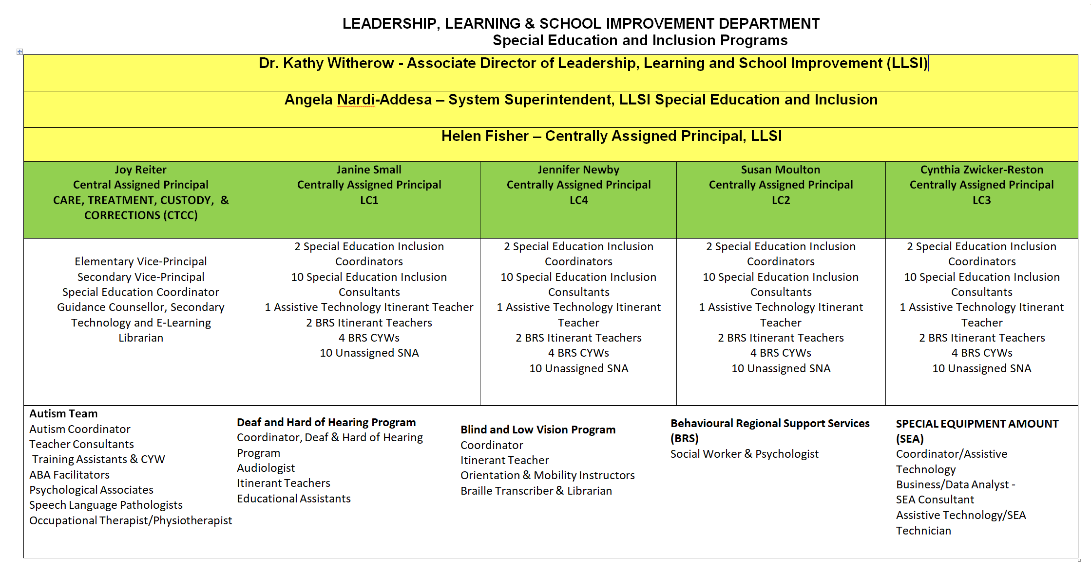

Learning and Leadership Department Roles and Responsibilities
The following outlines the role descriptions for centrally assigned educational personnel, who are available to provide assistance to schools in teaching students with special needs and students with exceptionalities.

Associate Director - Leadership, Learning and School Improvement
- Support the TDSB school improvement process which focuses on the interests, strengths, identities and abilities of each student
- Support staff to provide what all students need by helping leaders create the conditions for improvements in achievement, well-being and equity in each school
- Support the implementation of ensuring that all students with special education needs are served within the most enabling learning environment.
- Challenge all aspects of streaming in the TDSB
- Support a continuum of programming based on child development from the early years through high school
- Champion research to provide support to school improvement processes
- Lead a consistent and sharp focus on improving student achievement for all
- Oversees, coordinates and reviews Business Practices, Department Plan, Key commitments, and department messages
- Liaises with the Ministry of Education with regard to initiatives, directions, Ministry funding, policies and procedures
- Responds to Trustees’ questions, concerns and suggestions
- Participates in various system-wide committees

Superintendent – Special Education Services
- Supports the system in fostering equity and inclusiveness in the implementation of special education programs and services
- Provides area leadership in the implementation of the TDSB Special Education Plan
- Communicates exemplary delivery standards for all special education programs and services
- Oversees the annual staff allocation process related to the provision of special education programs and services, using data-informed decision-making
- Oversees the development, implementation, and review of secondary and elementary special education initiatives across the TDSB
- Works collaboratively with Special Education Learning Center Centrally Assigned Principals to build capacity and maintain consistency across the system
- Communicates with other staff in the system to ensure that services and programs are responsive to the needs of students, schools, families and communities
- Assists the appropriate Executive Superintendent in supporting SEAC members in carrying out their role as a statutory committee that advises the Board on matters related to special education
- Builds system capacity by working collaboratively with providers of professional learning across TDSB Departments to ensure the consistent use of professional learning strategies across the system
- Provides central coordination of special projects/initiatives (e.g., research projects)
- Oversees decision-making, data-gathering, analysis, prioritization and solution design related to the delivery of special education programs and services
- Responds to critical issues and concerns related to special education
- Represents the Special Education Department in various system wide committees and external committees with community partners

Principals

Centrally Assigned Principal – Central
- Provides leadership in implementing the Special Education component of the Integrated Equity Framework;
- Provides leadership in fostering equity and inclusiveness in the development and implementation of programs and services;
- Provides direct leadership in the implementation and review of the TDSB Special Education Plan;
- Collaborates in developing, implementing and communicating delivery standards for all special education programs and services including integral use of technology that is informed by current research-based pedagogy;
- Supports the Identification, Placement and Review Committee (IPRC) process consistent with relevant legislation and the Special Education Plan of the Toronto District School Board;
- Administers all aspects of staff allocation as related to the provision of special education programs and services;
- Provides support and oversight in the implementation of Ministry of Education initiatives and Policy/Program Memoranda;
- Fosters exemplary practices in assessment and instructional strategies, using evidence-based research and current best practices
- Develops, implements and provides effective Professional Learning, aligned to the Integrated Equity Framework, guided by the TDSB System Standards for Professional Learning in response to the needs of TDSB staff and their students with special needs in an inclusionary model of program delivery;
- Assists the Superintendent of Special Education and CTCC and Executive Superintendent as appropriate in reporting to the Board and the Ministry of Education as required;
- Collaborates on an on-going basis with other principals in the region and the system to ensure that services and programs are responsive to the needs of students, schools, families and communities;
- Provides leadership for Special Education Inclusion Coordinators and Inclusion Consultants;
- Responds to critical issues and concerns related to special education;
- Maintains effective budget control and fiscal management;
- Enhances opportunities for parent engagement to improve understanding of special education programs and services within the Board;
- Participates in meetings with parents, schools and communities to further an understanding of special education services;
- Attends a range of meetings within and outside the Board as required;
- Works in collaboration with the Special Education Advisory Committee (SEAC); and
- Other duties as assigned.

Centrally-Assigned Principal – Special Education Learning Centre
Within the Learning Centre:
- Provides leadership in fostering equity and inclusiveness in the development and implementation of programs and services
- Provides leadership in implementing the Special Education component of the Integrated Equity Framework;
- Provides direct leadership in the implementation and review of the TDSB Special Education Plan;
- Supports the implementation of the Vision For Learning;
- Collaborates in developing, implementing, and communicating delivery standards for all special education programs and services including integral use of technology that is informed by current research-based pedagogy
- Organizes all aspects of the IPRC process, consistent with relevant legislation and the TDSB Special Education Plan of the Toronto District School Board
- Effectively deploys and manages special education staff and resources to schools and Learning Networks
- Administers all aspects of staff allocation as related to the provision of special education programs and services
- Provides support and oversight in the implementation of Ministry of Education initiatives and Policy/Program Memoranda;
- Fosters exemplary practices in assessment and instructional strategies, using evidence-based research and current best practices of students with exceptionalities within ISP and regular classroom settings;
- Develops, implements and provides effective Professional Learning, aligned to the Integrated Equity Framework , guided by the TDSB System Standards for Professional Learning in response to the needs of TDSB staff and their students with special needs in an inclusionary model of program delivery;
- Assists the Superintendent of Special Education and CTCC in reporting to the Board and the Ministry of Education, as required
- Collaborates on an on-going basis with other principals in the region and the system to ensure that services and programs are responsive to the needs of students, schools, families and communities;
- Supervises and provides leadership for a regional special education leadership team of coordinators, consultants and teachers
- Supervises and provides leadership for a regional special education leadership team of Coordinators, Consultants and Teachers;
- Provides leadership for a team of exceptionality Coordinators;
- Responds to critical issues and concerns related to special education;
- Maintains effective budget control and fiscal management
- Attends a range of meetings within and outside the Board, as required
- Enhances opportunities for parent engagement to improve understanding of special education programs and services within the Board;
- Participates in meetings with Parent(s)/Guardian(s), schools, and communities to further an understanding of special education services
- Works in collaboration with the Special Education Advisory Committee (SEAC)
- Other duties as assigned

Centrally Assigned Principal - CTCC
- Provides leadership in fostering equity and inclusiveness in the development and implementation of programs and services to elementary and secondary schools and TDSB
- Supports the implementation of the TDSB A Vision for Learning
- Manages complex communication with teachers, educational assistants, agency staff, TDSB senior staff and central contacts, Ministry contacts, parents and students in support of sixty-five disparate programs across the GTA
- Manages ongoing relationships with 31 agencies and numerous staff within each agency, holding a high standard of accountability
- Coordinates the development and implementation of programs and services using data-informed decision-making;
- Fosters student and parent voice in alignment with the Six Threads of Inclusive Design;
- Ensures that program and service standards are developed and adhered to and that there is consistency and coordination is maintained in the delivery of exemplary programs
- Facilitates exemplary practices in assessment and instructional strategies, based upon evidence-based research and current best practices
- Collaborates and coordinates between several Ministries and the TDSB in terms of fulfilling the expectations of CTCC.
- Oversees tracking and monitoring of student achievement
- Oversees coordination of Individual Education Plans (IEPs) and Identification, Placement and Review Committee processes
- Ensures effective transition processes for students entering or exiting programs by aligning with TDSB system goals for student success in collaboration with Toronto District School Board staff
- Leads, supervises, evaluates and collaborates elementary and secondary vice-principals, chairs, assistant curriculum leaders, coordinator, teachers, educational assistants, office supervisor and office assistants
- Provides leadership related to effective networking opportunities and Professional Learning to build capacity for CTCC staff, guided by the TDSB System Standards for Professional Learning in response to the needs of staff and their students
- Oversees all operational procedures associated with the Toronto District Secondary School (TDSS) and the Toronto District Elementary School (TDES) such as grade reporting, staffing, timetabling of students and teachers, teacher performance appraisals, staff discipline processes, teacher absence, curriculum and program development, budget, deployment of resources, etc.
- Organizes and supervises annual Summer School
- Participates in Learning Networks and Special Education/TDSB initiatives to promote staff development and student achievement
- Participates in meetings with Superintendents of Education, Trustees, school communities and other central departments to further the understanding of excellence in teaching and engaged learning for students
- Negotiates and supports the Memorandum of Understanding between the TDSB and specific agencies under the mandate of the Ministry of Education (MOE) for “non-resident pupils”
- Liaises and collaborates with TDSB staff, outside agencies and government ministries who support the Care and Treatment component for students in CTCC to promote student wellbeing and achievement
- Liaises with the Ontario Administrators Association for Care, Treatment, Custody and Corrections (CTCC) in order to improve staff/administrator effectiveness through research into best practices
- Assists senior staff in providing reports to the Board, MOE and Special Education Advisory Committee (SEAC)
- Works collaboratively with agencies, TDSB staff, Central Accommodation Team and planning department on securing appropriate space with schools for CTCC
- Throughout the year, plans and leads vice principals, teachers and agency partners through all aspects of the Ministry Monitoring process
Vice Principals

Vice Principal – CTCC- Elementary and Secondary
- Provide leadership in anti-oppressive, equitable and inclusive practices in development and implementation of programs and services;
- Work in collaboration with the Centrally Assigned Principal to provide curriculum leadership and build teacher capacity across the developmental continuum;
- Extensive knowledge of TDSB Vision for Learning, Integrated Equity Framework Action Plan and Enhancing Equity Task Force Report and the Director’s Response;
- Leadership in the implementation of the TDSB Special Education Plan; coordinate the development and implementation of programs and services within the region using data-informed decision-making;
- Collaborate with 31 agencies serving elementary and secondary aged students to develop programming that meets the academic, social and emotional needs of students; Leadership in bi-monthly Partnership Meetings with all agency partners;
- Work effectively with parents and families who have need of agency intervention and assume a leadership role in the Central Intake Process;
- Facilitate IEP development and plan for the IPRC process and or case conferences to ensure the best possible transition for students exiting CTCC programs;
Develop methodology, in collaboration and consultation with the Coordinators of Special Education, for the smoothest possible transition of students;
- Understand and support the Memorandum of Understanding between the TDSB and specific Agency, realizing that this is under the mandate of the Ministry of Education for “non-resident pupils” who are in Care, Treatment, Custody and/or Corrections programs (C.T.C.C.);
- Manage and supervise all aspects of the grade reporting process for all students and facilitate the use of current assessment and evaluation practices through deep implementation of the Ministry’s Growing Success document;
- Manage and supervise the timetabling of students and teachers;
- Oversee teacher absence reporting;
- Complete Teacher Performance Appraisals;
- Support all aspects of secondary staffing:
- Coordinate Staff Professional Learning including the three foci on Achievement, Equity and Well-being and serve as a member of the Leadership Team and the Administrative Team;
- Participate in Learning Centre/Special Education initiatives for system-wide learning;
- Mentor and support new teachers through the NTIP Process;
- Liaise with other team members to provide direction to the office administrators in support of the disparately located programs and teachers;
- Perform all duties associated with a Vice-Principal as directed and delegated by the Centrally Assigned Principal;
- Lead effectively the infusion of technology in teaching and learning to increase digital fluency for all learners and to promote equity of outcomes;
- Leadership with each associated Ministry in consultation with the Principal: Ministry of Child and Youth Services Mental Health and Youth Justice, Ministry of Health;
- Participate actively in Ontario Administrators’ Organization for C.T.C.C. and attend meetings around the Province four times a year;
- Manages complex communication with teachers, educational assistants, agency staff, TDSB central staff contacts, Ministry contacts, parents and students in support of disparate programs across the GTA; and
- Other duties as assigned.

Coordinators

Central Coordinator – Autism Services
- Provides leadership in fostering equity and inclusiveness in the development and implementation of programs and services
- Acts as an expert resource to TDSB administrators, school staff, Parent(s)/Guardian(s) and the community
- Supports the implementation of the Special Education component of the TDSB Vision for Learning, Integrated Equity Framework and Director's Response to the Enhancing Equity Task Force.
- Is responsible for the development, implementation and provision of effective Professional Learning, aligned to the TDSB Vision for Learning, Integrated Equity Framework and Director's Response to the Enhancing Equity Task Force, guided by the TDSB System Standards for Professional Learning in response to the needs of TDSB staff and their students
- Liaises with other educational authorities and community agencies in response to program and service delivery needs within the Education Offices
- Coordinates the review, development, and implementation of current and identified special education processes and practices, in keeping with the needs-based focus of the Special Education Plan
- Liaises with Consultants/Co-ordinators/Centrally Assigned Principals in the regions to ensure the effective implementation of Autism Services;
- Provides expertise in programming for students with ASD needs, based on current research and best practices
- Coordinates services within the Connections Initiative for students with autism
- Fulfills specific TDSB-wide special education operational responsibilities, as assigned by the Senior Superintendent – Special Education
- Coordinates the development and implementation of programs and services for students with ASD in elementary and secondary schools
- Ensures that program and service standards are developed and adhered to, and that TDSB-wide consistency and coordination are maintained in the delivery of special education programs and services
- Coordinates services within the Autism Services Team
- Liaises with TDSB School Services to coordinate service practices with respect to instruction and assessment/evaluation for students with exceptional needs
- Provides leadership in TDSB elementary/secondary IEP development, transition planning, and quality assurance procedures
- Develops and implements relevant data management and research processes
- Provides central coordination for special projects/initiatives (e.g., research projects)

Central Coordinator – Processes, Practices and Procedures (SEA/SIP)
- Provides leadership in fostering equity and inclusiveness in the development and implementation of programs and services
- Acts as an expert resource to TDSB administrators, school staff, Parent(s)/Guardian(s) and the community
- Supports the implementation of the Special Education component of the TDSB Vision for Learning, Integrated Equity Framework and Director's Response to the Enhancing Equity Task Force.
- Is responsible for the development, implementation and provision of effective Professional Learning, aligned to the TDSB Vision for Learning, Integrated Equity Framework and Director's Response to the Enhancing Equity Task Force, guided by the TDSB System Standards for Professional Learning in response to the needs of TDSB staff and their students
- Liaises with other educational authorities and community agencies in response to program and service delivery needs within the Education Offices
- Coordinates the review, development, and implementation of current and identified special education processes and practices, in keeping with the needs-based focus of the Special Education Plan
- Fulfills specific TDSB-wide special education operational responsibilities, as assigned
- Liaises with Consultants/Co-ordinators/Centrally Assigned Principals in the regions to ensure the effective implementation of SEA (assistive technology) and SIP
- Works together with SEA/SIP Consultant, Assistive Technology Teachers and Technicians as a member of a team
- Ensures that program and service standards are developed and adhered to related to assistive technology and that TDSB-wide consistency and coordination is maintained in the delivery of exemplary Special Education programs and services
- Liaises with appropriate TDSB and Ministry of Education personnel re: Special Education business and procedural practices, e.g. SEA Claims, SIP Claims, standards, regulations
- Provides leadership in TDSB elementary/secondary IEP development, transition planning, and quality assurance procedures
- Develops and implements appropriate system-wide communication strategies that support an understanding of assistive technology in the TDSB (i.e., maintaining website, developing resources, newsletters, podcasts, Twitter, Facebook, etc.)
- Provides central coordination for special projects/initiatives

Special Education Coordinator – CTCC
Within the scope of the TDSB Special Education Plan, coordinate the development and implementation of programs and services using data-informed decision-making for students in TDES and TDSS
- Support the implementation of the TDSB A Vision for Learning
- Organize and facilitate the Central Intake process each month
- Provide leadership in fostering equity and inclusiveness in the development and implementation of programs and services
- Ensure that program and service standards are developed and adhered to and that TDSB-wide consistency and coordination are maintained in the delivery of exemplary Special Education programs and services
- Facilitate exemplary practices in assessment and instructional strategies, based upon evidence-based research and current best practices for specific exceptionalities
- Provide leadership as assigned in matters related to the coordination of special education services and the implementation of Shared Solutions
- Develop, implement and provide effective Professional Learning, guided by the TDSB System Standards for Professional Learning, in response to the needs of TDSB staff and their students with special education needs in the elementary level and in the secondary level in credit and non-credit courses
- Ensure that IEPs for students who are exceptional in CTCC meet TDSB system standards
- Coordinate the IPRC and SEPRC process for CTCC inclusive of TDES and TDSS
- Support students with special needs transitioning in and out of TDES and TDSS
- Support on-going use of web-based IEPs and IPRCs
- Develop and implement relevant data management and research processes, to determine current and future needs
- Act as an expert resource to principals, teachers, educational assistants, school staff, School Support Teams, special education staff, curriculum leaders, partner agencies and parents
- Liaise with TDSB departments, as well as educational authorities and community services in response to program and service delivery needs for students with exceptionalities
- Implement Ministry of Education and TDSB initiatives, policies and procedures related to Special Education
- Assume leadership for portfolios and/or projects related to special education within CTCC
- Assist the Centrally Assigned Principal in all administrative duties related to the programs and services for students who are exceptional
- Participate in meetings as required (including IPRCs, Case Conferences, Administrative Team, Student Success Team, Transition Committee, Special Education Department, etc.)

System Coordinators – Deaf/Hard of Hearing, Blind/Low Vision
Across the system for their exceptionality:
- Provides leadership in fostering equity and inclusiveness in the development and implementation of programs and services
- Coordinates the development and implementation of programs and services for Deaf and Hard of Hearing, Blind/Low Vision, and deafblind students in elementary and secondary schools
- Ensures that the Ministry of Education program and service standards are developed and adhered to, and that TDSB-wide consistency and coordination are maintained in the delivery of special education programs and services for students who are Deaf and Hard of Hearing and/or students who are Blind/Low Vision.
- Supports the implementation of the Special Education component of the Board Improvement Plan
- Responsible for the development, implementation and provision of effective Professional Learning, aligned to the Board Improvement Plan, guided by the TDSB System Standards for Professional Learning in response to the needs of TDSB staff and their students
- Acts as expert resources and support to TDSB administrators, central and regional staff, school staff, Parent(s)/Guardian(s) and the community with respect to the needs of students who are Blind/Low Vision, Deaf and Hard of Hearing, and deafblind.
- Liaises with Support Services with respect to assessment needs and ongoing support services
- Provides program-related leadership and expertise to staff
- Liaises with other educational authorities, provincial schools, and community agencies in response to program and service delivery needs
- Conducts assessments on referred students, and consult with special education staff, principals, teachers, and Parent(s)/Guardian(s) regarding possible placements
- Coordinates supports to identified students in conjunction with other School Services staff within the region and centrally
- Develop and implement professional development programs for staff working in the programs
- Coordinates all aspects of Special Education Equipment Funding claims
- Participates in the interview/selection process of qualified teachers and support staff

Special Education Inclusion Coordinators
The Special Education System Coordinator provides system leadership to promote success for all students with special education needs, K-12. The Special Education System Coordinator supports schools, families and communities in their work to promote inclusion, enhance student outcomes, and build community trust. An integral part of the System Coordinator role is the coordination and support for the IPRC process, and ensuring compliance with Ministry and TDSB policies and procedures related to special education.
:
- Provide leadership in fostering equity and inclusiveness in the development and implementation of programs and services;
- Provide system leadership within each Learning Centre for the coordination of central IPRC meetings for students with any/all exceptionalities;
- Collaborate with other Special Education System Coordinators to support the appropriate placement of all students;
- Support the implementation of the Multi-Year Strategic Plan and Special Education Plan’s focus on promoting inclusion;
- Ensure that program and service standards are developed and adhered to and that TDSB-wide consistency and coordination is maintained in the delivery of exemplary Special Education programs and services in all placement options throughout the TDSB;
- Support the process of collecting and interpreting data to enable staff to make informed decisions about programming for students;
- Provide leadership to schools as assigned in matters related to the coordination of special education programs and services, student placement decisions through the IPRC process, and the implementation of Shared Solutions;
- Develop, implement and provide effective Professional Learning in response to the needs of TDSB staff and their students with special education needs;
- Support projects involving assistive technology; this can include planning the use of technology in the school, providing support to students and teachers to incorporate technology into teaching and learning in collaboration with the Special Equipment Amount (SEA);
- Act as a resource to superintendents, principals, school staff, school support teams and parents to provide the latest information related to Special Education;
- Coordinate IPRCs for all Special Education class placements in the Learning Centre;
- Sit as a member of IPRCs;
- Contribute to the consideration of student placements into special education programs (e.g. Regular Class with Indirect/Resource Assistance/Withdrawal Assistance, Special Education Class Full Time/Partial Integration) with the goals of individual student needs and the Multi-Year Strategic Plan at the forefront of decision making;
- Liaise with Special Education Inclusion Consultants, System Coordinators and with other Board departments to ensure positive, inclusive outcomes for students;
- Liaise with other educational authorities and community services in response to program and service delivery needs;
- Support the Centrally Assigned Principal of Special Education in budget, staff and resource allocation;
- Support collaborative learning teams, supporting the school/department improvement process effectively; and
- Perform other duties as assigned with consideration to the unique needs of the department.

Consultants

Special Education Inclusion Consultant
Within an assigned Learning Network in the region the Inclusion Consultant provides instructional leadership, supports principals with the local IPRC process, works collaboratively with staff and families to promote success for students with special education needs K-12. The Special Education Inclusion Consultant is responsible for providing leadership and support for Special Education programs and services:
- Provide leadership in fostering equity and inclusiveness in the development and implementation of programs and services;
- Support staff and students so that all students can achieve success;
- Advocate for learning for all and inclusive education by coaching and supporting school administration and staff;
- Within the scope of the TDSB Special Education Plan and in collaboration with Superintendents, Principals, Special Education System Coordinators, and parents, provide consultative support and act as a resource for Special Education programs and services, including the TDSB Inclusion Initiative;
- Support Principals in the coordination, facilitation, and leadership of Identification, Placement, and Review Committee (IPRC) meetings at the school level.
- Support the School Support Teams in the referral of students to the Identification, Placement and Review Committee;
- Participate in annual local IPRC Reviews; Provide support for parents and schools with special education program, services, and decision making.
- Provide leadership to schools as assigned in matters related to the coordination of special education programs and services, and the implementation of Shared Solutions;
- Support and facilitate resource allocation processes focused on student and program needs;
- Provide leadership and direct instruction, mentoring and coaching to teachers to support exemplary practices in assessment and instructional strategies, Differentiated Instruction and Universal Design, and decision making based upon research and current best practices to allow students to receive education in the most enabling environment possible ;
- Provide support in projects involving assistive technology; this can include planning the use of SEA technology in the school, providing support to students and teachers to incorporate technology into teaching and learning;
- Provide direct modelling, job-embedded professional learning and coaching to teachers and students in using assistive technology;
- Support and collaborate with Principals, Special Education and regular class teachers, and parents in the development and monitoring of Individual Education Plans including transition plans, which reflect exemplary programming and assessment, to meet student needs;
- Contribute to School Support Team meetings to determine appropriate responses, recommendations and strategies for students with special education needs;
- Act as a resource to superintendents, principals, school staff, school support teams and parents to provide the latest information related to Special Education;
- Provide direct service to students as it supports the capacity building of the classroom teacher to in response to the needs of TDSB staff and their students with special education needs (i.e.. IEP development, IPRC Referrals, Behaviour Analysis);
- Support the principal and School Support Teams in the Special Equipment Amount (SEA), Special Incidence Portion (SIP), Identification, Placement, and Review Committee (IPRC) and Special Education Program Recommendation Committee (SEPRC) processes;
- Support the process of collecting and interpreting data at the school level to enable staff to make informed decisions about programming for students;
- Support positive, collaborative, and constructive relationships between the school and parents to effectively and collaboratively meet students’ needs
- Support collaborative learning teams, supporting the school improvement process effectively; and continually increase professional knowledge and skills through participation in professional learning activities and research; sharing knowledge and expertise with the Learning Centre;
- Perform other duties as assigned with consideration to the unique needs of the Learning Centre and to meet system need.

Special Education Consultants – ASD Team
Within two assigned Learning Centres and as assigned:
- Provide leadership in fostering equity and inclusiveness in the development and implementation of programs and services
- Support and collaborate with both special education and regular class teachers in the development and monitoring of Individual Education Plans and Transition Plans to meet the needs of students with an ASD
- Acts as a resource to principals, school staff, school support teams, special education staff, and parents
- Collaborate with Toronto Partnership for Autism Services (TPAS) and other Intensive Behaviour Intervention (IBI) or Applied Behaviour Analysis (ABA) service providers in the transition of students
- Collaborate with the Central Coordinator, Autism Services, special education consultants and coordinators and other board departments in the identification of training and resource requirements within the TDSB
- Monitor and maintain a database of students with ASD, including those transitioning into the TDSB
- Provide direct service including modeling strategies with students, demonstrating how to use resources or implementing suggestions offered to teachers
- Support the implementation of all Special Education Policies, Procedures, and Policy/Program Memoranda (e.g. PPM 8, PPM 140, PPM 156) including the TDSB Inclusion Initiative
- Develop, implement and provide effective Professional Learning in response to the needs of TDSB staff and their students with special education needs (e.g. IEP development, IPRC Referrals, Behaviour Analysis)
- Collaborate with Special Education Consultants and Coordinators and with other Board departments to ensure positive outcomes for students
- Perform other duties as assigned with consideration to the unique needs of the department

Special Education Consultant – Assistive Technology (SEA)
Across the system and as assigned:
- Provides leadership in fostering equity and inclusiveness in the development and implementation of programs and services
- Acts as an expert resource and provide training as necessary to the principals, staff, school support teams, special education staff, instructional leaders, teachers and parents about the SEA and SIP processes
- Audits and completes SEA and SIP application packages to meet Ministry standards and participate in Ministry audits
- Supports the implementation of the Special Education component of the Board Improvement Plan
- Supports SEA and SIP processes by ensuring appropriate data is collected for Ministry and maintained on SAP
- Works together with Central Coordinator responsible for SEA/SIP and Assistive Technicians as a member of a team
- Supports and promotes initiatives through social media
- Works alone or in collaboration with other staff to implement & provide effective Professional Learning and training , guided by the TDSB System Standards for Professional Learning, to support system-wide specific initiatives, assist staff in incorporating assistive technology in their teaching methods, and to educate students and staff on the software programs in order that students are able to access the curriculum and meet the goals set out by the IEP
- Aids teachers in development of IEPs to reflect use of assistive technology for SEA claims and behaviour management strategies for SIP claims
- Supports the implementation of Read and Write across TDSB and other initiatives supported by the SEA claim process, i.e., Ministry software, Interactive whiteboards and/or other initiatives
- Provides professional development support for parents regarding assistive technology software via online resources and workshops throughout the year
- Maintains a central database and records, including student achievement data to assist in assessing the effectiveness of specific initiatives
- Other duties as assigned

Special Education Itinerant Teachers

Special Education Itinerant Teacher – Behaviour (Elementary & Secondary)
Within a Learning Centre and as assigned:
- Provide leadership in fostering equity and inclusiveness in the development and implementation of programs and services, while improving student achievement and well-being and ensuring equitable access and outcomes
- Support teachers, in both regular and special education classes, in the development and implementation of a range of programming interventions, strategies and resources that address the needs of students with behavioural challenges
- Write reports to document recommended interventions, strategies and resources
- Work as part of a multi-disciplinary team to promote positive behaviour support strategies that enhance student understanding of the school environment and its expectations
- Support and collaborate with teachers in the development, implementation, and monitoring of Individual Education Plans (Behaviour Support Plans), Safety Plans, ABC Chart Data, functional behaviour approaches and procedures related to PR 699
- Support and collaborate with teachers in the collection and analysis of data to support student success
- Attend regular BRS meetings to develop and promote best practices
- Support the implementation of all Special Education Policies, Procedures, and Policy/Program Memoranda (e.g., PPM 8, PPM 140, PPM 156)
- Gather information through observations, consultation with school staff and the collection of data to determine variables contributing to the challenging behaviour
- Maintain written records and documentation related to services provided (e.g., log notes, report writing, tracking forms)
- Develop, implement and provide effective professional learning in response to the needs of TDSB staff and their students with behavioural challenges
- Support the implementation of the Special Education Plan, including the TDSB Inclusion Initiative
- Partner with TDSB staff, parents and appropriate community services in ongoing program development, implementation and evaluation
- Communicate as necessary with teachers and parents with respect to student behaviour support plans
- Provide expertise in programming and assessment for students with behavioural challenges through mentoring, demonstration, and the provision of professional learning opportunities
- Participate in the prioritization of referrals and management of complex cases
- Attend training and professional learning sessions commensurate with the role
- Perform other duties as assigned with consideration to the unique needs of the department

Special Education Itinerant Teacher – Assistive Technology (SEA)
Within a Learning Centre and as assigned:
- Provide leadership in fostering equity and inclusiveness in the development and implementation of programs and services
- Provide support in all aspects of implementing projects (K-12) involving assistive technology; this can include consulting with the school regarding hardware, software and training needs, planning the use of technology in the school, providing one to one support to students and teachers to incorporate technology into teaching and learning, and follow up on an ongoing basis
- Provide direct modelling, job embedded professional learning and coaching to teachers and students in using assistive technology on an ongoing basis (ie. Ministry software, SEA software, interactive whiteboards and /or new projects being explored for students in Special Education)
- Support teachers in using assistive technology with students in order that they are able to access the curriculum and meet the goals set out by the IEP
- Directly support and collaborate with teachers in the development of IEPs to reflect the use of assistive technology for SEA claims
- Assist school staff in the development of SEA claims
- Provide and implement effective professional learning and training regarding system initiatives and assistive technology to school staff and administration
- Act as an expert resource to principals, school staff, school support teams, special education staff and instructional leaders, teachers and parents to provide the latest information and research
- Attend and participate in Ministry and TDSB sponsored professional learning to be aware of the latest developments in technology and find and share innovative ways to integrate new technology into Special Education programs
- Collaborate with Special Education Consultants and Coordinators and with other Board departments to ensure positive outcomes with students
- Develop and implement appropriate communication strategies that support an understanding of assistive technology and a sharing of excellent practices in the TDSB to build capacity among staff who are implementing initiatives
- Provide professional development for parents regarding assistive technology (e.g. online resources, workshops)
- Support the implementation of the Special Education Plan, including the TDSB Inclusion Initiative
- Liaise with SEA Team technicians with respect to solutions regarding technical issues that may arise when implementing projects
- Maintain a central database and records, including student achievement data to assist in assessing the effectiveness of specific special education initiatives
- Develop learning communities that support the implementation of assistive technology projects and provide ongoing mentorship through coaching/job embedded in-school professional development
- Perform other duties as assigned with consideration to the unique needs of the department.

Special Education Itinerant Resource Teachers – Secondary Alternative Programs
- Provides leadership in fostering equity and inclusiveness in the development and implementation of programs and services
- Provides support for instruction based on students’ learning styles, strengths and needs in a variety of settings which will include Secondary Alternative School sites
- Assists school staff in determining appropriate responses and strategies to address the issues of students with special needs
- Works collaboratively with school staff/classroom teachers to effectively support the classroom program for their students with special education needs
- Supports and collaborates with both Special Education and regular class teachers, as well as students and parents in the development and monitoring of Individual Education Plans and transition plans to meet the exceptional needs of secondary students
- Participates in the ongoing assessment of the academic progress of secondary students with special needs
- Supports the School Support Teams in the referral of students to the Identification, Placement and Review Committee (IPRC)
- Facilitates the delivery of secondary Special Education programs and services that meet standards developed by the TDSB
- Acts as a resource to the principals, school staff, School Support Teams and curriculum leaders within the secondary alternative schools
- Builds capacity among in-school staff who are implementing strategies for students with special needs;
- Establishes effective working procedures, a data management system and an effective communication process to track students receiving support
- Maintains effective communication with Central Special Education staff
- Develops, implements and provides effective professional learning for schools, Family of Schools, quadrant or at the system level, aligned to the Board Improvement Plan, guided by the TDSB System Standards for Professional Learning in response to the needs of TDSB staff and their secondary students
- Assists staff in the implementation of the principles of ABA as outlined in PPM 140
- Supports the principal and School Support Teams in the SEA and SIP process
- Other duties as assigned

School-Based Special Education Teaching Staff
Within each school, teachers holding additional qualifications in Special Education may receive the following assignments:
Elementary Home School Program (HSP) Teacher
The Special Education teacher in the Home School Program works in collaboration with the student's regular classroom teacher to address the student's needs. The primary role of the HSP teacher is to deliver and support specific parts of the curriculum and work with the regular classroom teacher to coordinate teaching responsibilities, schedule the student's day, assign homework, and monitor the student's progress.
Elementary Methods and Resource Teacher (MART)
This is a voluntary role for a Special Education teacher within each elementary school designed to provide support to students and staff. Ongoing professional learning opportunities prepare the Special Education teacher to offer Special Education programming expertise and resources in the school.
Elementary and Secondary Resource Program Teacher
In both Elementary and Secondary schools, the Resource Program provides students with support from a Special Education teacher. Depending on the school model, this can be delivered in a number of ways. For more information see Community Based Resource Model (CBRM).
Teacher in Special Education Class Full Time
Teachers in full time Special Education classes work with those students who require a more intensive level of support than is available through a regular class placement.
Secondary Curriculum Leader (CL) & Assistant Curriculum Leader (ACL)
The Curriculum Leader and Assistant Curriculum Leader of Special Education are positions of responsibility assumed by qualified Special Education teachers in Secondary Schools. These teachers may have subject teaching assignments in addition to those related to the management and delivery of differing levels of support to students with IEPs.
Kindergarten Early Language Intervention (KELI) Program Teacher
The KELI staff work under the supervision of the Centrally Assigned Principals of Special Education and Chiefs of Speech-Language Pathology for the assigned regional office. The teacher, in collaboration with the KELI speech-language pathologist:
- Implements oral language and early literacy programming to meet the needs of the KELI students
- Instructs four groups of eight Senior Kindergarten students, for a total of 32 students
- Observes the KELI Program students in their home school Kindergarten programs and provide programming suggestions/supports for their teachers
- Evaluates KELI program students’ oral language, early literacy, and social communication skills
- Communicates regularly with and provide support for Parent(s)/Guardian(s) of KELI Program students
- Reports orally in each term and in writing to Parent(s)/Guardian(s) and home school teachers mid-program and on completion of the program to Parent(s)/Guardian(s) and home school teachers
Special Education Teacher – CTCC Programs
- Provides leadership in fostering equity and inclusiveness in the development and implementation of programs and services as reflected in Years of Action
- Works as a member of a multi-disciplinary team who programs for the educational needs of the students in concert with the treatment goals of the partnership agency within a structured, nurturing and non-traditional environment
- Collaborates with the agency to develop programming that meets the academic, social and emotional needs of the students
- Participates in all aspects of Special Education Plan (IEP) development and implementation and IPRC planning
- Participates in and initiates transition planning with the agency and community
- Leads and facilitates the delivery of Ontario Ministry of Education Curriculum, and for students with MID or DD, curriculum delivery is linked to functional academics and activities of daily living
- Uses current assessment practices through implementing Growing Success
- Works in partnership with Agency personnel in a shared governance classroom
- Teachers in the Secondary Panel may also be responsible for the delivery of credit accumulation courses
- Teachers in CTCC are responsible for the stewardship of the resources and alignment with current best practices

Paraprofessional Support Staff
ABA Facilitator
- Works as a member of a multi-disciplinary team in support of other members of the ASD team, bringing expertise in the area of ABA instructional methods
- Supports the implementation of TDSB and Ministry of Education initiatives such as PPM 140, etc;
- Collaborates with Toronto Partnership for Autism Services (TPAS) and other IBI service providers in the transition of students receiving IBI services
- Works directly in the classroom to model appropriate ABA instructional methods to teachers and support staff
- Acts as a resource to principals, school staff, school support teams, special education staff, instructional leaders, teachers and parents
- Participates in and deliver professional development activities
- Other duties as assigned
Deafblind Intervenor
Deafblind Intervenors work with students, who have been assessed by the W. Ross Macdonald School for the Blind, Deafblind Resource Department as being “educationally deafblind”. They have been specially trained to intervene between students who have a dual sensory hearing and vision loss and the environments/classrooms. Following the TDSB tiered approach, Deafblind Intervenors may work with more than one student who is deafblind.

Educational Assistant (EA)
EAs work under the direction of the teacher and/or principal. They provide assistance in the presentation of a meaningful program by involvement in the classroom and playground activities, on excursions, and other areas as directed by the principal. Depending on their qualification categories, they enable students with a variety of emotional, behavioural, physical, personal care, and medical and academic needs to access the curriculum.
Sign Language Facilitator
Sign Language Facilitators communicate through American Sign Language (ASL) to help make the curriculum accessible to students who use sign language as their primary method of communication.
Special Needs Assistant (SNA)
SNAs are assigned to schools to assist regular or special-needs classroom teachers who have students with special needs who are “high risk” (special safety or medical needs) in their classes. Such needs present a constant, immediate, and extreme risk to the students and/or others.

Professional Support Services Department Roles and Responsibilities
The following outlines the role descriptions for centrally assigned professional support services personnel, who are available to provide assistance to schools in working with students with special needs and/or exceptionalities. The TDSB provides a variety of support services to:
- Assist teachers in understanding the special needs of students
- Support students in accessing the curriculum
- Link programming suggestions and/or recommendations to curriculum expectations
- Help teachers to select accommodations and modifications for IEPs for students with special needs

Professional Support Services includes the following professional services:
- Child and Youth Services
- Occupational Therapy and Physiotherapy
- Physiotherapy and Occupational Therapy
- Psychology
- Social Work and Attendance
- Speech and Language Pathology
Professional Support Services staff may be contacted through the School Support Team. Support Services staff are supervised and organized by the Senior Manager of Professional Support Services, through the Managers of the individual professional services.
Senior Manager of Professional Support Services
The Senior Manager of Professional Support Services is responsible for the organization and coordination of all professional support services available to students, schools, families, and communities within the TDSB. The primary objectives for this position are to:
- Develop related policy initiatives and implement a coordinated service delivery plan for psychological, social work and attendance, occupational therapy/physiotherapy, and speech-language pathology, and child and youth services
- Allocate all staff and resources as they relate to support services to ensure equitable delivery of support services across the TDSB
- Develop, create, recommends, and implements strategies for effective budget control and fiscal management
- Develop, implement, and communicate delivery standards for all support services within established frameworks defining professional practice and ethics
- Ensure all services are provided on the basis of best practices, are needs driven, and are supported by appropriate professional development
- Implement a Board-wide strategy for the deployment of Support Services personnel in response to tragic events
- Participate in meetings with schools and communities to further an understanding of student support services and respond to concerns raised regarding services provided
- Liaise with other stakeholders to represent the Board as required
- Report to the Board and the Ministry of Education as required

Child and Youth Services
Manager of Child and Youth Services
The Manager of Child and Youth Services is responsible district wide for the effective delivery of Child and Youth Services (CYS). The Manager:
- Is a resource to Principals and Employee Services, and participates in the hiring, supervising, and monitoring of the performance of Child and Youth Services staff
- Provides leadership to CYS staff in the development and implementation of programs and a service delivery model for Child and Youth Services that supports student achievement, well-being and equity
- Monitors and authorizes budget expenditures within established parameters
- Provides supervision to staff requiring consultation of specific issues
- Works collaboratively with Special Education Services and Safe and Caring Schools
- Chairs regularly scheduled staff meetings and system-wide professional development initiatives for CYS staff
- Consults with schools, school officials, and Parent(s)/Guardian(s) regarding delivery of child and youth services, to clarify and communicate the role and functions of Child and Youth Counsellors and Child and Youth Workers within the TDSB, and address issues or concerns about these services
- Liaises with the Senior Manager of Professional Support Services to maintain an ongoing understanding of student, school, and community needs of child and youth services
- Liaise with outside resources, including children’s mental health centres, community organizations, social agencies and professional bodies regarding provision of service

Child and Youth Worker
- Provide support to students in the acquisition, reinforcement and maintenance of academic, communication, social and personal management skills
- Collaborate with teachers on effective classroom programming and behaviour management techniques to prevent and remediate learning and behaviour problems and to develop social/emotional and life skills
- Develop and provide behaviour management plans for individual students and groups of students, including objectives and evaluation criteria
- Develop and provide social, emotional and life skill development programming to individual students and groups of students
- Intervene to prevent or respond to disruptive and/or behavioural situations as they arise in the school/classroom setting with life space interventions, de-escalation, mediation, conflict resolution, removal, isolation or containment
- Collaborate with teachers to refer students to School Support Team, and in the completion and implementation of ABC logs and safety plans
- Liaise with other Professional Support Service staff to address factors that affect student achievement and well-being
- Support the supervision of regularly assigned students during non-classroom activities as required
- Provide professional development workshops to teachers and parents, guardians, caregivers, and family
- Liaise and provide information to students and families regarding community resources
Child and Youth Counsellor
- Provide assistance to students in the acquisition, reinforcement and maintenance of academic, communication, social and personal management skills
- Collaborate with Social Workers and Attendance Counselors to provide a continuum of counseling services for at-risk students
- Liaise with other Professional Support Service staff to address factors that affect student achievement and well-being
- Work as part of the multidisciplinary team (Guidance, Student Success, Safe and Caring Schools, Special Education) to develop proactive strategies and programs aimed at enhancing student success
- Provide group or individual short term goal oriented, crisis intervention and conflict resolution counseling
- Report on students’ needs, progress, problems, etc. on a regular basis
- Provide professional development workshops to teachers and parents, guardians, caregivers, family
- Liaise and provide information to students and families regarding community resources

Occupational Therapy and Physiotherapy Services
Manager of Occupational Therapy and Physiotherapy
The Manager of Occupational and Physiotherapy (OT/PT) Services is responsible district wide for the effective delivery of OT/PT services to special programs and students. The Manager:
- Hires, supervises, and monitors the performance of Physiotherapy and Occupational Therapy Services staff
- Allocates staff to Families of Schools and special programs, where possible
- Monitors and authorizes budget expenditures within established parameters
- Works collaboratively with Special Education and other Support Services to support and ensure readiness of response to any medical emergency/fire and evacuation
- Implements regularly scheduled staff meetings and professional development initiatives, and provides leadership to staff to promote an understanding of the service delivery model for OT/PT services
- Consults with school administrators, staff, and Parent(s)/Guardian(s) regarding delivery of the OT/PT services and to resolve issues or concerns about these services
- Works collaboratively with special education services regarding IPRCs and other priorities
- Chairs regularly scheduled staff meetings and implements professional development initiatives, and provides leadership to staff to promote an understanding of the service delivery model for Physiotherapy and Occupational Therapy services
- Liaises with the Senior Manager of Professional Support Services to maintain an ongoing understanding of student, school, and community needs for physiotherapy and occupational therapy services
- Liaises with outside agencies, including but not limited to LHIN, Bloorview Kids Rehab, and Hospital for Sick Children, regarding provision of PT/OT services.
- Consults regarding PT/OT Services to maintain an ongoing understanding of student, school, and community needs for PT/OT services within the context of a coordinated support service
- Manages/monitors all aspects of PT/OT files, as required by PHIPA and the Colleges of Occupational and Physiotherapy
- Consults with staff regarding specific case issues
- Provides leadership to staff to promote an understanding of the service delivery model for Physiotherapy and Occupational Therapy services
- Liaises and coordinates with Local Health Integration Networks (LHIN) all OT/PT services for school-age students by LHIN (in programs not directly supported by TDSB OT/PT services)
Occupational Therapist / Physiotherapist
Physiotherapists / Occupational Therapists provide consultation and therapeutic programming support for students with physical disabilities or developmental disabilities. They:
- Liaise with the Manager of Physiotherapy and Occupational Therapy Services to maintain an ongoing understanding of student, school, and community needs for Occupational and Physiotherapy services
- Liaise with outside agencies, including LHIN, Bloorview Kids Rehab, and Hospital for Sick Children, regarding provision of service
- Participate on School Support Teams to contribute specialized knowledge and resources regarding developmental disabilities, physical disabilities, and health issues, as well as fine, gross, and sensory motor difficulties and how they impact on independence and classroom function
- Participate as part of an interdisciplinary team (IEP, intake, transition reports, etc.)
- Assess gross motor, fine motor, and sensory motor function and adaptive skills, and provide physical-management recommendations
- Conduct feeding assessments
- Collaborate with regular and special education teachers to design programming based on classroom curriculum according to Ministry of Education expectations
- Make recommendations for Parent(s)/Guardian(s) to support independence and development at home
- Provide early fine, gross, and sensory motor intervention, while encouraging literacy and numeracy and social programming for young students at risk in all diagnostic Kindergartens, in collaboration with the teachers in the Kindergarten Education, Early Intervention, and Prevention (KEEP) program
- Provide transition intake support for daycares and specialized nursery schools for students with physical and developmental disabilities who have received community occupational and physiotherapy services
- Provide recommendations, design, and provision of adapted equipment and assistive devices (SEA, ADP) for all students, as required to facilitate independence within the school environment and full participation in curriculum, including adapted and modified curriculum

Psychological Services
Managers of Psychology Services
The Managers of Psychological Services have responsibility within an Education Office for the effective delivery of psychological services. They:
- Allocate staff to Families of Schools and special programs based on relevant data about need
- Monitor and authorize budget expenditures within established parameters
- Supervise staff regarding case issues
- Work collaboratively with Special Education Services regarding IPRCs and other priorities
- Chair regularly scheduled staff meetings, implement professional development initiatives, and provide leadership to staff to promote an understanding of the service delivery model for psychological services
- Consult with schools, school officials, and Parent(s)/Guardian(s) regarding delivery of psychological services and resolve issues or concerns about these services
- Liaise with the Senior Manager of Professional Support Services to maintain an ongoing understanding of student, school, and community needs for psychological services
- Liaise with outside agencies, including children’s mental health centres, social agencies, and hospitals, regarding provision of service
Psychologist / Psychological Associate / Psychoeducational Consultant
- Consult with teachers and School Support Teams on effective classroom programming and behaviour-management techniques to prevent and remediate learning and behaviour problems
- Provide comprehensive individual psychological assessment of students’ learning and social-emotional development to diagnose disorders, identify students’ learning strengths and needs, and to recommend effective intervention strategies
- Provide short-term counselling to students
- Provide crisis management to teachers, students, and their families for traumatic experiences such as suicide, school and community violence, child abuse, and death
- Provide risk assessments and develop risk-management plans for students who demonstrate violent behaviours that put themselves or others at risk
- Liaise and refer to community healthcare and social service professionals and agencies, and coordinate services
- Provide clinical crisis intervention to students who are at imminent risk of suicide
- Provide professional development workshops for teachers and Parent(s)/Guardian(s)
- Coordinate with Special Education Services to develop IEPs and participate as a member of the Identification, Placement, and Review Committee (IPRC) and Appeals Committees
- Liaise with other Professional Support Service staff to address factors that affect student performance and well-being
- Provide professional individual and group counseling services to address factors that affect student performance and well-being (e.g., anxiety, depression, stress management)
- Provide assistance and support to school staff in increasing student well-being (e.g., mindfulness, resilience, positive psychology)

Social Work and Attendance Services
Manager of Social Work and Attendance
The Managers of Social Work and Attendance are responsible within an Education Office for the effective delivery of attendance and Social Work services. They:
- Hire, supervise, and monitor the performance of Social Work and attendance staff
- Allocate staff to Families of Schools and special programs
- Monitor and authorize budget expenditures within established parameters
- Consult with staff regarding professional case issues
- Convene and supervise the crisis response teams, as required within the Education Office
- Implement regularly scheduled staff meetings and professional development initiatives, and provide leadership to staff to promote an understanding of the service delivery model for social work and attendance services
- Consult with schools, school officials, and Parent(s)/Guardian(s) regarding delivery of Social Work and attendance services and to resolve issues or concerns about these services
- Liaise with the Senior Manager of Professional Support Services to maintain an ongoing understanding of student, school, and community needs for Social Work and Attendance services
- Liaise with outside agencies, including CAS, CCAS, JCAS, social service providers, children’s mental health centres, and hospitals, regarding provision of service
- Provide Social Work expertise and perspective on board-wide committees

Social Workers
- Provide a lead role in Mental Health and Wellness promotion, education, initiatives, resources, policies and procedures
- Participate on School Support Teams to contribute expertise regarding the connections between social-emotional development, mental health and wellness home life, and student achievement
- Consult with teachers, guidance staff, and school administrators regarding behavioural management, social-emotional issues, social skills development, and anger management strategies to facilitate students’ academic success
- Consult, mediate, advocate, and problem-solve with principals and superintendents regarding high-risk students and their families, child abuse, and crisis/tragic events
- Provide attendance counselling when students are identified with attendance problems at the elementary level
- Provide risk assessments as part of a school team and develop risk-management plans for students who exhibit behaviours that put themselves or others at risk
- Offer accessible professional counselling services to students and/or their families in the school and/or home setting
- Provide professional counselling to victim(s), students, school personnel, Parent(s)/Guardian(s), and community when staff or volunteers are charged with any sexual offence
- Offer clinical crisis intervention and support to students and families at imminent risk (suicide)
- Facilitate links between the family and the school
- Provide consultation to behavioural classes on social-emotional issues
- Provide group counselling to address factors that affect student performance and well-being (e.g., grief, separation/divorce, social skills, bullying and anger management)
- Per Board Policy C.07, Procedure 001, Section D, provide consultation to principals and teachers
- Identify and report abuse and neglect of students, and provide ongoing counselling to the victim and family and others affected by the incident
- Liaise with community agencies to ensure effective responses to students and families
- Provide professional development to teachers and Parent(s)/Guardian(s) on child abuse, behaviour management, and Parent(s)/Guardian(s)/child relationships, bullying, anger management, etc.

Social Workers, Mental Health and Well Being – System Support
- Provide support and guidance to school staff, students and parents regarding social/emotional issues which impact on students’ success and well-being;
- Provide consultation in the area of mental health and well-being to: School administrators and teachers, parents, central staff and departments and community agencies.
- Provide support to students, families and school communities in crisis intervention/tragic event response;
- Provide support, guidance and training related to identifying and reporting child abuse; and
- Provide leadership and work with other staff and central departments to support the implementation of the Children and Youth Mental Health and Well-Being Strategy;
- Work with all Professional Support Services staff, Superintendents, Principals, school staff, students and parents to support “Mentally Healthy Schools”;
- Organize, plan and deliver effective professional learning in the area of mental health and well-being;
- Develop and adapt materials and resources in a variety of media for use throughout the system;
- Chair meetings and work with a variety of committees including the FOS Mental Health Lead Principals/Vice-Principals and the Mental Health Leadership Team, as they relate to mental health and well-being activities at the TDSB;
- Implement all Ministry of Education expectations related to School Mental Health – ASSIST;
- Attend and participate in Ministry of Education School Mental Health – ASSIST meetings and activities;
- Develop working relationships with community agencies and external partners, including the Mental Health and Addictions Nurses and Toronto Public Health to support service provision to students;
- Support students and families to navigate and access needed community resources and external services; and
- Represent the Toronto District School Board on community-based partnerships/forums/collaboratives related to students’ mental health and well-being.
- Other duties as assigned by the interim Senior Manager, Professional Support Services.
Attendance Counsellors
- Are assigned to address attendance issues at the secondary school level (at the elementary level, the school social worker is responsible for these referrals)
- Consult with school personnel and Parent(s)/Guardian(s) and examine patterns of irregular attendance
- Work with students to continue their education, helping them return to their regular classes or attend modified or alternative programs
- Present students to the SAL committee and monitor their progress (Attendance Counsellor – SAL)
- Initiate court proceedings for students and families around truancy issues (Attendance Counsellor – SAL)

Speech-Language Pathology Services
Manager of Speech-Language Pathology Services
The Managers of Speech-Language Pathology Services have responsibility for the effective delivery of speech-language pathology services. They:
- Hire, supervise, and monitor the performance of Speech-Language Pathology Services staff
- Allocate staff to Families of Schools and special programs
- Monitor and authorize budget expenditures within established parameters
- Consult with staff regarding case issues
- Work collaboratively with special education services regarding IPRCs and other priorities
- Chair regularly scheduled staff meetings, implement professional development initiatives, and provide leadership to staff to promote an understanding of the service delivery model for speech and language services
- Consult with school staff and Parent(s)/Guardian(s) regarding delivery of speech-language pathology services and to resolve issues or concerns about these services
- Liaise with the Senior Manager of Professional Support Services to maintain an ongoing understanding of student, school, and community needs for speech-language pathology services
- Liaise with outside agencies, including Local Health Integration Networks (LHIN) and hospitals, regarding provision of service
Speech-Language Pathologists
- Participate on School Support Teams to contribute specialized knowledge and resources regarding the connections between communication, learning, literacy, and social development
- Assess students’ communication skills in oral language, phonological awareness, related difficulties in literacy development, and functional social communication, working with cultural-linguistic informants to distinguish second-language issues (e.g., ESL, ELD) from language disorders
- Collaborate with regular and special education teachers to design language, literacy, and social communication programming based on classroom curriculum according to Ministry of Education expectations
- Provide recommendations for Parent(s)/Guardian(s) to support communication development at home
- Support teachers in developing curriculum-based oral language, written language, and communication skills on IEPs
- Provide early language, literacy, and social programming for young at-risk students from high-need schools in collaboration with the teacher at ten Kindergarten Early Language Intervention (KELI) programs
- Provide transition support for preschool children who have received community speech and language services and referral of school-age students for Community Care Access Services (speech therapy for voice disorders, articulation, stuttering)

Transportation for Students in Special Education
These guidelines have been developed to provide general information about the transportation service for students who are eligible for transportation, and to outline the responsibilities of all parties involved in the safe transportation of students. The success of the transportation service depends on the co-operation of parent(s)/guardian(s), teachers and transportation companies.
Parent(s)/Guardian(s) are encouraged to review these guidelines and to keep this information in a convenient location for easy reference. Specific details may vary from school to school. Clarification can be obtained through the school principal or Area Supervisor of Transportation.
Additional information and all forms can be found on the Student Transportation pages of the TDSB website.

TDSB Transportation Policy and Procedures
The Toronto District School Board is committed to providing safe and reliable transportation for resident students in accordance with the Education Act, Section 21 and the Operational Procedures (PR 504) of the TDSB Transportation Policy (PO20).
Transportation is provided for students who are placed by the Identification, Placement, and Review Committee (IPRC) to a Special Education program that is not located in their home school and who meet the eligibility criteria.
When a special education placement is offered at a school other than the home school, transportation needs should be discussed with the parent(s)/guardian(s) to determine if transportation arrangements are required. If so, the sending school arranges for the parent(s)/guardian(s) to complete a Student Transportation Application form (which forms the individual school transportation plan) and forwards it to the transportation office once the school section is also completed.
Parents shall ensure that all relevant information as it pertains to the student’s ability to access transportation is documented, any limitations clearly identified, and a safety plan is noted on Page 2 of the application or forwarded as an attachment. Parents shall also be provided with a copy of the Transportation Brochure for Students with Special Needs available at: http://tdsbweb/webdocuments/Transportation/docs/Transportation%20Brochure_tstg_special2016.pub
It highlights roles and responsibilities for the various parties including the boarding, securement, and de-boarding of students from transportation vehicles.
The transportation office forwards a copy of the application form to the receiving school, indicating on the form whether or not a student has met board criteria and been approved for transportation. In late August, the administrator of the receiving school is asked to ensure that school bus information (bell times, pick-up and drop-off locations, documented student disabilities/accessibility issues, etc.) is correct for the students at their school.

Method of Transportation Service
For eligible students in Junior Kindergarten to Grade 5 transportation is provided by contracted carrier services (70 and 18 passenger buses, wheelchair buses, mini-vans or taxis). Each student is entitled to a total of two trips per day. Mid-day routes are intended for students attending half-day programs. Methods include:
- School to school transportation
- Designated site-to-school transportation as a result of an Identification, Placement, and Review Committee or for medical reasons
- Home-to-school transportation for Special Education students in district-wide programs
- Mini-van or taxi service for eligible students in warranted circumstances
For students in Gifted programs up to and including Grade 5, the method of service is school to school or school to designated stop (stop determined by Student Transportation Services). Students must walk to a school or designated stop to meet the bus. Parent(s)/Guardian(s) are responsible for the supervision of students before they board and after they disembark from the school bus. Transportation service is not provided from the home or daycare addresses (unless the address is located at a TDSB designated stop).
For all eligible students from Grade 6 through 8, TTC tickets are provided at the request of parent(s)/guardian(s). Grade 6 students may be provided with bus transportation if the most direct TTC route requires more than one transfer. Also please note that a recent policy change allows students age 13 and under to ride for free. Students in Grades 9 to 12 may receive TTC tickets, provided the distance and financial criteria are met.

Requirements and Responsibilities

Changes to Transportation Arrangements
  - Temporary Cancellation of Service
If a child will be absent from school due to illness or for other reasons, parent(s)/guardian(s) are required to inform the transportation company.
Parent(s)/Guardian(s) must notify the transportation company before 7:00 a.m., or the evening beforehand, when transportation is to be resumed following their child’s absence. (A directory of companies is listed at the end of the Provision of Transportation section.)
  - Permanent Cancellation/Changes of Pick-up and Drop-off Locations
The transportation company and its drivers are NOT authorized to accept changes of pick-up and drop-off locations (either permanent or temporary). Changes to transportation must be communicated by completing an updated transportation application and re-submitting it to the attending school office, may require up to 10 working days to process.
If there is a permanent cancellation of service or change in pick-up and drop-off location, parent(s)/guardian(s) are required to advise the principal of the school where the child attends. The principal must then ensure that a student transportation form is completed and forwarded to Student Transportation to cancel or change information.
  - Requiring Return from School Only
When a student is on two-way transportation and comes to school by other means of transportation on any occasion, the parent(s)/guardian(s) are required to call the transportation company to ensure that the transportation company returns their child from school to the designated drop-off location. (For example, if a child is brought to school in the morning, the bus company needs to be informed that the child will need a ride back in the afternoon.)

Pick-up and Drop-off
It is essential that a responsible adult be present for a child at both pick-up and drop-off.
It is not possible for daily transportation services to be reorganized to accommodate parent(s)/guardian(s) work or daycare schedules. Parent(s)/Guardian(s) may designate an alternate adult (i.e., caregiver) to be present for a child’s pick-up and drop off. However, parent(s)/guardian(s) must inform the school and bus company if someone unexpected will be meeting their child at the end of the school day.
Parent Responsibilities
The success of transportation services depends on parent(s)/guardian(s) assuming the following responsibilities:
- Parent(s)/Guardian(s) are expected to have the child ready for transportation at least 5 minutes before the scheduled pick-up time, and to be prompt in meeting the vehicle at the usual drop-off time.
- If the child misses the bus, it is the responsibility of parent(s)/guardian(s) to transport the child to school. A student who is regularly late for pick-up may lose the privilege of being transported.
- Parent(s)/Guardian(s) are encouraged to maintain open communication with the driver about the unique characteristics of their child, (such as behavioural concerns, seizure information, anxiety, vision or hearing impairment). This is in the best interests of the child, especially if an emergency situation were to occur.
- Parent(s)/Guardian(s) should initially discuss transportation problems or concerns with the school principal. If the problem cannot be resolved at the school level, the school principal should contact the Student Transportation office.
Parent(s)/Guardian(s) are asked to keep the following in mind:
- In September, routes may not settle for up to 4 weeks.
- Drivers do their best to pick up and drop off children on time and strive to ensure that schedules are kept. However, bus schedules are affected by traffic, weather, students’ behaviour, and promptness of caregivers in meeting the vehicle.
- It is not always possible to maintain consistent drivers or pick-up and drop-off times. Transportation schedules may vary throughout the year, when new students begin school in your area or transfer to another school.
- No consumption of food or drinks are allowed on buses due to the hazard of choking or the possibility of another student on the bus with food allergies.
Drivers are expected to report to the principal in writing when a student’s behaviour is causing problems or an unsafe condition on the bus. The principal will contact the parent(s)/guardian(s) to seek co-operation in solving the problem.
If the problem cannot be resolved, the parent(s)/guardian(s) may be requested to provide alternate transportation for their child.

Driver Responsibilities
The transportation company shall transport students from the nearest curbside in front of their pick-up location to their respective schools and return to the nearest curbside in front of their drop-off location. Parent(s)/Guardian(s) are responsible for their child to and from the curbside.
No student shall be left by a driver at the student’s designated location for drop-off unless the student is met by a responsible adult – parent(s)/guardian(s) or caregiver designated by parent(s)/guardian(s). A driver will not leave a student unattended or with a person unknown to him or her. If a responsible person is not available to meet the student upon arrival from school, the driver may be instructed to exercise the following options after notifying dispatch:
- Continue to drop off the remaining students on the run and return to the drop-off location
- Deliver the student to the emergency contact person, if available and within reasonable distance
- Return the student to the school, if staff is available to receive the student
- Deliver the student to the nearest Police Division or Children’s Aid Society
The driver must call the parent(s)/guardian(s) of new students to advise them of the pick-up and drop-off times the evening before transportation service is to start. The driver must notify the parent(s)/guardian(s) of any change in pick-up or drop-off times.

Seat Belts, Seat Belt Covers, Car Seats, Booster Seats, Safety Vests
Car Seats
- Car seats may be used on 18-passenger buses for daily home to school transportation
- Car seats must be used for students who require them because of their medical condition and the student’s weight is under 40 lbs.
Booster Seats
The following is mandatory by law for a student riding in a minivan or taxi:
- If student is between 40 and 80 lbs., under 145 cm tall and up to 8 years of age, a booster seat is required
- All car and booster seats must be Transport Canada approved, have a current validation date and be tethered into the school vehicle as required by the Ministry of Transportation before transportation can start
- Parent(s)/Guardian(s) must provide the car or booster seat and must leave them on the vehicle for the school year
- Trained staff from the bus company will inspect and install the car seat or booster seat
Seat Belts, Seat Belt Covers, Safety Vests
Students who remove their seat belts or seat belt covers and fail to remain seated while in transit, or are aggressive to other students create an unsafe condition for both students and driver. A safety harness vest may be required to provide safe transportation. If a student requires a safety harness, a “Harness Request Form” must be completed and authorized by a medical practitioner. Where appropriate and prior to a request for a safety harness vest, a seat-belt buckle guard/cover may be considered. Additional equipment may be required to further secure a safety harness vest, by adding other apparatus.
Collective Responsibility
Parent(s)/Guardian(s), school staff, and drivers are collectively responsible for ensuring that each student is secured by a seat belt and/or in a car seat or safety vest, where applicable:
- Parent(s)/Guardian(s) are responsible for securing their child when the bus arrives in the morning and when unloading in the afternoon
- School staff is responsible for unloading in the morning and securing students when they are dismissed from school
- The driver is responsible for ensuring that students are safe and secure while the vehicle is in motion

Transportation for Students in Wheelchairs or with Severe Mobility Limitations
Transportation may be provided, regardless of distance, for students who have a medical condition or disability that severely limits walking. A medical certificate, along with a TDSB Medical Form to Determine Eligibility (obtained from the school principal and signed by a physician) is required. The Board reserves the right, with the signed consent of parent(s)/guardian(s), to discuss transportation issues with the physician.
- Transportation is not provided to students due to the medical condition of the parent(s)/guardian(s)
- Transportation is not provided for students attending any school or special program at their request, even when distance or medical condition is a factor
- Students utilizing walkers are not permitted to use wheelchair ramps
Parent(s)/Guardian(s) and Staff:
- At school, staff must physically assist the child to and from the wheelchair bus, and at home parent(s)/guardian(s) must assist the child between the residence and the vehicle
- Are responsible for securing all personal chair restraints such as wheelchair seat belts, harnesses, and trays
The Driver:
- Is responsible for ensuring that all “Q Straint” belts are secured on the wheelchair vehicle
- Only the driver or authorized personnel shall operate the wheelchair ramp. Parent(s)/Guardian(s) and school staff may not assist at this time
- In a circumstance where the student rocks in the chair to the point where the chair is in danger of tipping over, the driver may need assistance holding the wheelchair on the ramp to ensure the child’s safety

Cancellation of Service Due to Inclement Weather
Inclement weather may force the closure of schools and/or the cancellation of transportation service.
  - Radio, television stations and the TDSB website will communicate a public-service announcement to inform parent(s)/guardian(s) about schools closures and transportation cancellations
  - If parent(s)/guardian(s) are concerned about inclement weather, they have the right to keep their child at home (especially in the case of medically fragile students), even if transportation is not cancelled by the School Board

September Start-up
Transportation planning for the next school year begins in the spring, when parent(s)/guardian(s) receive a Student Transportation Application from the school. Parent(s)/Guardian(s) are required to complete the Student Transportation Application and return it to their child’s school according to the due date. The applications should be forwarded to the Transportation Department by way of the child’s school office as soon as possible but no later than the end of June. Applications not received by the end of June may not receive transportation by the first week of school
Transportation service will not start for a student unless the Transportation Department has a completed application on file.

For students routed on 72-passenger vehicles, route information is posted at the program school the week prior to school beginning in September. For students routed on smaller vehicles, parent(s)/guardian(s) are contacted during the last week of August by the bus driver, to advise them of their pick-up and drop-off times. If contact is not made prior to the first day of school, parent(s)/guardian(s) are responsible for contacting the school to find out which transportation company is providing the service, in order to confirm the times. Parents may also register for the Parent Portal located on the TSTG (Student Transportation Group) website at: https://www.torontoschoolbus.org to view their child’s transportation information.

In an emergency, information on the application may be released to a medical practitioner. It is the responsibility of parent(s)/guardian(s) to keep the school and transportation company up-to-date on any changes to their child’s medical health. It is critical that phone numbers for parent(s)/guardian(s) and emergency contacts be accurate at all times throughout the year.

For more information about Transportation, please visit the Toronto Student Transportation Group website - https://www.torontoschoolbus.org/.

Transportation Safety
Transportation safety is the number one priority. A list of Mandatory Performance Requirements can be found in PR 504 Transportation of Students.
Additionally, all transportation suppliers must adhere to strict safety requirements. In the event of unsafe practices, transportation may be suspended.

Appeal Process
Parent(s)/Guardian(s) may appeal the decisions made regarding transportation. The appeal process is outlined in PR 504, Section 3.2. A copy of the Appeal Form can be found within the PR504 information.

Transportation Company Contact Information
Student transportation in the TDSB is provided by a number of transportation companies, which may change from year to year. Parent(s)/Guardian(s) should refer to the transportation notification they receive prior to the start of the school year, to learn which company will be transporting their child, and record the contact telephone number in a convenient location.
(AR) Attridge Transportation 416-255-5199
(CL) First Student Toronto 416-444-7030
(DT) Dignity Transportation 416-398-2109
(MC) McCluskey Transportation 416-246-1422
(SH) Sharp Bus Lines 416-477-4804
(ST) Stock Transportation West 416-244-5341
(SC) Stock Transportation East 416-754-4949
(SN) Stock Transportation North 416-757-0565
(SW) Switzer Carty Transportation 905-361-1084
(WA) Wheelchair Accessible Transit 416-884-9898

Appendices
Appendix C(4)

Appendix A: Guide to Special Education for Parent(s)/Guardian(s)
Guide to Special Education for Parent(s)/Guardian(s)
Learning Centres 1 and 3: 140 Borough Drive, Scarborough, Ontario M1P 4N6 (416)396-7968
Learning Centres 1 and 4: 1 Civic Centre Court, Etobicoke, Ontario M9C 2B3 (416)394-4898
The Toronto District School Board (TDSB) Special Education Plan adheres to the TDSB Mission and Values Statements:
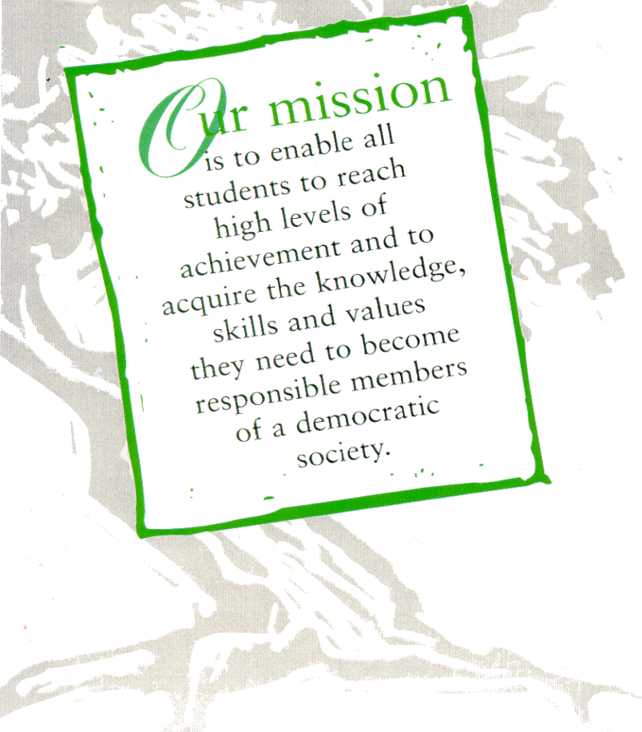
We value:
- Each and every student
- A strong public education system
- A partnership of students, schools, family and community
- The uniqueness and diversity of our students and our community
- The commitment and skills of our staff
- Equity, innovation, accountability and accessibility
Serving Our Students, Schools, and Their Communities
- Learning environments that are safe, nurturing, positive and respectful
The TDSB SPECIAL EDUCATION PLAN is also guided by the following principles:
All students, their families and the staff who support them have the right to be treated with respect.
All students have the right to a program developed in response to their strengths and needs;
All students have the right to a range of placements, programs, and services to meet their individual requirements in their neighbourhood or Family of Schools, wherever possible.
All students and the staff who support them have the right to a safe, accepting, welcoming, secure, and encouraging environment.
We believe that active and meaningful collaboration with all stakeholders and a partnership of students, school, family and support services
is essential to the success of all students.
For a copy of this year’s Special Education Plan visit: www.tdsb.on.ca/specialeducation

This Guide to Special Education for Parent(s)/Guardian(s) provides information about supports and services for students with special education needs in the Toronto District School Board (TDSB). It sets out the Identification, Placement, and Review Committee (IPRC) procedures involved in identifying a pupil as “exceptional”, in deciding on program placement and in appealing such decisions when parents* do not agree with the IPRC. (*Throughout this guide, the word “parents” includes guardians.)
What is TDSB’s Vision for Special Education?
TDSB’s Vision for Special Education is that students identified with special education needs be welcomed, included and supported within well-resourced neighbourhood schools. We are committed to providing all students with equitable access to special education programs, services and resources in the most supportive and inclusive environment for learning, to the fullest extent possible in the local community.
Who are students with special education needs?
Students identified with special education needs often benefit from greater support, accommodations and differentiated instruction in order to be successful in school. The Education Act requires that school boards provide, or purchase from another board, special education programs and services for their exceptional pupils. The Ministry of Education directs funding to school boards for this purpose.
What is a Special Education Program?
A special education program is defined in the Education Act as an educational program that:
- Is based on and modified by the results of continuous assessment and evaluation; and
- Includes a plan (called an Individual Education Plan or IEP) containing specific objectives and an outline of special education services that meet the needs of the exceptional pupil.
What are Special Education Services?
Special education services are defined in the Education Act as the facilities and resources, including support personnel and equipment, necessary for developing and implementing a special education program.
What special education programs and services are provided by the board?
TDSB provides a full range of programs and services to ensure that the needs of students are clearly identified and that the appropriate educational programs and services are provided for them, whether in the regular classroom, a specialized setting, or a combination of both. TDSB’s Special Education Plan reflects the board’s commitment to the development, implementation and consistent provision of effective special education programs and services to all students who need them, whether or not they are deemed to be “exceptional”. The Special Education Plan can be found at: www.tdsb.on.ca/specialeducation.
What is an Individual Education Plan (IEP)?
An Individual Education Plan (IEP) is a written plan describing the special education program and/or services developed for a particular student. It outlines any accommodations and special education services needed to assist the student in achieving his or her learning expectations. It may also identifies specific, measureable learning expectations that are modified from or alternative to the expectations given in the curriculum policy document for the grade level subject or course. Ontario Regulation 181/98 governs the development of IEPs.
The IEP must be developed in consultation with parents. It must include:
- Accommodations – strategies and supports that differ from what is normally provided during instruction
- Appropriately specific and measureable educational expectations
- An outline of the special education program and services that will be received
- A statement about the methods for reviewing your child’s progress
- A personalized transition plan with specific goals and actions that build on student strengths, needs and required supports. If a student does not need a transition plan, the plan will state that no action is required.
The IEP must be completed within 30 school days after a child has been placed in a special education program and the principal must ensure that parents receive a copy of it. An IEP can also be developed for students who have not been formally identified as exceptional but who require special education programs and/or services. For more information see: The Individual Education Plan (IEP) A Resource Guide available at: http://www.edu.gov.on.ca/eng/general/elemsec/speced/guide/resource/
Who is identified as an “Exceptional” Pupil?
The Education Act defines an exceptional pupil as “a pupil whose behavioural, communicational, intellectual, and physical or multiple exceptionalities are such that he or she is considered to need placement in a special education program...” Students are identified through an Identification, Placement and Review Committee (IPRC) process, according to the categories and definitions of exceptionalities provided by the Ministry of Education. Categories include Behaviour, Communication, Intellectual and Physical Exceptionalities.
What is an Identification, Placement, and Review Committee (IPRC)?
Students being considered for identification of an exceptionality and special education programs and/or services may be presented to an Identification, Placement, and Review Committee (IPRC). Ontario Regulation 181/98 requires that all school boards set up IPRCs. It also sets out the procedures involved in identifying a pupil as “exceptional”, deciding the pupil’s placement and appealing such decisions when the parent does not agree with the IPRC. The committee is composed of at least three persons, one of whom must be a principal or supervisory officer of the board. Resident students enrolled in and attending a TDSB school are eligible for consideration by a TDSB IPRC.
What does the IPRC do?
The IPRC will:
- Decide whether or not your child should be identified as an exceptional pupil
- Identify the areas of your child’s exceptionality, according to the categories and definitions of exceptionalities provided by the Ministry of Education
- Decide an appropriate placement for your child:
- Regular Class with Indirect Support, Resource Assistance or Withdrawal Assistance
- Special Education Class with Partial Integration or Full Time
- Review the identification and placement at least once in each school year
How is an IPRC meeting requested?
An IPRC can be requested by the principal of your child’s school or in writing by parents. The principal:
- May, in consultation with the School Support Team (SST) and with written notice to you, refer your child to an IPRC when the principal believes that your child may benefit from a special education program
- Must request an IPRC meeting for your child, upon receiving your written request
Within 15 days of receiving your request, or of giving you notice, the principal must provide you with a copy of this guide and a written statement of approximately when the IPRC will meet.
May parents attend the IPRC meeting?
Regulation 181/98 entitles parents and pupils 16 years of age or older:
- To be present at and participate in all committee discussions about your child
- To be present when the committee’s identification and placement decision is made
Who else may attend an IPRC meeting?
The principal (or vice principal) of your child’s school will attend. You or the principal may request the attendance of others at the IPRC meeting, such as:
- Your representative, that is, a person who may support you or speak on behalf of you or your child
- Other resource people who may provide additional information or clarification, such as your child’s teacher, special education staff, board support staff, or the representative of an agency
- A translator or an interpreter, if one is required (You can request the services of a translator or an interpreter through the principal of your child’s school.)
What information will parents receive about the IPRC meeting?
Within 15 days of giving you notice of an IPRC, or receiving your request, the principal will provide you with written notification of approximately when the IPRC will meet. At least ten days in advance of the meeting, you will receive an invitation to attend the meeting as an important partner in considering your child’s placement. This letter will notify you of the date, time, and place of the meeting, and it will ask you to indicate whether or not you will attend.
Before the IPRC meeting occurs, you will receive a written copy of any information about your child that the members of the IPRC have received. This may include the results of assessments or a summary of information.
What if parents are unable to attend the scheduled meeting?
If you are unable to make the scheduled meeting, you may:
- Contact the school principal to arrange an alternative date or time
- Let the school principal know you will not be attending and advise the principal of issues that he or she may take forward to the IPRC on your behalf
If you do not attend, as soon as possible after the meeting, the principal will forward to you, for your consideration and signature, the IPRC’s written statement of decision. The statement will note the decision of identification and placement and any recommendations regarding special education programs and services.
What happens at an IPRC meeting?
- The chair of the IPRC introduces everyone and explains the purpose of the meeting.
- The IPRC will review all available information about your child. The committee will:
→ Consider an educational assessment of your child
- Consider, subject to the provisions of the Health Care Consent Act, 1996, a health or psychological assessment of your child conducted by a qualified practitioner, if they feel that such an assessment is required to make a correct identification or placement decision
- Interview your child if the committee considers it useful to do so (Your consent is required if your child is less than 16 years of age)
- Consider any information that you submit about your child, or that your child submits if he or she is 16 years of age or older
- The committee may discuss any proposal that has been made about a special education program or special education services for the child. Committee members will discuss any such proposal at your request or at the request of your child, if the child is 16 years of age or older.
- You are encouraged to ask questions and join in the discussion.
- Following the discussion, after all the information has been presented and considered, the committee will make its decisions
What will the IPRC consider in making its decision about exceptionality?
The IPRC will consider all of the information presented about your child in light of the Ministry definitions for the different exceptionalities and TDSB criteria for different kinds of program support.
What will the IPRC consider in making its placement decision?
Before the IPRC can consider placing your child in a special education class, it must consider whether placement in a regular class with appropriate special education services will:
- Meet your child’s needs, and
- Be consistent with your preferences
If, after considering all of the information presented to it, the IPRC is satisfied that placement in a regular class will meet your child’s needs and that such a decision is consistent with your preferences, the committee will decide in favour of placement in a regular class with appropriate special education services.
If the committee decides that your child should be placed in a special education class, it must state the reasons for that decision in its written statement of decision.
What will the IPRC’s written statement of decision include?
The IPRC’s written statement of decision will state:
- The IPRC’s description of your child’s strengths and needs
- Whether the IPRC has identified your child as exceptional
- Where the IPRC has identified your child as exceptional:
- The categories and definitions of any exceptionalities identified, as they are defined by the Ministry of Education
- The IPRC’s placement decision
- The IPRC’s recommendations regarding a special education program and special education services
- Where the IPRC has decided that your child should be placed in a special education class, the reasons for that decision
What happens after the IPRC has made its decision?
- The chair of the IPRC will sign the statement of decision and review it with you.
- If you agree with the identification and placement decisions made by the IPRC, you will be asked to indicate this by signing your name on the statement of decision. It may be signed at the IPRC meeting or taken home and returned later to your child’s school principal.
- No committee placement decision can be implemented unless you have consented to the decision, or unless the time limit for filing a notice of appeal about the decision has expired and no such notice has been filed.
- If the IPRC has identified your child as an exceptional pupil and you have agreed with the IPRC identification and placement decisions, the following will take place:
- Where placement is not special education class full time and your child remains at his or her current school, the appropriate school staff will be informed of the need to develop an Individual Education Plan (IEP) for your child.
- Where placement is a special education class full time or with partial integration with intensive program support, the appropriate special education coordinator will be directed to prepare an “offer of placement” and assist the home school principal with arranging a visit to the proposed placement for you and your child.
- Following the visit, you will be asked to indicate your acceptance or refusal of the offer of placement. The offered placement will not proceed without your signed acceptance.
What can parents do if they disagree with the IPRC decision?
If you do not agree with either the identification or placement decision made by the IPRC, you may:
- Within 15 days of receipt of the decision, request that the IPRC hold a second meeting to discuss your concerns and revisit the decisions; or
- Within 30 days of receipt of the decision, file a notice of appeal
If, after a second meeting, you do not agree with the decision, you may, within 15 days of your receipt of the decision at the second meeting, file a notice of appeal.
If you do not consent to the IPRC decision and you do not appeal it, the Board will instruct the principal to implement the IPRC decision.

How do I appeal an IPRC decision?
If you disagree with the IPRC’s identification of your child as exceptional or with the placement decision of the IPRC, you may, within the timelines described above, give written notification of your intention to appeal the decision. This written notice should be addressed to: Director and Secretary Treasurer, Toronto District School Board, 5050 Yonge Street, Toronto, ON, M2N 5N8.
The notice of appeal must:
- Indicate the decision(s) with which you disagree
- Include a statement that sets out your reasons for disagreeing
What happens in the appeal process?
The appeal process involves the following steps:
- The Board will establish a special education appeal board to hear your appeal. The appeal board will be composed of three persons who have no prior knowledge of the matter under appeal. One of the three is to be selected by you and one by the board. (For more about membership see Regulation 181/98.)
- The chair of the appeal board will arrange a meeting, to take place at a convenient time and place, but no later than 30 days after he or she has been selected (unless parents and board both provide written consent to a later date).
- The appeal board will receive the material reviewed by the IPRC and may interview any persons who may be able to contribute information about the matter under appeal.
- You, the parent, and your child (if he or she is 16 years old or over), are entitled to be present at and to participate in, all discussions.
- The appeal board must make its recommendation within 3 days of the meeting’s ending. It may:
- Agree with the IPRC and recommend that the decision be implemented, or
- Disagree with the IPRC and make a recommendation to the board about your child’s identification or placement, or both.
- The appeal board will report its recommendations in writing, to you and to the school board, providing the reasons for its recommendations.
- Within 30 days of receiving the appeal board’s written statement, the school board will decide what action it will take with respect to the recommendations. (Boards are not required to follow the appeal board recommendation.)
- You may accept the decision of the school board, or you may appeal to a Special Education Tribunal. You may request a hearing by writing to the Secretary of the Special Education Tribunal. Information about making an application to the tribunal will be included with the appeal board’s decision.
Once a child has been placed in a Special Education Program, can the placement be reviewed?
A Review IPRC meeting will be held within the school year, unless the principal of the school at which the special education program is being provided receives written notice from you, the parent, dispensing with the annual review.
A request for a Review IPRC meeting may be made any time after your child has been in a special education program for three months.
What does a Review IPRC consider and decide?
The IPRC conducting the review will consider the same kinds of information that were originally considered by the previous IPRC. It will also consider the progress your child has made in the special education program and, with your written permission, will reference the IEP.
The IPRC will review the placement and identification decisions and decide whether they should be continued or whether a different decision should now be made.

What if my child is new to the board and has extremely complex special needs but has not been to an IPRC?
Eligibility for placement in a Special Education Class requires an Identification, Placement and Review Committee (IPRC) decision. An IPRC does not take place until the child has been attending for sufficient time to permit school staff to collect the required information and documentation. To address this delay and avoid disruption to a student’s schooling that would be caused by a possible program move part way through the year, the TDSB developed a process for conditional placement of new students, who are pre-registered (on paper) but not yet attending a TDSB school.
Subject to parental preference, the principal may consult with the School Support Team (SST) to determine whether or not a referral to a Special Education Program Recommendation Committee (SEPRC) is appropriate. Where it is determined that a SEPRC meeting will proceed by the SST, including the Special Education Consultant, a referral is completed by the home school and submitted to Special Education staff for scheduling. The SEPRC can provide a recommendation for conditional placement in a special education program, which the student may attend until the time at which the formal IPRC process can take place.
The membership of a SEPRC is the same as that of an IPRC and the SEPRC / IPRC processes are sequential. SEPRC recommendations are tracked so that subsequent IPRCs can be planned appropriately. When parents agree to participate in a SEPRC, they do not forgo their right to request an IPRC once their child is attending school.
What does the SEPRC do?
The SEPRC will:
- Note, for programming purposes, whether the student meets the requirements for an exceptionality, based on Ministry definitions and TDSB criteria
- Determine whether an intensive support special education class would be appropriate for meeting the student’s special education needs
- Provide a written Statement of Recommendations, outlining the student’s strengths and needs and stating whether or not a special education program or services are recommended
- Clarify that any recommendation for an intensive support special education program would be for a time period of approximately 6 to 9 months, after which an IPRC would be convened. Students placed by SEPRC in kindergarten intensive support programs will generally have an IPRC during their senior kindergarten year in preparation for the primary division.
Is a SEPRC meeting like an IPRC meeting?
The main similarities are:
- You will receive a letter of invitation and will be encouraged to participate in the meeting
- You may invite others to attend with you
- The committee membership is the same as for an IPRC
The main differences are:
- The SEPRC process is not based on Ministry Regulation 181/98
- A student may only be referred to a SEPRC by the decision of the home school principal in consultation with parents and members of the School Support Team (SST)
- The SEPRC meeting cannot go ahead if parents do not want one or do not attend
- No decisions about exceptionality and placement are made; only a program recommendation is made
- Parents may decline the recommendation(s) of the SEPRC but may not appeal them. Instead, they can request an IPRC once their child is attending school.
What organizations are available to assist parents?
Many local associations are available to provide information and support to parents of exceptional children. Some of them are members of the board’s Special Education Advisory Committee (SEAC). Information about SEAC associations and how to contact members of SEAC can be found at www.tdsb.on.ca/seac .
Where can parents obtain additional information about special education?
If you have unanswered questions about special education in the TDSB,visit the TDSB website at: www.tdsb.on.ca/specialeducation. You can also contact the Centrally Assigned Principal for Special Education in your local area. Telephone numbers can be found on the front page of this document.
What are the Ministry's Provincial Schools and Demonstration Schools?
The Ministry of Education operates Provincial Schools and Demonstration Schools throughout Ontario for deaf, blind, deafblind, and severely learning-disabled students. Access is usually by way of an IPRC recommendation. The schools operate primarily as day schools with transportation provided by school boards. Residential programs are offered at the schools from Monday to Friday for students who live too far from school to travel daily.
- Demonstration Schools provide intensive, one-year programs for students with severe learning disabilities, including learning disabilities associated with Attention-Deficit/Hyperactivity Disorder (ADD/ADHD). An in-service teacher education program is offered at each Demonstration School. Application for admission is made by the school board with parent consent and eligibility is determined by the Provincial Committee on Learning Disabilities.
Sagonaska School 350 Dundas Street West, Belleville, ON K8P 1B2 Tel: 613-967-2830
Trillium School 347 Ontario Street South, Milton, ON L9T 3X9 Tel: 905-878-8428
Amethyst School 1090 Highbury Avenue, London, ON N5Y 4V9 Tel: 519-453-4408
Centre Jules-Léger (for French-speaking students) Tel: 613-761-9300
281 rue Lanark, Ottawa, ON K1Z 6R8 TTY: 613-761-9302/9304
- Provincial Schools for the Deaf provide programs for deaf students from preschool level to high school graduation and resource services for families, school boards and other agencies. Admittance is determined by the Provincial Schools Admission Committee in accordance to requirements set out in Regulation 296.
Ernest C. Drury School 255 Ontario Street South Milton, ON L9T 2M5 Tel: 905-878-2851
TTY: 905-878-7195
Robarts School 1090 Highbury Avenue, P.O. Box 7360, Tel/TTY: 519-453-4400
Station E, London, ON N5Y 4V9
Sir James Whitney School 350 Dundas Street West, Belleville, ON K8P 1B2 Tel/TTY: 613-967-2823
Centre Jules-Léger (French-language school for the deaf) Tel: 613-761-9300
281 rue Lanark, Ottawa, ON K1Z 6R8 TTY: 613-761-9302/9304
→ The Provincial School for students who are Blind and Deafblind is a residential school operated through the Ministry of Education. Delivered by specially trained teachers, instruction follows the Ontario Curriculum and offers a comprehensive “life skills” program, tailored to student needs and designed to help students learn to live independently.
W. Ross Macdonald School 350 Brant Avenue, Brantford, ON N3T 3J9 Tel: 519-759-0730
For more information about Demonstration Schools or Provincial Schools contact:
Ministry of Education Provincial Schools Branch
255 Ontario Street, South Milton, ON L9T 2M5
Tel: 905-878-2851 Fax: 905-878-5405

Appendix B: Individual Education Plan

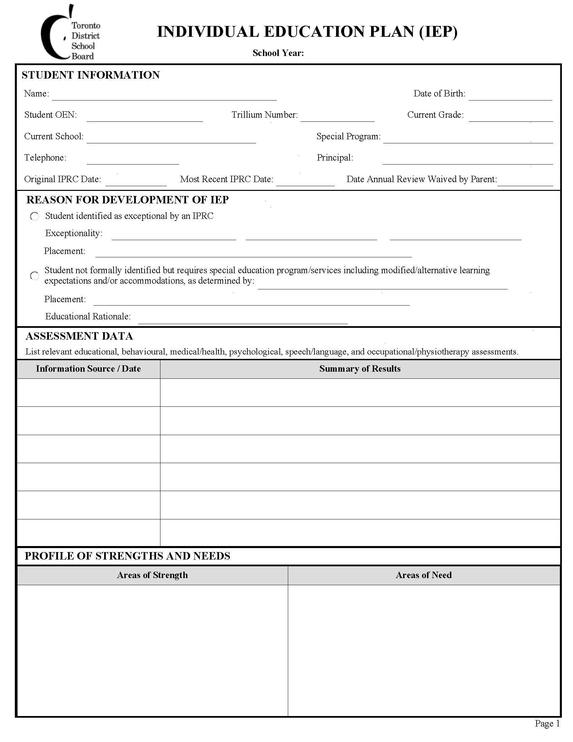

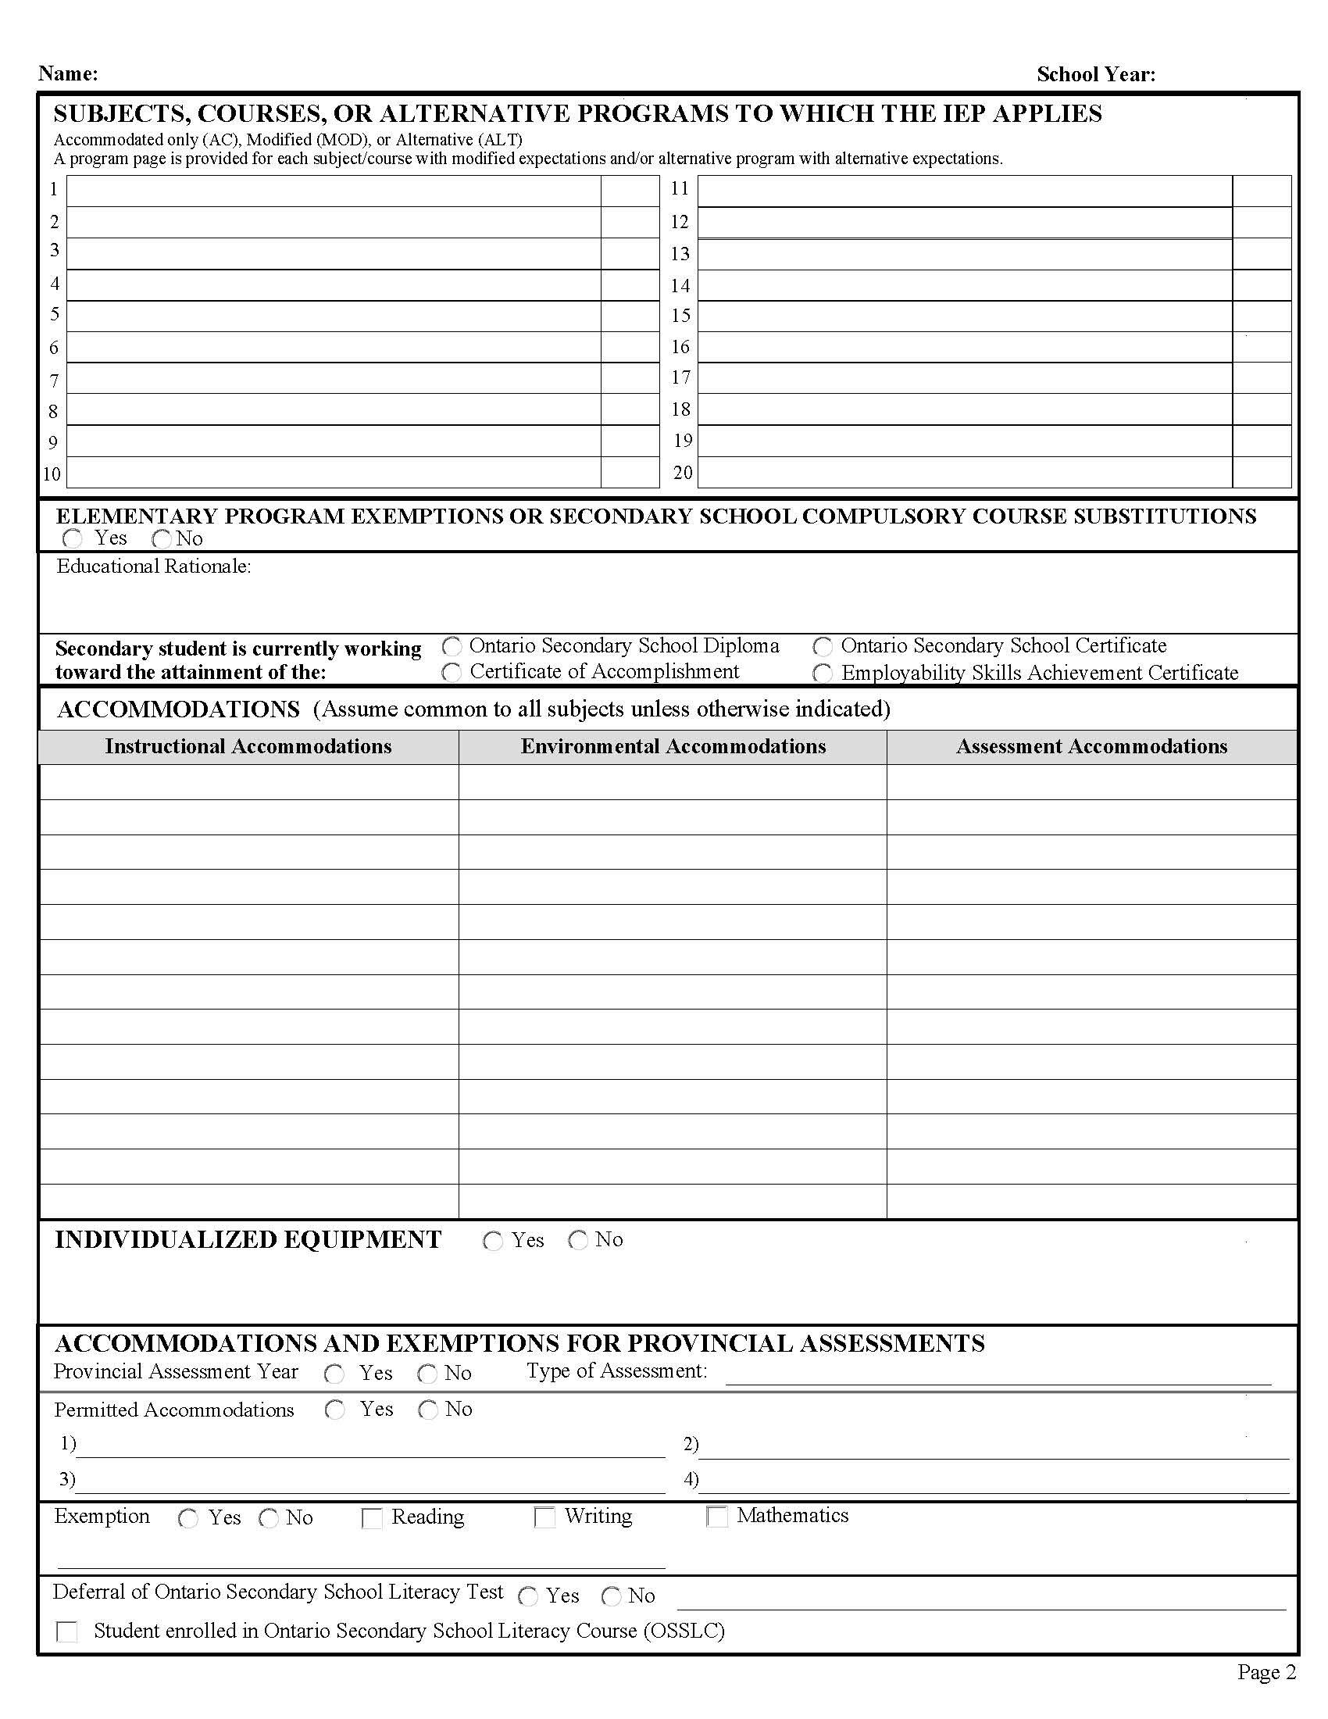

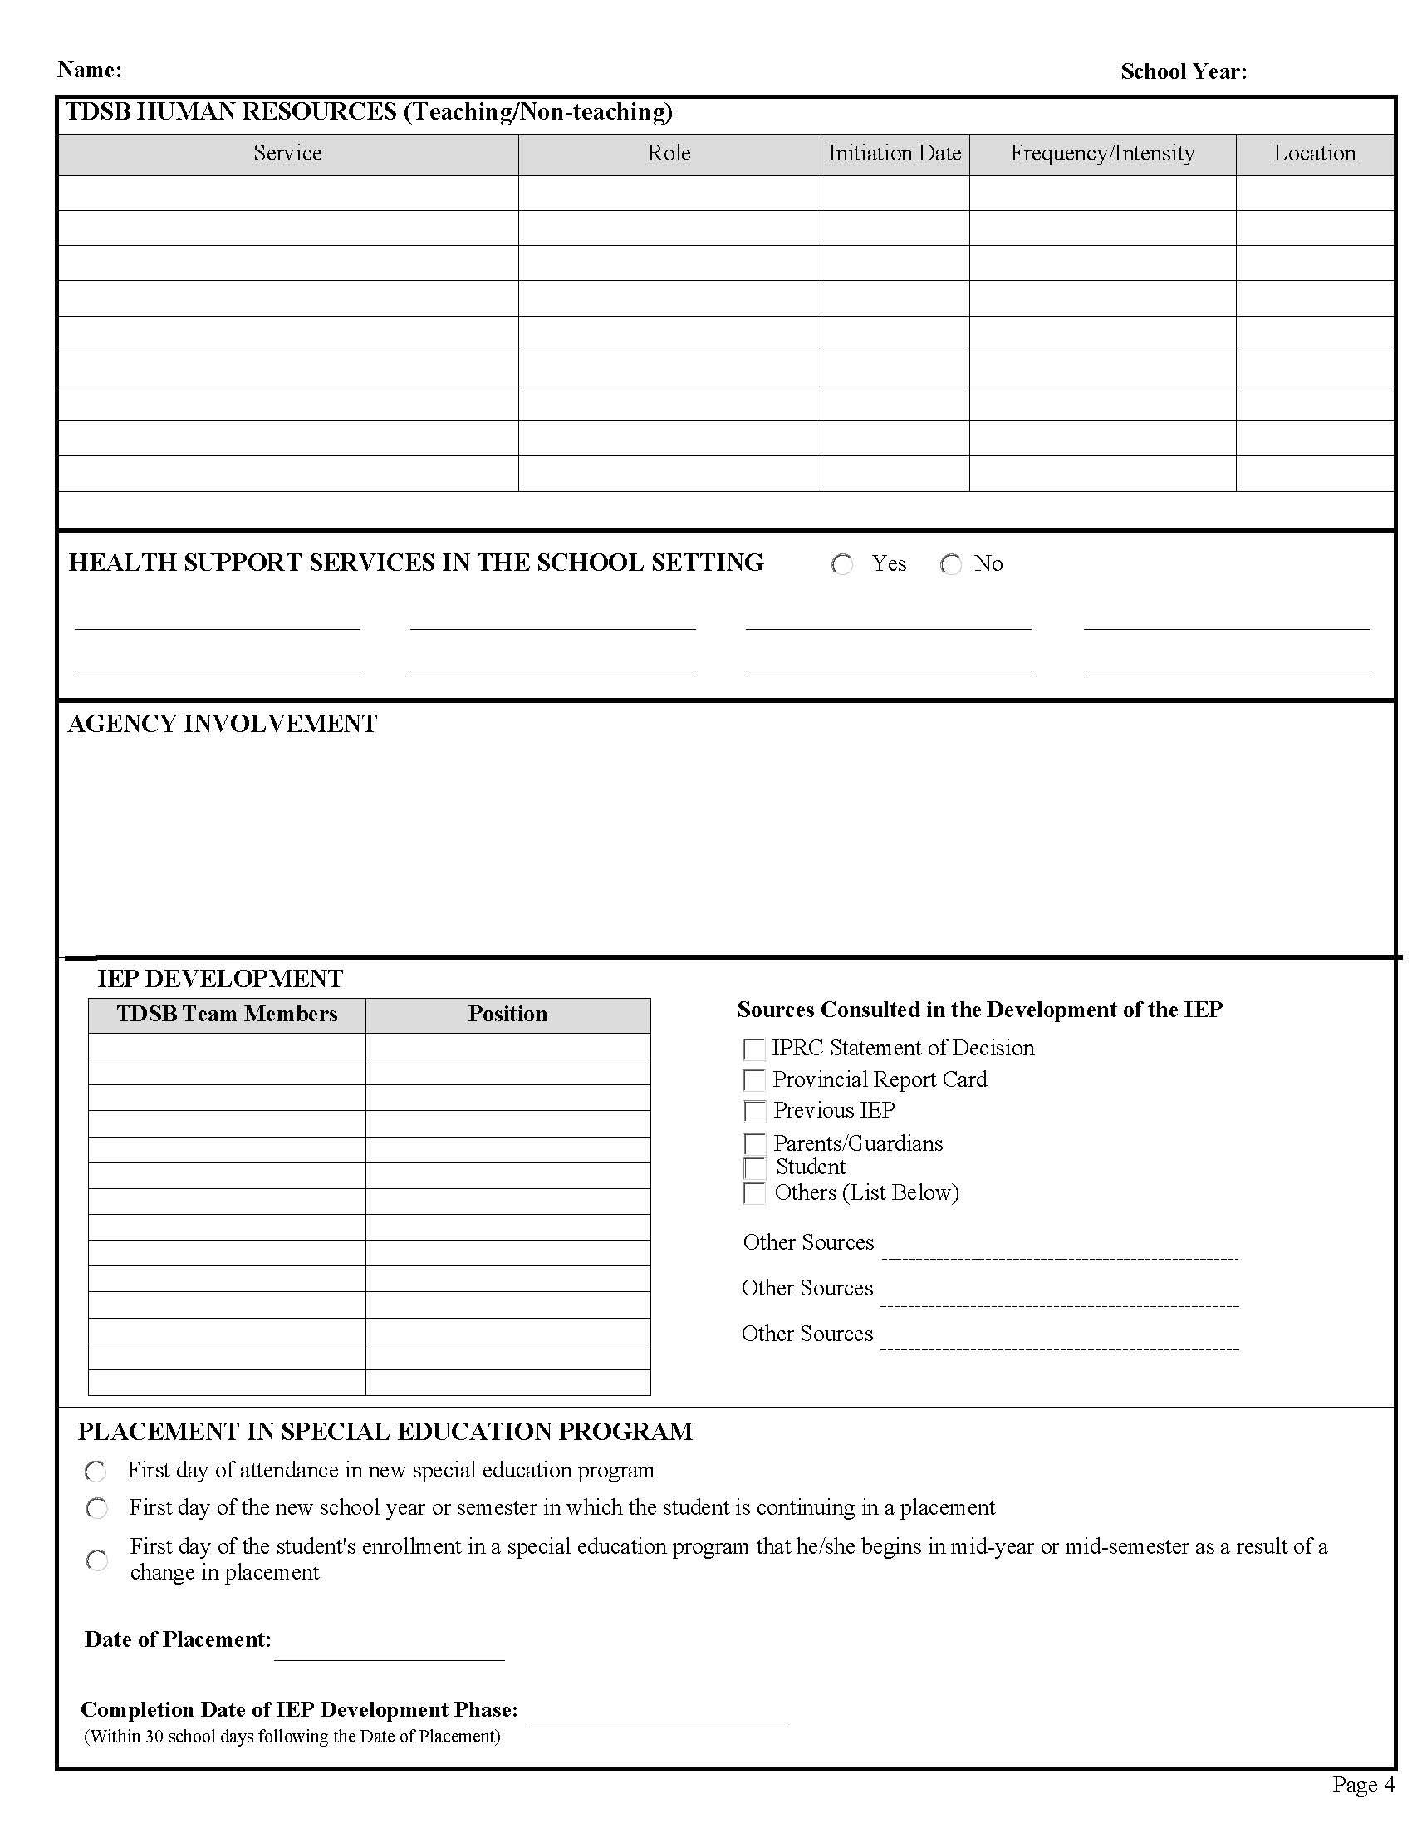

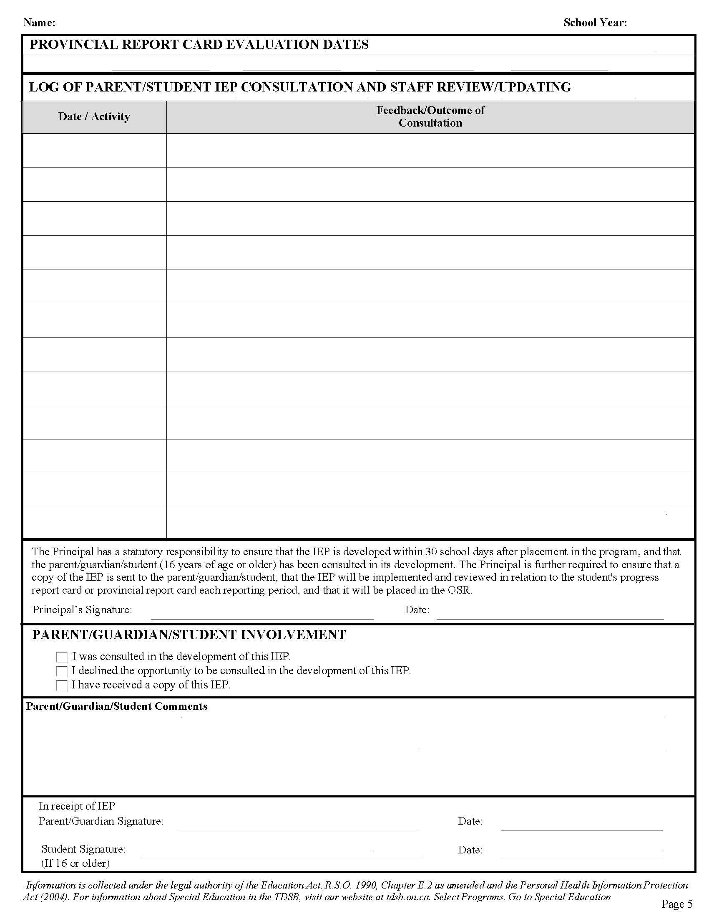

Appendix C (1): Consent for Release of Confidential Information

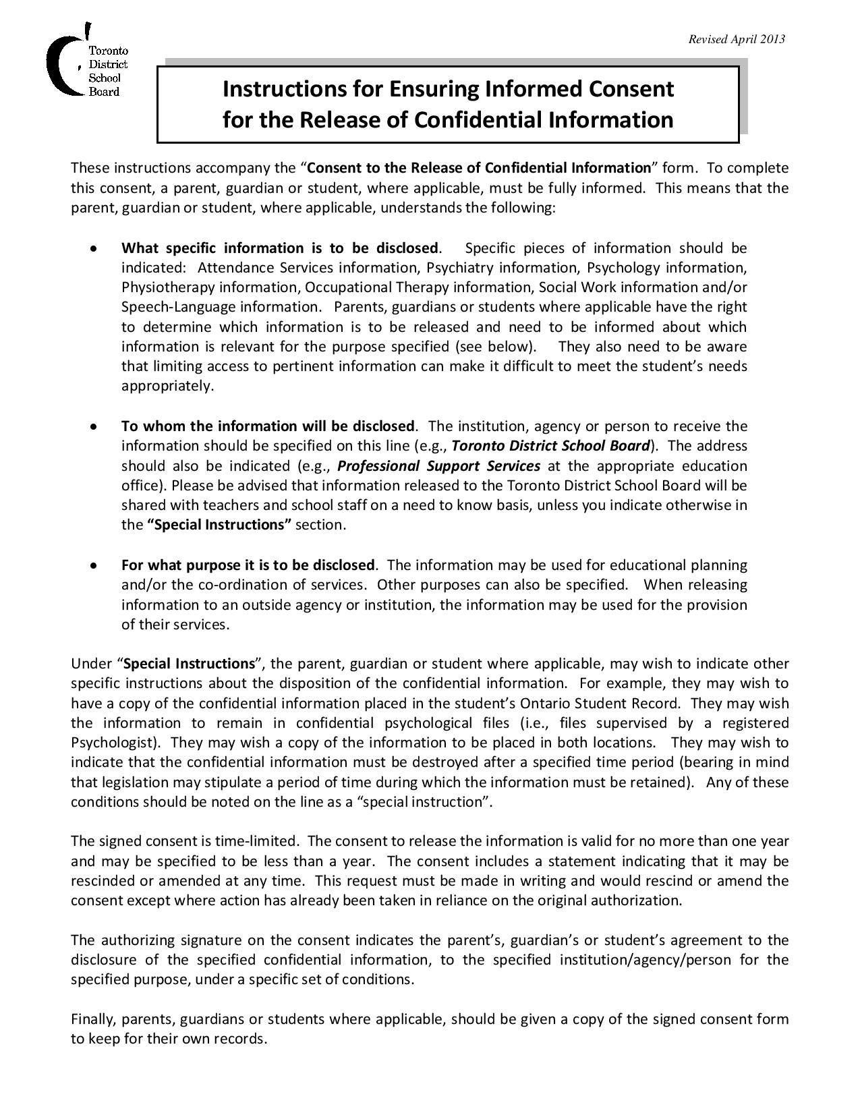
Page 6

Appendix C (1)

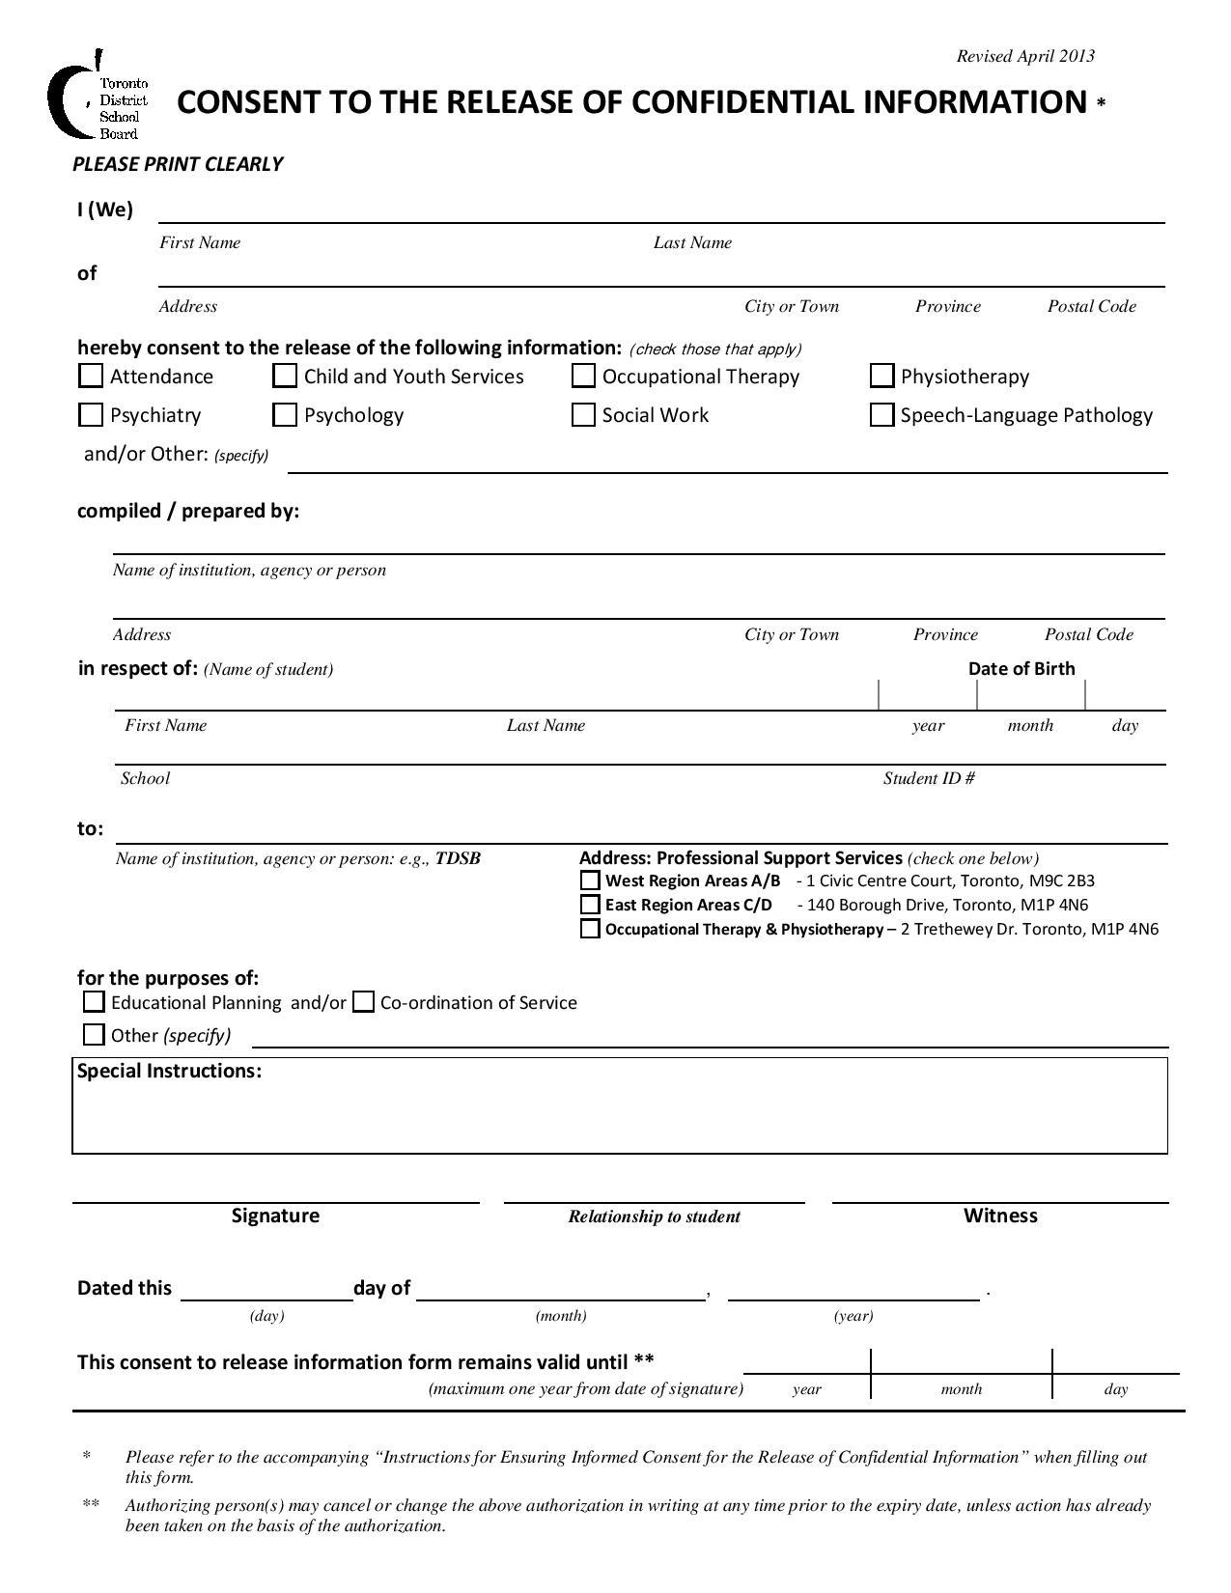

Consent for Two-Way Release of Confidential Information
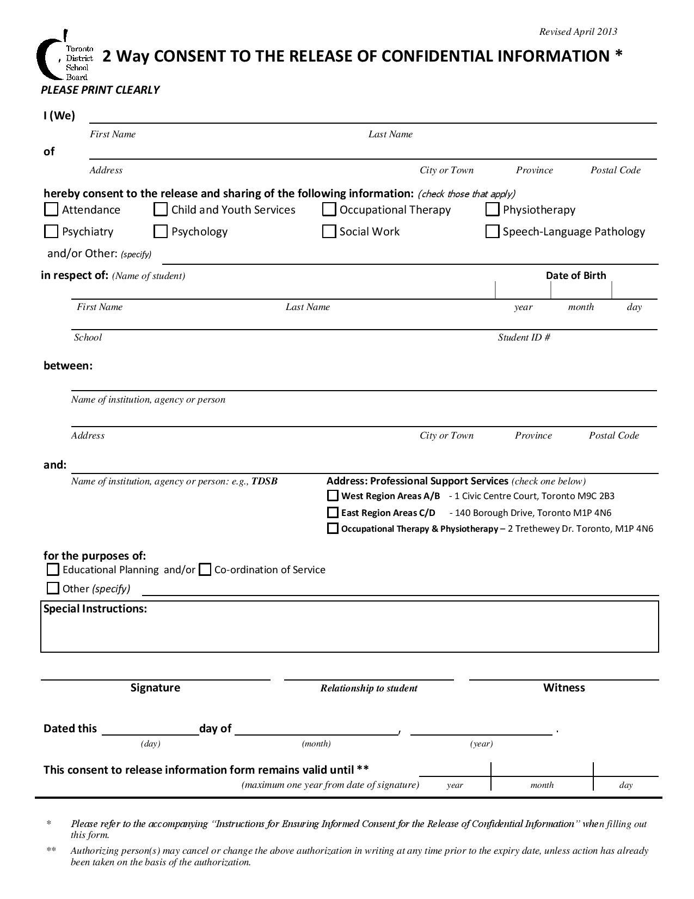

Appendix C (2): Individual Learning Profile (Elementary)

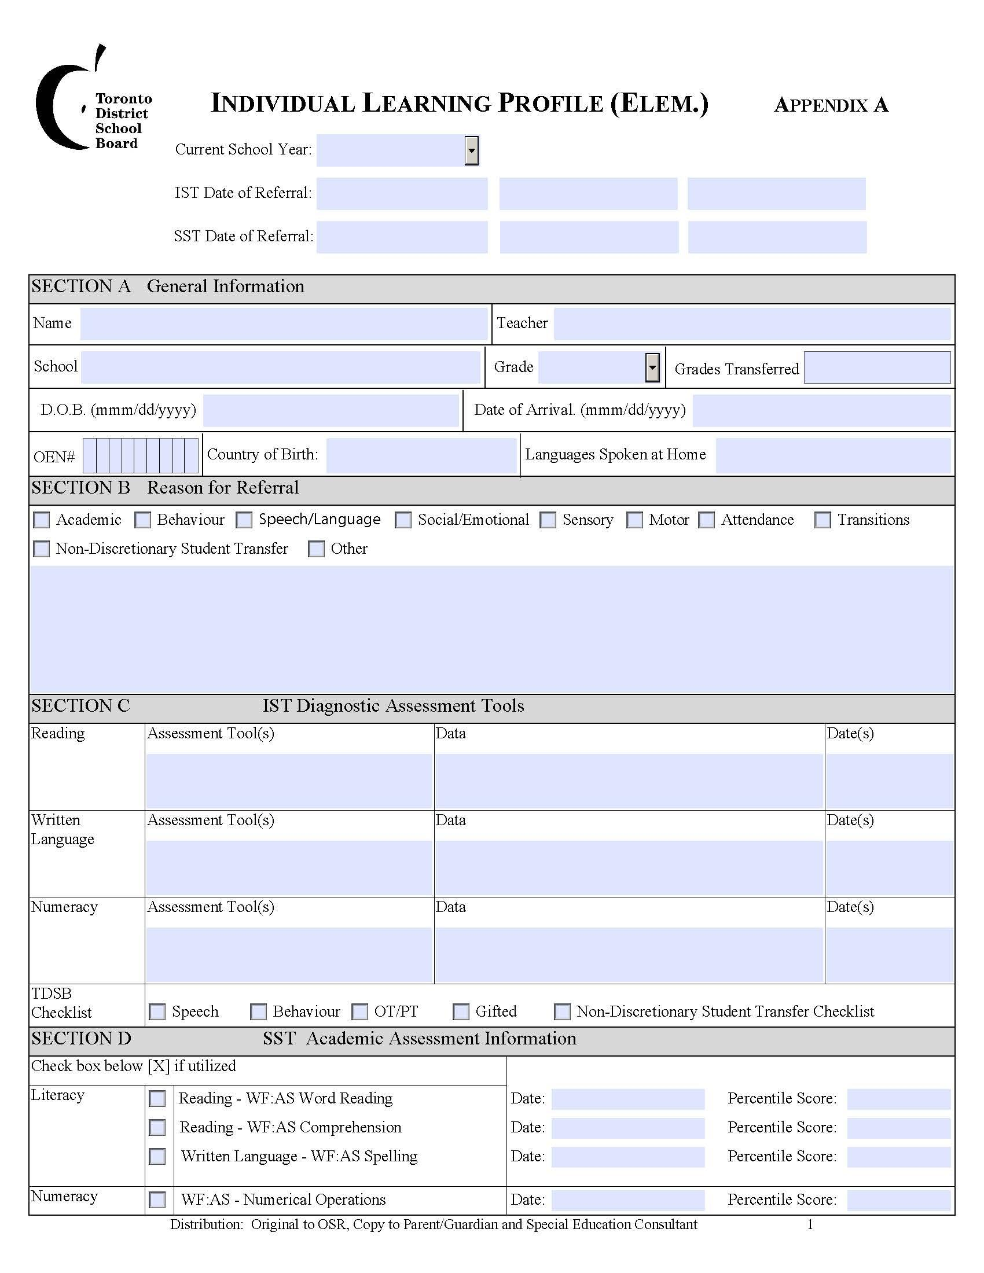

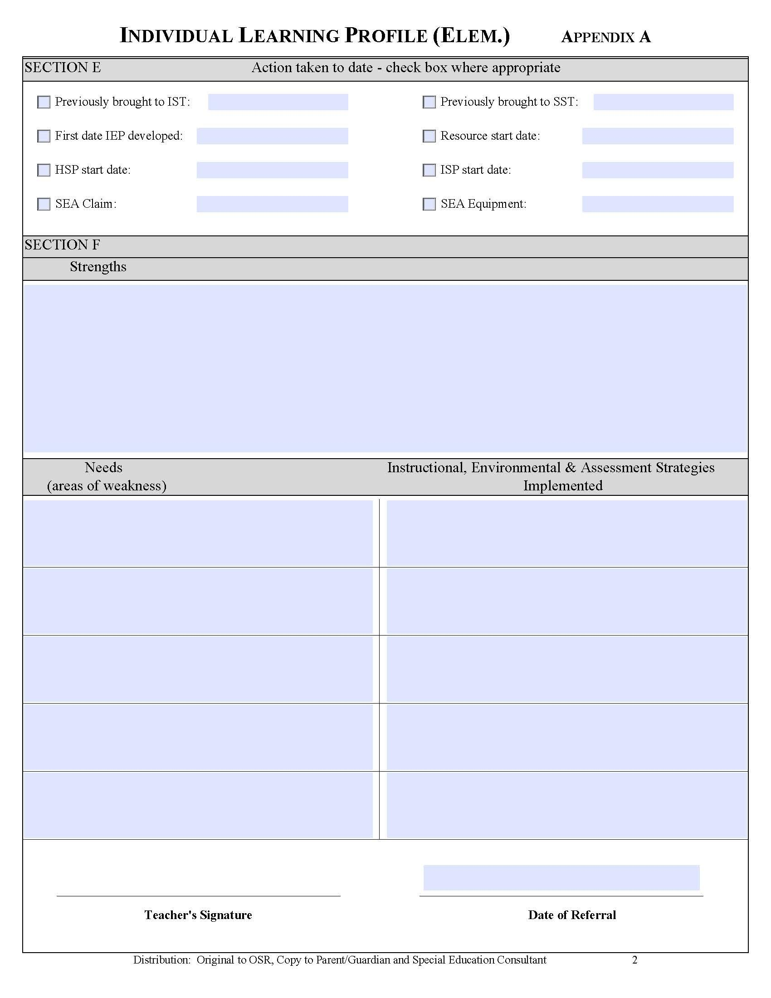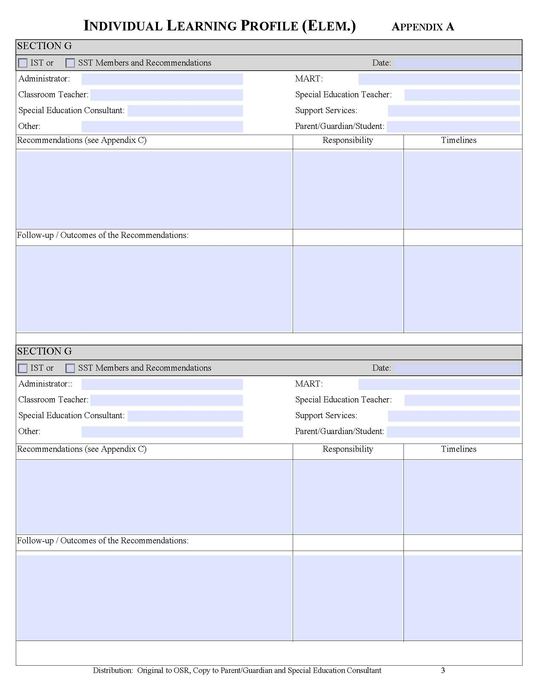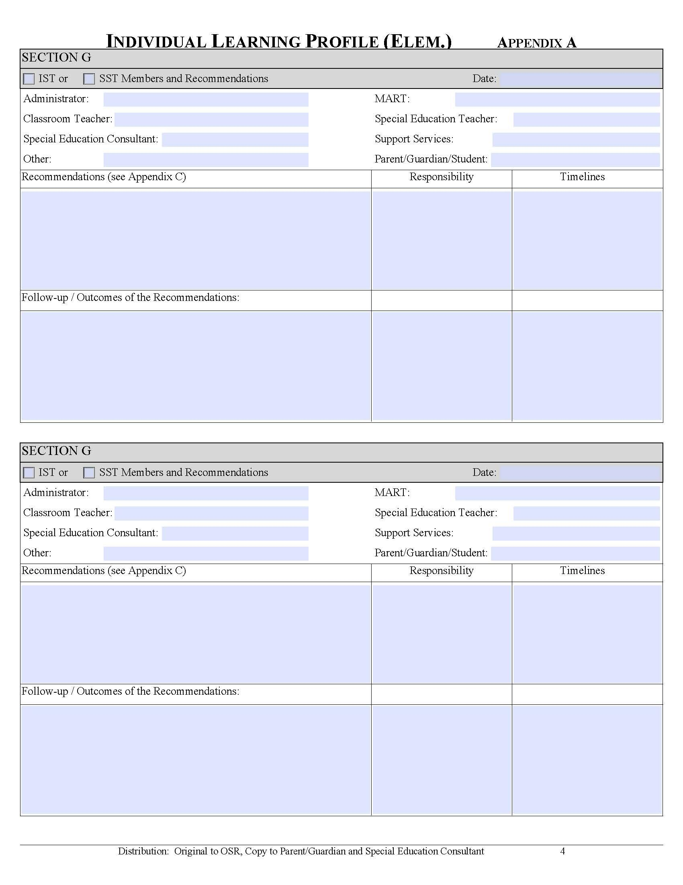

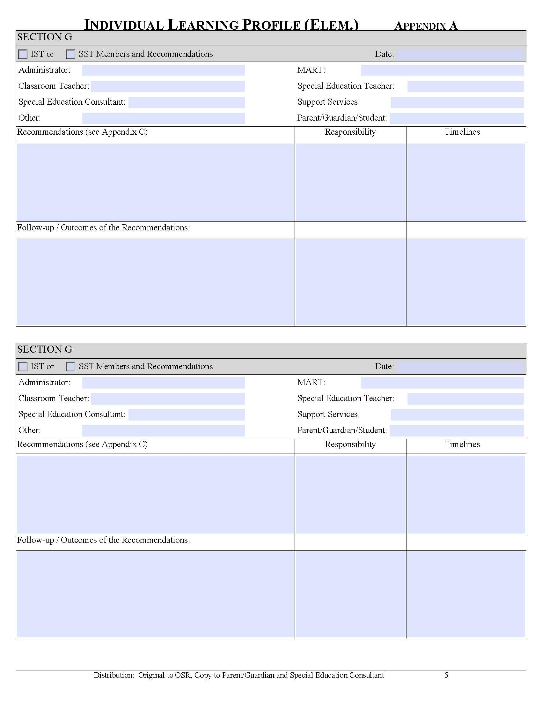

Appendix C (3): Individual Learning Profile (Secondary)

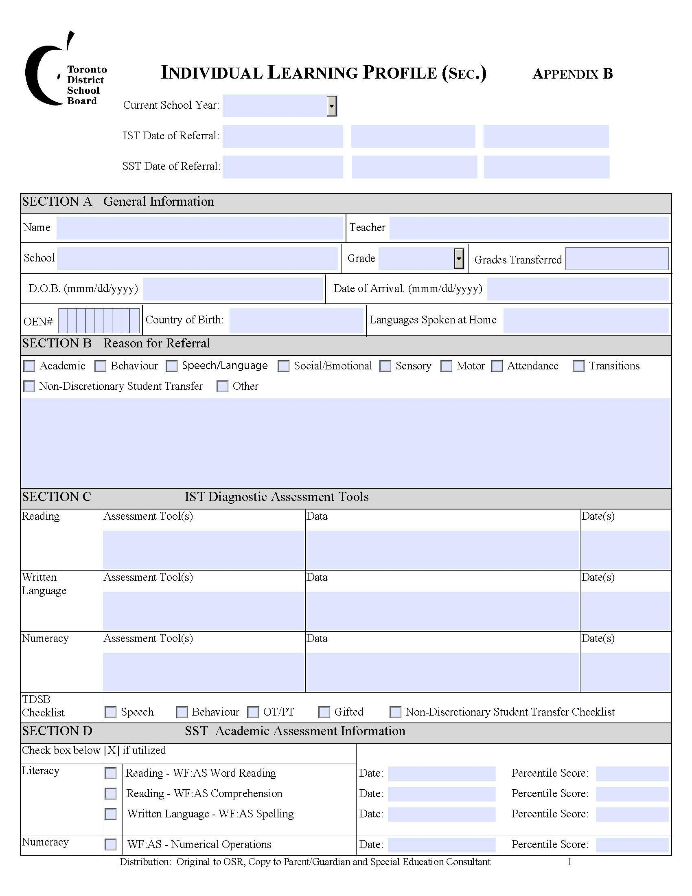

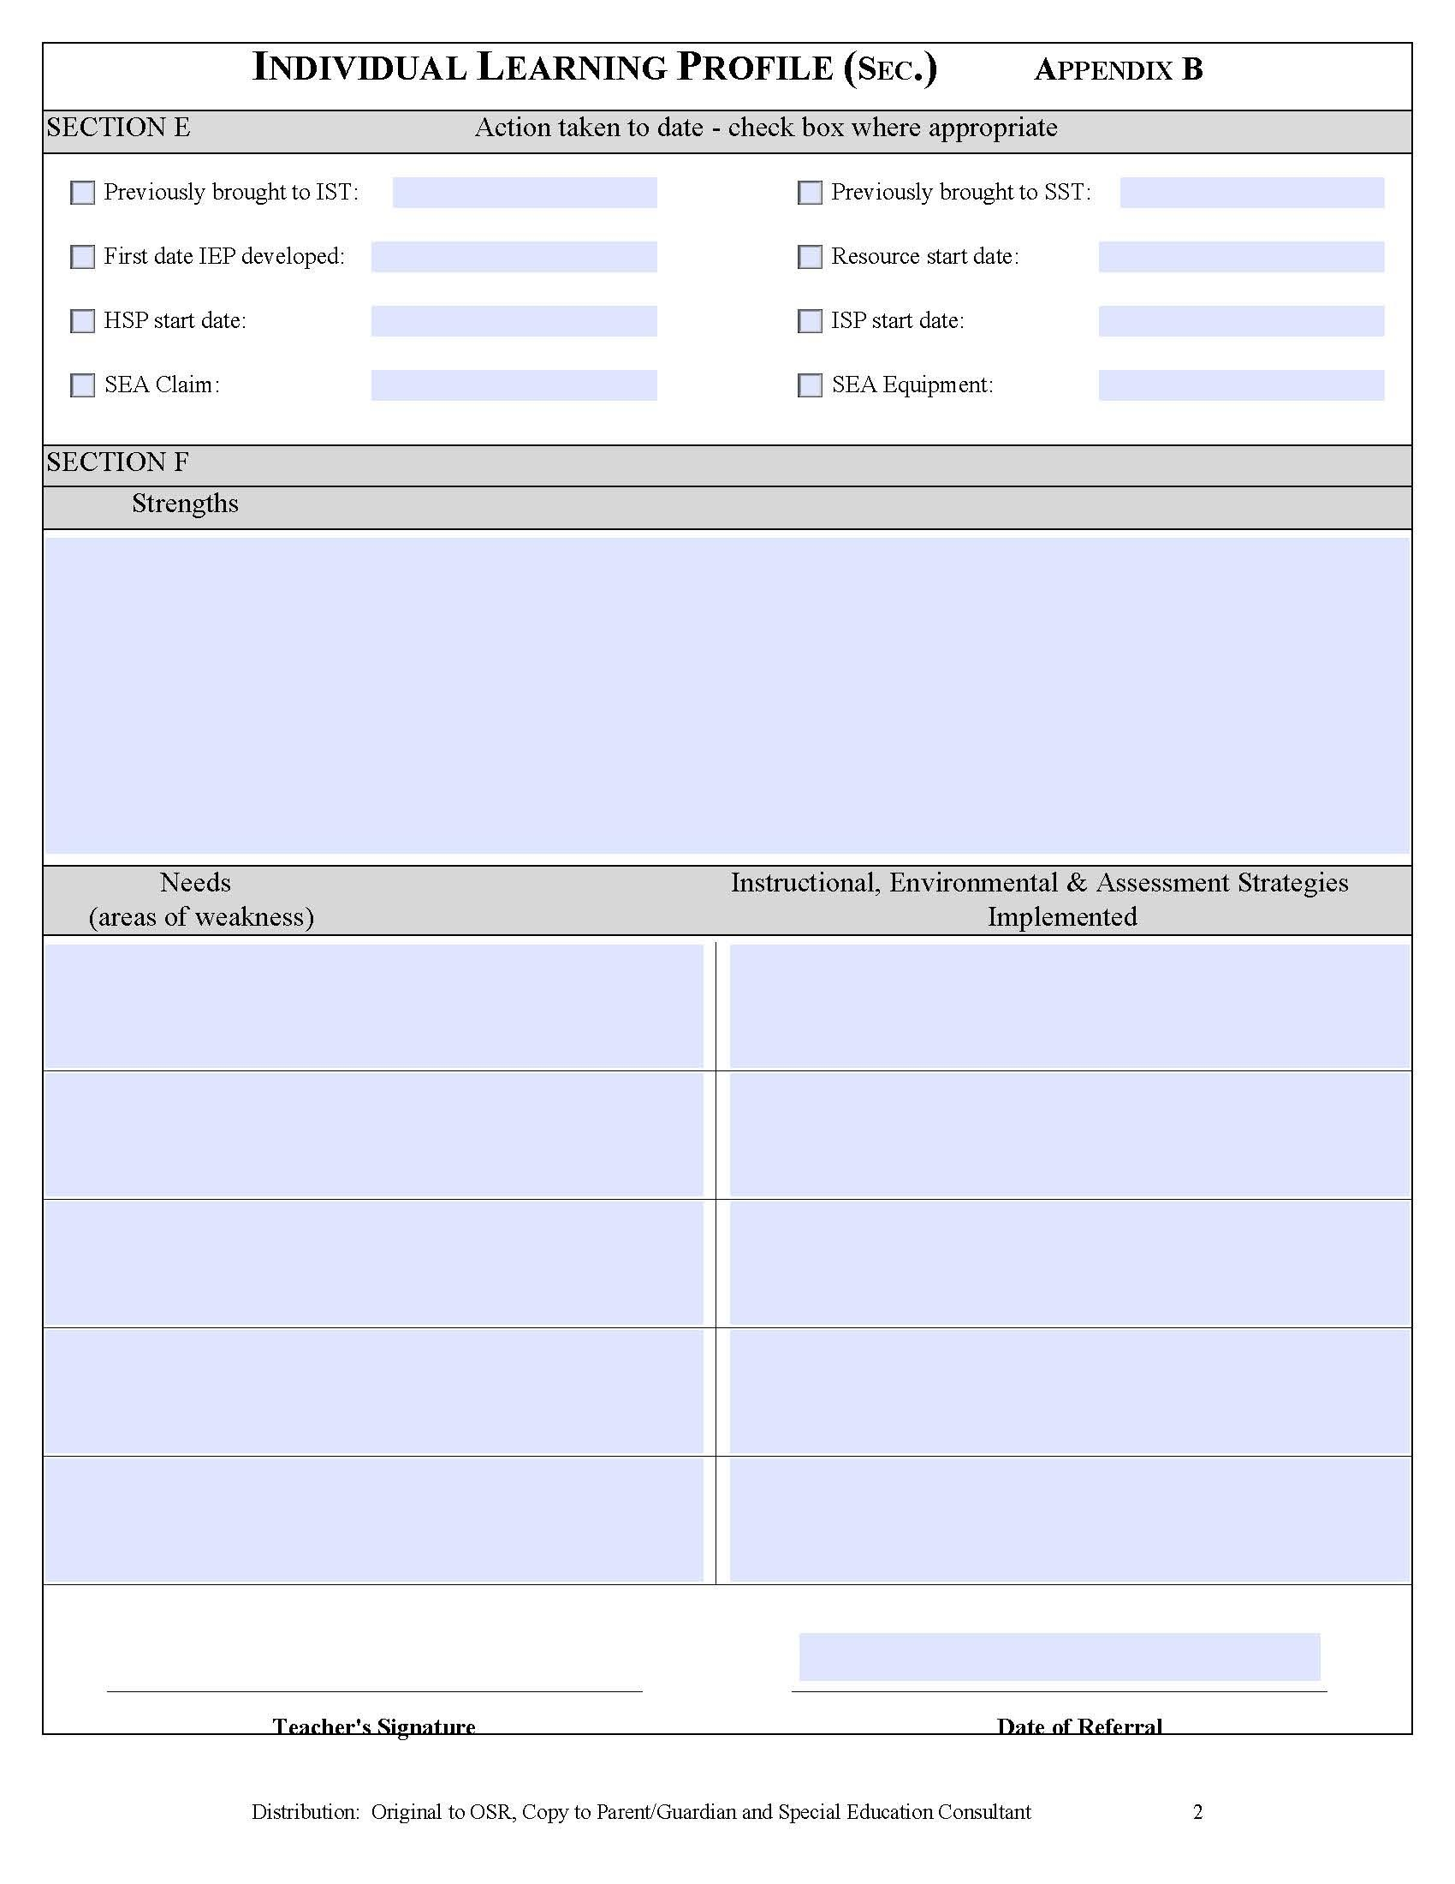

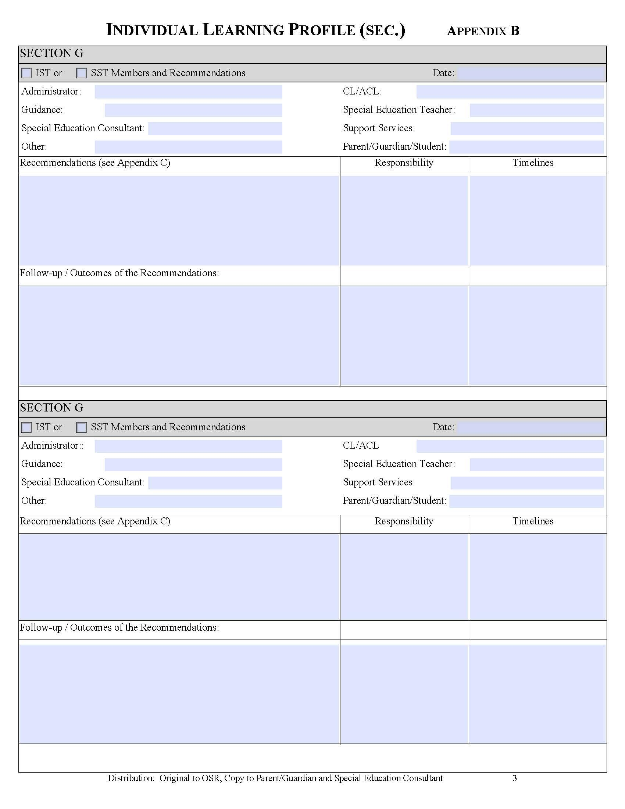

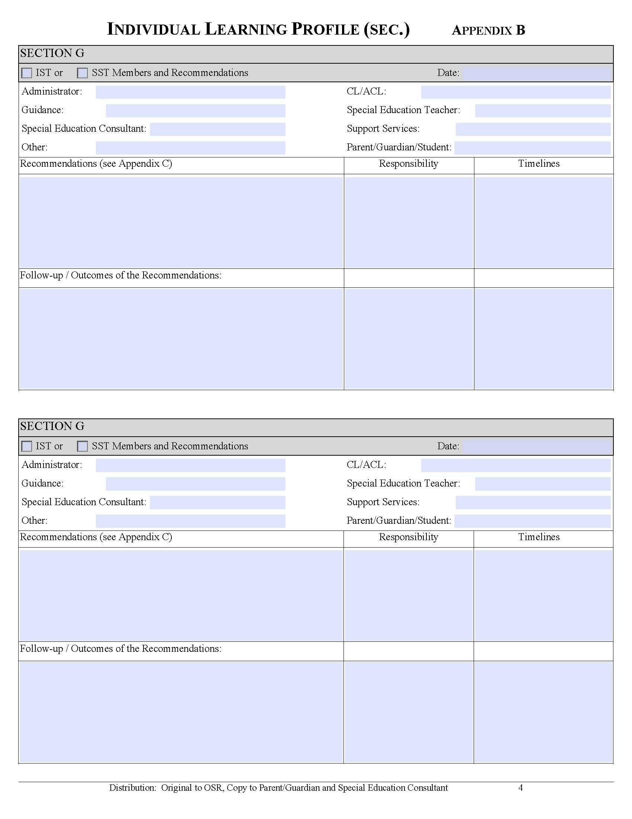

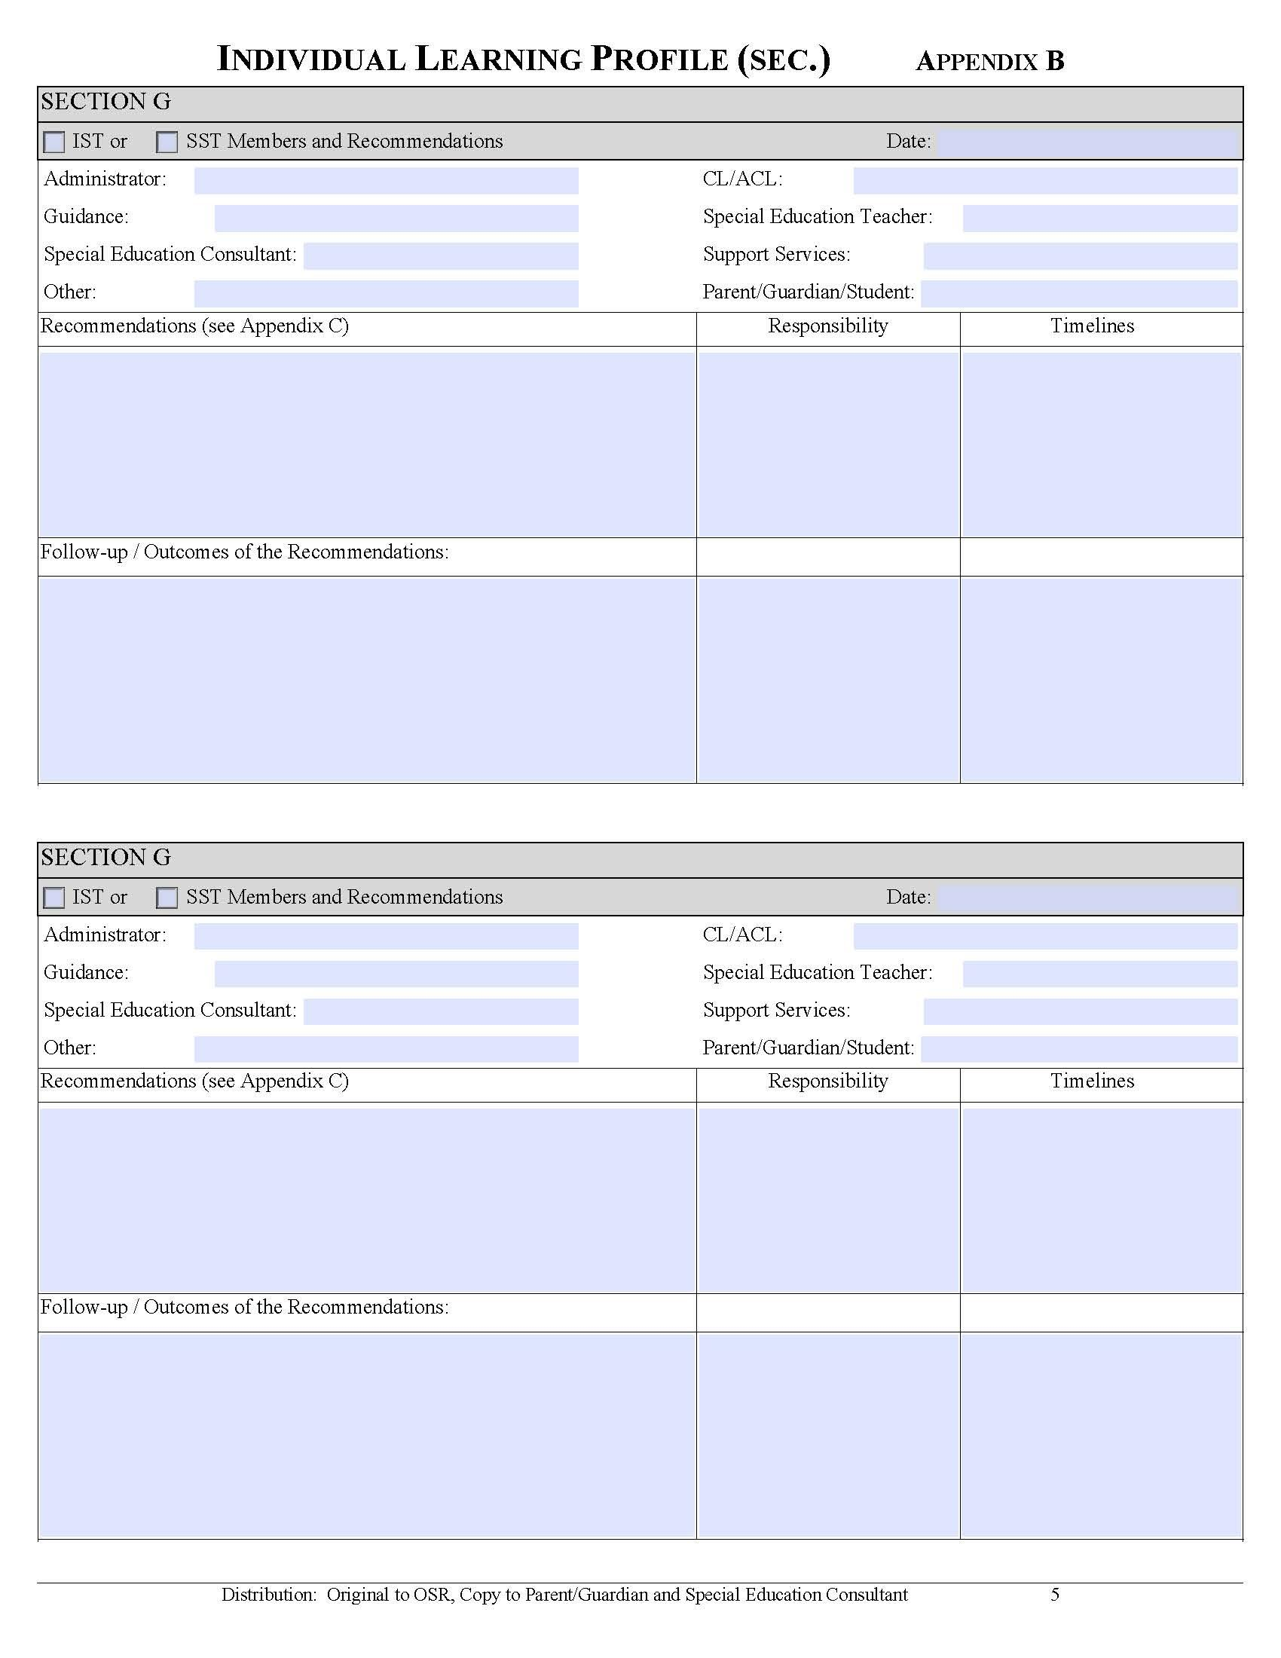

Appendix C (4): Professional Support Services Referral Form

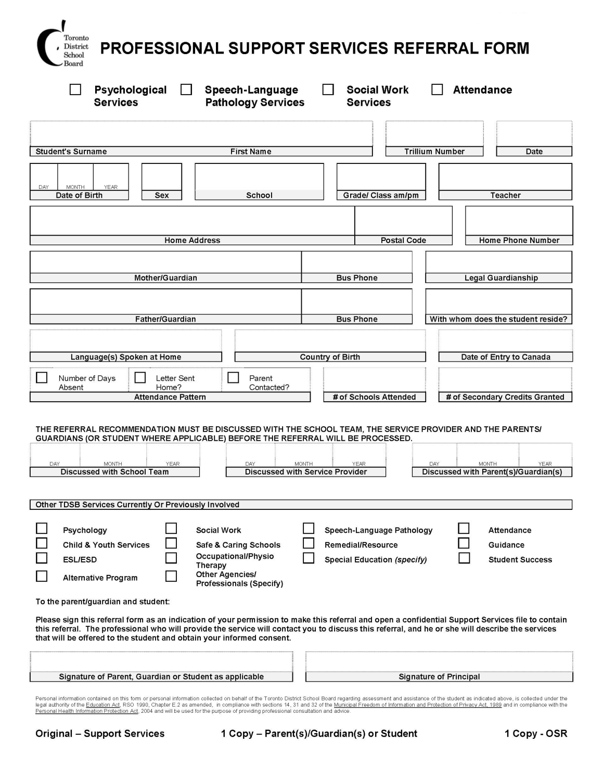

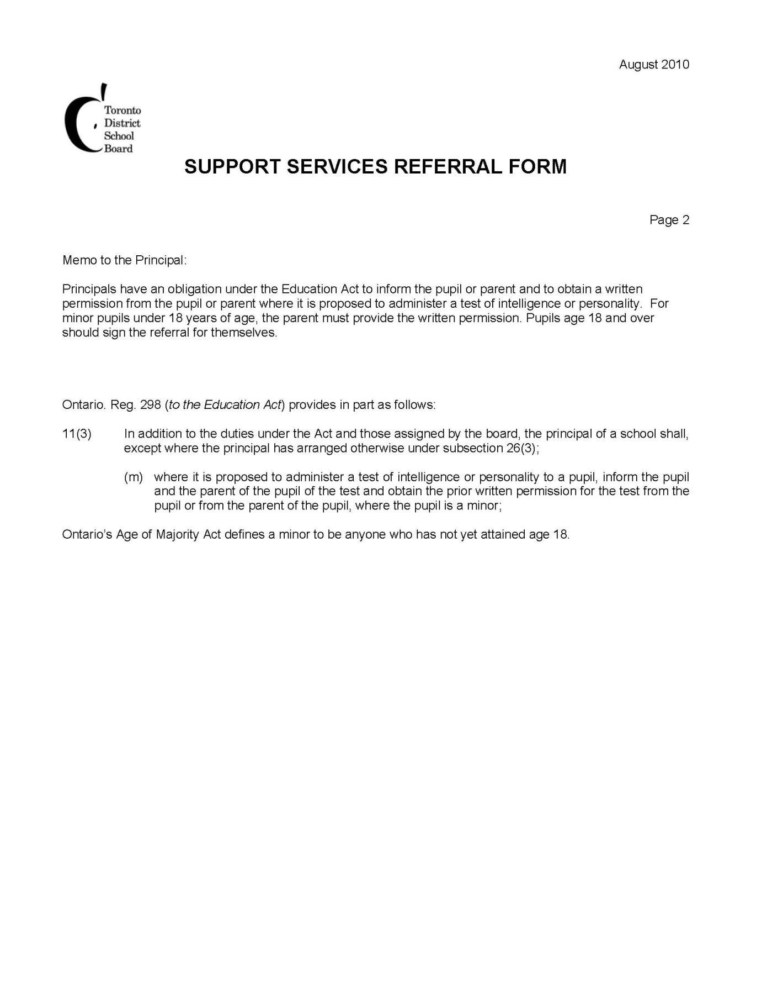

Appendix D: Parent Concern Protocol
Toronto District School Board
Operational Procedure PR 505
Title: PARENT CONCERN PROTOCOL
Adopted: June 24, 2003
Revised: November 19, 2008
Authorization: Executive Council
1.0 TITLE: PARENT CONCERN PROTOCOL
2.0 OBJECTIVE
To outline the procedures for addressing educational concerns brought to staff and trustees by parents. Appropriate flexibility will be exercised in implementing these procedures to suit individual circumstances.
3.0 DEFINITIONS
Concern A school-related problem or issue affecting a child/children, families or the community, which is perceived to require the attention of the school or the Board.
Parent Parent includes guardian or any caregiver with recognized responsibility for the care of the student; in this document the word parents includes families, and parent groups.
Principal Includes vice-principal throughout this document.
4.0 RESPONSIBILITY
Executive Officer, Student and Community Equity
5.0 PROCEDURES
5.1 Classroom Concerns Brought to the Principal
If a parent brings a concern to the principal about a classroom or teacher-related matter, the principal will undertake one or more of the following actions depending on the nature of the concern and its circumstances:
- Advise the parent to discuss the concern directly with the teacher and resolve it at that level;

- Gather any relevant information to determine the facts and circumstances;

- Discuss the concern with the teacher and offer advice to the teacher where advice is required to resolve the concern, and inform the parent of the outcome;

- Meet jointly with the teacher and the parent to discuss the concern where the principal determines that such a meeting will resolve the concern;

- Consult with the superintendent of education, other Board staff, or the Board’s Legal Services where required, in order to assist in resolving the concern;

- Refer the concern to the superintendent of education if the parent does not agree with the decision of the principal and wishes to appeal to a higher staff authority;

- Where the principal refers the concern to the superintendent of education, the superintendent of education will consult with the principal and parent, make a final decision and communicate the decision to the principal and parent
5.2 School Concerns Brought to the Principal
If a parent brings a concern about a school policy, procedure, activity, event, or situation to the principal, the principal will undertake one or more of the following actions depending on the nature of the concern and its circumstances:
- Contact the parent to discuss and resolve the concern;

- Gather any relevant information to determine the facts and circumstances;

- Consult with the superintendent of education, other Board staff, or the Board’s Legal Services where required, in order to assist in resolving the concern;

- Refer the matter for school council discussion and advice where the concern relates to a matter appropriate for school council consideration;

- Refer the concern to the superintendent of education if the parent does not concur with the decision of the principal and wishes to appeal to a higher staff authority;

- Where the principal refers the concern to the superintendent of education, and/or the parent brings the concern directly to the superintendent of education, the superintendent of education will consult with the principal and parent, make a final decision and communicate the decision to the principal and parent;

- Where the parent brings a concern about a policy or program matter which is beyond the scope or jurisdiction of the school to address, the principal advises the parent of the appropriate person(s) to whom such concern should be directed, and assists the parent with the referral where necessary.
5.3 School Concerns Brought to the Superintendent of Education
If a parent brings a classroom, teacher-related, or school concern directly to the superintendent of education for response, the superintendent of education will undertake one or more of the following actions, depending on the nature of the concern and its circumstances:
- Refer the parent to the principal where prior discussion with the principal has not taken place, and follow up with the principal on the outcome;

- Gather any relevant information to determine the facts and circumstances;

- Consult with the principal about the concern and advise the principal of options to consider, or make a recommendation to the principal for addressing the concern, and inform the parent of the outcome;

- Make a final decision about the concern in consultation with the principal and inform the parent and principal about the outcome;

- Where the superintendent of education determines that the concern about a particular school or community of schools, require informing and consulting with the Executive Superintendent, or other appropriate central staff, or trustee, the Superintendent of education initiates such communication with those persons;

- Where a parent brings a concern to a central manager or supervisor, the manager or supervisor takes appropriate action if relevant to his/her area, or refers the concern to the appropriate principal, Superintendent of education or other central staff for follow up.
5.4 School Concerns Brought to the Director of Education or Chair of the Board
If a parent or parent group brings a concern about a particular school or group of schools directly to the Director of Education or the Chair of the Board, the Director of Education or Chair of the Board refers the matter to the appropriate superintendent(s) of education, central superintendent(s), or local trustee(s) for their attention.
5.5 Guidelines for Staff
In addressing parents’ concerns staff will strive to:
- Foster a climate of respect and trust which focuses on working towards mutually acceptable solutions;

- Ensure that every parent with a concern has an adequate opportunity to express the concern fully;

- Encourage the parent to address the concern at the level at which the concern is related, except where circumstances warrant otherwise;

- Conduct a process for addressing a concern that is seen to be fair by the parent and by all other parties directly involved in addressing the concern;

- Maintain a written record of the concern(s) where necessary;

- Provide the parent with timely updates, as needed, about the progress made in resolving the concern;

- Adhere to the relevant procedures governed by legislation or Board policy where the concern relates to such legislation or policy.
5.6 Guidelines for Trustees
  - Where the parent brings a concern directly to the trustee about a school matter (classroom or teacher-related, school policy, procedure, activity, event or situation), the trustee refers the matter to the principal, and the superintendent of education for their attention;

- Where the trustee makes a referral to the principal or superintendent of education about a parent’s concern, the trustee may discuss the concern with the principal or superintendent of education in order to receive additional information or provide advice to resolve the concern;

- Where the trustee, in consultation with the superintendent of education, determines that the concern relates to a matter beyond the scope or jurisdiction of the school, the trustee advises the parent accordingly and informs the superintendent of education and/or any other relevant central staff, for follow up.
5.7 Guidelines for Parents
In bringing concerns to staff or trustees, parents will strive to:
- Present their concerns to staff or trustees in a respectful manner which allows the opportunity for due consideration of the concern;

- Allow for a reasonable timeline for addressing and resolving the concern;

- Address the concern first to the staff person(s) responsible for the area to which the concern directly relates, unless circumstances warrant raising the concern with staff at a higher level;

- Direct the concern to the school council where the concern relates to a school policy or program matter which can be more appropriately addressed by the council;

- Direct the concern about a Board policy or program matter to the appropriate superintendent of education, central staff, or trustee where the concern should be addressed at those levels;

- Maintain an openness to receiving the information and advice that may be offered by staff or trustees as possible resolutions to the concern;

- Ensure that confidentiality is maintained concerning personal or private matters addressed by all parties.

Appendix E: Glossary of TDSB Terms
Accommodations – teaching strategies, supports, and/or services required to help a student access the curriculum and to demonstrate learning. Examples of individual accommodations:
- giving students extra time to complete classroom assignments
- allowing students to complete tasks or present information in alternative ways
- providing students with various learning tools, such as calculators or adaptive computers, to help them complete tasks
- providing scribes for students who need assistance with writing
- using pictorial schedules to help students make transitions
Articulation – refers to the production of speech sounds
Barrier Free – a building/structure that is physically accessible, including access to all areas and equipment within the school environment
Basic Living Skills – the skills that people require to meet their basic needs at a given age level (e.g. self-feeding, self-dressing, and toileting skills). As social environment and expectations become more complicated, basic living skills encompass such things as the ability to use public transportation, shop, and ask for directions.
Composite Score – on a test of intellectual ability, the aggregate score produced from various sub-test scores
Curriculum – Alternative Expectations – expectations not derived from an Ontario (provincial) curriculum document or that are modified so extensively that the Ontario curriculum expectations no longer form the basis of the student’s educational program
Curriculum – Modified Expectations – expectations derived from an Ontario (provincial) curriculum policy document for a grade level or for grade levels above or below the student’s age-appropriate grade level
Educational Assistant (EA) – if assigned, someone who works under the direction of the teacher and principal, and assists with classroom and playground activities or excursions and other areas, as directed by the principal
Exceptional Student – defined by the Education Act as “…a pupil whose behavioural, communicational, intellectual, physical, or multiple exceptionalities are such that he or she is considered to need placement in a Special Education Program....” Students are identified according to the categories and definitions provided by the Ministry of Education.
Fresh AER: Assessment, Evaluation, and Reporting in Elementary/Secondary Schools – TDSB resources (elementary and secondary versions) that provide guidelines for teachers and administrators to follow in order to increase consistency in assessment and evaluation practices, as well as to provide clarity around reporting practices.
Identification, Placement, and Review Committee (IPRC) – a committee composed of at least three persons appointed by the Board, one of whom must be a principal or supervisory officer of the Board. The IPRC will:
- decide whether or not a student should be identified as exceptional
- identify the areas of a student’s exceptionality (according to the categories and definitions provided by the Ministry of Education)
- decide an appropriate placement for a student
- review the identification and placement at least once in each school year.
Inclusion – an attitude toward the need and right to “belong” to one’s community
Individual Education Plan (IEP) – a plan developed (in consultation with Parent(s)/Guardian(s), and the student, where the student is 16 years of age of older) for each student who has been identified as exceptional by the IPRC process. An IEP is a written plan. It is a working document that describes the strengths and needs of an individual exceptional student, the special education program, and services established to meet that student’s needs, and how the program and services will be delivered. It also describes the student’s progress.
Informed Consent – with the exception of special education teachers, the involvement of professionals requires informed consent from a Parent(s)/Guardian(s) or student who is of age in order to initiate an individual assessment. In all instances, Parent(s)/Guardian(s), or students who are of age, are contacted to obtain their informed consent to ensure they understand the reasons for the assessment, the nature of the assessment, the risks and benefits of the assessment, and possible outcomes of the assessment. Issues of where and how the record will be stored and the limits to confidentiality are also outlined.
IPRC Annual Review Meeting – a meeting held every school year unless the principal of the school at which the special education program is being provided receives written notice from the parent(s)/ guardian(s), waiving the Annual Review. Parent(s)/Guardian(s) may request an IPRC Review meeting any time after a student has been in a special education program for three months.
Intensive Support Amount (ISA) – Ministry funding for school boards to support the needs of students who require high-cost specialized equipment:
- ISA 4, based on the number of educational programs offered in care, treatment, custodial, or correctional facilities
- Special Incidence Portion (SIP) for students with extraordinarily high health and safety needs (see also Specialized Equipment Amount)
Percentile – expressed in a number between 0 and 100, that tells what percentage of individuals in a group receives a score between certain points. A percentile of 78 says that the person scored higher than 78 % of the group. This should not be confused with the percentage score on a test.
Phonology – the language component that governs the manner in which speech sounds are combined and patterned. Aspects related to intonation, stresses, pausing, etc., are also included.
CTCC (formerly Section 20) Care, Treatment, and Correctional Facilities – educational programs in a variety of settings to address student needs that have not been met in the traditional school model
Special Education Advisory Committee (SEAC) – an advisory committee established in accordance with Regulation 464/97 of the Education Act. SEAC makes recommendations to the Board concerning any matter affecting the establishment, development, and delivery of special education programs and services. The TDSB and SEAC work together to protect the rights of students with special needs.
Special Education Per-Pupil Amount (SEPPA) – funding that is determined according to a formula based on each board’s total enrolment of secondary and elementary students, including those students with special needs
Specialized Equipment Amount (SEA) (formerly known as ISA 1) – funding amounts based on students’ special individualized equipment needs
TTY – telephone devices for the deaf and hard of hearing

Appendix F: Special Education Acronyms

Acronym | Description
ACL | Assistant Curriculum Leader
AODA | Accessibility for Ontarians with Disabilities Act
AQ | Additional Qualification Course
ASD | Autism Spectrum Disorder
BEH | Behaviour
BMS | Behaviour Management System Training
CAP | Centrally Assigned Principal
CAS | Children’s Aid Society
CCAS | Catholic Children’s Aid Society
CBRM | Community Based Resource Model
CCAC | Community Care Access Centre
CL | Curriculum Leader
CS | Consultant
CO | Coordinator
CPI | Non-Violent Crisis Prevention Intervention Training
CYW | Child and Youth Worker
DD | Developmental Disability
EA | Educational Assistant
Ele | Elementary
FBA | Functional Behaviour Assessment
FOI | Freedom of Information
FOS | Family of Schools (former organizational structure denoting a cluster of schools)
GC | Guidance Counsellor
HSP | Home School Program (elementary special education class with partial integration)
IEP | Individual Education Plan
ILP | Individual Learning Plan
Int | Intermediate
IPRC | Identification, Placement, and Review Committee
IS | Indirect Support Delivery Model
ISA | Intensive Support Amount
ISP | Intensive Support Program (full time special education class)
IST | In-School Team
JCAS | Jewish Children’s Aid Society
Jr | Junior
LangLab | Language Lab
LC | Learning Centre
LD | Learning Disability
LHIN | Local Health Integration Network
LI | Low Incidence
LN | Learning Network
MART | Methods And Resource Teacher
ME | Multiple Exceptionality
MID | Mild Intellectual Disability
NCFS | Native Child and Family Services
ORG | Organization
OSR | Ontario Student Record
OT/PT | Occupational Therapy / Physical Therapy
P | Principal
PD | Professional Development
PD | Physical Disability
PHIPA | Personal Health Information Protection Act
PI | Partially Integrated Delivery Model
PL | Professional Learning
PLC | Professional Learning Community
PR | Primary
PSSP | Professional Support Services Personnel
Psych | Psychology
RA | Resource Assistance
RES | Resource Program
SC | Self-Contained (Congregated) Delivery Model
SAL | Supervised Alternative Learning
SAP | Systems Applications Products in Data Processing
SEA | Special Equipment Amount
SEAC | Special Education Advisory Committee
Sec | Secondary
SEPPA | Special Education Per Pupil Amount
SEPRC | Special Education Program Recommendation Committee
SIP | Special Incidence Portion
SLP | Speech-Language Pathologist
SNA | Special Needs Assistant
SOE / SO | Superintendent of Education
Sp Ed | Special Education
Sr | Senior
SSP | School Support Program (Surrey Place Centre)
SST | School Support Team
SST | Student Success Team
SW | Social Worker
TSAA | Toronto School Administrators’ Association
VP | Vice-Principal
WA | Withdrawal Assistance Delivery Model

Appendix G: TDSB Approved List of Diagnostic Assessment Tools

Assessment/Tool | Grades/Division | Purpose | Recommended Timelines
Observation Survey | Early Years | Provides a comprehensive overview of a student’s level of literacy development; measures students’ skills and understanding of reading and writing | On-going
Running Records and Reading Conference | Primary | Document students’ reading behaviours to determine a student’s instructional reading level; to create dynamic guided reading groups; to allow for documentation of progress over time | On-going for all students; more frequently for those students who are experiencing difficulty with text (i.e., at least once every 2 weeks)
DRA | Primary K – 3  Junior 4 – 6  Intermediate 7 – 8 | Provides information about individual student’s skills in reading (decoding, fluency and comprehension); assists in making instructional decisions when grouping students for modelled, shared, guided and independent reading | Senior kindergarten: Spring – only for those students demonstrating an understanding of the concepts of print  Grades 1 – 8: minimally twice a year, especially for students who are at level 2 and below in reading and writing
CASI | Junior 4 – 6  Intermediate 7 – 8 | Assists teachers in determining students’ strengths and learning needs individually, as small groups or whole class profile; provides information on students’ attitudes to reading, reading preferences and interests; assists in making instructional decisions when grouping students for modelled, shared, guided and independent reading | Grades 4 – 8: Fall and Spring  Reading assessment may be administered in the middle of the year with students who require closer monitoring in reading
Literacy Success Kit | Intermediate 9 – 10 | Intended for Grade 9 or Grade 10 English courses or any subject; assists teachers in determining students’ strengths or learning needs individually, as small groups or whole class profile | Grades 9 – 10: 4 to 6 weeks into the course in a semestered school, or 10 to 12 weeks in a non-semestered school
Le Sondage d’observations | French Immersion  K – Grade 1 | Provides a comprehensive overview of a student’s level of literacy development; measures students’ skills and understanding of reading and writing | SK to Grade 1: Fall, as appropriate
Alpha Jeunes | French Immersion  Grades 1 – 3 | Provides information about individual student’s skills in reading through miscue analysis of oral reading and assessing a retell of the text in French; Assists in making instructional decisions when grouping students for modelled, shared, guided and independent reading | SK and Grade 1: students who demonstrate readiness  Grade 1: Spring only  Grades 2 to 3: Fall and Spring
Trousse Diagnostique de Lecture | French Immersion  Grades 4 – 8 | Assists teachers in determining students’ strengths and learning needs with respect to reading comprehension and critical thinking skills and to determine appropriate teaching strategies for reading; Assists in making instructional decisions when grouping students for modelled, shared, guided and independent reading | Grade 4: Fall and Spring  Grades 5 to 8: once a year in French and CASI once a year in English  Middle of the year for students requiring monitoring in French, English or both
Assessment/Tool | Grades/Division | Purpose | Recommended Timelines
Nelson Mathematics  (version Française disponible) | Mathematics  K – 12 | Allows the teacher to assess prior mathematics concepts and skills and assists teachers in making instructional decisions | Before beginning a new unit of study
Pearson Mathematics  (version Française disponible) | Mathematics  K – 12 | Allows the teacher to assess prior mathematics concepts and skills and assists teachers in making instructional decisions | Before beginning a new unit of study
McGraw-Hill  (version Française disponible) | Mathematics  K – 12 | Allows the teacher to assess prior mathematics concepts and skills and assists teachers in making instructional decisions | Before beginning a new unit of study
Leaps and Bounds | Mathematics  Grades 3 – 9 | Identifies significant gaps in understanding to enable teachers to build on what students know, to close critical gaps; assist in making instructional decisions and provide strategies to address gaps | As needed when working with struggling students
Gap Closing | Mathematics  J/I English and French  I/S English and French | Helps teachers to identify more specifically what students know and where difficulties lie; assist in making instructional decisions to address difficulties | As needed when working with struggling students
ONAP | Mathematics | Provides data on achievement of the overall and specific expectations from the previous grade; allows for detailed student and class profiles; areas where students require additional support; trends in achievement; planning of learning experiences so that the different needs of students are addressed | ONAP can be administered before the teaching of a strand or a cluster of expectations within a strand
Burns-Roe Reading Inventory | ELD - LEAP | Determines students’ levels of literacy in reading vocabulary, comprehension and decoding skills; information taken into account at the yearly LEAP review (April/May) | Twice per year – beginning and near year-end
ERGO | ESL – Elementary and Secondary | Initial assessment of oral, reading and writing skills; elementary assessment enables teachers to provide the appropriate program, resources and modifications and/or adaptations to an ELL’s program; secondary version is aligned with ESL courses of study for secondary school program placement | The tool is used once as initial assessment
STEPS to English Language Proficiency | ESL | For assessing and monitoring English language learners’ language acquisition and literacy development across the Ontario curriculum (oral, reading, writing) | K to 12 initial diagnostic and at reporting intervals

Appendix H: TDSB Special Education Brochures

- Individual Education Plan
- School Support Team
- Identification, Placement and Review Committee
- Parent Concern Protocol

PDF and Accessible versions of the brochures listed below are available through the link below

http://www.tdsb.on.ca/Leadership-Learning-And-Special-Education/Special-Education/Brochures

Section 30 of the Ontario Human Rights Code authorizes the Ontario Human Rights Commission (OHRC) to develop policy documents to provide guidance on interpreting provisions of the Code. OHRC policies are frequently considered during human rights proceedings before the Human Rights Tribunal of Ontario. “Guidelines on Accessible Education” is one such document, a companion to the OHRC Disability Policy and the OHRC report The Opportunity to Succeed: Achieving Barrier Free Education for Students with Disabilities.
Parekh, 2014
Parekh and Underwood, 2016
Parekh & Underwood, 2016
Underwood, 2013
Parekh & Underwood, 2016
Growing Success (p 28) referring to terminology from Harlen, W. (2006): On the relationship between assessment for formative and summative purposes. in J. Gardner, ed., Assessment and learning. Los Angeles, CA: Sage Publications
Ontario Ministry of Education: Growing Success: Assessment, Evaluation and Reporting In Ontario Schools, 2010
The Ontario Secondary School Literacy Credit Course (OSSLC) Grade 12, 2003, p. 13

