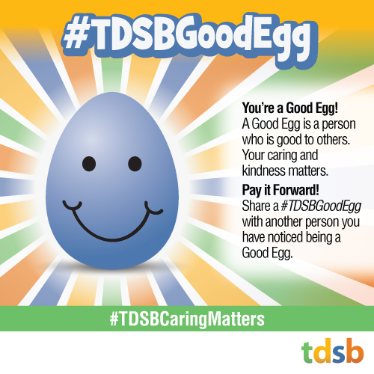
#TDSBCaringmatters
#TDSBGoodegg Initiative
We are hearing about amazing stories of kindness and caring throughout the TDSB, so we are re-launching the #TDSBGoodEgg initiative. We know it makes a difference for everyone’s well-being, especially during this challenging time!
If you want to learn more about the #TDSBGoodEgg initiative, please watch this video made by some students at Thorncliffe Park Public School:
https://youtu.be/UvenUde5Mbw
Instructions: When you notice someone being kind or caring, send them a virtual #TDSBGoodEgg (by email, tweet, instagram, text). Invite the recipient to pay it forward by acknowledging another person being a #TDSBGoodEgg.

Recipe for a Good Egg:

- It’s important to notice and acknowledge when you are touched by an individual’s genuine act of kindness and caring. Although we are not in the same physical space, we can notice kind and caring actions in other ways (through emails, phone conversations, video conferences, etc.)
- To be “GoodEgged” is an honour - be mindful when you choose someone to “Good Egg.” It’s essential that it’s thoughtful and meaningful.
- To let’s keep it rolling, tweet or submit a #TDSBGoodEgg story @ MentalHealthandWellBeing@tdsb.on.ca with a line or two about their kind and caring ways.
Let’s get cracking on noticing when others are being kind and caring and see how many #TDSBGoodEggs we can acknowledge and inspire.

