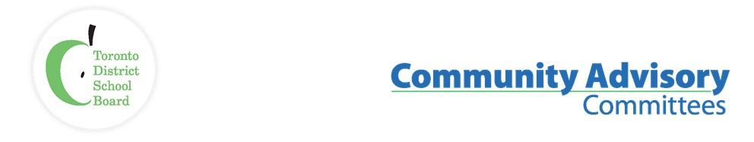

Name of Committee: Urban Indigenous Community Advisory Committee

Meeting Date: Tuesday, April 19th, 2022

Time: 6:00 p.m. – 7:30 pm
Attendance via Zoom:
Core Voting Constituents:
Present: Elder Dr. Joanne Dallaire, Elder Pauline Shirt, Elder Dr. Duke Redbird, Elder Clayton Shirt, Tanya Senk (System Superintendent, Indigenous Education, UIEC and Kâpapâmahchakwêw / Wandering Spirt School, TDSB), Christina Saunders (Principal, TDSB), Robert Durocher (Centrally Assigned Vice-Principal, TDSB), Isaiah Shafqat (Indigenous Student Trustee, TDSB), Tracy Mackenzie (Community Liaison, TDSB), Marilyn Hew (TYRMC), Joe Rock (City of Toronto, Early ON), Sean Gale (Student Success Teacher, TDSB), Shannon Judge (Community), Mary Doucette (Administrative Liaison, TDSB), Natasha Gleeson (Instructional Leader, TDSB), Bonnie Johnston (Social Worker, TDSB)
TDSB Staff:
Present: Michelle Blackie (Vice-Principal), Michael Sanders (Principal), Jim Spyropoulos (Executive Superintendent, Human Rights, and Indigenous Education), Sandy Spyropoulos (Executive Superintendent, Learning Centre 4), Elise Twyford (Centrally Assigned Vice-Principal), Irit Kelman (Interim Senior Manager, Human Rights Office)

TDSB Trustees:
Present: Trustee Alexander Brown (Ward 12), Dan McLean (Ward 2), Michelle Aarts (Ward 16), Stephanie Donaldson (Ward 9),
Trixie Doyle (Ward 14), Indigenous Student Trustee Isaiah Shafqat

Guests: Reta Red Sky Hamlin (City of Toronto, Early ON)

Regrets: Selina Young (Director of Indigenous Affairs, City of Toronto), Bob Philips (Community), Trustee Christopher Mammoliti (Ward 4)

ITEM | DISCUSSION | MOTION/RECOMMENDATION
Call to Order, Traditional Opening, Review of Meeting Etiquette, Code of Conduct | Elder Dr. Joanne Dallaire chaired and conducted a traditional opening.  Elder Dr. Joanne Dallaire spoke to the code of conduct for UICAC (Urban Indigenous Community Advisory Committee) members and guests.  Introductions from the membership in attendance.
Approval of Agenda | The agenda of May 17, 2022
Review and Approval of the minutes | The minutes of April 19, 2022
Declaration of conflict of interest, Terms of Reference | None
UICAC Priorities for 2020-21 Re-visited:  Facility, 16 Phin – Mobility, Accessibility, Health & Safety, Renovations.  Indigenous Trustee (TDSB)  Hiring practices, recruitment, retention, and mobility. | UICAC Priorities:  Facility, 16 Phin – Mobility, Accessibility, Health & Safety, Renovations  Tanya Senk (System Superintendent, Indigenous Education, TDSB)  - Second meeting held with the Ministry of Education and the Elders Council to discuss the new build. The Ministry is supportive of the work by the UIEC, Elders Council and TDSB. The Board continues to work with the Ministry of Education.  Indigenous TDSB Trustee  - As a Board we continue to explore the role of an Indigenous Trustee and the implementation of the role and what that looks like in the City of Toronto.  Hiring Practices, Recruitment, Retention, and Mobility  Tanya Senk (System Superintendent, Indigenous Education, TDSB)  - Employee Services held a meeting with OSSTF and other Unions. Conversations will continue and we will explore best practices.
Elders Council Update: | Elder Dr. Joanne Dallaire  - No update  Elder Pauline Shirt  - No update  Elder Dr. Duke Redbird  - Attending OPSOA’s conference in May and will open with a land acknowledgement.  Elder Clayton Shirt  - No update
Staff Update: | Jim Spyropoulos (Executive Superintendent, Human Rights, and Indigenous Education, TDSB)  - The Board is working towards Indigenous self determination by separating the staffing and funding from the larger processes.  Tanya Senk (System Superintendent, Indigenous Education, TDSB)  - 5th annual Creating Spaces of Belonging will take place in May.  - Planning is underway for Indigenous History Month and National Indigenous Peoples Day.  Christina Saunders (Principal, TDSB)  - Highlighted the momentous occasion of her Excellency, The Right Honourable Governor General Mary Simon’s visit to the school and the UIEC.  Michael Sanders (Principal, TDSB)  - Expressed gratitude to staff of the UIEC and their continued support to Eastview students, caregivers, and staff.
Indigenous Student Trustee & Trustee Update: | Isaiah Shafqat (Indigenous Student Trustee, TDSB)  - Bowmore Public School’s International Day of Pink celebration and opened in a good way.  - OSTA-AECO continues to work thru their Indigenous Education work online series.  - Facilitated professional learning with staff of LN15 and discussed Indigenous allyship.  - The Toronto Indigenous Youth Council continues to work on many projects, one of which includes a submission for Focus on Youth (FOY) funding to create paid student jobs.
New and Other Business
Future Topics: | Indigenous Board Trustee Committee (Dr. Susan Dion)  Sub Committee:  - Tanya Senk  - Tracy MacKenzie  - Isaiah Shafqat  - Stephanie Donaldson  - Christopher Mammoliti
Traditional Closing: | Elder Dr. Joanne Dallaire closed the meeting

