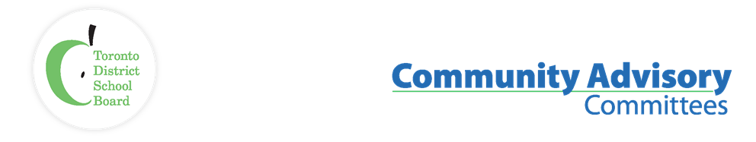
Name of Committee: Black Student Achievement Community Advisory Committee
Meeting Date: March 27, 2023
A meeting of the Black Student Achievement Community Advisory Committee convened from 7:00 p.m. to 9:00 p.m. in a virtual Zoom meeting with Co-Chairs Liban Hassan(Trustee) & Sharon Beason (Community)
Voting Members: | Sharon Beason (Community), Tina Beason (Community), Mikael Blacksmith Ben-Moodie (Education/Guidance), Sophia Ruddock (Parent), Mohamed A. Mohamed (Social Service)  Regrets: Co-Chairs, Liban Hassan(Trustee), Yasmina Drame (Corrections), Dennis Keshinro (EPAC Rep.)
Staff Representatives: | Lorraine Linton, Interim Executive Superintendent, Employee Services  Karen Murray, System Superintendent Equity, Anti-Racism, Anti-Oppression  Lisa White, Administrative Support
Student Trustee: | Naomi Musa, Jeffrey Osaro
Staff/Community | Andrea Cross, Cherie Mordecai-Steer, Rosalie Griffith, Jeffrey Caton, Jamea Zuberi, Yvette Blackburn, Kurt Lewin, Deborah Buchanan-Walford, Omar Kowthar, Shalone, Neil Logik, Thando Hyman, Trudy J, Valarie Tait  Regrets: Alice Bhyat, Novlette Mitchell
Guests:
ITEM |  | DISCUSSION | ACTION/ RECOMMENDATION / MOTION
Call to Order / Quorum |  | The quorum was reached at 7:11 pm. The meeting was called to order.
Approval of Agenda |  | The motion to accept the agenda was moved by Sophia Ruddock. Seconded Tina Beason. All in favor. Motion carried
Approval of Minutes |  | The motion to accept the December & January BSACAC minutes was deferred to the next meeting.
Declaration of possible conflicts of interest |  | No conflict was declared
Student Trustees: Naomi Musa, Jeffery Osaro |  | - Provided updates about Student Senate & Student Trustee elections.  - Discussed student safety and meeting with students in schools experiencing violence.  - The Student Trustees attended OSTA-AECO’s Board Council Conference in Ottawa from February 16th – 19th.  - The Student Trustees have begun drafting the first-ever TDSB Student Trustee handbook which will include important information for incoming student trustees to ensure a smoother transition into the role.  - The Student Trustees have recently joined the steering committee for the Multi-Year Strategic Plan (MYSP) renewal.
Staff up-date |  | - Lorraine Linton: Reported that the multi-year strategic plan has been released to staff. https://www.tdsb.on.ca/Leadership/Boardroom/Multi-Year-Strategic-Plan  - Introduce Director Colleen Russell-Rawlins monthly report which is available at the website indicated below: https://www.youtube.com/watch?v=mBa8Kv6KSiM  - March 29th Financial Budget Enrolment Committee Meetings available to view.https://pub-tdsb.escribemeetings.com/Players/ISIStandAlonePlayer.aspx?Id=893047e1-1301-4061-b77e-d45dec7e003b  - The next board meeting will be held on April 26th.
Co-Chairs Update |  | No updates reported
Expression of Interest, Sharon Beason |  | Expression of Interest now posted on BSACAC webpage:  https://www.tdsb.on.ca/Portals/0/Community/Community%20Advisory%20committees/BSACAC_Expression_of_Interest_Form.doc
Centre of Excellence for Black Student Achievement, Jeff Caton |  | Jeffrey Caton, presented on the events upcoming and ongoing at the Center of Excellence for Black Students Achievement
Other Business |  | Other Business  - Cherie Mordecai-Steer presented on AI.  https://drive.google.com/file/d/1yHnrWpR7f5jb3_nshd1C4l6PLVdkkJjX/view  - Cherie also provided the below attachments for further information.  AI is Evolving Faster Than You Think [GPT-4 and beyond] - YouTube'  What's New In Warehousing Playlist - Boston Dynamics  McDonald's First Robot Restaurant - YouTube  Robot restaurant: machines prepare, cook and serve all the food at eatery in China - YouTube  - Amani Ausar and Deborah Buchanan from Ontario Alliance of Black School Educators (ONABSE) informed the committee of the upcoming 8th annual conferences in April https://linktr.ee/onabseconference2023
Adjournment |  | 9:00.
Next Meeting Date |  | May 1st, 2023

