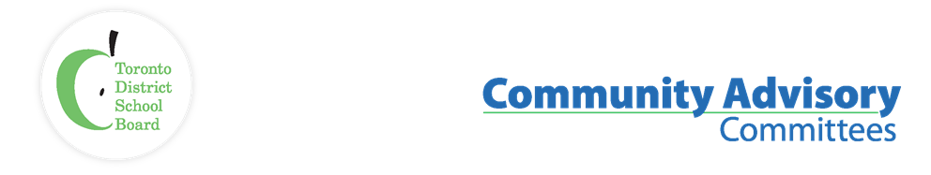

Name of Committee: Alternative Schools Community Advisory Committee
Meeting Date: 27 March 2023
A meeting of the Alternative Schools Community Advisory Committee convened on March 27, 2023, from 6:30 pm to 8:30 pm via Virtual Meeting (Zoom) with Jacob Leibovitch and Laurie McAllister (Co-Chairs) presiding.
Membership  Attendance: | Sarah Bogatie (Student, Avondale Alternative Secondary School; Secondary School Student Representative); Diana Grimaldos (Parent, Mountview Alternative Junior School, ASCAC Member); Joanne Huber (Parent, High Park Alternative JS, ASCAC Member), Shelley Laskin (Trustee Ward 8, ASCAC Trustee Co-Chair); Jacob Leibovitch (Parent, ALPHA Alternative Junior School, ASCAC Co-Chair); Laurie McAllister (Parent, Avondale Secondary Alternative School, ASCAC Co-Chair)
Staff Lead: | Peter Chang (TDSB System Superintendent)
Recorder: | Anna Catalano, ASCAC Committee Assistant
Regrets: | Serge Guschin (Parent, Beaches alternative School, ASCAC Member); Olga Ingrahm (Parent, Alternative Scarborough Education 1, ASCAC Member)

ITEM | DISCUSSION
- Land Acknowledgement, Welcome/ Introductions | Laurie McAllister, Secondary Alternative School Parent Co-Chair welcomed everyone to the meeting.
- Approval of Agenda  Declarations of Possible Conflicts | The agenda was approved.  No conflicts were declared.
- Co-Chairs Updates | Terms of Reference  - Terms of Reference are rules ASCAC develops  - This year the Terms of Reference were supposed to be reviewed and possibly revised  - The review has been deferred until CACs receive guidance from PCEO  Student Census  - The Student Census was to be implemented Fall 2022  - There were some concerns, and the implementation was paused  - During the pause, requirements of the Anti-Racism Act became mandatory for school boards to follow as of January 1, 2023, which necessitated review of the following identity questions: Indigenous identity, ethnicity, race, and religion  - At the same time, new data collection guidelines from the Ministry of Education regarding parental consent and alignment with the Health and Physical Education curriculum led to a review of the questions related to gender identity and sexual orientation  - As a result of this review, the consent process for students in grades 4 to 8 were changed. Parents now provide consent for their grade 4 to 8 child to participate in the Census at school, complete the Census at home, or opt-out completely  - Due to the increased concerns surrounding school violence, perception questions related to safety and bullying were also reviewed  - Topic areas identified as being most relevant to school improvement planning were also prioritized, while those less relevant were considered for removal  - Staff from the Research Department attended the 2SLGBTQ+ CAC meeting on February 28, 2023, and were able to make minor corrections only where necessary. No material changes were made.  - All parents should have received an email by now. Parents whose child is in JK to Grade 3 will receive a link to complete the Census on behalf of their child; parents whose child is in Grade 4 to 8 will receive an email to provide consent for their child to complete the Census; and students in Grades 9 to 12 will receive a link to the Census  - The Census is voluntary and confidential, but the data is very important to guide decision making. Participants are encouraged to complete the Census  Action: once the data collection is complete and released invite staff from the Research department to present the highlights at an ASCAC meeting
- ALPHA Equity Committee Presentation | Ariana Gonzalez Stokas, Chair of the Equity Committee at ALPHA Alternative Elementary School, has been working with the families to create their equity survey to better understand the school’s environment.  Purpose of the survey is to understand what resource barriers exist for families at ALPHA preventing them from fully participating at the school. The survey would give more information beyond the anecdotes.  The survey has 25 questions including demographics, family income, transportation challenges and barriers, food & security, supports families have, exceptionalities and if students have support, etc.  The survey has been implemented to about 80 families at ALPHA Alternative  Elementary School. Once the data has been collected and analyzed, the Equity team hopes to better plan for the 2023-24 school year in areas such as: field trips, lunch support, car pooling for transportation, fundraising, etc.  Ariana mentioned that if anyone wanted to see a copy of the survey, she would be happy to share. She also mentioned that she would be willing to come back to an ASCAC meeting to share the results.
- TDSB Board Updates | Budget Process  - TDSB’s annual budget is approximately $3.4 billion, 76% of its budget is allocated to staffing costs, educational tools, and classroom materials. Approximately 10% of the budget relates to school operations, such as caretaking, utilities, and maintenance. 12% of the budget relates to transportation, renewal, amortization, fundraising and other fixed costs. Only 2% of the budget relates to administration. See Appendix A for the 2022-23 GSN and Revised Estimates and Appendix B for the 2023-24 Total Revised Estimates as presented at a Trustees’ Information Session  - The majority of school board funding is through Ministry Grants  - This year’s budget process is different because the release of the GSNs has been delayed  - The GSNs should be released early to mid-April  - Presently, staffing is based solely on projected enrolment and staffing for Secondary Alternative Schools has been decreased by 1 compared to last year’s staff allocation  - Please visit Trustee’s Laskin’s Weekly Update Newsletter for information about the budget and the Pandemic Recovery Plan  - For additional information on the budget process, including upcoming meeting dates, please visit the Developing the 2023-2024 Budget webpage  Multi Year Strategic Plan Renewal  - One of the core duties for Trustees is to have a Multi Year Strategic Plan (MYSP)  - The webpage for the MYSP Renewal can be found here.  - There is a MYSP Renewal survey that can be completed. Trustee Laskin, and other Trustees, will have Ward Forums in Fall 2023 about the MYSP renewal and survey  Summer School  - Please visit the Summer Programs webpage for information about:  - Elementary summer school and programs (extended day program – summer camp, Summer International Languages Elementary & African Heritage Program, outdoor education camp and music & arts camps)  - Secondary summer school and programs (e-Summer, Continuing Education secondary credit summer program, international youth summer Program)  - Special education and inclusion summer program  - Adult Summer programs including adult ESL summer programs and Learn4Life general interest courses  Learning Opportunities Index (LOI)  - The LOI ranks TDSB schools based on measures of external challenges affecting student success.  - The 2023 LOI has been released. Read the current full report.  - Peter noted that for the secondary school list, 8 of the top 18 schools with the most external challenges on the LOI are secondary alternative schools
- Secondary Alternative Schools  Updates, discussions, potential recommendations | Staffing  - Over the last five years, enrolment at secondary alternative schools dropped from about 1,500 to just over 1,000 students  - The 21 secondary alternative schools will be receiving a supplement of 16 teachers for the 2023-24 school year. In the 2022-23 school year, the 21 secondary alternative schools received a supplement of 17 teachers  - There were discussions around the staffing of secondary alternative schools (SAS) as the system that is used for the mainstream schools does not work for the SAS.  Secondary Alternative Schools Program Review  - On May 5, 2021, ASCAC presented to the Program and School Services Committee (PSSC) a recommendation that the Board conduct a review of Secondary Alternative Schools. Staff were asked to review ASCAC’s recommendation and report back  - Staff reviewed the recommendation to determine the feasibility and potential timelines of a review of all Secondary Alternative Schools in TDSB, and presented the Review of Secondary Alternative Schools Feasibility Report to PSSC on June 9, 2021  - The secondary alternative schools program review will start in fall 2023. The review will not only look at the strengths but also the weaknesses. Using the SWOT (Strengths, Weaknesses, Opportunities, Threats) model  - During the review, the working group will speak to students, staff, ASCAC and other CACs, and the TDSB community.  - The review will also look at the locations of the SAS – students are travelling for a few hours to get to an SAS  Delegating at a Board Committee Meeting  - Members of the public can bring forward issues and concerns they have through a delegation. For complete information on the delegation process, including the delegation request form please click here  Recommendation to FBEC  - Trustee Laskin suggested that the ASCAC members make a recommendation to the next FBEC meeting that the Board be reminded of their commitment to secondary alternative schools in the review and approval of the 2023-24 operating budget ASCAC drafted a recommendation in principle, to be refined and agreed via email exchange following the meeting, to remind the Board of its commitment to secondary alternative schools and the necessity for supporting its students  - Sarah moved the recommendation and Jacob second the motion.  - Trustee Laskin is a member of FBEC and abstained from voting on the recommendation. ASCAC members voted and the recommendation passed  - The final recommendation was agreed via email as follows:  ASCAC Recommendation:  WHEREAS TDSB Secondary Alternative Schools provide a lifeline for students who are affected by external challenges, and challenges within the system, which put them at increased risk of being pushed out of the system, not returning to the system, not graduating, and the related risks to their well-being;  AND WHEREAS the Board has strongly committed to maintain the viability Secondary Alternative School programming;  THEREFORE the Alternative Schools Community Advisory Committee recommends that the Board be reminded of its commitment to Secondary Alternative School programming and the students relying on the lifeline it provides, in the Board’s review and approval of the 2023-24 Operating Budget.
- Elementary Alternative School Admissions  Status of admissions to elementary schools through the new centralized procedure | - The second round of offers were made on March 22 and families have until 4pm March 28 to accept or decline their offer  - Just under 1,300 applications were received for admissions to one of the 17 elementary alternative schools (2 schools chose not to participate this year)  - There were approximately 458 available seats  - Once the process closes, the staff in the Research department will review our data and draft a report which will inform how we move forward the following school year  - If there are still available seats and there are students on the waitlist, a possible third round may be offered to fill those seats  - There were discussions around elementary alternative schools opting out of this year’s application process. Peter mentioned that staff decided that since this was the first year and a pilot, schools were able to opt out this year  - ASCAC’s recommendation was never to allow an elementary alternative school to opt out. Once the procedure is approved, all elementary alternative schools will be participating  - Joanne recommended that ASCAC create an admissions sub-committee to look at some of the information presented this evening. She also mentioned that since ALPHA II is unique, should they still be allowed to opt out
- Elementary Alternative Schools  Updates, discussions, potential recommendations | No additional updates to present
- Open Floor | Meeting participants were welcomed to ask questions, provide feedback and or let the Committee know of any concerns they may have.  A participant spoke about the stand alone middle schools (schools with only Grades 7 & 8 only) not fitting in with the elementary alternative schools nor the secondary alternative schools. The middle schools went from 4 staff members to 2.5 which negatively impacts the students and staff.
- Adjournment and Next Meeting | Meeting was adjourned at 8:41 pm  Next Meeting: Monday, May 29, 2023 (last meeting), from 6:30pm to 8:30pm via Zoom
- Future Meeting Dates | Monday, October 23, 2023, from 7:00 p.m. to 9:00 p.m.  Monday, December 18, 2023, from 7:00 p.m. to 9:00 p.m.

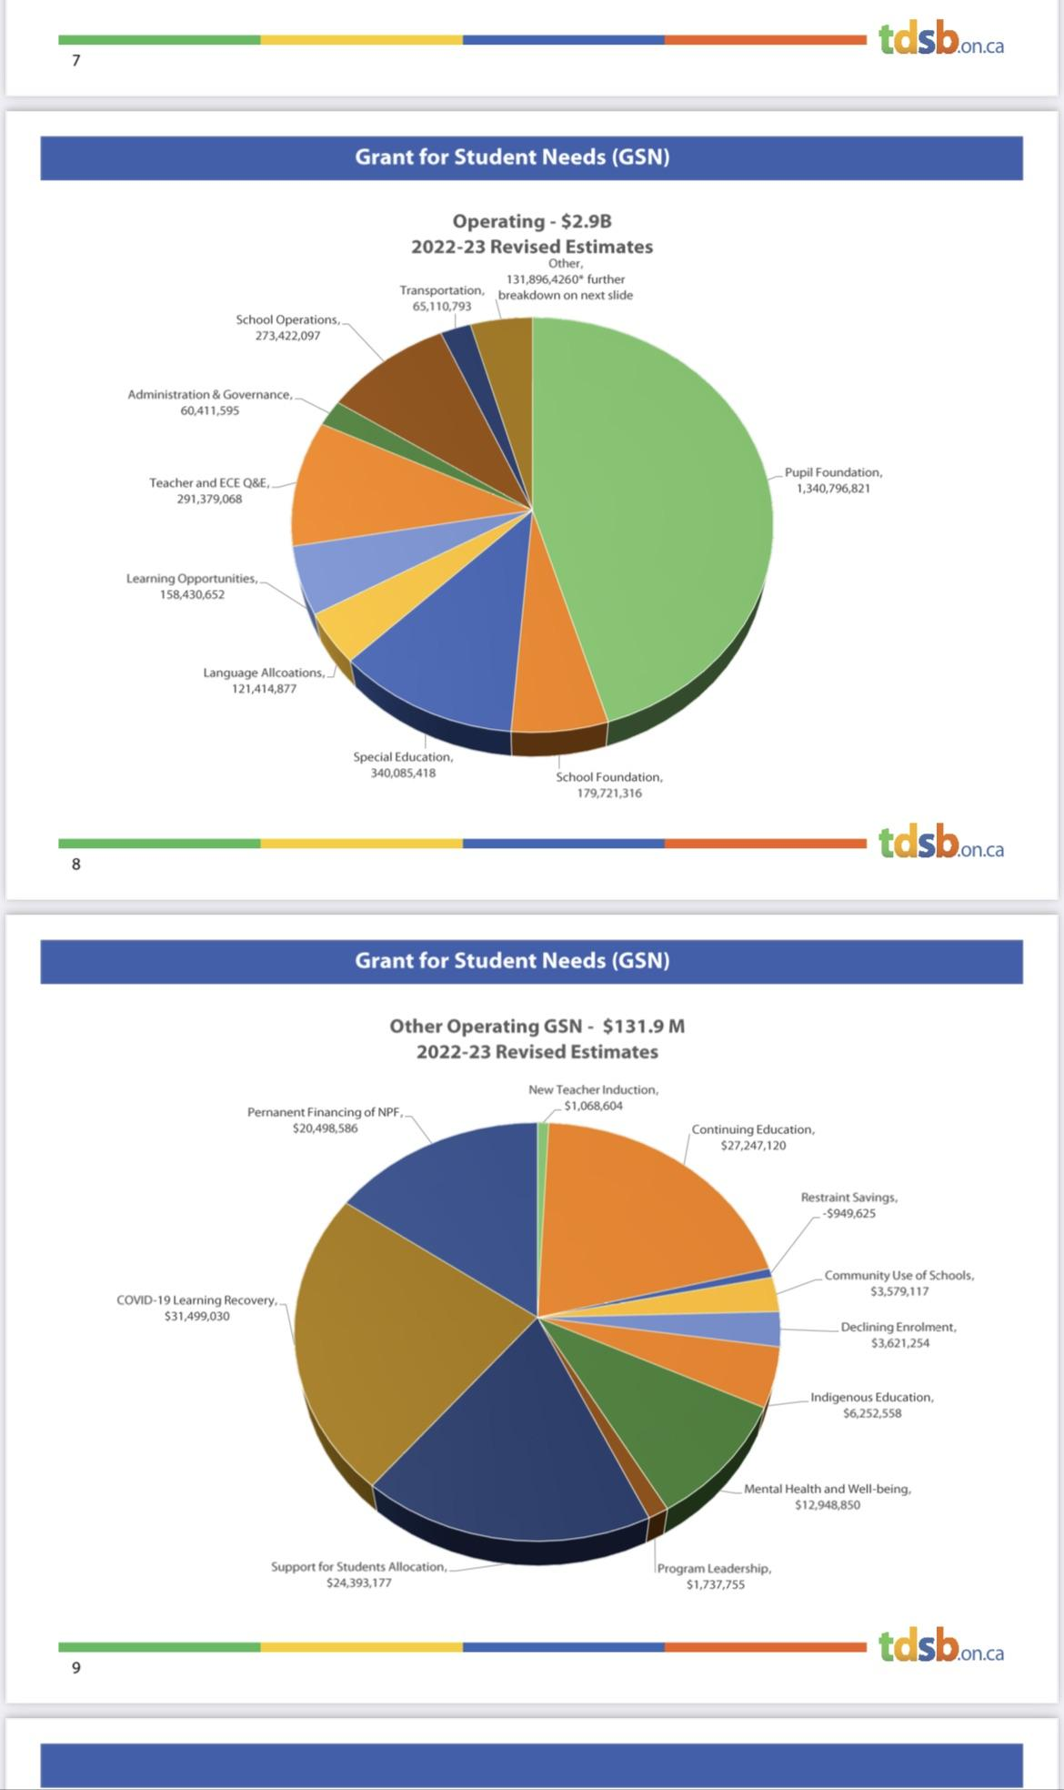
Appendix A

Appendix B

