Approved Minutes
Name of Committee: Special Education Advisory Committee
Meeting Date: April 11, 2022
A meeting of the Special Education Advisory Committee convened on April 11, 2022, from 7: 00 p.m. to 9:09 p.m. via Zoom with SEAC Chair Steven Lynette and Vice-Chair Diane Montgomery
Attendance:
Melissa Rosen (Association for Bright Children (ABC), Steven Lynette (Epilepsy Toronto), Richard Carter (Down Syndrome Association of Toronto), , Tracey O’Regan (Community Living Toronto), Aliza Chagpar (Easter Seals), Tania Principe (Integrated Action for Inclusion (IAI), David Lepofsky (VIEWS for the Visually Impaired), Juanita Beaudry (CADDAC), Shanna Lino (VOICE for Hearing Impaired Children), Nadia Persaud (Learning Disability Association), Lisa Kness (Autism Ontario), Tracey Burrell (BPSG), Aliza Chagpar (Easter Seals) , Aline Chan LC1, Nora Green LC1, Jean-Paul Ngana LC2, Jordan Glass LC2, Kirsten Doyle LC3, Olga Ingrahm LC3, Diane Montgomery LC4, Izabella Pruska-Oldenoff LC4, Trustee Michelle Aarts, Trustee Alexander Brown, Trustee Dan MacLean
Alternates attending: Julie Diamond (Autism Society), Ioanna Agelothanasis (LC2), Caren Watkins (LC1), George Petrovic (LC4). Adebukola Adenowo-Akpan (Easter Seals Ontario), Nerissa Hutchison (BPSG)
Regrets:
Staff:
Andrew Gold, Associate Director, Audley Salmon, Associate Director, Janine Small, Centrally Assigned Principal, Special Education, Andrea Roach, Centrally Assigned Principal, Special Education LC4, Effie Stathopoulos, Centrally Assigned Principal, Special Education LC1, Susan Moulton, Centrally Assigned Principal, Special Education LC2, Jennie Petko, Centrally Assigned Principal, Special Education LC 3, Wendy Terro, Centrally Assigned Principal, Special Education, Special Education, Mun Shu Wong, Media Services, Lianne Dixon, SEAC Liaison, Shameen Sandhu, System Leader, Mental Health

Item | Discussion | Motion | Recommendation
Call to Order - Quorum | Live stream announced |  | Quorum achieved
Land Acknowledgement | Read by Chair
Approval of Agenda | Approved | Motion to approve the agenda | Carried
Approval of Minutes from March SEAC Meeting | Minutes were approved | Motion to approve the minutes | Carried
Conflicts of interest | No Conflicts of Interest
Working Group Updates | Working Groups Updates  Budget – Will meet prior to May meeting and report  Special Education Plan – In depth look at Section C of the current Special Education Plan  - Timeline of working on the 2022-23 plan were shared  - SEAC members asked to continue to provide feedback  Communication – no report  K-12 - will meet prior to May meeting and report back  - Report shared with SEAC prior to meeting is attached to minutes (Appendix A)  SEAC Operations – no report  PIAC/SEAC – no report  Operational – no report
Association Updates
Motion - Legislated Mandate  - Motion Affirming SEAC’s Mandate | Melissa Rosen presented a motion affirming SEAC’s Mandate and Requirement to Provide Advice and Recommendations on Any and All Special Education Matters (Appendix B)  It was discussed that a number of the items in this motion have been addressed already. Decision was made to present the motion as is, and to vote on it. |  | Motion carried
Leadership and Learning Report | Andrew Gold  As per SEAC’s request, a written leadership report has been provided to accompany the PowerPoint and presentation.  (Appendix C)  OnSIS Data  TDSB OnSIS Data from 2020 regarding special education categories of exceptionality and placement types was shared with SEAC.  In 2020, TDSB reported a total headcount of 241,151 students elementary and secondary with 45,513 or 18.9% of students receiving special education programs and/or services. Of those receiving special education programs and/or services, approximately 73.4% were in regular class with the setting Indirect Support, Resource or Withdrawal and 26.6% were in special education classes with the setting of Fully- Self Contained or Partial Integration.  Of all students receiving special education programs and/or services, approximately 58% were not identified by an IPRC, whereas 42% were identified as exceptional by an IPRC.  Aged Data will follow at a later meeting  Psychological Assessments statistics for March 2022 were shared. The number of Gifted vs Comprehensive Assessments were shared.  The backlog of assessment referrals is steadily being decreased.  IPRC numbers were also shared.  .
Trustees Report  - Trustee Aarts  - Trustee MacLean  - Trustee Brown | Nil
Other Business  B. Correspondence - none  Adjournment  Next Meeting: May 9, 2022 @ 7:00 pm | Onboarding Meeting – materials will be sent out before next meeting and a date will be planned so that new members can be included.  Audley Salmon (Associate Director) and Nandy Palmer (System Superintendent, Special Education and Inclusion) were introduced and welcomed by SEAC Chair.

Appendix A
Report to Toronto District School Board Special Education Advisory Committee by the K12 Working Group
April 4, 2022

1. Introduction

This is the report to SEAC by the K12 Working Group. It arises from our April 4, 2022 meeting. we ask that this report be made part of the formal proceedings and minutes of the upcoming April 2022 SEAC meeting.
This report addresses next steps on SEAC's motion passed at the March 2022 SEAC meeting on the implementation of the K-12 Education Standards Development Committee final report. All of these measures can be acted upon now.

2. Pressing Need for TDSB to Create Strong Staff Leadership on Disability and Accessibility

In order to make the system-wide changes that the K-12 Education Standards Development Committee report recommends across TDSB, TDSB cannot take a "business as usual" approach to students with disabilities. It needs to be ready with a leadership team that can steer significant change and improvement.

The K12 Working Group of TDSB's Special Education Advisory Committee is very concerned. We now face a staff leadership vacuum. This has included revolving door changes in leadership, and for the first third of this year, a vacancy in the senior special education leadership position.

As but one small but important example, TDSB was to assign staff to meet with the K12 Working Group at its April 4, 2022 meeting. No one attended. We were told that morning by Lianne Dixon that no staff had been identified for her. Staff names were only provided after that meeting had concluded. We were told that these staff will work with us: Janine Small - Centrally Assigned Principal, Special Education and Inclusion
Effie Stathopoulos - Centrally Assigned Principal, Special Education and Inclusion
Dina Anker – Accessibility Coordinator
Jenny Clement - Accessibility Consultant

We would appreciate it if another K12 Working Group meeting could be arranged before our next SEAC meeting, where staff can attend. We could do it day or evening.

3. Need for TDSB to Create and Implement a Comprehensive Plan to Let parents of Students with Disabilities Know What Options are Available for Their Child and How to Access Them

Had TDSB staff attended the April 4, 2022 meeting of the K12 Working Group, it had been our intention to ask them to develop and bring back to us for discussion a comprehensive communication plan. It should aim to inform parents/guardians of students with disabilities about the options available to their child (including disability services and supports), how and where to advocate for these, and rights advice about their rights in the TDSB process. Through this report, we are now making that request.

This plan should ensure that the information on education options, supports, etc. be conveyed in multiple ways (leaflets, website, Youtube videos). It must be in plain language, using no special education jargon. It should be available in multiple languages. It should be easy to find and easy to use. It should be prominently placed on the TDSB website. It could be field-tested with SEAC and others.

The K12 Working Group would welcome and requests a chance to review a draft of this plan, even a very rough draft, to give input. After staff get a chance to incorporate that feedback, a revised draft could be brought to the entire SEAC at its May meeting for input from the entire Committee. We ask that agenda time be allocated for this.

To begin, TDSB staff, both from the special education area and the communications area, should carefully review the results of the SEAC parents survey that we provided to TDSB some four years ago, again attached to this report.

Often a large organization will try to build an entire strategy before launching anything. The need to help parents/guardians of students with disabilities is great. They cannot wait. As such, we recommend as a first step that TDSB publicize through its broadcast emails to and post a link on its website to this video that offers practical tips for parents of students with disabilities on how to advocate for their child's disability-related needs at school: https://www.youtube.com/watch?v=TtadvCvcGC0 parents/guardians

4. Notifying Parents that They Can Request an IEP Meeting

At its March meeting, SEAC approved, once again, that parents/guardians of students with special education needs should be offered a meeting to discuss what could be included in their child's IEP. The K12 Working Group proposes that staff include the following, or words to the same effect, in clear and plain language, in the standard letter that is sent to all parents/guardians about the forthcoming development or review of their child's Individual Education Plan:

"We want to work collaboratively with you on the development of the Individual Education Plan for your child. You can ask us to arrange a meeting, either in person or virtually (by Zoom or even by phone), to talk about what should be included in your child's Individual Education Plan to ensure that they can fully benefit from school. You can bring with you anyone you want who can help, such as any specialists who work with your child outside school."

We would like to receive a copy of that standard form letter.

5. Establishing a TDSB Board-Level Accessibility Committee

The K-12 Education Standards Development Committee recommended that each school board establish a board-level Accessibility Committee. Some school boards have one. TDSB does not.

At the March SEAC meeting, TDSB Board chair Alexander Brown said he would take this recommendation back to the trustees.

It would be helpful if a staff member from the TDSB Board governance team could meet with the K12 Working Group on steps that the Board will take to act on this recommendation.

Appendix B

Motion Passed at SEAC – April 11, 2022 - Legislated Mandate
Motion Affirming SEAC’s Mandate and Requirement to Provide Advice and Recommendations on Any and All Special Education Matters
WHEREAS O. Reg. 464.97: “Special Education Advisory Committees” under the Ontario Education Act, R.S.O. 1990, c. E.2 set up the requirement that every school board in Ontario have a Special Education Advisory Committee (“SEAC”), and that SEACs may “make recommendations to the board in respect of any matter affecting the establishment, development and delivery of special education programs and services for exceptional pupils of the board” and “[b]efore making a decision on a recommendation of the committee, the board shall provide an opportunity for the committee to be heard before the board and before any other committee of the board to which the recommendation is referred”. O. Reg. 464/97, s. 11.
AND WHEREAS TDSB staff have made significant changes to Special Education, without consulting or disclosing these changes to SEAC in advance,
AND WHEREAS some of the significant changes made by TDSB to Special Education without consulting or disclosing to SEAC in advance, include the following examples of changes to special education policies, procedures, and practices:
(a) “Primary IEP Strategy”: TDSB staff did not consult or inform SEAC before implementing this very significant change to eliminate and substantially reduce access to Primary Individual Education Plans (“IEPs”);
(b) Cancellation of and Significant Delays to Special Education Assessments, IEPs, Identifications, Placements, and other Supports: initially “in response to the new pandemic”, but persisting significantly for many months thereafter;
(c) Elimination of DHH (Deaf and Hard of Hearing), BLV (Blind and Low Vision), and other Itinerant Specialist special education staff’s “write” access to IEPs;
(d) Undisclosed cancellation of the entire SEPRC (“Special Education Placement and Review Committee”) meeting and process for almost all new students with special education needs and issues.
AND WHEREAS these changes restrict access to necessary, efficient, and effective supports for many students with identified and unidentified special education needs;
AND WHEREAS TDSB staff did not disclose these significant changes to SEAC prior to their implementation;
AND WHEREAS as a result SEAC was not able to provide its advice and recommendations on these issues and changes, as it is fundamentally required to do pursuant to O. Reg. 464.97: “Special Education Advisory Committees” under the Ontario Education Act, R.S.O. 1990, c. E.2 (the “Legislation”) and as is in the best interest of the vulnerable children that we represent.
NOW THEREFORE IT IS RESOLVED:
THAT all of the preamble (“WHEREAS”) statements above are included as part of this “IT IS RESOLVED” and recommendation section of this motion;
AND THAT TDSB staff fully inform and consult with SEAC about all previous changes made to Special Education policies, procedures, and practices;
AND THAT TDSB be required to now submit and provide to SEAC full information about these and all changes to special education policies, procedures, and practices (herein collectively referred to as “Special Education Policies”) in order to allow SEAC to consult on these issues and provide its recommendations;
AND THAT TDSB then consider this advice and recommendations, and consider amending and / or retracting these Special Education Policies based on these recommendations;
AND THAT going forward TDSB staff comply with the Legislation’s mandate to fully inform and consult with SEAC on matters pertaining to the education of students with special education needs IN ADVANCE of decisions to implement changes to Special Education policies, practices, and procedures, AND BEFORE the implementation of any of these changes.
Appendix C
Special Education Advisory Committee Meeting
April 11, 2022
Leadership Report
Leadership, Learning and School Improvement
Audley Salmon, Associate Director Learning Transformation and Equity
Andrew Gold, Associate Director Student Well-Being & Innovation
Nandy Palmer, System Superintendent of Special Education & Inclusion

Welcome

Virtual Learning 2022-2023

Families were provided with the opportunity to register for virtual learning for the entire 2022-2023 school year. This option also included special education Intensive Support Programs (ISPs). Staff allocation to support students in special education secondary and elementary virtual learning is provided through a combination of Ministry COVID Funds and shifting of resources.

Over 4000 students and families have selected virtual learning for the 2022-2023 school year, of which 19.7% of those are students with special education needs. The registration data shows that of all students receiving special education support, approximately 21% are in ISP programs and the remaining in regular class through resource support.

TDSB OnSIS Data - Report 2020

In 2020, TDSB reported a total headcount of 241,151 students elementary and secondary with 45,513 or 18.9% of students receiving special education programs and/or services. Of those receiving special education programs and/or services, approximately 73.4% were in regular class with the setting Indirect Support, Resource or Withdrawal and 26.6% were in special education classes with the setting of Fully- Self Contained or Partial Integration.

Of all students receiving special education programs and/or services, approximately 58% were not identified by an IPRC, whereas 42% were identified as exceptional by an IPRC.

Table 1: Special Education Categories (Exceptionalities and Placement Types*) for Elementary and Secondary Students for October 2020
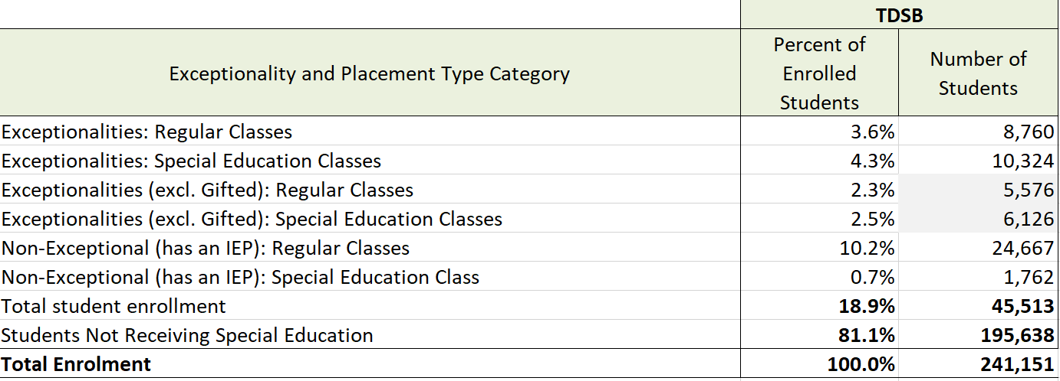

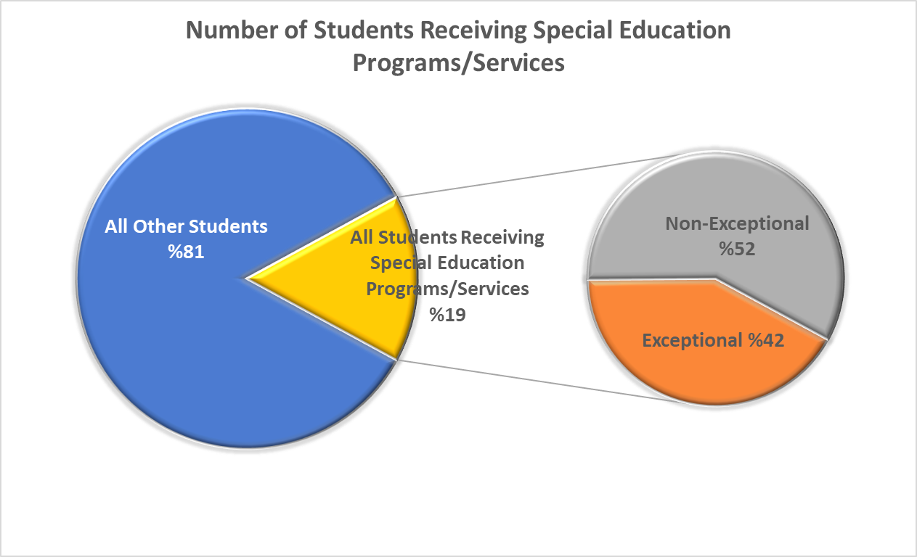

When excluding Gifted, Learning Disability continues to be the exceptionality with the highest number of students across the province with 27% in TDSB and Autism with 14.7% continues to be the fastest growing exceptionality across the province and in TDSB. This is aligned to the provincial trends.

Note: OnSIS data does not include exceptionality or IEPs by grade. However, we are able to provide this data based on the number of students receiving special education programs and/or services in TDSB.

Table2: Elementary and Secondary Students with Special Education Exceptionalities or Non-Identified as of October 31, 2020

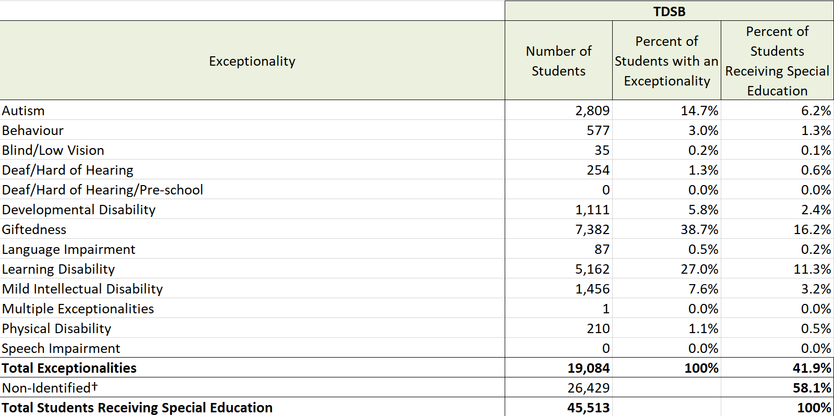

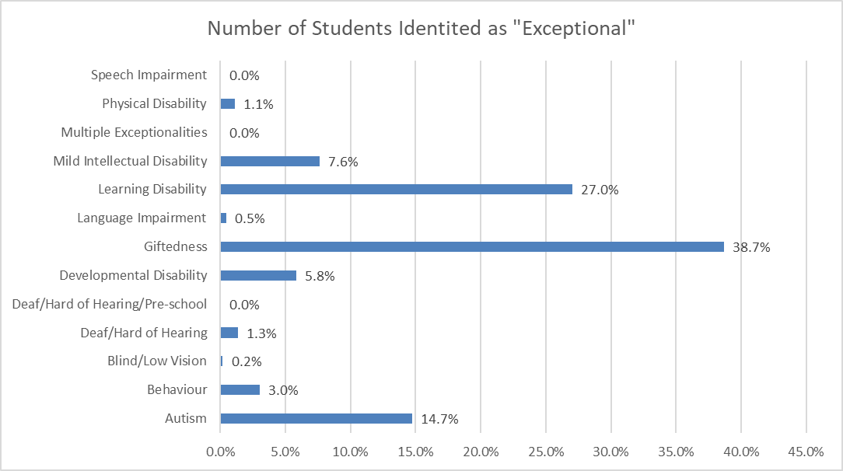
Psychological Assessments - March 2022
Provided below is the report of assessments completed in March.
March | LC1 | LC2 | LC3 | LC4 | Total
Completed | 235 | 247 | 109 | 206 | 797
Referrals | 154 | 167 | 84 | 124 | 529
Cumulative stats from September 2021
Completed | 647 | 787 | 497 | 845 | 2776
In Progress | 209 | 249 | 219 | 302 | 979
Waiting* | 286 | 239 | 301 | 393 | 1219
Removed | 112 | 188 | 101 | 223 | 624
Total Referrals** | 1254 | 1463 | 1118 | 1763 | 5598

IPRC - March 2022

March IPRCs
IPRC Completed | 100
IPRC Scheduled | 244
IPRC Cumulative since August 2021
IPRC Cumulative since August 2021 | 1,526

Since September 2021 to March 31, 2022, the total number of referrals for comprehensive and gifted assessments requested has totalled 4974 (5598-624 which were removed).
Gifted assessment referrals usually begin in late October after students have completed the CCAT.
Total Referrals vs Gifted Assessments (September-March)
Total Referrals: 31%
Total Comprehensive Referrals: 69%

Comprehensive and Gifted Assessment waitlists are 80% and 20% respectively at this time.
Comprehensive Waitlist: 975 or 90%
Gifted Waitlist: 244 or 20%
Slide 4 and 5:
Psychological Referrals (September – March)
Total Referrals: 5598
Waiting: 1219
Completed: 2776
In Progress: 979
Removed: 624
*Note that 1219 are on a waitlist of 244 Gifted Assessments and 975 Comprehensive Assessments.
• 2776 Referrals (Comprehensive & Gifted) have been completed since September 2021.
• 979 Referrals (Comprehensive & Gifted) are in progress
• 624 have been removed for some the following reasons:
• The parent/guardian has not consented to the assessment
• The student has left the board
• The student moved out of the country
• Other supports were provided that supported the initial needs which initiated the assessment (trauma therapy; outside private psycho-educational assessment by parent/guardian; supports/differential strategies provided to the educators in the classroom that have positive outcomes etc.)
LC1 Referrals -
Completed: 647
In Progress: 209
Waiting: 286
Removed: 112
Total Referrals, LC1: 1254
LC2 Referrals -
Completed: 787
In Progress: 249
Waiting: 239
Removed: 188
Total Referrals, LC2: 1463
LC3 Referrals -
Completed: 497
In Progress: 219
Waiting: 301
Removed: 101
Total Referrals, LC3: 1118
LC4 Referrals -
Completed: 845
In Progress: 302
Waiting: 393
Removed: 223
Total Referrals, LC4: 1763
LC1:
Number of Schools: 134
Elementary Student Population: 42430
Secondary Student Population: 20258
Total Student Population: 62688
LC2:
Number of Schools: 136
Elementary Student Population: 41428
Secondary Student Population: 16877
Total Student Population: 58305
LC3:
Number of Schools: 133
Elementary Student Population: 40878
Secondary Student Population: 15589
Total Student Population: 56467
LC4:
Number of Schools: 157
Elementary Student Population: 49445
Secondary Student Population: 17837
Total Student Population: 67277
Higher referral numbers in LC4 are attributed to:
• LC4 has 20 plus more schools than the other LC’s
• LC4 has 5000-10,000 more students than the other LC’
Comprehensive Assessments Aged Waitlist
All LCS:
0-3 Months: 537, 55%
4-6 Months: 275, 28%
7-9 Months: 82, 9%
10+ Months: 81, 8%
Total: 975
Gifted Assessments Aged Waitlist
All LCS:
0-3 Months: 162, 66%
4-6 Months: 60, 25%
7-9 Months: 9, 4%
10+ Months: 13, 5%
Total: 244
Psychological staff are working on ensuring comprehensive assessments, over 6 months, are attended to and completed, including any referrals from 2021 that remain on the comprehensive waitlist.
Some reasons why some of the referrals continue to be on the waitlists:
1) Parents/Guardians want to continue with the assessments and the students are in virtual school where only a portion of psychoeducational assessments can be completed virtually. These students and parents/guardians are being offered local school spaces and administrative buildings to support the completion of in person testing but have declined.
2) Students who left, in between testing, to go out of the country/city/province and want to remain on the waitlist.
3) Students who enrolled into virtual school in between testing and want to remain on the waitlist.
4) Students and parents/guardians who are not responding to the staff and staff are working with the school and Attendance Counselors to locate.
Staff will be completing as many compressive assessments they can over the summer and gifted if funding from the Ministry continues, as it has over the past two summers, (i.e. during the summer of 2021- 234 Gifted and 43 Comprehensive Assessments were completed).

