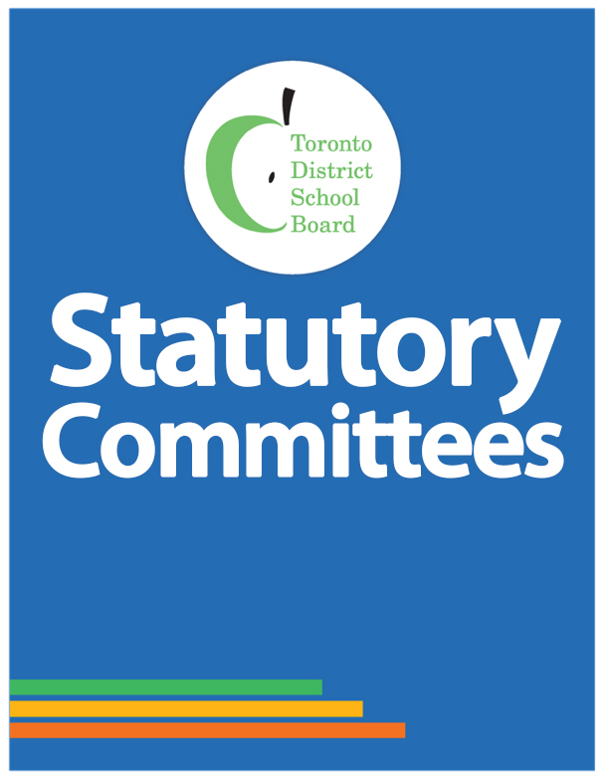

**Special Education Advisory Committee (SEAC)**

**2018-2019 ANNUAL REPORT**

Table of Contents

Co-Chair Message 3

Advisory Committee Mandate/ Purpose 4

Advisory Committee Activities 5

Meetings 5

Outreach initiative(s) 5

Special Event(s) 6

Board Directed Events/Consultations 6

Committee Members 7

Co-Chair Message

Advisory Committee Mandate/ Purpose

Advisory Committee Activities

*Meetings*

*Outreach initiative(s)*

Advisory Committee Activities cont’d…

*Special Event(s)*

*Board Directed Events/Consultations*

*Committee Members*

Text goes here