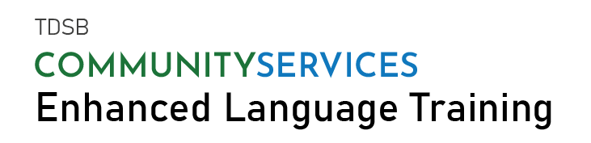
Program Start Dates in JANUARY 2022
Sector | Location |  | Start Date | End Date
Information Technology | Online / 6464 Yonge St. |  | Jan. 10, 2022 | Mar. 7, 2022
Office Administration & Customer Relations | Online / 1470 Don Mills Rd. |  | Jan. 10, 2022 | Mar. 7, 2022
Health & Wellness | Online / 6464 Yonge St. |  | Jan. 10, 2022 | Mar. 7, 2022
Accounting & Financial Services | Online / 6464 Yonge St. |  | Jan. 14, 2022 | Mar. 11, 2022
Engineering | Online / 6464 Yonge St. |  | Jan. 14, 2022 | Mar. 11, 2022
8-week training +  6-week work placement*  Space is limited. Register now. |  | TO REGISTER, EMAIL US AT  ELTEMPLOYMENT@TDSB.ON.CA  Or call us at  416-395-8270 or 416-395-3669  Mon-Fri 8:30am-4:30pm  Visit www.elt4employment.ca for more information
Participants must be:
- PR or Convention Refugee
- CLB Level 6 or higher
- experienced, trained, or educated in the program sector of interest
- and prepared to commit to a full-time 14-week program to find employment.
Documents required for registration: PR Card/ Landing Record /Convention Refugee Document (Notice of decision); Language Assessment Document; Resume
!!! Pre-screening for suitability is required.
*There is an opportunity to receive work placement

