PROGRESS OF CONSTRUCTION WORK

- Windows installation completed.
- Roofing completed except for the small south canopy to be done during the weekend.
- Millwork installation in progress.

UPCOMING WORK

- Roof Top Unit.
- Elevator.
- Continue Brick Veneer
- Continue mechanical and electrical
- Continue Asphalt and outdoor work
- Metal Siding installation.

COMMUNITY UPDATE:
There will be earthwork/outdoor work that may cause vibrations, so TDSB has hired a third-party consultant to monitor and manage the vibrations and ensure that all the readings are in accordance with the city's regulations.
CONSTRUCTION PROGRESS PHOTOS:
- West Facade
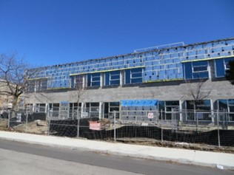

- Southeast Corner

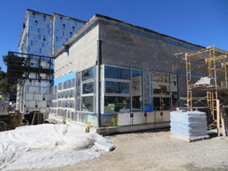

- One of the Classroom
