PROGRESS OF CONSTRUCTION WORK

- The site servicing work is nearly complete.
- The concrete topping for the second floor has been placed.
- The structural steel & roof joists/roof deck installation is ongoing.

UPCOMING WORK

- Windows installation during March.
- After the windows are installed the brick veneer starts.
- Continue interior masonry walls
- Continue mechanical and electrical rough-in

COMMUNITY UPDATE:
- The roof build-in beginning in March and continuing until the second week of April 2024, causing unpleasant smells.
- Toronto Hydro is awaiting a permit from the city for the street work from Guestville Ave to the new school build, after receiving the permit there will be some construction along Dennis Ave.
CONSTRUCTION PROGRESS PHOTOS:
- Site Looking Southwest

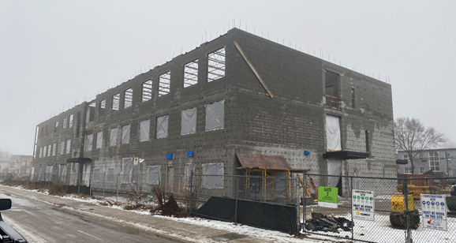

- Site Looking Southeast

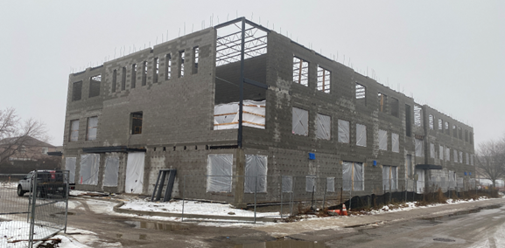

- Site Looking Northeast

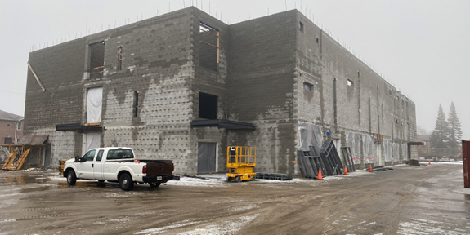

- Third Floor N/W corner looking Southeast

