

5050 Yonge Street, Toronto, Ontario M2N 5N8

Tel: (416) 397-3951 Fax: (416) 397-3226

**Questions and Answers for Trustees**

**TDSB 2019-2020 Proposed Balanced Operating Budget**

**June 7, 2019**

**1. For the past three budgets, how much has been allocated for the cost of Centrally Assigned Principals?**

**Answer:** The following amounts were allocated to central principals over the last three years:

|  |  |  |
| --- | --- | --- |
| **Year** | **FTE** | **Amount** |
| 2018-19 | 55.0 | $8.1M |
| 2017-18 | 47.0 | $6.9M |
| 2016-17 | 37.7 | $5.1M |

**2. At the Special Finance, Budget and Enrolment Committee meeting on 3 June 2019, delegates spoke to realizing cost savings.  Trustees requested further information on the following:**

**(a) Could staff differentiate between what a preferred vendor is versus an approved vendor of record?**

**Answer:** “Preferred” vendors isn’t a term we use. When we use the term “approved” vendor, it refers to a vendor who has participated in a competitive procurement process and been awarded a contract and/or purchase order as a result. These competitive processes could be a Request for Proposals (RFPs), Request for Tenders (RFTs), Request for Quotations (RFQs) or Request for Supplier Qualifications (RFSQ). The first three typically result in a single successful bidder, though on occasion there could be more than one. The latter (RFSQ) typically results in a list of pre-qualified vendors who meet established criteria (for example insurance requirements, criminal background checks, experience, etc.) that provide a choice of vendors in that product/service category.

The SAP vendor database includes approved and pre-qualified vendors as well as some typically small-dollar vendors who may not have been subject to a competitive process but are accessible for low dollar “Local Purchase Order” transactions (<$3,500).

**(b) If the City is interested in offering additional programming and requires more space, why isn’t the TDSB providing the space as the TDSB has a lot of empty space within its schools?**

**Answer**:  The TDSB’s Community Planning and Partnerships process allows public agencies to lease unused rooms in schools. The City of Toronto is an eligible public agency and can express interest in leasing space in schools through this process. As per the TDSB’s policy, the leases are to occur at no cost to the TDSB (the agencies are signed to leases at a cost recovery rate and they pay for capital improvements to their leased space).

**3. Following a June 3 deputation on TDSB vendors, can staff provide more information on the suggestion to move to the use of preferred vendors, as opposed to approved vendors? Is this a viable option for finding savings on purchases like hardware/software/furniture?**

**Answer:** TDSB as a part of the broader public sector we are required for purchases over $10,000 to use a competitive procurement process for goods and services. As a result having “Preferred” vendors without going through some competitive process is not allowed. Where a competitive process has been conducted bidders compete against one another to provide the best price/value for the board based on specific requirements. Left open to select a product/service from a “preferred” vendor may prove difficult to determine if best value was achieved.

With respect to computer purchases incorporated in the price of computers/laptops is the following:

·Imaging – each device is delivered with the TDSB image pre-loaded by the vendor meaning the device is essentially ready to go right out of the box when delivered;

·Software – within that image there are multiple software titles pre-loaded (Admin image includes 21 types of software including Office Professional, SAP, Trillium, etc; the Academic image includes about 32 types of software including Read Write, Office, Google Earth, Markbook, etc; and the Special Education image includes about 28 types of software including Office, Boardmaker, Dragon Naturally Speaking, etc);

·Delivery & set up including removal of packaging;

·Warranty – includes extended on-site warranty for new and used Intel products ranging from 3-5 years;

·Asset tagging/tracking – vendor labels devices and provides the Board with a list of what assets were shipped to our various locations and tracks warranty;

·Chromebooks – there is a license fee included for the Chromebook Management Console that allows central remote installation of apps, locking of lost/stolen devices, and remote set up other Chrome features

**4. Can you please provide:**

* **a detailed breakdown of the 2017-18 actuals and 2018-19 project revenue and expenditures;**
* **a detailed breakdown of the 2019-20 and 2020-21 projected costs, in particular, the projected costs arising from City of Toronto benchmarks ."**

**Answer:**

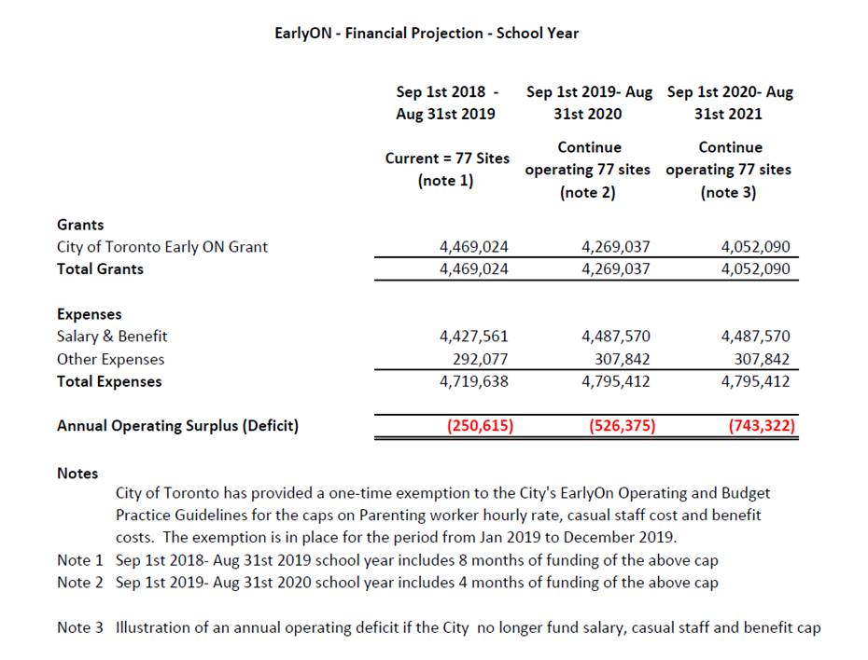

**5. How many supply teachers are currently serving high school students?**

**Answer:** There are currently 1,950 occasional teachers on the secondary occasional teacher roster.

**6.  If we are not receiving $1.6 million in PSI grant and we are completely removing free permits, why do we still have $1.6 million in deficit?**

**Answer:**

The Priority Schools Initiative (PSI) program provided funding to not-for-profit community based organizations offering programs in designated priority neighbourhoods.   The program was offered in 77 school locations across the City.  After the Ministry of Education reduced funding for the program in the 2018/19 budget year, the Board approved a continuation of the program for the remainder of the budget year.  The PSI funding was subsequently eliminated for the 2019/20 budget.  In recognition of the value of this program, and the opportunities offered to communities, staff are recommending that we continue with a modified PSI program, subject to the following conditions:

* The Board will not incur any additional costs to run the program.
* The program will be offered in up to 77 of the current PSI schools, provided sufficient regularly scheduled Caretaking staff are assigned to the school.
* Schools will only be available after school hours, Monday to Friday

In the current school year, approximately $520,000 of the $1,600,000 budget was used for caretaking overtime.  Since we are not recommending weekend permits, this cost will be eliminated.  The remain $1,100,000 shortfall will be made up as we reallocate caretaking staff based on proposed room closures; this may mean that a smaller number of schools will be available for PSI use.

The approval process will follow the same criteria currently in place for PSI permits:

Participants: No cost permits only available for children, youth and seniors groups

Community needs: Over 75% of participants should be from the community

Space availability: School usage takes priority and space approval is subject availability and caretaking allocation.

Uniqueness of program: Groups will be allocated space based on the program focus/type in line with community needs.

Participation cost: Priority will be given to organizations offering free or subsidized programs.

**7. What is the annual salary/benefit cost for superintendents?**

**Answer:** The average salary and benefit cost for a Superintendent of Education is $200,748.

**8. Please provide the following information:**

* **are lunchroom supervisors under collective bargaining agreement?**
* **are centrally assigned principals under collective bargaining agreement?**
* **are superintendents under a collective bargaining agreement?**

**Answer:** Lunchroom supervisors are part of our Collective Agreement with CUPE. Centrally assigned Principals are part of our Terms and Conditions with the Toronto School Administrators Association. Superintendents are part of our Terms and Conditions with the Toronto Supervisory Officers Association.

**9. What criteria were used to determine which Outdoor Education centres would be proposed for closure?**

**Answer:** staff looked at the leased sites from the Toronto and Region Conservation Authority namely Etobicoke Outdoor Education Centre and Etobicoke Field Studies Cenre.

Etobicoke Field Studies Centre, Warren Park and TUSC* are the 3 highest costing sites on a per student basis. *This take into consideration that there are no transportation costs associated with TUSC.

All student visits at these sites could be somewhat accommodated through the remaining centres.

**10. Trustees have asked for information regarding potential layoffs. Can you provide an update?**

**Answer:** The staffing situation in all employee groups is very dynamic. At this time, based on the staff proposed plan for a balanced budget, we are expecting minimal numbers of lay-offs in all employee groups except secondary teachers.

As previously shared via email with respect to Secondary Teacher layoffs, there are two factors at play. We have secondary teachers returning from leave as well as secondary teachers currently in central positions that may return to schools depending on the results of budget deliberations. As these teachers were not in a classroom this year, funding for those positions is not covered by the government’s attrition protection funding and will result in potential layoffs.  We are hopeful that most bumped staff will be placed by the end of the summer and that the remainder will be placed in the next school year.

Further, with respect to CUPE, there may be some positions in specialized central positions where the ability to place employees is limited and layoffs will occur.

**11. Is the "EarlyON child care programming" referred to in the documents (16.2, item 8) from May 22nd Board meeting a different program from the TDSB run EarlyON child and family centers?**

**Answer:** No 

**12. Has the TDSB had discussions with the city about using the annual salary range limit vs the hourly range limit when funding TDSB EarlyON Staff?**

**Answer:** Annually, staff has conversations with TCS to mitigate the operating deficit of the program.

**12 (b). Could the board approach the City and ask for an exemption or modification to fund our programs based on a 10-month prorated salary that would then still come well within their annual salary limits?**

**Answer:** Yes

**13. What are the major reasons why Other Revenue in Financial Statements always seems to exceed the budget, could this not be a method of balancing the budget.**

**Answer:** Below are the last three years of variances between the budget and actuals for other revenue from the financial statements with an explanation:

|  |  |  |  |  |
| --- | --- | --- | --- | --- |
| Year | Budget | Actual | Variance | Major variances (millions) |
| (millions) | | |
| 2017-18 | $96.505 | $113.916 | $17.421 | 15.3M - from Proceeds of disposition used for land acquisition, not for operating budget use |
| $2.0M – Donations as these are not predictable no budget assigned. Also Donations usually are for specified purposes and cannot be used as general revenues. |
| 2016-17 | $83.164 | $109.799 | $26.635 | $5.2M - Legal Settlement, one time item |
| $1.8M - Donations as these are not predictable no budget assigned. Also Donations usually are for specified purposes and cannot be used as general revenues. |
| $5.7M -Tuition Fees, significant enrolment increase in 16-17 school year, revenue budget was adjusted in the following school years and additional teachers released. |
| $2.7M - Interest on Debt, used to pay off long term debt, not for operating purpose |
| $2.8M - Interest on Reserve Funds, not for operating budget purpose |
| $1.4M –Secondment revenue associated with offsetting expenditures |
| $4.7M - Revenues in capital purposes, not for operating budget |
| $1.2M -Contract Services fee associated with offsetting expenditure |
| 2015-16 | $81.134 | $102.960 | $21.826 | $2.5M - Interest on Debt, used to pay off long term debt, not for operating purpose |
| $6.2M – Revenues in capital natural, not for operating budget |
| $1.9M - Donations as these are not predictable no budget assigned. Also Donations usually are for specified purposes and cannot be used as general revenues |
| $4.1M - Interest on Reserve Funds, not for operating budget purpose |
| $1.0M – Secondment revenue associated with offsetting expenditures |
| $0.8M – Prior Year change per Ministry not anticipated |
| $1.0M – Insurance rebate, no longer exist after board change insurance policy |
| $1.5M - Contract Services fee associated with offsetting expenditures |

**14. How much $ do we put into the equity fund on a yearly basis -%(flexible budget) and amount since we've had it in place or at least the last 10 years. How is that determined? (especially given that poverty is increasing in the city) How much of this fund is used each year & what is it allocated for? One of them is Outdoor Education... others? Please be as specific as possible in listing these. What is the % change in allocation to this fund over the past 10 years or since it's been in existence. How are these allocations to schools made? What are the key determining factors?  Who makes those decisions? What challenges have we had with the Equity Fund in general or specific issues? Is this fund sustainable given the current fiscal realities and if the proposals pass?**

**Answer:**

The Central Equity Fund was established on 15 January 2003. At the time, the trust criteria established was as follows:

“On June 12, 2002 a central equity fund was approved to hold funds voluntarily donated for equity purposes. All funds generated would be distributed annually to the 40% of schools ranked most in need according to the Learning Opportunities Index. Using the index as a weighting factor, the proceeds of the fundraiser would be allocated on a prorated basis to the schools most in need of support. The expenditure of these funds will adhere to the Fundraising Policy. Part of the proceeds includes proposed voluntary Read-a-thon with a fundraising goal of $ 100,000 (Cash, in-kind donations & prizes are anticipated support). In addition, it was felt that undirected centrally received donations could also be earmarked for the equity fund, thereby potentially increasing the size of the amount to be distributed."

Between 2005-06 and 2008-09, the vending machine commissions were deposited into the Central Equity Fund. The commissions ended with the introduction of the Ministry of Educations Policy/Program Memo 150 (PPM150), which enforced a school food and beverage policy, and prohibited soft drinks sales in schools.

The Central Equity Fund has received ad hoc donations between 2003 and 2019. The total of all proceeds during the 16 year period is around $662K. Disbursements between 2003 and 2007 were $302,218, and were calculated based on 40% of the schools ranked most in need according to the Learning Opportunities Index.

The current balance of the Central Equity Fund, as of 21 May 2019, is $399,654.

The Central Equity Fund is not widely known or promoted; hence stakeholders may not be aware of its existence. The Central Equity Fund could be depleted in a short period of time without steady inflows of funding. Since 2010, the majority of the donations received were from estates or corporate donors, who did not designate the funds to any particular school or cause. To ensure its sustainability, the Board could engage in central fundraising initiatives, such as by adding an "online donation link/button" for donors to give directly to the Central Equity Fund. To ensure transparency and equitable distribution of funds, donors must be made aware of how the funds will be spent.

Staff are recommending that in future years a budget allocation of $500,000 be made to the Central Equity Fund to ensure its long-term sustainability. Staff are working on developing a procedure to allocate these funds so support disadvantaged students so that all student have equitable access to resources.