ATTENTION: PARENTS/GUARDIANS/CAREGIVERS OF CHILDREN
WHO WILL BE ENTERING JUNIOR KINDERGARTEN IN SEPTEMBER 2022
OR WHO ARE CURRENTLY IN JUNIOR KINDERGARTEN

For 2022-2023, Junior or Senior Kindergarten is the ONLY time
your child may begin the Early French Immersion program.
The next available entry point is Grade 4 with the Middle French Immersion Program.

TO NOTE: For September 2022 only, children who will be entering Junior Kindergarten or Senior Kindergarten are eligible to apply for Early French Immersion. Looking ahead to September 2023, the only entry point for Early French Immersion will be Junior Kindergarten.

WHAT IS EARLY FRENCH IMMERSION?

Early French Immersion programs are designed for students who do not speak French at home. The Early French Immersion program (JK/SK Entry for 2022-2023 only) provides the maximum French language experience available in our schools.

The Early French Immersion program offers a 100% model of instruction in French from Kindergarten to Grade 3 in most schools (with the exception of a PREP-providing subject that may be delivered in English if required). In Grades 4 to 8, the program will be taught 50% in French and 50% in English. The subjects taught in French from Grades 4 to 8: French Language, Math and Social Studies.

After Grade 8, students continue the French Immersion program at designated secondary schools. Students who successfully complete a minimum of 10 credits in French at the secondary school level are eligible for a Certificate of Bilingual Studies in French within the TDSB.

WHO IS EARLY FRENCH IMMERSION FOR?

- Designed for families who speak a language other than French at home.
- We believe strongly that students are capable of learning another language so students of all learning styles and language backgrounds are welcomed and supported in the program.
- The Early French Immersion programs are suited to all families who are interested in the opportunity to develop proficiency in French.

For information on the Application process or how to find your associated Early French Immersion school for your area, please visit the website below and/or access the Frequently Asked Questions under Application Process – left menu bar:

www.tdsb.on.ca/Elementary-School/School-Choices/French-Programs

*Catchments are based on the student’s home address and may change in accordance with TDSB procedures.

FIND US AT: www.tdsb.on.ca/French

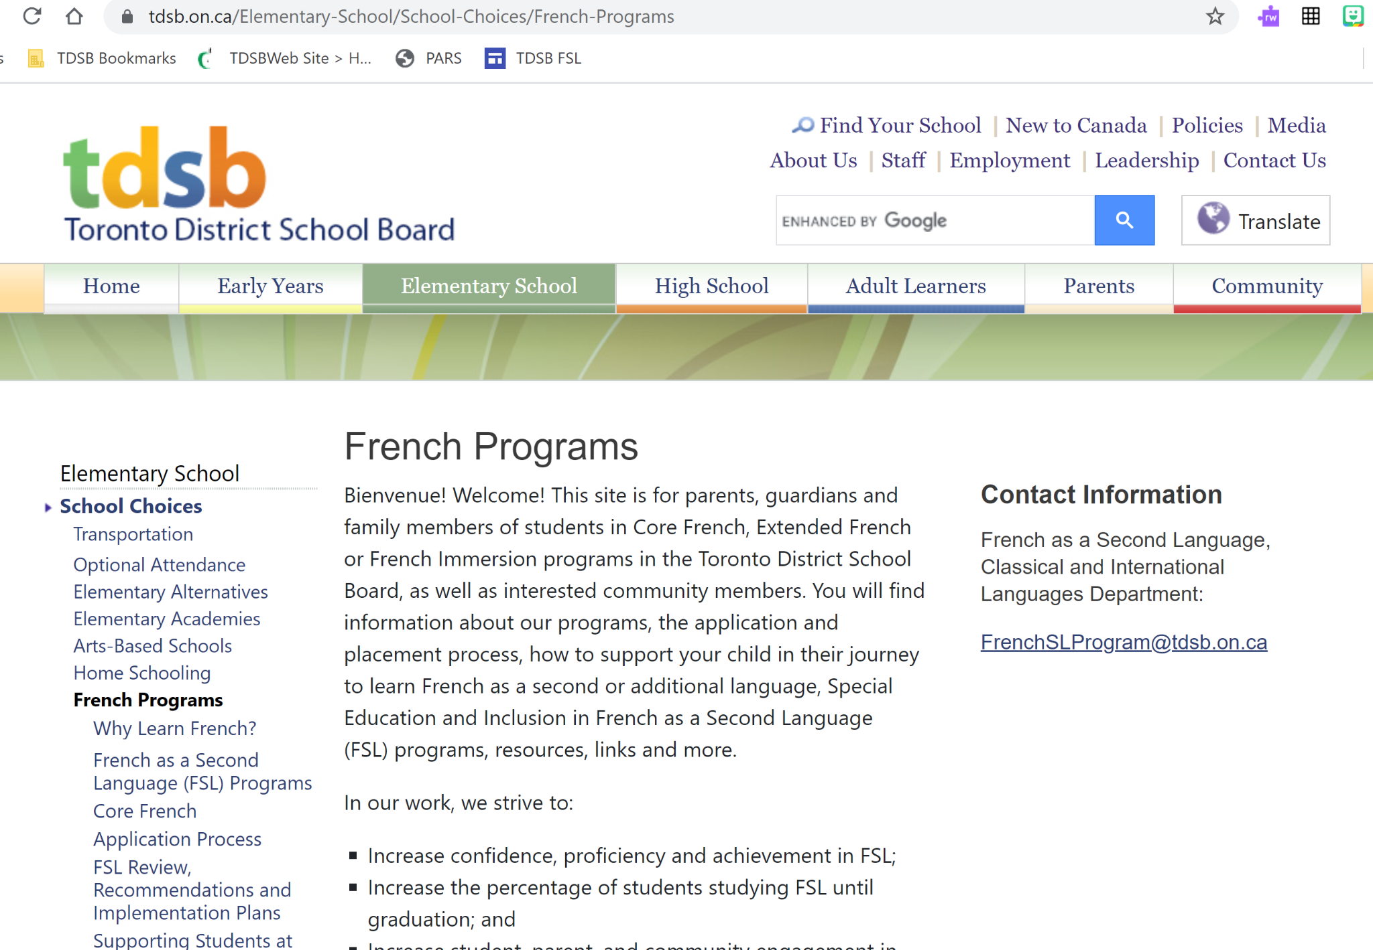

WHERE TO APPLY ONLINE:
www.tdsb.on.ca/Elementary-School/School-Choices/French-Programs/Application-Process/PARS

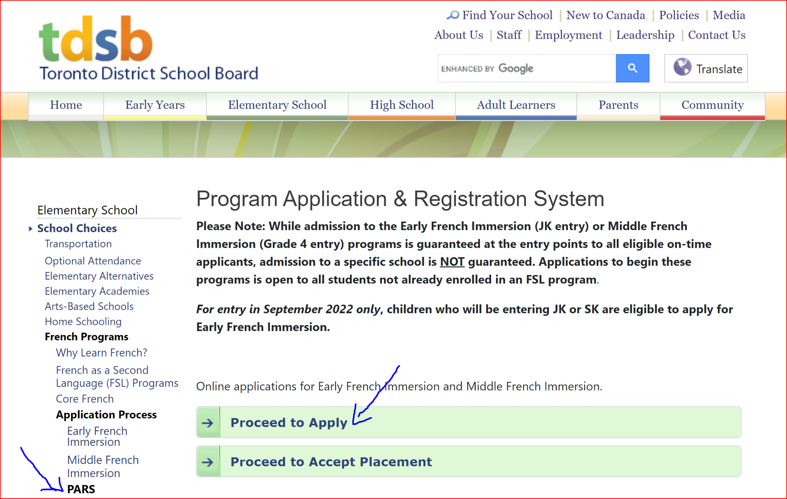

VIDEO AND FLYER INFORMATION ON THE APPLICATION PROCESS

At any time, parents/guardians/caregivers can visit www.tdsb.on.ca/french to view a video that provides a great deal of information about our French programs as well as the application and placement process in the Early French Immersion and the Middle French Immersion programs. Click here for Early French Immersion flyers in 22 languages.

Applications for the Early French Immersion Program
are completed online for September 2022

Applications to the Early French Immersion program are made in November of the year before the child begins Junior Kindergarten for entry in September of Junior Kindergarten. For 2022-2023 only, students who are currently in Junior Kindergarten may also apply for entry in September of Senior Kindergarten. Going forward, Junior Kindergarten will be the only entry point for Early French Immersion.
- It is an entirely online application process.
- All communication will be sent via the email address provided online at the time of application.
- Please check this email regularly including junk mail.
- Families with an older sibling currently enrolled in the same French program and who will be in attendance the following year are still required to complete an online application for the new student. Please select the “sibling option” within the online application.

Please visit the application site www.tdsb.on.ca/pars during the application period:

For children born in 2018:
- Please select the “Non-TDSB Student” option and follow the steps to generate an identification number. You must then return to the PARS site and follow the application procedure with this number.
- Once in PARS, please select the Early Immersion Program from the drop-down menu, and complete the application process.
- On-time applicants will be offered a placement via the email address you have provided.
- You MUST take action to reserve a spot by the deadline requested when you are offered a placement
For children born in 2017:
- You will need your child’s date of birth and OEN. The OEN is a 9-digit number found on any report card from the TDSB.
- For non-TDSB students, please select the “Non-TDSB Student” option and follow the steps to generate an identification number. You must then return to the PARS site and follow the application procedure with this number.
- Please select the Early Immersion Program from the drop-down menu, and complete the application process.
An offer of placement in Early French Immersion is guaranteed to all eligible on-time applicants, however placement in a particular school is NOT guaranteed.

On-time applicants will be offered a placement online via the email address provided at the time of application. Parents/Guardians/Caregivers MUST take action to accept this placement by the deadline requested when offered a placement in order to reserve a spot in the program.
Offers of placement will be ongoing through the weeks and months following the close of the application period. Please check email regularly (including junk mail) and follow all instructions found therein.

IMPORTANT DATES
Online Application process opens: November 1, 2021
Deadline for applications: November 26, 2021

Please note the following information: While every effort will be made to place students in the school identified as their area's French Immersion school, this is not always possible. In cases where the number of applications in a given area is greater than the number of allotted program spaces in the school, students may be redirected to schools with available program space.

Placements are made based on the child's primary home address of record prior to the application deadline. If the address changes between the application deadline and the September when the child will enter the program, there is no guarantee of placement in the new area.
Applicants who have older siblings currently enrolled in the same program and who will be in attendance the following year have a priority placement in that school.

NB: Please note that classes with fewer than 25 students may not open.

CENTRAL PARENT/CAREGIVER/COMMUNITY INFORMATION SESSIONS

For information on specific sessions, please visit our French website regularly for updates:

www.tdsb.on.ca/Elementary-School/School-Choices/French-Programs/Information-Sessions
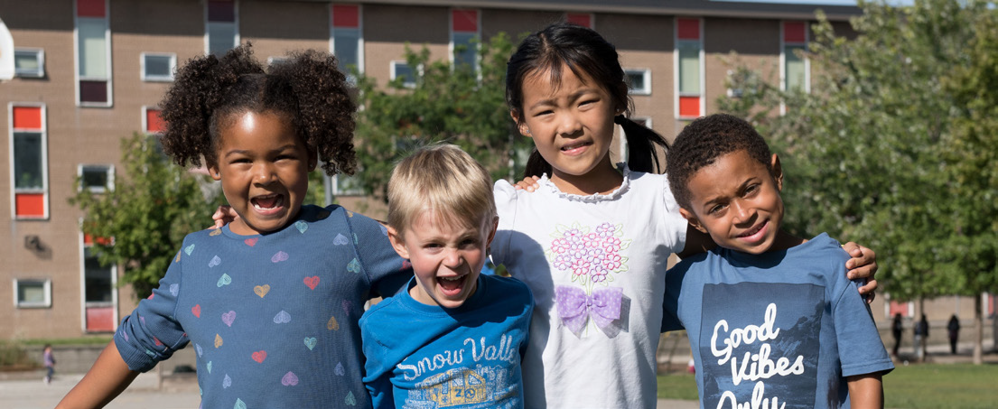
The scheduled information sessions are as follows:
- November 8, 2021, 7 p.m.
- November 15, 2021, 10 a.m.
- November 23, 2021, 7 p.m.

Please note: To participate in a live scheduled web chat, please visit the web page above and a link will be available to join on the dates/times as outlined above.

PLEASE BE REMINDED

For September 2022 only, children who will be entering Junior Kindergarten or Senior Kindergarten
are eligible to apply for Early French Immersion. Looking ahead to September 2023, the only entry
point for Early French Immersion will be Junior Kindergarten.

