Special Education & Inclusion
in French as a Second Language Programs

- All students are welcome, encouraged and supported in Core French, Extended French, Early and Middle French Immersion programs.
- Students with a range of learning needs, learning styles and linguistic backgrounds are currently participating and thriving in FSL programs.
- The full range of achievement levels appear in all FSL programs as they might in the regular English program.
- Classroom teachers of French programs are equipped with a similar range of strategies to differentiate for different learning styles, provide instructional accommodations or curriculum modifications where necessary as they would in the English program.
- If interventions outside the classroom prove necessary, they can be effectively delivered in French.
- Interventions delivered in English (during instructional time already dedicated to English instruction) may benefit the student in both languages.
- The additional language focus in a FSL class may indeed improve outcomes for students with learning disabilities specific to language.
From the TDSB Special Education Plan 2019  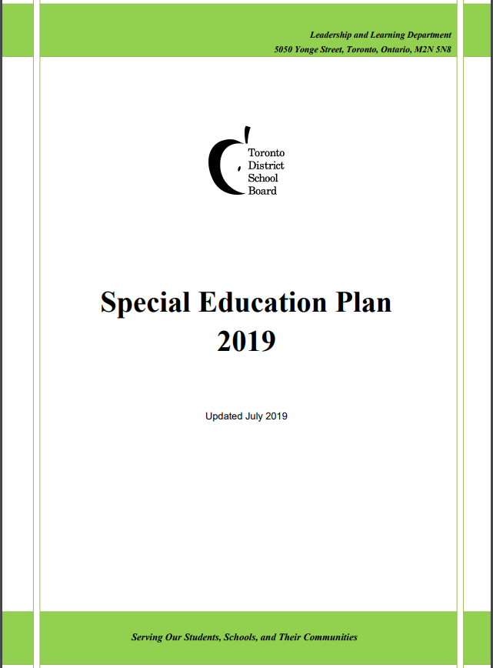 | “What is TDSB’s Vision for Special Education?  TDSB’s Vision for Special Education is that students identified with special education needs be welcomed, included and supported within well-resourced neighbourhood schools. We are committed to providing all students with equitable access to special education programs, services and resources in the most supportive and inclusive environment for learning, to the fullest extent possible in the local community.
There is no exception to these principles for students in FSL programs.  From the Ministry of Education  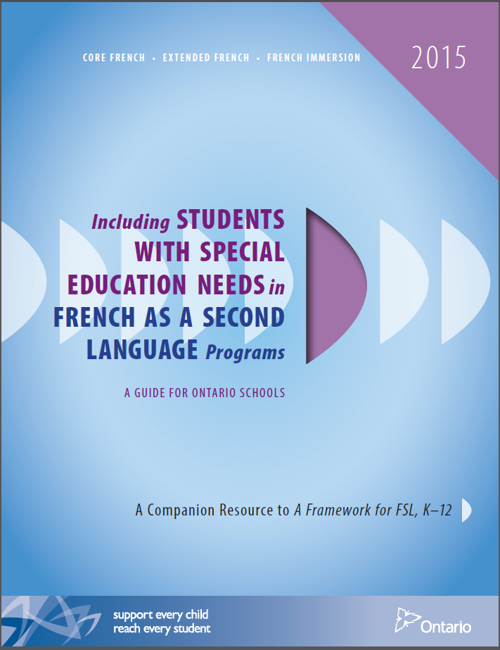 | - Students with special education needs can thrive in FSL  - Students with special education needs may benefit from FSL (i.e., more explicit work on reading strategies)  - There is nothing in policy or legislation that supports exclusion from FSL programs  - Not all exceptional students face difficulties in learning a second language  - Instruction must be based on the belief that all students can be successful and that learning French is important and valuable  - Accommodations and modifications can be part of a student’s program in FSL  - There is no ministry policy outlining exceptions to the inclusion of students in FSL programs
From the curriculum document  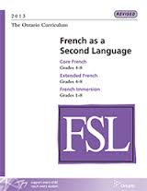 | All students can succeed.  • Each student has his or her own unique patterns of learning.  • Successful instructional practices are founded on evidence-based research, tempered by experience.  • Universal design and differentiated instruction are effective and interconnected means of meeting the learning or productivity needs of any group of students.  • Classroom teachers are the key educators for a student’s literacy and numeracy development.  • Classroom teachers need the support of the larger community to create a learning environment that supports students with special education needs.  • Fairness is not sameness.

